Day 25 - 19th Aug 2025

Task 1
Q1. How does the 12-Factor App methodology ensure that applications remain portable and resilient across different cloud environments?
- The 12-Factor methodology ensures portability and resilience by treating the app as a set of independent, environment-agnostic processes.
- It separates code from configuration, treats backing services (databases, queues, caches) as attachable resources rather than hard-wired dependencies, and standardizes how apps build, release, and run.
- Because nothing environment-specific is baked into the codebase, the same build can move from a developer's laptop to staging to production — or from AWS to Azure — without modification. This decoupling is what lets cloud platforms scale, restart, or reschedule instances freely without breaking the app.

Q2. Why is externalizing configuration (including secrets in Spring Boot profiles) critical for maintaining dev/prod parity, and how does it differ from dependency management?
Externalizing configuration (like DB URLs, API keys, and secrets in Spring Boot profiles) matters because it keeps the exact same build artifact usable across dev, staging, and prod — only the config changes, not the code. This is what "dev/prod parity" really means: minimal drift between environments so bugs don't hide until production. It also protects secrets from being committed to source control, which is a security necessity, not just a best practice.
Dependency management is a different concern entirely — it's about explicitly declaring and isolating the libraries/packages your app needs (via Maven/Gradle in Spring Boot) so builds are repeatable and don't silently rely on whatever happens to be installed on a machine. In short: config changes per environment, dependencies stay fixed across environments.

Home Task
Q3. In what ways do stateless processes and port binding enable horizontal scaling and self-contained services in microservice architectures?
- Stateless processes mean no session or in-memory data is stored on the instance itself — any state lives in a database, cache, or external store.
- This makes each instance disposable and interchangeable, so you can spin up 10 more identical copies behind a load balancer with zero coordination overhead.
- Port binding (the app exposing its own service via a port, e.g., Spring Boot's embedded Tomcat) means each instance is self-contained and doesn't depend on an external web server being configured for it — making it trivial to deploy the same artifact anywhere and scale horizontally just by adding instances.

Q4. How do disposability, graceful shutdown, and health/readiness/liveness endpoints (via Actuator) collectively improve reliability in cloud-native deployments?
- Disposability means processes can start fast and shut down gracefully — finishing in-flight requests, releasing connections cleanly — instead of dying abruptly.
- Combined with Spring Boot Actuator's health, readiness, and liveness endpoints, orchestrators like Kubernetes can make smart decisions: liveness tells it "is this instance stuck and needs a restart," readiness tells it "is this instance ready to receive traffic," and health gives an overall status snapshot. Together, these let the platform self-heal — killing bad instances, holding back traffic from ones still starting up, and rolling deployments without downtime.

Q5. Why are logs treated as event streams in cloud-native systems, and how does this approach differ from traditional logging in monolithic applications?
- Cloud-native systems treat logs as event streams — a continuous, timestamped flow of output — rather than files the app manages itself.
- The app just writes to stdout/stderr; it's the platform's job (via tools like Fluent, Logstash, or a cloud logging service) to collect, route, and store them.
- This differs from traditional monolithic logging, where each app manages its own log files on local disk, making it painful to aggregate logs across many servers or trace a request across services.
- In distributed, ephemeral, multi-instance environments, treating logs as streams is what makes centralized monitoring, searching, and correlation actually possible.

Task 2:
Cloud-Native Application & 12-Factor Methodology
What Makes an Application Cloud-Native?
1. How does cloud-native design differ from traditional monolithic application design in terms of scalability and resilience?
Cloud-native applications are designed as small, loosely coupled services that can be deployed and scaled independently. If one service fails, the entire application does not necessarily go down. They can also add more instances when demand increases.
In contrast, a monolithic application is usually tightly coupled, so scaling or fixing one part may require deploying the entire application.
2. Why is containerization considered a key enabler of cloud-native applications?
Containerization packages the application along with its required libraries and dependencies into a portable container. This ensures that the application behaves consistently across development, testing, and production environments. Containers are also lightweight and can be easily created, stopped, and scaled, which makes them ideal for cloud-native applications.

Introduction to the 12-Factor App Methodology
3. How does the 12-Factor methodology ensure portability across cloud platforms?
The 12-Factor methodology encourages applications to keep code, configuration, dependencies, and infrastructure resources separate. Configuration is stored outside the code, dependencies are explicitly declared, and backing services are treated as replaceable resources. Because of this, the same application can be moved between different cloud platforms with minimal changes.
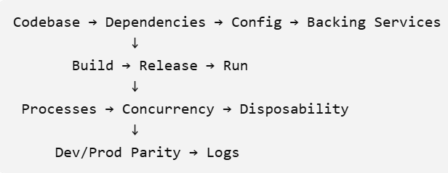
4. Which factors directly address developer productivity versus operational stability?
Factors such as codebase, dependencies, development/production parity, and logs mainly improve developer productivity by making development consistent and easier to debug. Factors such as stateless processes, disposability, concurrency, configuration, and build-release-run separation mainly improve operational stability, scalability, and reliability.

Code & Configuration
Codebase and Dependency Management
5. Why is maintaining a single codebase with multiple deploys critical for consistency?
A single codebase means that development, testing, and production deployments are based on the same source code. Different environments can have different configurations, but the application code remains consistent. This reduces the chance of environment-specific bugs and makes version control and deployment easier.
6. How does explicit dependency declaration improve application reliability?
Explicit dependency declaration means clearly specifying all libraries, frameworks, and their required versions. This prevents the application from depending on packages that happen to be installed on a particular machine. As a result, the application can be built and deployed consistently across different environments.

Externalized Configuration
7. Why should configuration be externalized instead of hardcoded in the application?
Configuration values such as database URLs, ports, API endpoints, and credentials can be different for each environment. If these values are hardcoded, developers must modify the application whenever the environment changes. Externalizing configuration allows the same application code to run in different environments without changing the code.
8. How does externalized configuration support dev/prod parity?
Externalized configuration allows development and production to use the same application build while providing different configuration values. For example, development can connect to a development database while production connects to a production database. This keeps the code consistent while allowing environment-specific settings.
Services & Resources
Backing Services as Attached Resources
9. Why should backing services like databases or queues be treated as attached resources?
Backing services such as databases, message queues, caches, and storage systems should be treated as external resources rather than being tightly connected to the application. This allows them to be replaced, upgraded, or moved without changing the application code. It also makes the application more flexible and portable.
10. How does this principle simplify migration between environments?
When backing services are treated as attached resources, the application only needs the correct connection details. For example, the development environment can use one database while production uses another. During migration, the database or queue can be replaced by changing configuration instead of modifying the application itself.

Build, Release, Run Separation
11. Why is it important to separate build, release, and run stages in deployment pipelines?
The build stage creates the application package, the release stage combines the build with environment-specific configuration, and the run stage executes it. Separating these stages makes deployments predictable and ensures that the same tested build can be promoted across environments.
12. How does this separation reduce risk during production deployments?
Once a build has been tested, the same build can be released to production without rebuilding it. This reduces unexpected changes and ensures that production uses the same tested version that was validated earlier.
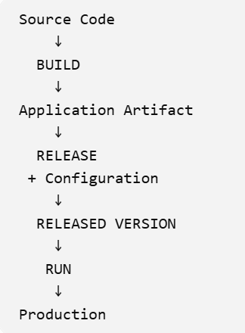

Processes & Scaling
Stateless Processes and Statelessness
13. Why is statelessness essential for horizontal scaling in cloud-native systems?
A stateless process does not store important user information locally between requests. Therefore, any instance can handle any request. When traffic increases, new instances can be added easily without needing to copy session information between them. This makes horizontal scaling faster and simpler.
14. How can session data be managed in a stateless architecture?
Session data can be stored in an external shared system, such as Redis or a database. The application instances retrieve the session information when needed. This allows users to move between different application instances without losing their session.
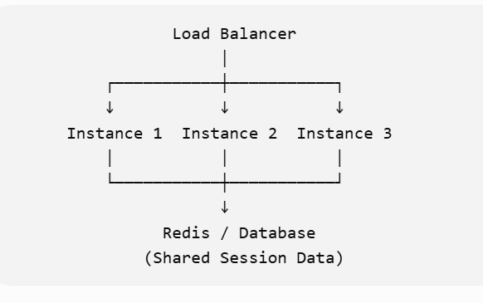

Port Binding and Self-Contained Services
15. Why does the 12-Factor methodology recommend port binding for service exposure?
Port binding allows an application to provide its own network service by listening on a specific port. The application does not need to depend on a separate web server to expose it. This makes the application self-contained and easier to deploy.
16. How does port binding enable microservices to remain self-contained?
Each microservice can run independently and listen on its own port. Other services can communicate with it through that port. This means each service contains everything it needs to operate and does not have to be tightly dependent on another application's runtime.

Concurrency and Scaling Out
17. How does process concurrency differ from vertical scaling?
Process concurrency means running multiple processes or instances of an application to handle more requests. Vertical scaling means increasing the resources, such as CPU or RAM, of an existing machine. Cloud-native applications generally favor adding more instances rather than relying on one larger machine.
18. Why is scaling out preferred over scaling up in cloud-native systems?
Scaling out provides better flexibility and fault tolerance because workloads are distributed across multiple instances. If one instance fails, other instances can continue serving users. Scaling up depends more heavily on a single machine and eventually reaches hardware limitations.

Reliability & Parity
Disposability and Graceful Shutdown
19. Why should processes be disposable in cloud-native environments?
Cloud-native systems frequently create and remove application instances due to scaling, deployments, or failures. Processes should therefore be quick to start and safe to stop. This makes the system more flexible and allows failed instances to be replaced easily.
20. How does graceful shutdown improve reliability during scaling events?
During shutdown, the application should finish existing requests and properly close connections and resources before stopping. This prevents requests from being interrupted unnecessarily and reduces the possibility of data loss or failed transactions during scaling or deployments.

Dev/Prod Parity
21. Why is minimizing differences between development and production environments critical?
Large differences between development and production can cause applications to work correctly during development but fail after deployment. Keeping environments as similar as possible helps developers identify problems earlier and reduces deployment surprises.
22. How does continuous deployment support dev/prod parity?
Continuous deployment uses automated processes to build, test, and deploy applications consistently. The same build can move through development, testing, and production environments. This reduces manual differences and ensures that production closely matches what was tested.

Observability & Configuration
Logs as Event Streams
23. Why should logs be treated as event streams rather than files?
In cloud-native applications, instances can be created and destroyed frequently, so relying on local log files is unreliable. Logs should be produced as continuous event streams that can be collected by a centralized logging system. This ensures logs remain available even after an application instance is removed.
24. How does centralized log aggregation improve debugging in distributed systems?
A distributed application may have many services running on different instances. Centralized logging collects their logs in one location, making it easier to search, compare, and trace errors across services. This helps developers identify the source of failures much faster.

Externalizing Config & Secrets in Spring Boot
25. How do Spring Boot profiles help manage environment-specific configurations?
Spring Boot profiles allow developers to maintain different configurations for different environments, such as development, testing, and production. For example, application-dev.properties can contain development settings while application-prod.properties contains production settings. The appropriate profile can be activated when the application starts.
26. Why should secrets be externalized instead of stored in application code?
Sensitive information such as passwords, API keys, and database credentials should not be stored directly in source code. Code repositories may be shared or exposed accidentally. Externalizing secrets through environment variables, secret managers, or secure configuration systems protects sensitive information and makes credentials easier to change or rotate.

Health, Readiness and Liveness Endpoints (Actuator)
27. What is the difference between readiness and liveness probes in Spring Boot Actuator?
A liveness probe checks whether the application is running and functioning sufficiently. If it fails, the platform may restart the application.
A readiness probe checks whether the application is ready to receive traffic. If it fails, the application can temporarily be removed from traffic while it recovers.
Example: An application may be alive but still waiting for a database connection. In that situation, liveness can be healthy while readiness is not.
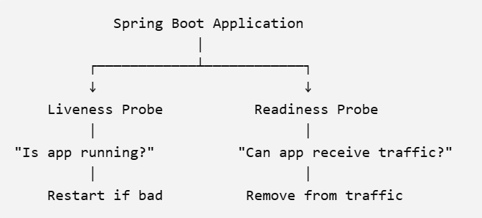
28. How do health endpoints contribute to automated monitoring and alerting?
Health endpoints provide information about the current state of the application and its dependencies. Monitoring systems can regularly check these endpoints and automatically detect unhealthy services. This can trigger alerts, traffic removal, or application restarts, helping maintain application availability and reliability.

