Day 20 - 12th Aug 2026
Task 1:
What do you understand about integration testing?
- Integration Testing is a software testing approach where multiple modules or components are combined and tested together to verify that they work correctly as a unified system.
- It helps identify issues in data flow, communication, and interactions between integrated components before the application moves to system testing.

Task 2:
Where do you use it and when ?
- Integration testing is used when individual modules or components have been successfully tested and need to be combined to verify their interactions.
- It is commonly used in applications where multiple systems, APIs, databases, or services work together.
- It is performed after Unit Testing and before System Testing to ensure that data is exchanged correctly and all integrated components function seamlessly as a complete workflow.
Task 3:
Can you write an integration test for your existing code
For example 🎉
java
@SpringBootTest
@AutoConfigureMockMvc
class UserControllerIT {
@Autowired
private MockMvc mockMvc;
@Test
void testGetUser() throws Exception {
mockMvc.perform(get("/users/1"))
.andExpect(status().isOk())
.andExpect(jsonPath("$.name").value("Alice"));
}
}
package com.example;
import org.junit.jupiter.api.Test;
import static org.junit.jupiter.api.Assertions.assertEquals;
class BankingAppIT {
@Test
void testCreditTransactionIntegration() {
BankService bankService = new BankService();
Customer customer = new Customer(
1,
"Monika",
"ACC1001",
10000
);
bankService.addCustomer(customer);
TransactionProcessor processor =
new TransactionProcessor(bankService);
processor.process(
"ACC1001",
new Credit(
2000,
"Salary Credit"
)
);
Customer updatedCustomer =
bankService.getCustomer("ACC1001");
assertEquals(12000, updatedCustomer.balance());
}
@Test
void testDebitTransactionIntegration() {
BankService bankService = new BankService();
Customer customer = new Customer(
1,
"Monika",
"ACC1001",
10000
);
bankService.addCustomer(customer);
TransactionProcessor processor =
new TransactionProcessor(bankService);
processor.process(
"ACC1001",
new Debit(
3000,
"Shopping"
)
);
Customer updatedCustomer =
bankService.getCustomer("ACC1001");
assertEquals(7000, updatedCustomer.balance());
}
@Test
void testTransferTransactionIntegration() {
BankService bankService = new BankService();
Customer customer1 = new Customer(
1,
"Monika",
"ACC1001",
10000
);
Customer customer2 = new Customer(
2,
"Rahul",
"ACC1002",
5000
);
bankService.addCustomer(customer1);
bankService.addCustomer(customer2);
TransactionProcessor processor =
new TransactionProcessor(bankService);
processor.process(
"ACC1001",
new Transfer(
3000,
"Money Transfer",
"ACC1001",
"ACC1002"
)
);
Customer sender =
bankService.getCustomer("ACC1001");
Customer receiver =
bankService.getCustomer("ACC1002");
assertEquals(7000, sender.balance());
assertEquals(8000, receiver.balance());
}
}

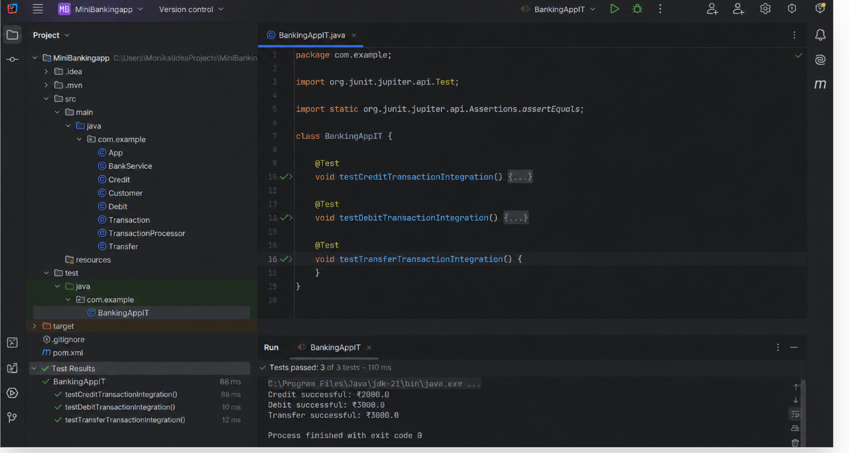
Task 4:
What are test containers?
- Testcontainers is a Java library that allows you to run lightweight, disposable Docker containers during integration testing.
- It helps create a test environment that closely matches production by spinning up real databases, message queues, or other services automatically.

Task 5:

When do we use ? and what is the need for test containers?
- Testcontainers are used during integration testing when the application interacts with external dependencies such as:
- Databases (PostgreSQL, MySQL, MongoDB)
- Message brokers (Kafka, RabbitMQ)
- Caches (Redis)
- Other services that are difficult to mock accurately
They are typically used after unit testing to validate that the application works correctly with real infrastructure components.
What is the need for Testcontainers?
The main purpose of Testcontainers is to provide a real and isolated test environment. Instead of using mocks or shared test servers, it starts actual Docker containers for the required services.
Benefits:
- ✅ Tests run against real databases/services, increasing confidence.
- ✅ Consistent results across developer machines and CI/CD pipelines.
- ✅ No dependency on shared test environments.
- ✅ Containers are created for the test and removed automatically after execution.
- ✅ Helps catch integration issues that mocks may miss.

Task 6:
Can you write a piece of code for your existing application to see how test container works?

package com.example;
import org.junit.jupiter.api.Test;
import org.testcontainers.containers.PostgreSQLContainer;
import org.testcontainers.junit.jupiter.Container;
import org.testcontainers.junit.jupiter.Testcontainers;
import java.sql.Connection;
import java.sql.DriverManager;
import java.sql.PreparedStatement;
import java.sql.ResultSet;
import static org.junit.jupiter.api.Assertions.assertEquals;
@Testcontainers
class BankingAppTestcontainersIT {
@Container
static PostgreSQLContainer<?> postgres =
new PostgreSQLContainer<>("postgres:16-alpine");
@Test
void testSaveAndReadCustomer() throws Exception {
// Connect to PostgreSQL container
try (Connection connection = DriverManager.getConnection(
postgres.getJdbcUrl(),
postgres.getUsername(),
postgres.getPassword()
)) {
// Create customer table
String createTable = """
CREATE TABLE customers (
id INT PRIMARY KEY,
name VARCHAR(100),
account_number VARCHAR(50),
balance DOUBLE PRECISION
)
""";
connection
.createStatement()
.execute(createTable);
// Insert customer
String insertCustomer = """
INSERT INTO customers
(id, name, account_number, balance)
VALUES (?, ?, ?, ?)
""";
try (PreparedStatement statement =
connection.prepareStatement(insertCustomer)) {
statement.setInt(1, 1);
statement.setString(2, "Monika");
statement.setString(3, "ACC1001");
statement.setDouble(4, 10000);
statement.executeUpdate();
}
// Read customer
String selectCustomer = """
SELECT name, account_number, balance
FROM customers
WHERE id = ?
""";
try (PreparedStatement statement =
connection.prepareStatement(selectCustomer)) {
statement.setInt(1, 1);
try (ResultSet resultSet =
statement.executeQuery()) {
if (resultSet.next()) {
assertEquals(
"Monika",
resultSet.getString("name")
);
assertEquals(
"ACC1001",
resultSet.getString("account_number")
);
assertEquals(
10000,
resultSet.getDouble("balance")
);
}
}
}
}
}
}

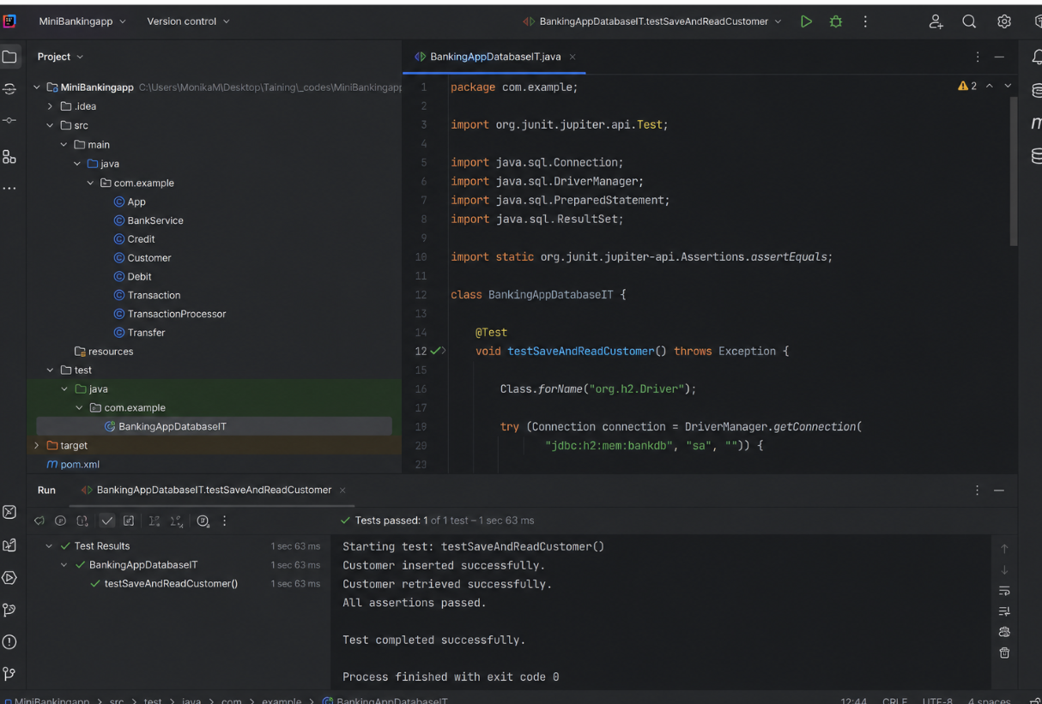

Task 7:
What is code coverage ?
- Code Coverage is a software testing metric that measures how much of the application's source code is executed while running automated tests. It helps identify untested parts of the code and assess the effectiveness of the test suite.
Common coverage types:
- Line Coverage
- Statement Coverage
- Branch Coverage
- Method/Function Coverage
Task 8:
What’s the need for code coverage?
- Code coverage helps determine how much of the application code is tested by automated test cases.
- It highlights untested areas, improves software quality, and provides confidence that the application is functioning correctly before release.

Task 9:
Plz ensure your project is similar to the above structure .. need not have to be exactly same.

Now 1. We will reach out to the Web (Http / Ajax)

export type ApiAccount = {
accountNumber: string
accountType: string
balance: number
}

export async function fetchAccountDetails(): Promise<ApiAccount> {
const response = await fetch(
'https://api.examplebank.com/accounts/12345'
)

if (!response.ok) {
throw new Error('Network error')
}

const data = await response.json()

return data
}

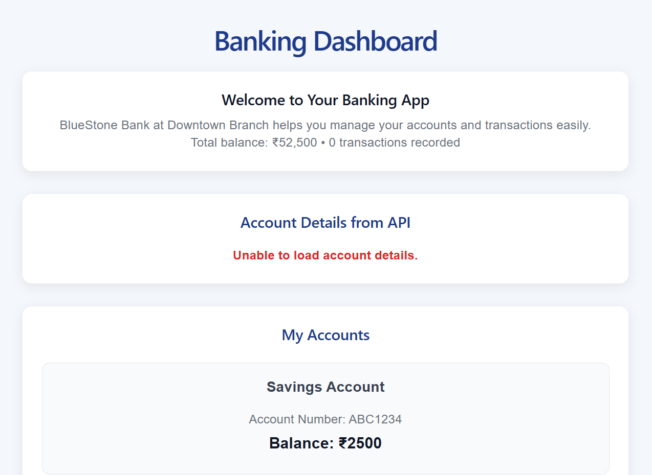

- Pages/About.tsx
function About() {
return (
<div>
<h1>About BlueStone Bank</h1>

<p>
We provide modern banking solutions
with React-powered applications.
</p>
</div>
)
}

export default About

AccountPage.txt
import Accounts from '../Components/Accounts'

function AccountsPage() {
const accounts = [
{
accountNumber: 'ABC1234',
accountType: 'Savings Account',
balance: 2500,
},
{
accountNumber: 'DEF5678',
accountType: 'Current Account',
balance: 50000,
},
]

return (
<div>
<h1>Your Accounts</h1>

<Accounts accounts={accounts} />
</div>
)
}

export default AccountsPage

Home.txt
import Accounts from '../Components/Accounts'

function AccountsPage() {
const accounts = [
{
accountNumber: 'ABC1234',
accountType: 'Savings Account',
balance: 2500,
},
{
accountNumber: 'DEF5678',
accountType: 'Current Account',
balance: 50000,
},
]

return (
<div>
<h1>Your Accounts</h1>

<Accounts accounts={accounts} />
</div>
)
}

export default AccountsPage

db. Jason
{
"accounts": [
{
"id": "1",
"accountNumber": "ABC1234",
"accountType": "Savings Account",
"balance": 2500
},
{
"id": "2",
"accountNumber": "DEF5678",
"accountType": "Current Account",
"balance": 50000
}
],
"transactions": [
{
"id": "1",
"accountNumber": "ABC1234",
"type": "credit",
"amount": 1000,
"date": "12/08/2026, 10:30:00"
},
{
"id": "2",
"accountNumber": "DEF5678",
"type": "debit",
"amount": 5000,
"date": "12/08/2026, 11:00:00"
}
]
}

App.ts

export type ApiAccount = {
id: string
accountNumber: string
accountType: string
balance: number
}

export async function fetchAccounts(): Promise<ApiAccount[]> {
const response = await fetch(
'http://localhost:3001/accounts'
)

if (!response.ok) {
throw new Error(
`Failed to fetch accounts: ${response.status}`
)
}

return response.json()
}

OUTPUT
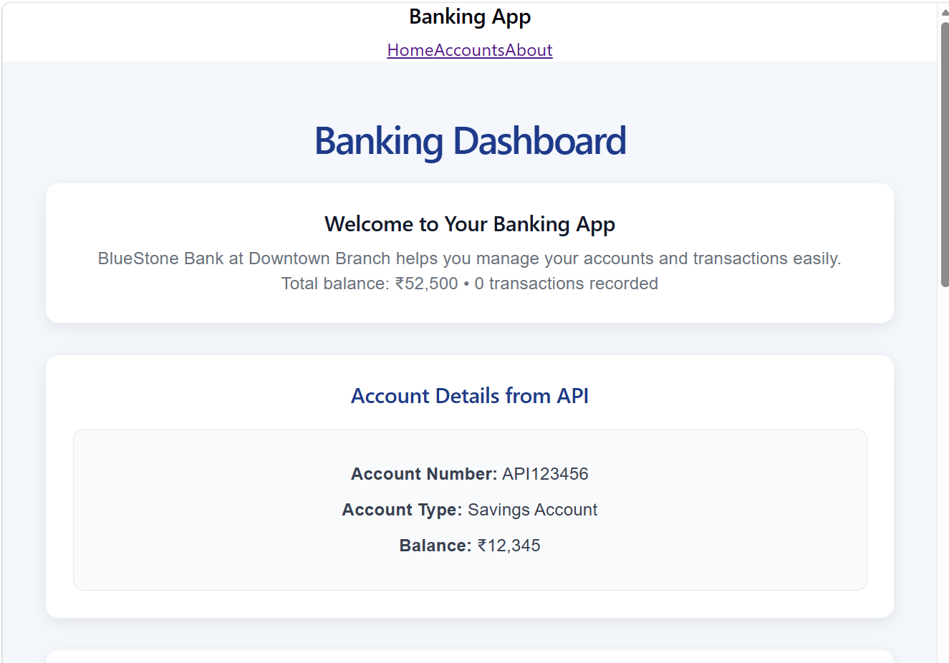

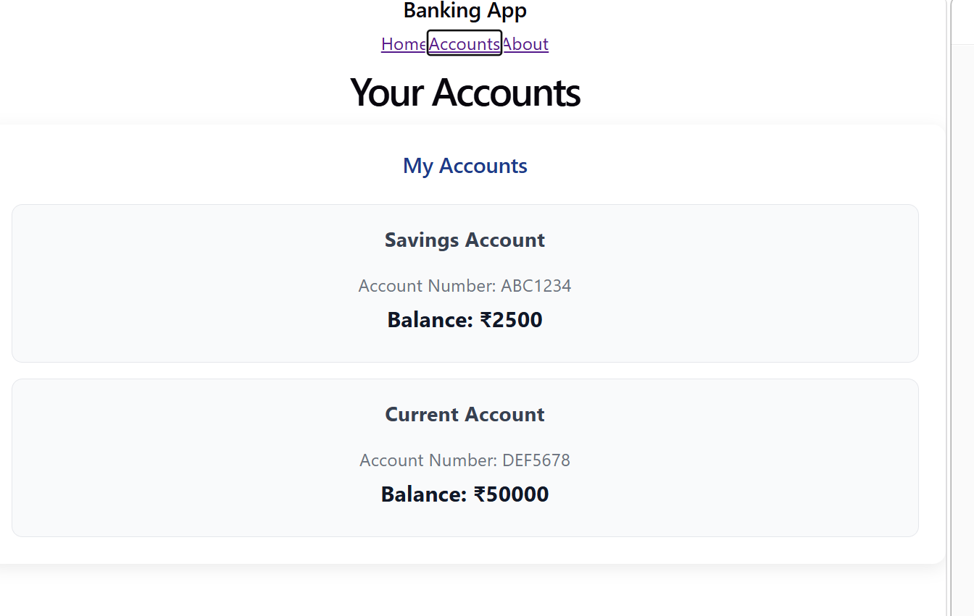
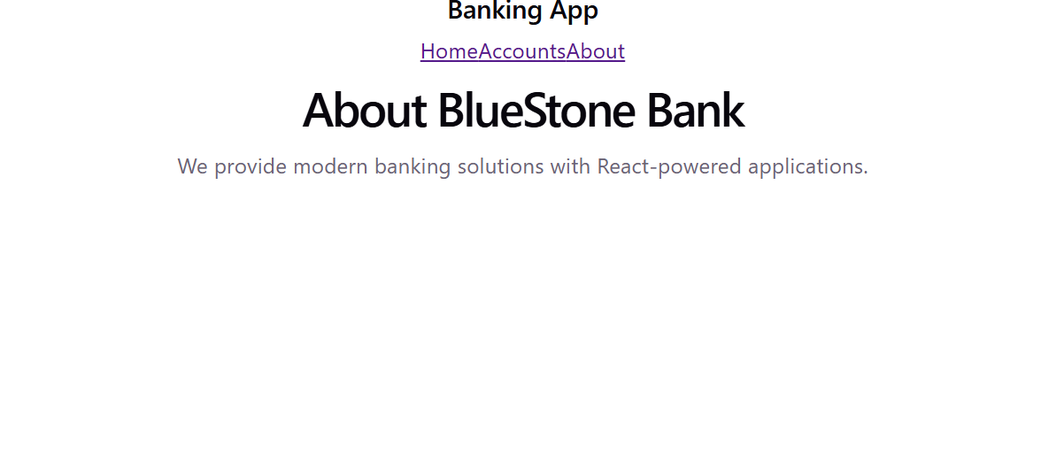
Task 10:
Redux:
What is REdux used for?
- Redux is used for managing and sharing application state across multiple components.
- It provides a centralized store that makes data flow predictable, organized, and easier to manage in large applications.

Task 11:
Why do we need to maintain the state throughout the app..?
Maintaining state throughout the application ensures that data remains consistent and accessible across different components and pages. It allows the UI to update automatically whenever the underlying data changes.
Benefits:
- Keeps data synchronized across components.
- Avoids unnecessary prop drilling.
- Improves user experience by preserving application data.
- Makes state updates predictable and easier to debug.

Task 12:
What is useSelector used for ?
- useSelector is a React-Redux hook used to read or retrieve data from the Redux store. It allows components to access specific parts of the global state without directly interacting with the store.

Task 13:
After the break we would be working with the Redux ..
In this can you create a store
Step 1:
Import createstore from Redux
show how the state changes based on the action type.. Like if with draw , deposit… etc..
Now create store with a reducer..
Step 2:
Now in app.js use – useSelector and useDispatcher from react-redux;
Access balance from redux store and dispatch action to the dispatch function
Step 3:
Create a controller class like BalanceController.js .. which has component for withdraw and deposit.
index.js, index. html (save in public folder) and package.json code is given for your ref

BalanceController.tsx
import { useState } from 'react'
import { useDispatch, useSelector } from 'react-redux'

import type { BankState } from '../store/store'

function BalanceController() {

// Read balance from Redux
const balance = useSelector(
(state: BankState) => state.balance
)

// Dispatch actions to Redux
const dispatch = useDispatch()

// Store input as a string
const [amount, setAmount] = useState('')

// =========================
// DEPOSIT
// =========================

const handleDeposit = () => {

console.log('Entered amount:', amount)

const value = parseFloat(amount)

console.log('Converted value:', value)

if (!amount || isNaN(value) || value <= 0) {
alert('Please enter a valid amount')
return
}

dispatch({
type: 'DEPOSIT',
amount: value,
})

setAmount('')
}

// =========================
// WITHDRAW
// =========================

const handleWithdraw = () => {

console.log('Entered amount:', amount)

const value = parseFloat(amount)

console.log('Converted value:', value)

if (!amount || isNaN(value) || value <= 0) {
alert('Please enter a valid amount')
return
}

if (value > balance) {
alert('Insufficient balance')
return
}

dispatch({
type: 'WITHDRAW',
amount: value,
})

setAmount('')
}

return (
<div className="transaction-form">

<h2>Redux Balance Controller</h2>

<h3>
Current Balance: ₹
{balance.toLocaleString()}
</h3>

<label htmlFor="redux-amount">
Enter Amount
</label>

<input
id="redux-amount"
type="number"
placeholder="Enter amount"
value={amount}
onChange={(event) => {
setAmount(event.target.value)
}}
/>

<div
style={{
display: 'flex',
gap: '10px',
marginTop: '15px',
}}
>

<button
type="button"
onClick={handleDeposit}
>
Deposit
</button>

<button
type="button"
onClick={handleWithdraw}
>
Withdraw
</button>

</div>

</div>
)
}

export default BalanceController

Redux/store.ts
import { createStore } from 'redux'

export type BankState = {
balance: number
}

const initialState: BankState = {
balance: 2500,
}

export type BankAction =
| {
type: 'DEPOSIT'
amount: number
}
| {
type: 'WITHDRAW'
amount: number
}

function bankReducer(
state: BankState = initialState,
action: BankAction
): BankState {

switch (action.type) {

case 'DEPOSIT':
return {
...state,
balance: state.balance + action.amount,
}

case 'WITHDRAW':
return {
...state,
balance: state.balance - action.amount,
}

default:
return state
}
}

const store = createStore(bankReducer)

export default store

OUTPUT
