Day 32 - 28th Aug 2026 - Happy Rakhi!
Task 1:
Introduction to Cloud Computing Concepts
Q: How does cloud computing differ from traditional on-premises IT infrastructure in terms of scalability and cost management?
Answer: Cloud computing allows businesses to quickly increase or decrease resources based on demand, while on-premises infrastructure usually requires buying and maintaining physical servers. Cloud also follows a pay-as-you-use model, which reduces the need for large upfront investments in hardware.

AWS Global Infrastructure (Regions & Availability Zones)
Q: Why is it important to deploy applications across multiple Availability Zones within a region?
Answer: Deploying across multiple Availability Zones improves the availability and reliability of an application. If one Availability Zone faces a failure or outage, the application can continue running from another zone, reducing downtime.

Identity and Access Management (IAM)
Q: What is the principle of “least privilege” in IAM, and why is it critical for cloud security?
Answer: Least privilege means giving users or applications only the permissions they actually need to perform their tasks. It is important because it limits the damage that can happen if an account or application is compromised.

EC2 – Compute Basics
Q: How does Amazon EC2 enable elasticity in application workloads compared to physical servers?
Answer: Amazon EC2 allows us to easily launch or terminate virtual servers based on the workload. For example, during high traffic, more EC2 instances can be added, and when traffic decreases, they can be removed. This provides flexibility without purchasing additional physical servers.

S3 – Storage Basics
Q: Why is Amazon S3 considered “object storage,” and how does it differ conceptually from block storage?
Answer: S3 stores data as objects along with their metadata inside buckets, making it suitable for files such as images, videos, documents, and backups. Block storage, such as EBS, stores data in fixed-size blocks and is mainly used like a disk attached to a server.

VPC – Networking Basics
Q: What role does a subnet play in a VPC, and how does it affect the accessibility of resources?
Answer: A subnet divides a VPC into smaller network sections and helps control where resources are placed. A public subnet can contain resources that need internet access, while a private subnet is generally used for resources that should not be directly accessible from the internet.

RDS – Managed Database Basics
Q: How does Amazon RDS reduce the operational burden of database management compared to self-hosted databases?
Answer: Amazon RDS handles many administrative tasks such as backups, software patching, monitoring, and maintenance. This allows developers to focus more on the application instead of spending time managing the database server.

Security Groups & Basic Cloud Security
Q: How do security groups function as virtual firewalls, and why are they stateful?
Answer: Security groups control incoming and outgoing network traffic for AWS resources such as EC2 instances. They are stateful, meaning if an incoming request is allowed, the response traffic is automatically allowed without needing a separate rule.

AWS CLI & Console Basics
Q: What are the advantages of using the AWS CLI over the AWS Management Console for managing resources?
Answer: The AWS CLI allows us to manage AWS resources quickly using commands and is useful for automation and scripting. Unlike the Console, repetitive tasks can be easily automated, making the CLI especially useful for developers and administrators.

Task 2:

Go to all services

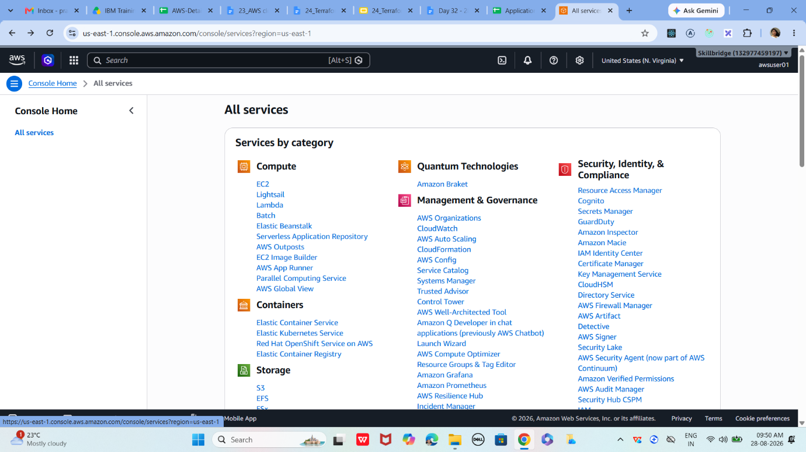

Task 3:
AWS Global Infrastructure
Get familiar with AWS regions and availability zones.
- Log in to AWS Console
- Navigate to Services → EC2 → Regions dropdown
- Identify your nearest region (e.g., ap-south-1 for Mumbai)
- Note that each region has multiple AZs for redundancy

Task 4:

Now lets create EC2 instance …

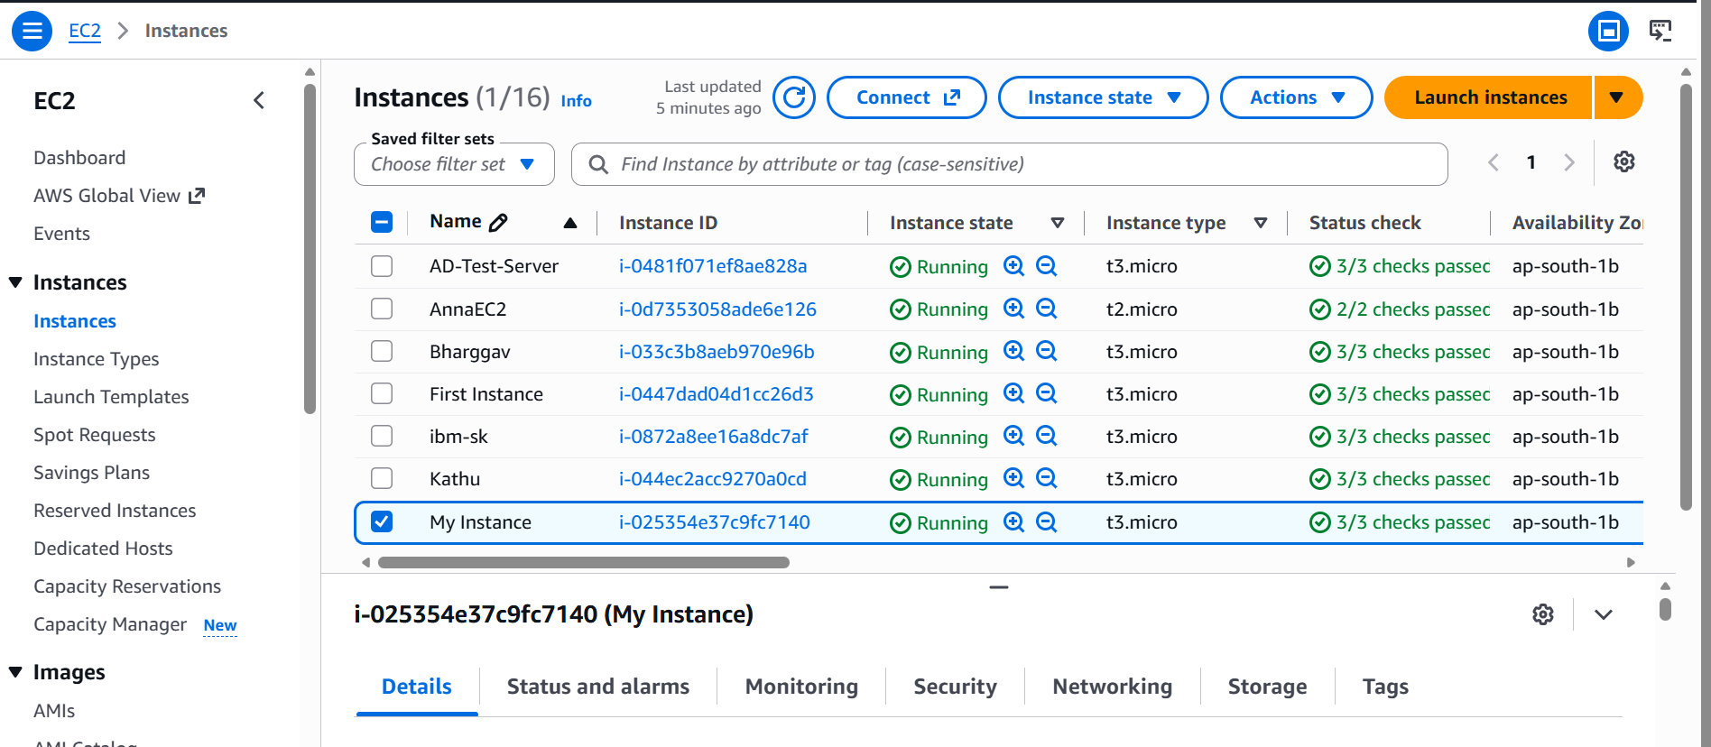

Task 5:

Create a directory in
step 01
Go to AWS Management Console
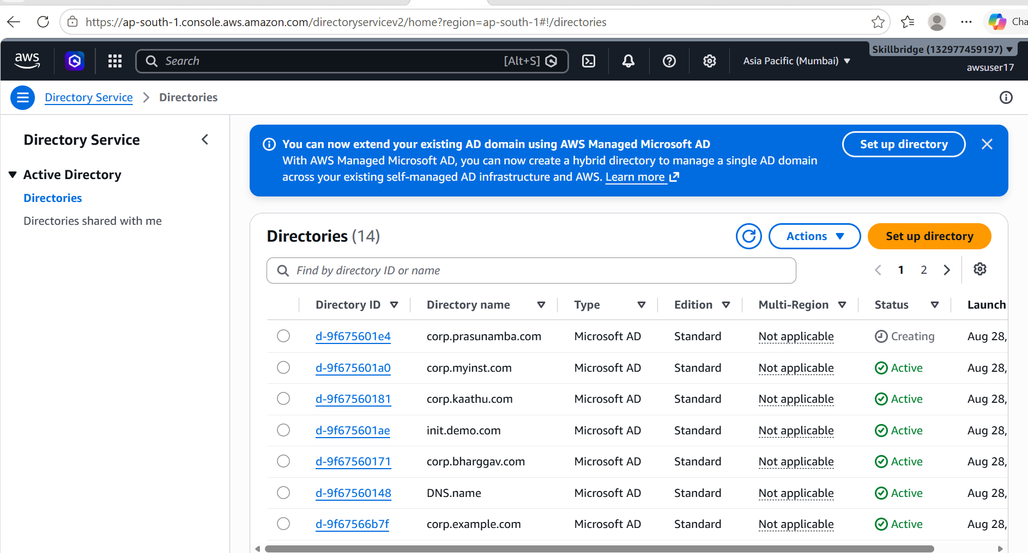

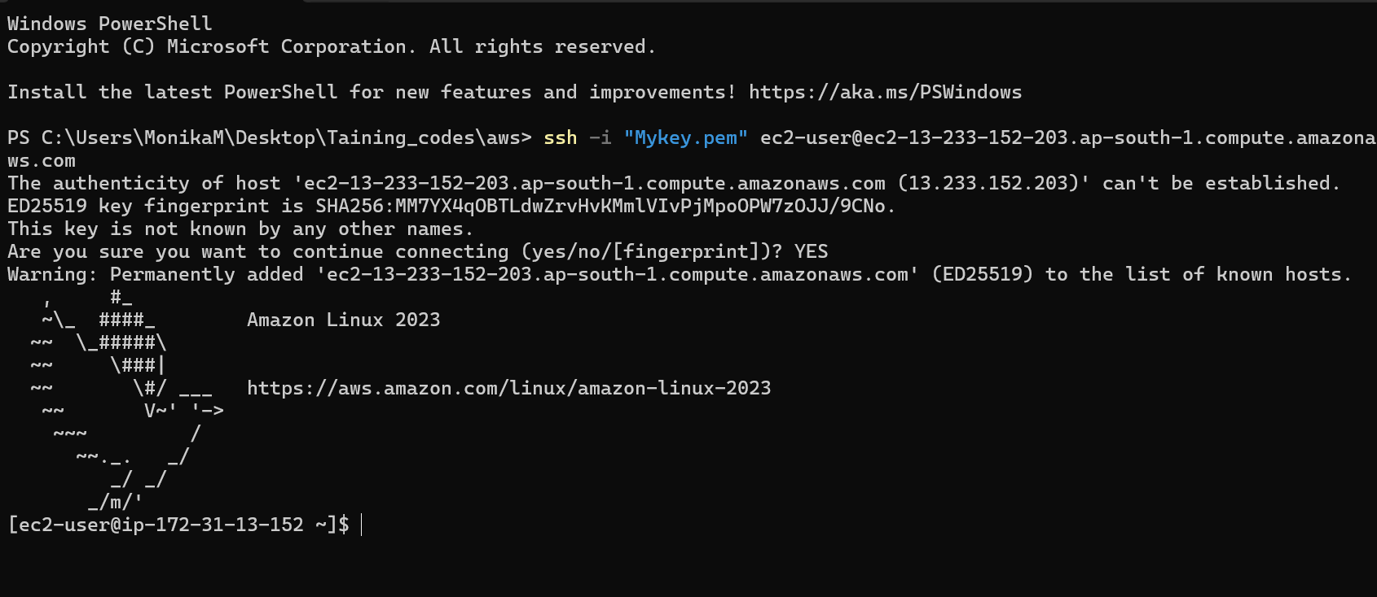

Task 6: S3 bucket
01
Log in to AWS Console
Ensure you are in the correct region (top-right corner)

02
Open S3 Service
Navigate to the S3 dashboard where you can manage buckets.
In AWS Console → Search bar → Type 'S3' → Select S3

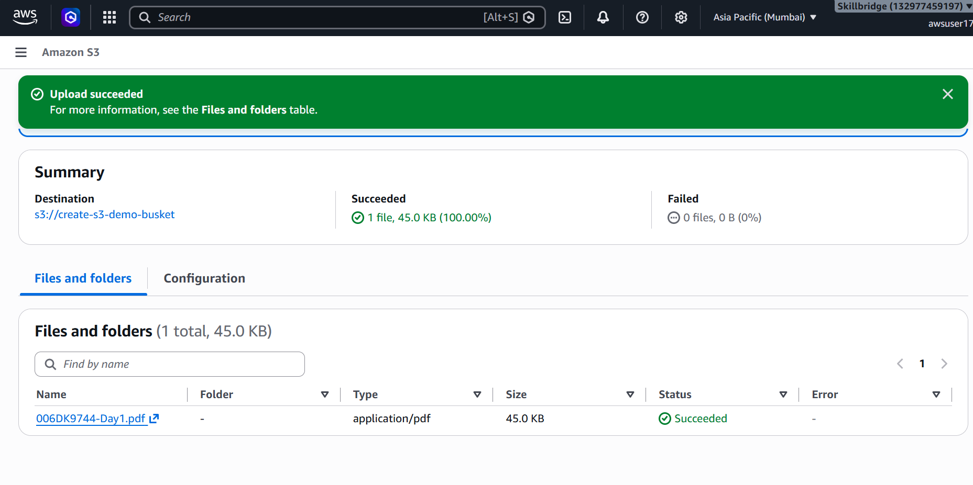

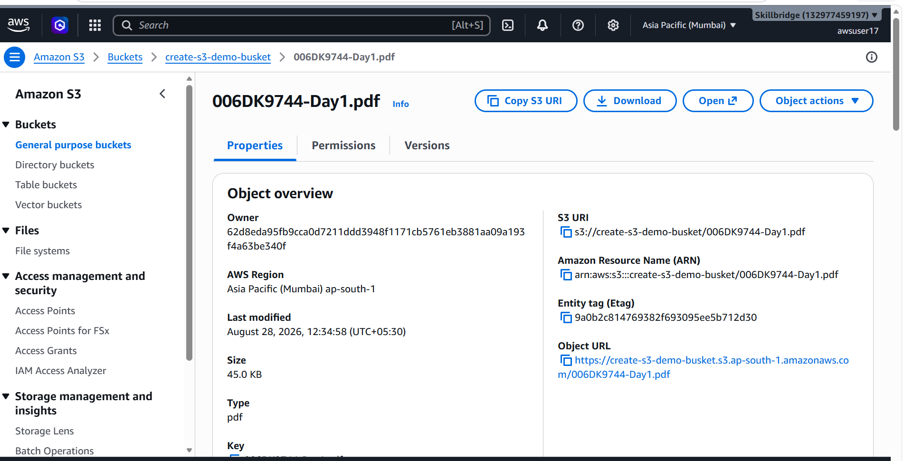

Task 7: IAM service
Open IAM Service
IAM is where you manage users, groups, and permissions.

Log in to AWS Console → Search for IAM in the Services menu
Click IAM to open the dashboard
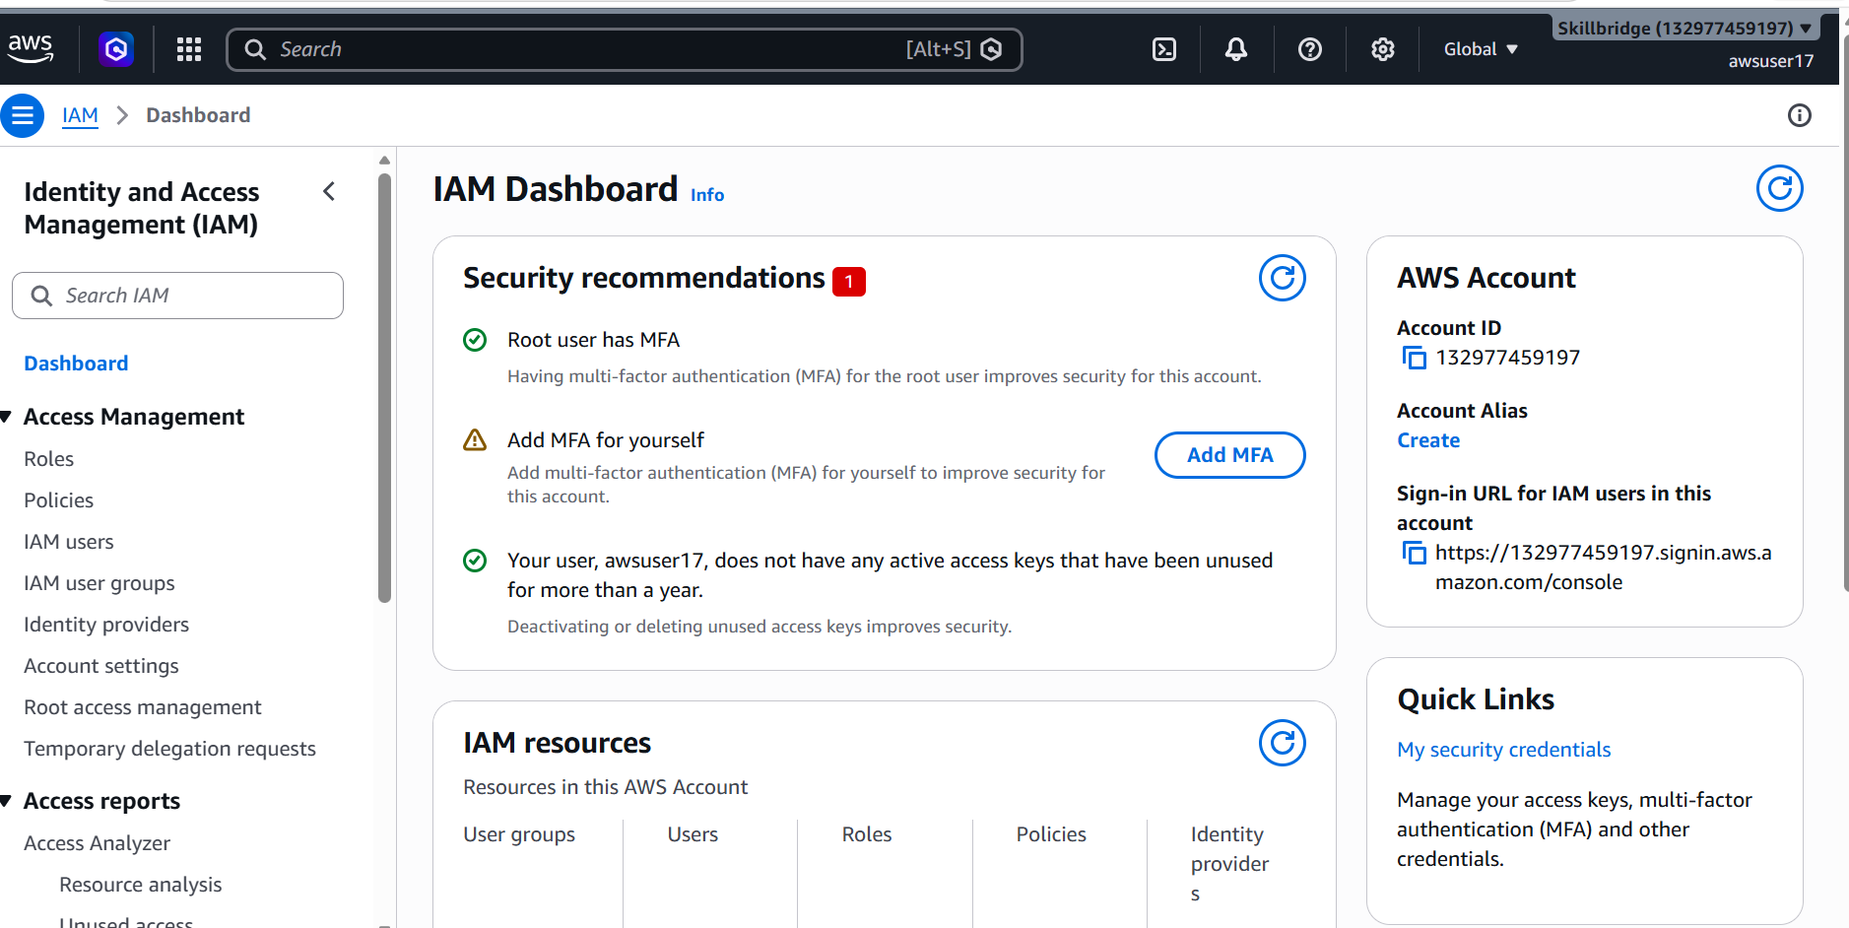

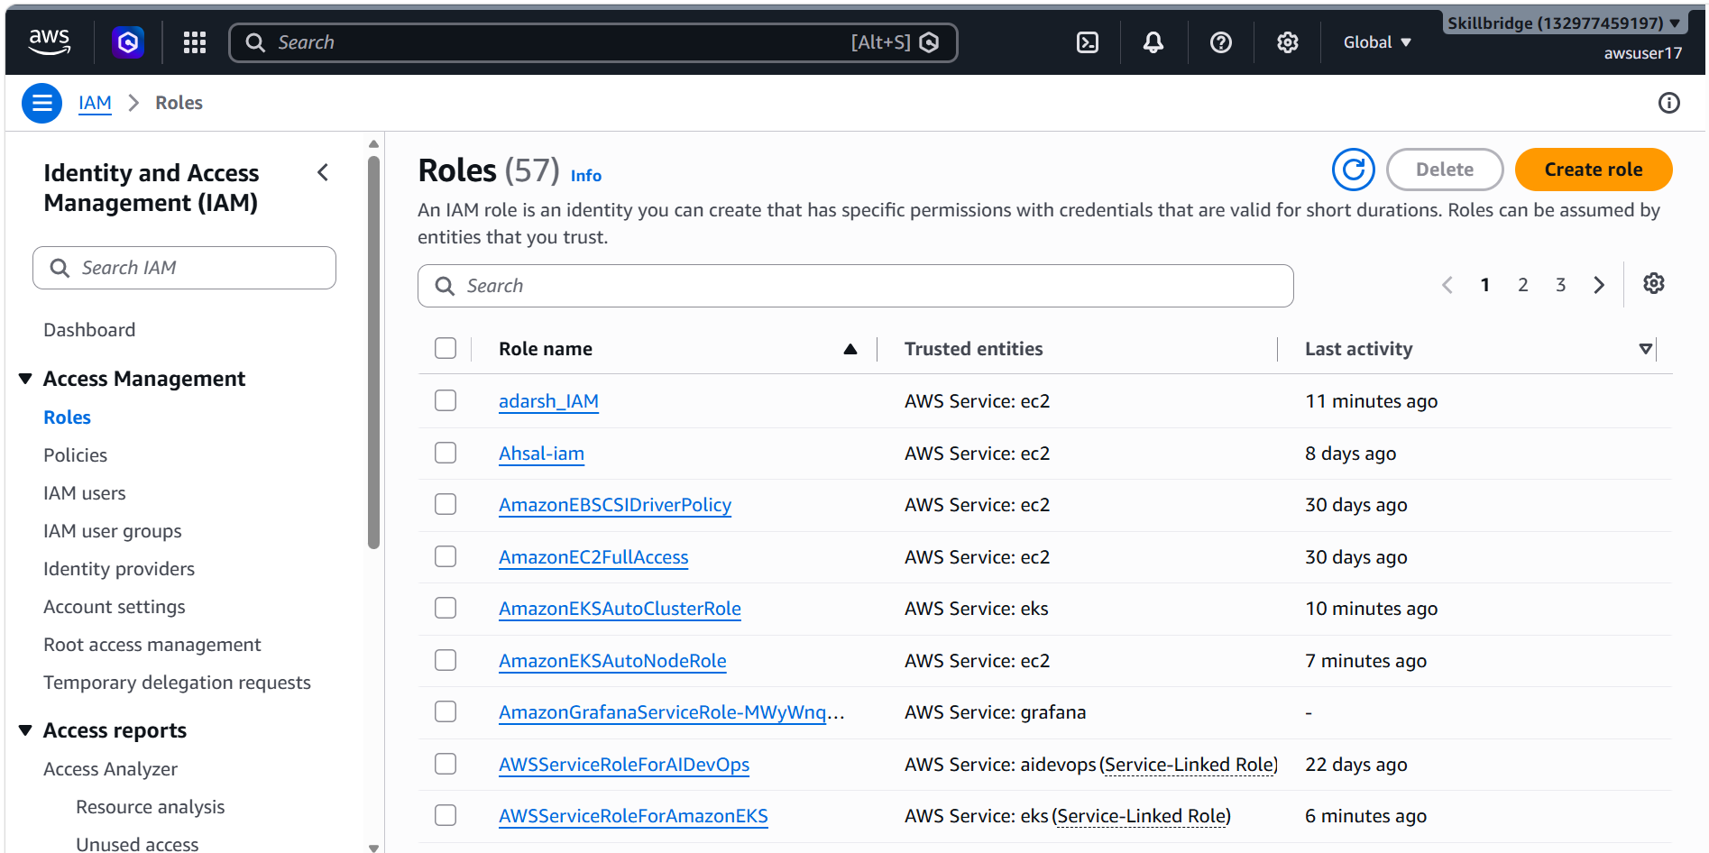

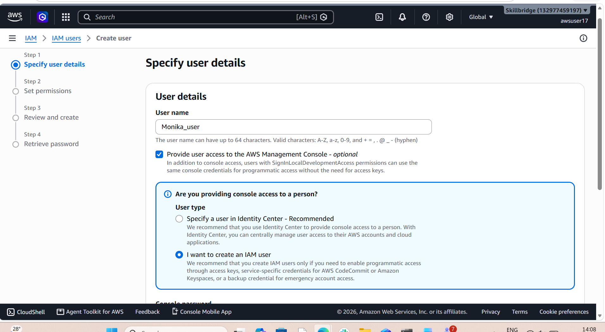

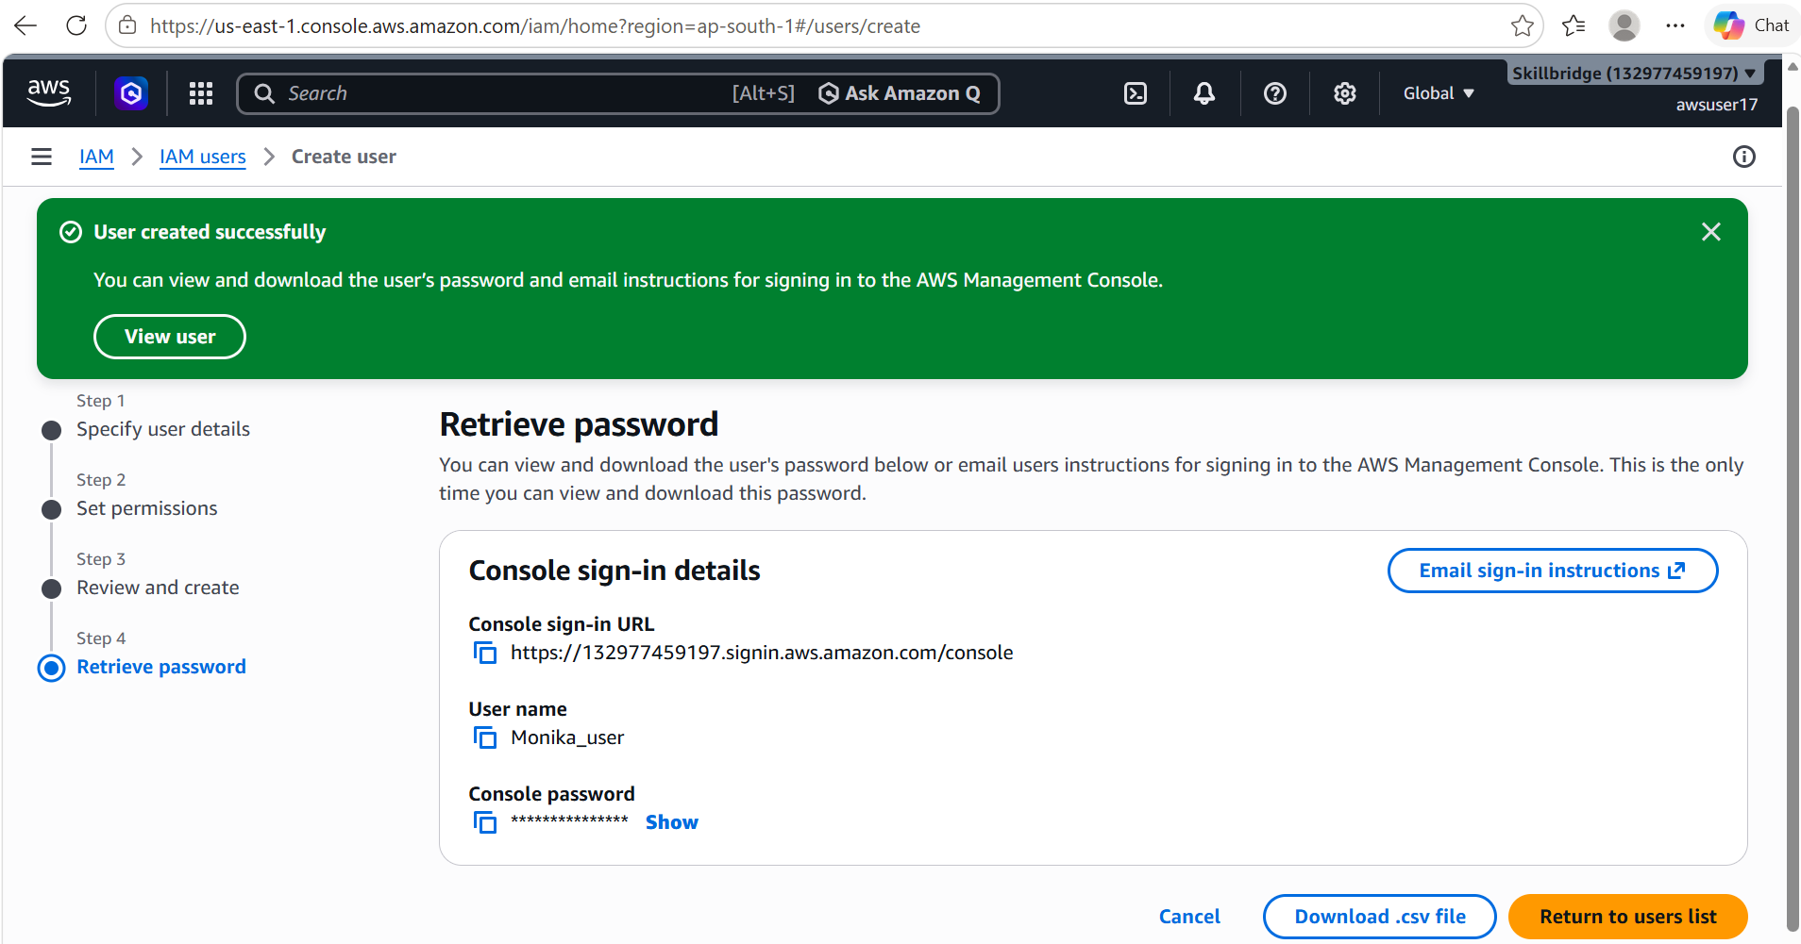

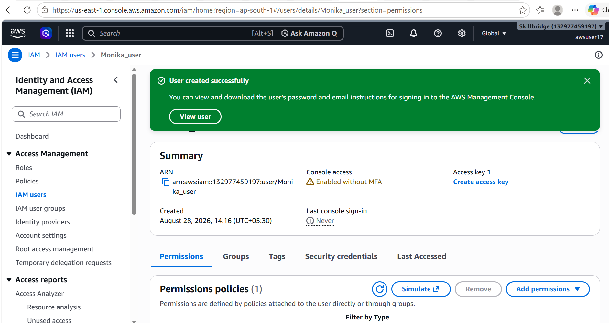

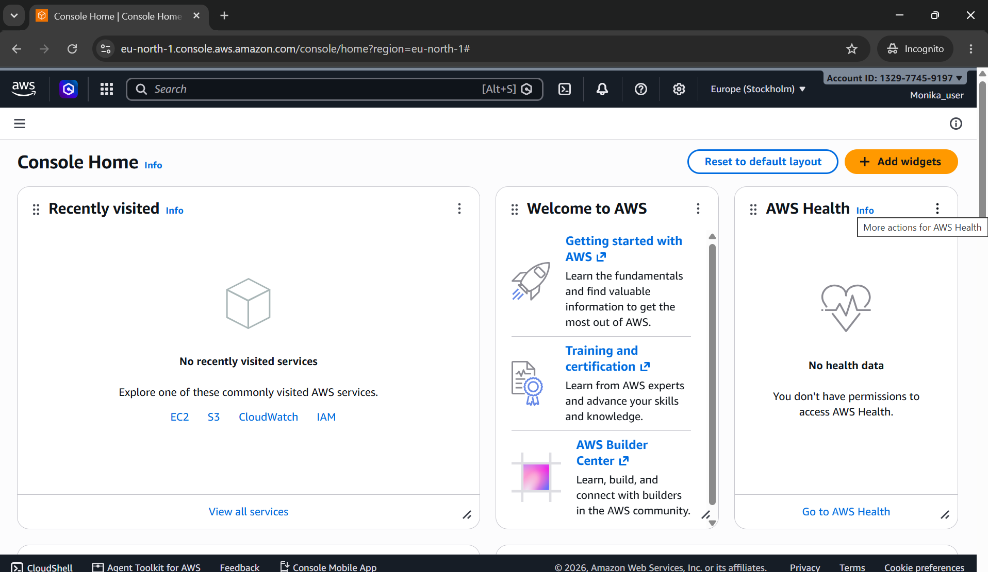

Task 8:

VPC (Virtual Private Cloud)
lets create a simple VPC with public and private subnets, an Internet Gateway, and routing rules.

01
Open the VPC Service
Start by accessing the AWS VPC dashboard.

AWS Console → Services → VPC

Log in to AWS Console

Search for VPC in the services menu

Click Your VPCs to begin setup

02
Create a New VPC
Define the core private network space.

Click Create VPC

Enter a name (e.g., DemoVPC)

Choose IPv4 CIDR block (e.g., 10.0.0.0/16)

Leave IPv6 optional for now

Click Create VPC

03
Add Subnets
Networking Basics
Divide the VPC into public and private subnets.

Go to Subnets → Create subnet

Select your VPC

Add a Public Subnet (e.g., 10.0.1.0/24)

Add a Private Subnet (e.g., 10.0.2.0/24)

Assign Availability Zones for redundancy

04
Attach an Internet Gateway
Enable internet access for resources in the public subnet.

Go to Internet Gateways → Create IGW

Name it (e.g., DemoIGW)

Attach it to your VPC

05
Configure Route Tables
Control traffic flow between subnets and the internet.

Go to Route Tables → Create route table

Associate with your VPC

Add route: 0.0.0.0/0 → Internet Gateway

Associate this route table with the Public Subnet

Keep Private Subnet route table without IGW

06
Test with an EC2 Instance
Verification
Launch an EC2 instance to confirm networking works.

Launch EC2 in Public Subnet

Assign a public IP

Connect via SSH to verify internet access

Launch EC2 in Private Subnet

Confirm it has no direct internet access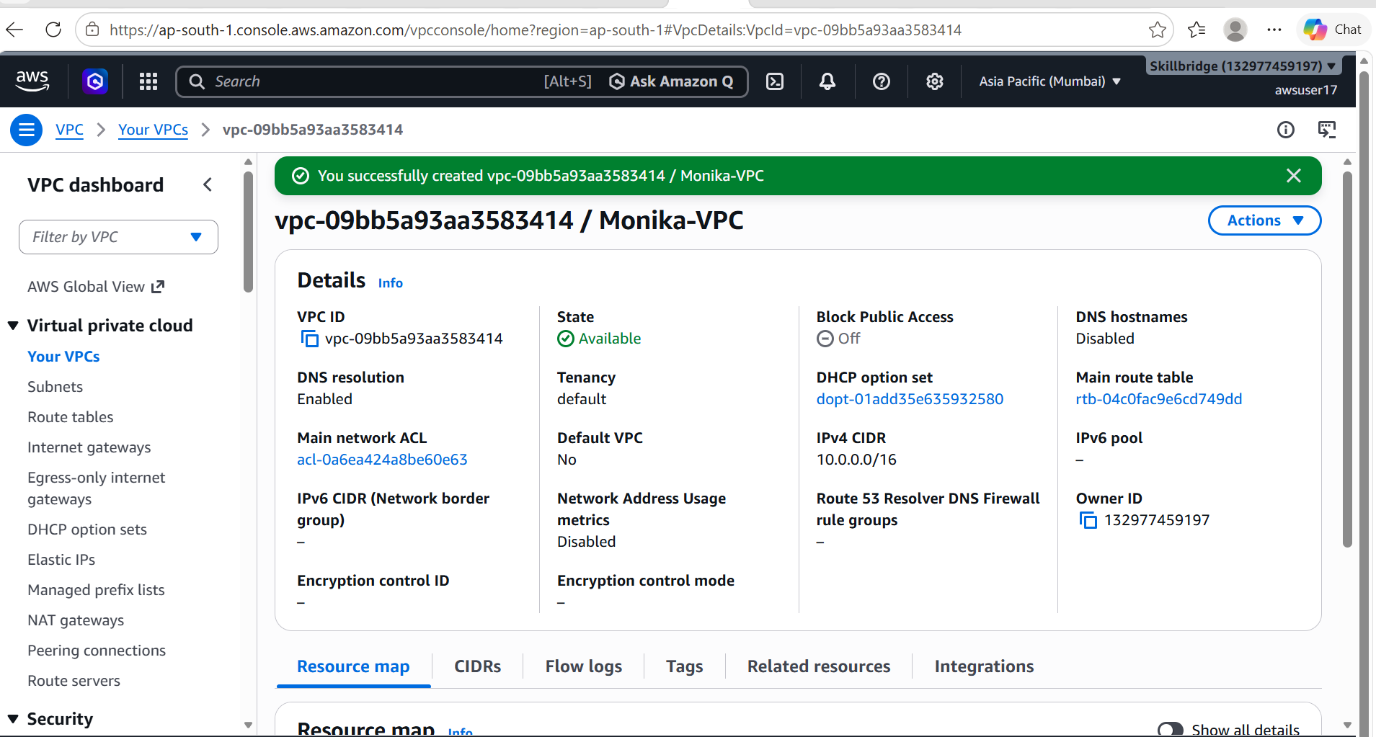

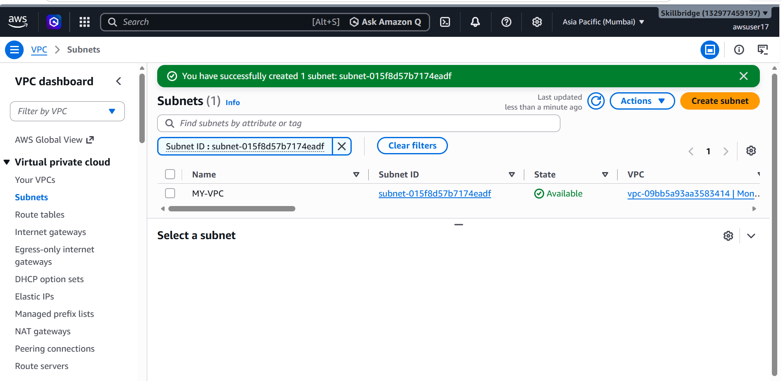

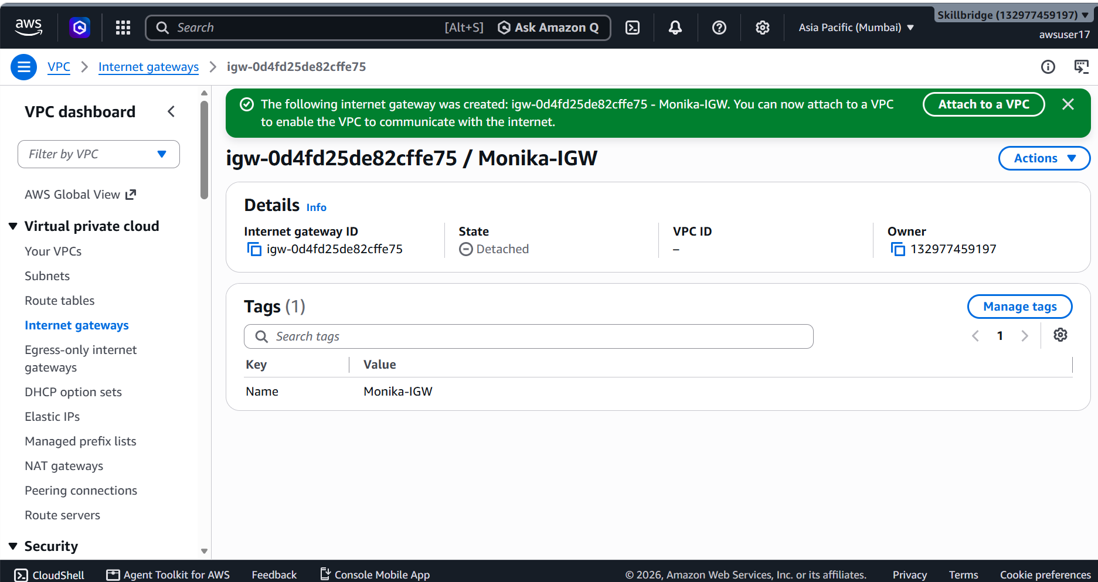

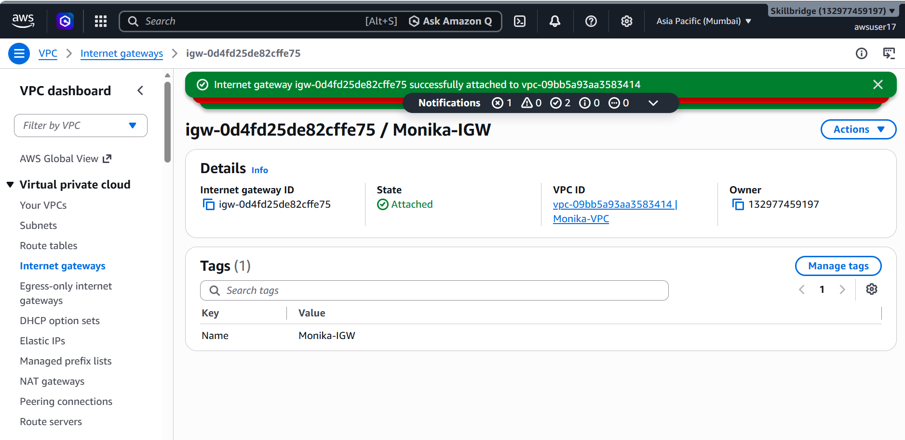

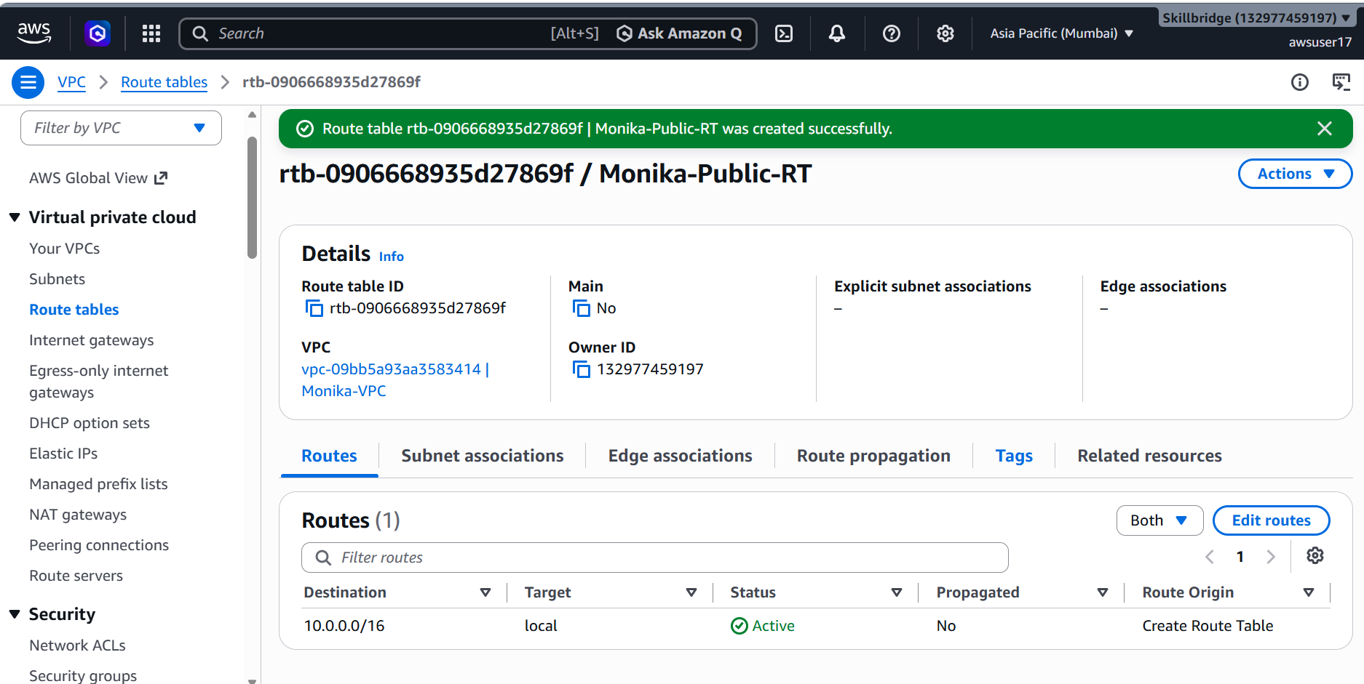
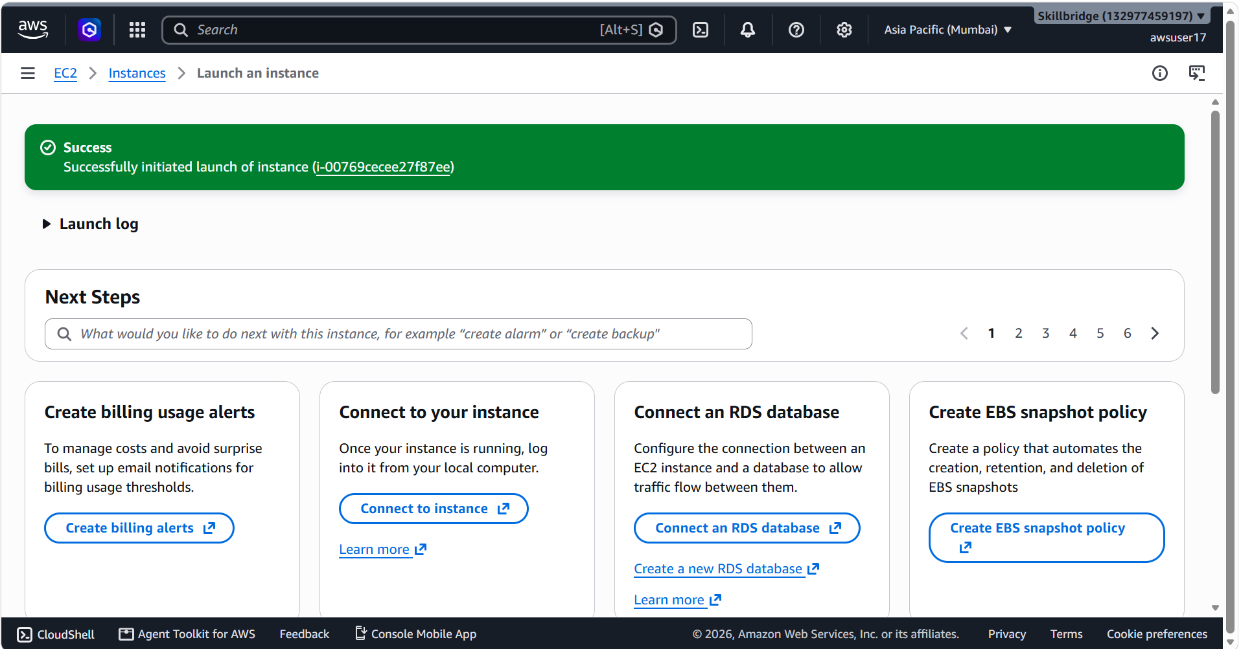
Task 9:

Cli based practice 👍
Before you proceed
Aws configure
