Day 17 - 07th Aug 2026
Task 1:
What is data binding?
- Data binding is the process of connecting data with the user interface so that changes in one are reflected in the other. It helps keep the UI and the application's data synchronized automatically, making development easier and more efficient.
Task 2:
What do you understand by one way data binding and two-way data binding?
- One-way data binding: Data flows only from the component to the UI. If the data changes, the UI updates, but changes made in the UI don't automatically update the component.
- Two-way data binding: Data flows in both directions between the component and the UI. Any change in the UI updates the component, and any change in the component updates the UI automatically.
Task 3:
When do you use one way data binding and when to use two way data binding?give examples.
- We use one-way data binding when you only need to display data and don't want users to modify it. It is commonly used for showing information like user profiles, product details, or dashboard statistics.
Example: Displaying a user's name on a profile page: <h1>{userName}</h1>
- We use two-way data binding when users need to enter or edit data, such as in forms or search boxes. It keeps the input field and the component's state synchronized.
Example :
const [name, setName] = useState("");
<input
value={name}
onChange={(e) => setName(e.target.value)}
/>

Task 4:
What is the state in react?
- State in React is an object or value that stores data that can change over time within a component. When the state changes, react automatically re-renders the component to display the updated information.
- Example: A counter value that increases when a button is clicked is stored in the component's state.
Task 5:
Can you explain SPA?
- SPA (Single Page Application) is a web application that loads a single HTML page and updates only the required content without reloading the entire page. This makes the application faster, smoother, and provides a better user experience.
- Examples: Gmail, Google Maps, and Facebook are popular Single Page Applications.
Task 6:
What is DOM?
- DOM (Document Object Model) is a programming interface that represents an HTML or XML document as a tree of objects. It allows JavaScript to access, modify, add, or remove elements, styles, and content on a web page dynamically.
Task 7:
What is virtual DOM?
- Virtual DOM is a lightweight copy of the real DOM that React keeps in memory. When the application's data changes, React first updates the Virtual DOM, compares it with the previous version, and then updates only the changed parts of the real DOM, making the application faster and more efficient.
Task 8:
What are props in react ? can you explain about prop drilling?
- Props (Properties) are read-only values passed from a parent component to a child component. They allow components to receive and display data, making them reusable.
Prop Drilling
- Prop drilling is the process of passing props through multiple intermediate components just to send data from a parent component to a deeply nested child. This can make the code harder to read and maintain because components that don't need the data still have to pass it along.
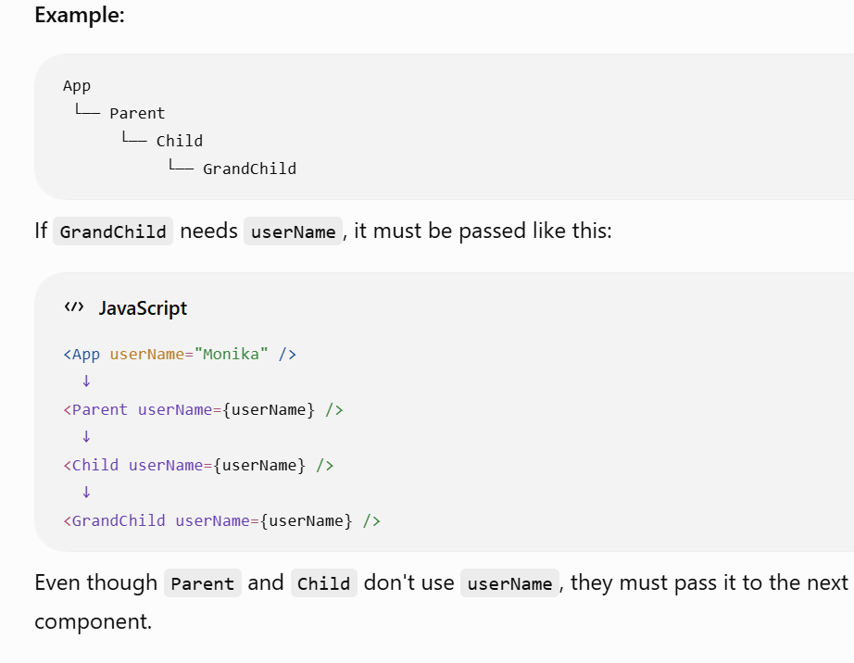
Task 9:
Why do we use react?give importance and describe in detail.
- We use React because it helps developers build fast, interactive, and reusable user interfaces for web applications. It simplifies UI development by breaking the application into small, reusable components and efficiently updates only the parts of the page that change.
Importance of React
- Reusable Components: Write once and reuse components across the application, reducing code duplication.
- High Performance: Uses the Virtual DOM to update only the changed parts of the UI, making applications faster.
- Easy to Maintain: Component-based structure keeps code organized and easy to manage.
- One-Way Data Flow: Makes data predictable and simplifies debugging.
- Rich Ecosystem: Large community, excellent documentation, and many third-party libraries.
- Supports SPAs: Ideal for building fast and responsive Single Page Applications.
- Cross-Platform: React can build web apps, and React Native can be used for mobile applications.
Task 10:
What do you understand by component based architecture?
- Component-Based Architecture is a design approach in React where the user interface is divided into small, independent, and reusable components. Each component has its own logic, structure, and functionality, making the application easier to develop, maintain, and reuse.
- Example: In an e-commerce website, components like Navbar, Product Card, Shopping Cart, and Footer are created separately and reused wherever needed.
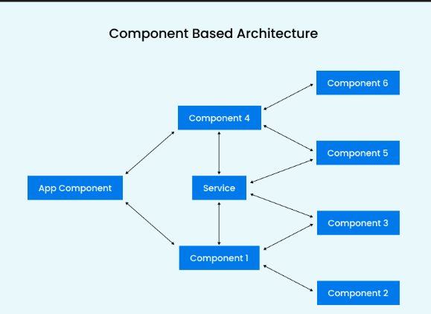
Task 11:
Explain lifecycle of react component with diagram.. Describe mounting , unmounting etc ..
- The React Component Lifecycle is the sequence of stages a component goes through from the time it is created until it is removed from the application. The three main phases are:
1. Mounting
The mounting phase occurs when a component is created and inserted into the DOM for the first time.
Key Points:
- Component is initialized.
- UI is rendered.
- API calls, event listeners, and timers can be started.

2. Updating
The updating phase occurs whenever the component's state or props change.
Key Points:
- React re-renders the component with updated data.
- Only the changed parts of the UI are updated using the Virtual DOM.
- Improves application performance.

3. Unmounting
The unmounting phase occurs when a component is removed from the DOM.
Key Points:
- Event listeners are removed.
- Timers and subscriptions are cleared.
- Cleanup is performed to avoid memory leaks.

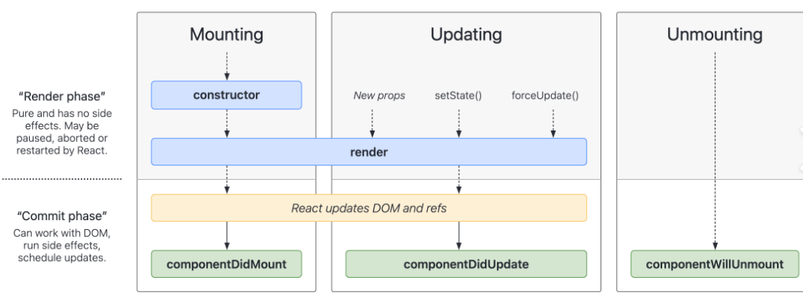

Task 12:
What are Hooks in react?why use hooks- importance ? What are different types of hooks?
Hooks are special functions introduced in React 16.8 that allow developers to use state, lifecycle methods, and other React features in functional components without writing class components.
Why Use Hooks? (Importance)
- Simpler Code: Eliminates the need for class components.
- State Management: Allows functional components to manage state using useState.
- Lifecycle Features: Handles lifecycle events using useEffect.
- Reusable Logic: Custom Hooks allow sharing logic across multiple components.
- Better Readability: Makes code cleaner, easier to understand, and maintain.
- Improved Performance: Hooks help optimize rendering with useMemo and useCallback.
Common Types of React Hooks
Hook | Purpose
useState | Manages state in functional components.
useEffect | Performs side effects such as API calls, timers, and event listeners.
useContext | Accesses data from React Context without prop drilling.
useReducer | Manages complex state logic using a reducer function.
useRef | Accesses DOM elements or stores mutable values without re-rendering.
useMemo | Memoizes expensive calculations to improve performance.
useCallback | Memoizes functions to avoid unnecessary re-creation.
useLayoutEffect | Similar to useEffect, but runs before the browser paints the screen.
useId | Generates unique IDs for accessibility and form elements.
Task 13:
What is react redux architecture ?explain in detail.
- Redux is a state management library used with React to manage and share application state across multiple components. It stores the application's data in a single centralized store, making state predictable, easier to manage, and easier to debug.

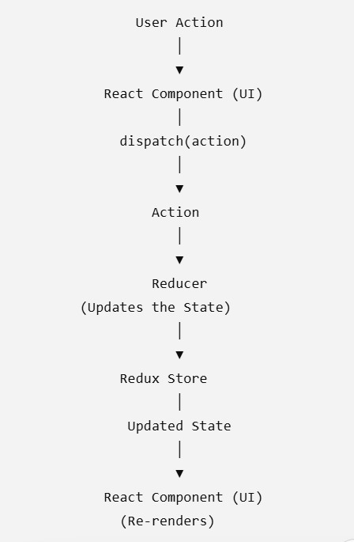
Components of Redux Architecture
1. Store
The Store is the central repository that holds the entire application's state. It provides access to the current state and updates it whenever an action is dispatched.

2. Action
An Action is a plain JavaScript object that describes what happened in the application. It contains a mandatory type property and may include additional data (payload) required to update the state.

3. Dispatch
Dispatch is a method used to send an action to the Redux store. When an action is dispatched, Redux forwards it to the appropriate reducer for processing.

4. Reducer
A Reducer is a pure function that takes the current state and an action as input and returns a new updated state. Reducers never modify the existing state directly; instead, they create and return a new state.

5. React Component
React components interact with the Redux store by reading data and dispatching actions. Components use useSelector() to access the store's state and useDispatch() to send actions that update the state.

6. Middleware (Optional)
Middleware is used to handle asynchronous operations and add custom logic between dispatching an action and reaching the reducer. A common example is Redux Thunk, which is used for API calls and asynchronous tasks.
REACT DEMO
- Increased the count
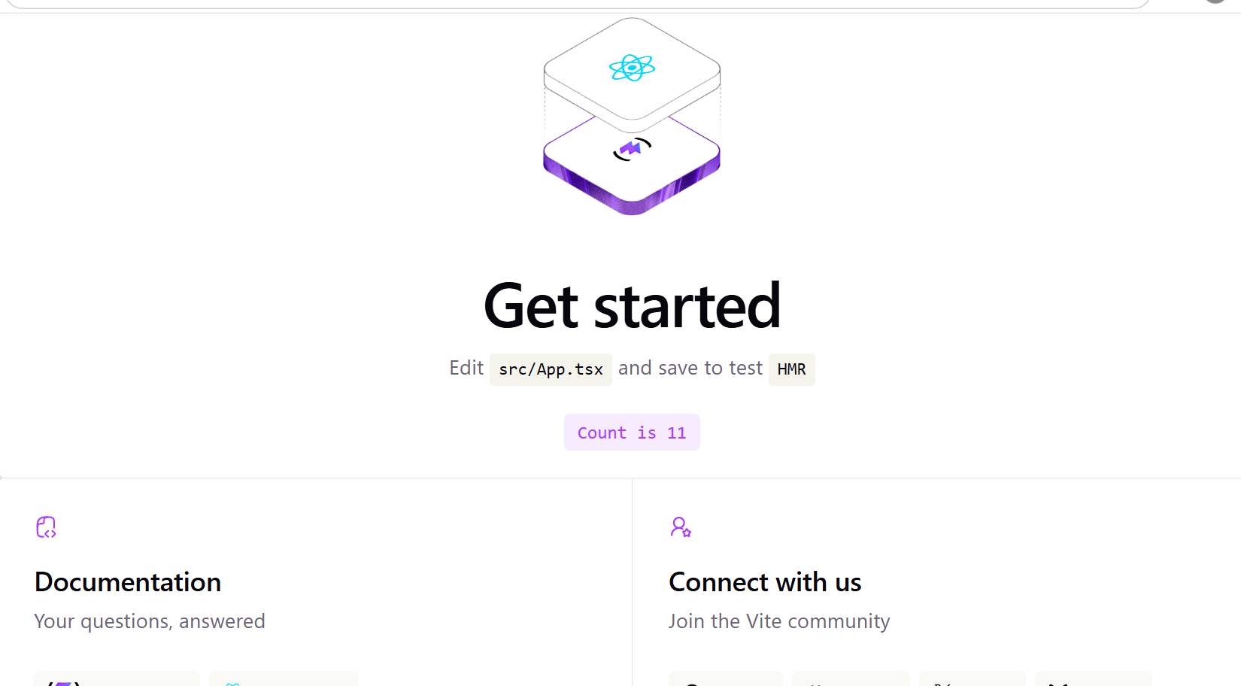

Step 1:

Create the root app —> app.jsx – with h1 tag in the function app
And export it..
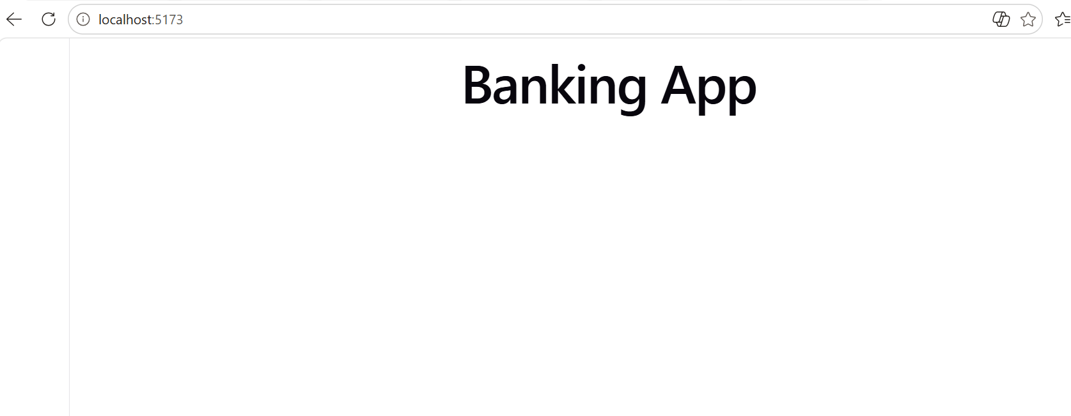
Step 2:
In src..
Create a components folder and add a function component.
Like dashboard.tsx
function Dashboard() {
return (
<div className="dashboard">
<h1>Welcome to Banking App</h1>

<div className="balance-card">
<p>Available Balance</p>
<h2>₹25,000.00</h2>
</div>

<div className="quick-actions">
<h2>Quick Actions</h2>

<button>Send Money</button>
<button>Receive Money</button>
<button>Pay Bills</button>
<button>Transaction History</button>
</div>

<div className="transactions">
<h2>Recent Transactions</h2>

<p>Amazon - ₹1,200</p>
<p>Salary - +₹40,000</p>
<p>Electricity Bill - ₹2,500</p>
</div>
</div>
)
}

export default Dashboard

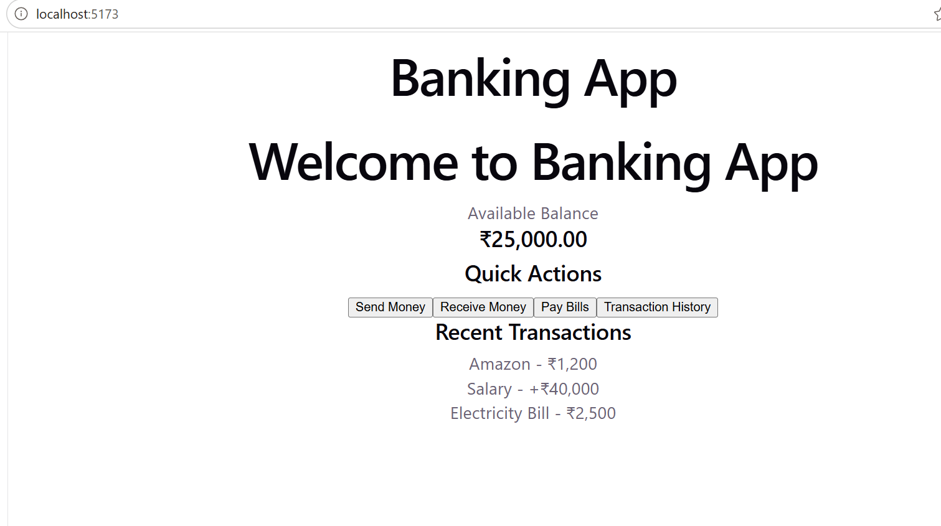
Step 3:
In components/ create Accounts.tsx
function Accounts() {
return (
<div>
<h2>My Accounts</h2>

<div>
<h3>Savings Account</h3>
<p>Account Number: ABC1234</p>
<p>Balance: ₹25,000</p>
</div>

<div>
<h3>Current Account</h3>
<p>Account Number: DEF5678</p>
<p>Balance: ₹50,000</p>
</div>
</div>
)
}

export default Accounts

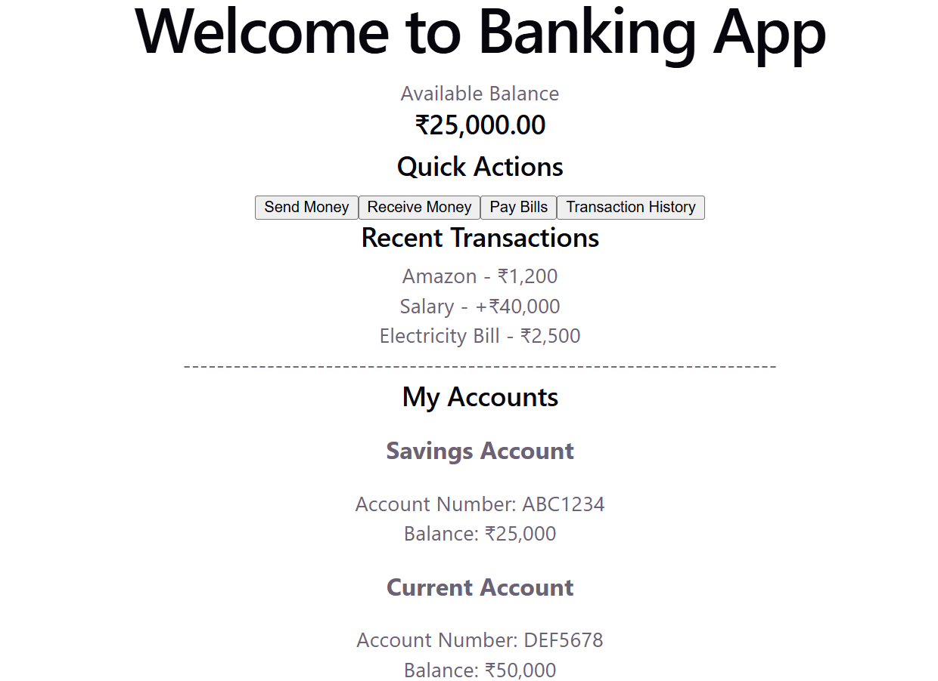
Step 4:

Create a usestate … initialize and use it to display the current balance

Import useState hook

- Import React,{useState} from ‘react’
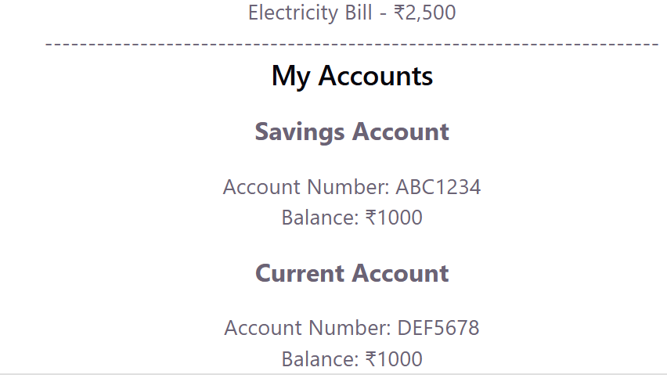

- Accounts.tsx
- import { useState } from 'react'

- function Accounts() {
- const [balance, setBalance] = useState(1000)

- const handleTransaction = (type: 'credit' | 'debit', amount: number) => {
- if (type === 'credit') {
- const newBalance = balance + amount
- setBalance(newBalance)
- } else {
- const newBalance = balance - amount
- setBalance(newBalance)
- }
- }

- return (
- <div>
- <h2>My Accounts</h2>

- <div>
- <h3>Savings Account</h3>
- <p>Account Number: ABC1234</p>
- <p>Balance: ₹{balance}</p>

- <button onClick={() => handleTransaction('credit', 1000)}>
- Credit ₹1000
- </button>

- <button onClick={() => handleTransaction('debit', 500)}>
- Debit ₹500
- </button>
- </div>

- <div>
- <h3>Current Account</h3>
- <p>Account Number: DEF5678</p>
- <p>Balance: ₹50,000</p>

- </div>
- </div>
- )
- }

- export default Accounts

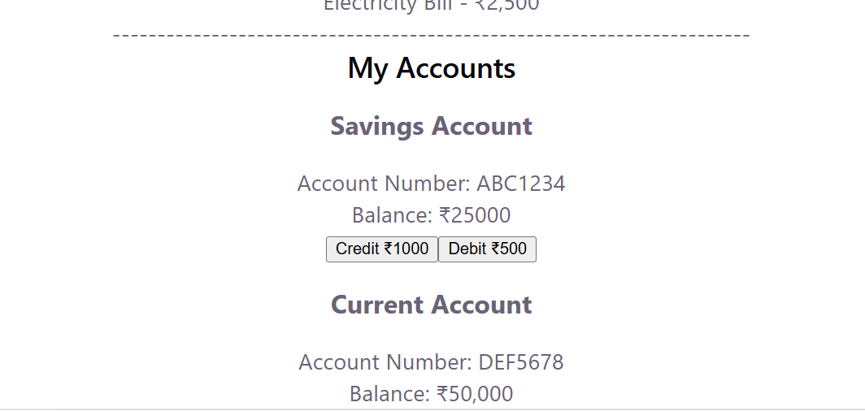

Step 5:
Conditional rendering like
{transactionType === 'credit' && (
<p style={{ color: 'green' }}>
₹{transactionAmount} Credited
</p>
)}

{transactionType === 'debit' && (
<p style={{ color: 'red' }}>
₹{transactionAmount} Debited
</p>

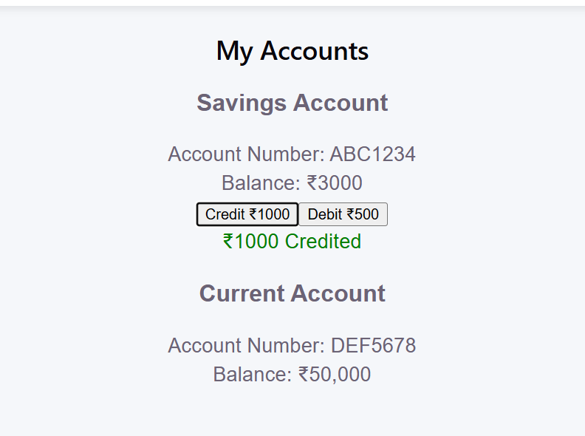
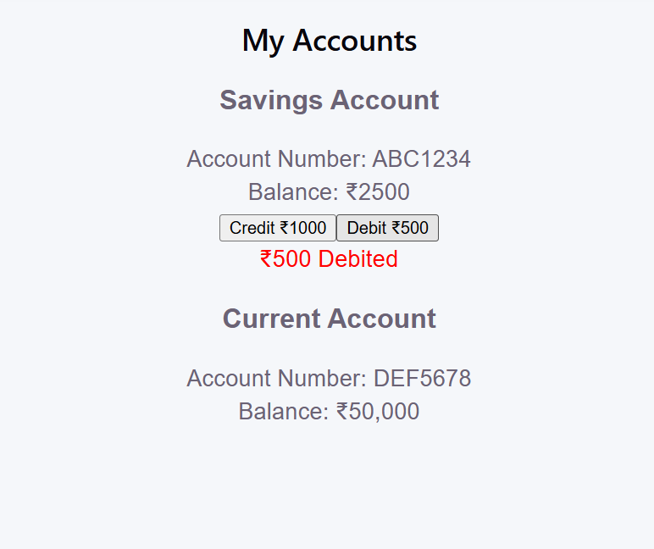
Step 6:
In cpomponents / create TransactionForm.tsx
Can you implement use state hook in TransactionForm.jsx
For setAmmount
Set Type → depoasit.. Or so

import { useState } from 'react'

type TransactionFormProps = {
onTransaction: (
accountNumber: string,
type: 'credit' | 'debit',
amount: number
) => void
}

function TransactionForm({
onTransaction,
}: TransactionFormProps) {
const [accountNumber, setAccountNumber] = useState('')
const [amount, setAmount] = useState('')
const [type, setType] = useState<'credit' | 'debit'>('credit')

const handleSubmit = (e: React.FormEvent) => {
e.preventDefault()

const transactionAmount = Number(amount)

if (!accountNumber || transactionAmount <= 0) {
alert('Please enter a valid account number and amount')
return
}

onTransaction(
accountNumber,
type,
transactionAmount
)

setAccountNumber('')
setAmount('')
}

return (
<div className="transaction-form">
<h2>Make a Transaction</h2>

<form onSubmit={handleSubmit}>

<div>
<label>Account Number</label>

<input
type="text"
placeholder="Enter account number"
value={accountNumber}
onChange={(e) =>
setAccountNumber(e.target.value)
}
/>
</div>

<div>
<label>Amount</label>

<input
type="number"
placeholder="Enter amount"
value={amount}
onChange={(e) =>
setAmount(e.target.value)
}
/>
</div>

<div>
<label>Transaction Type</label>

<select
value={type}
onChange={(e) =>
setType(
e.target.value as 'credit' | 'debit'
)
}
>
<option value="credit">Credit</option>
<option value="debit">Debit</option>
</select>
</div>

<button type="submit">
Submit Transaction
</button>

</form>
</div>
)
}

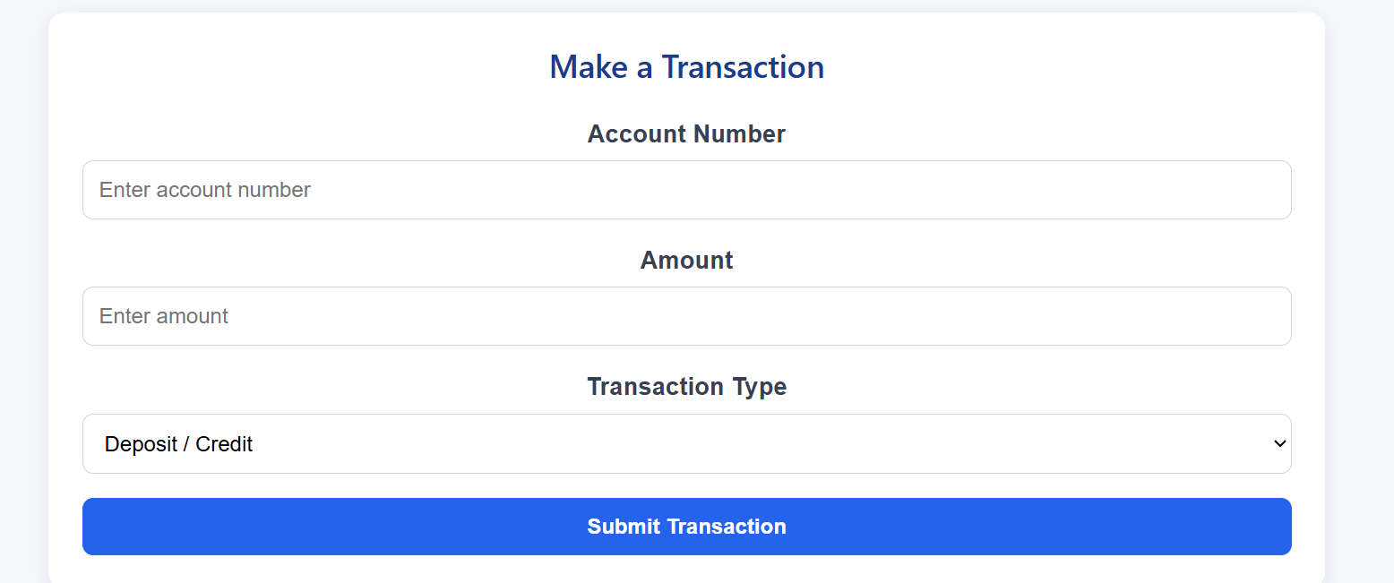
Step 7:
- Transaction history
- Use the concept of prop drilling
- type Transaction = {
- id: number
- accountNumber: string
- type: 'credit' | 'debit'
- amount: number
- date: string
- }

- type TransactionHistoryProps = {
- transactions: Transaction[]
- }

- function TransactionHistory({
- transactions,
- }: TransactionHistoryProps) {
- return (
- <div className="transaction-history">
- <h2>Transaction History</h2>

- {transactions.length === 0 ? (
- <p className="no-transactions">
- No transactions yet.
- </p>
- ) : (
- transactions.map((transaction) => (
- <div
- className={`transaction ${
- transaction.type === 'credit'
- ? 'credit'
- : 'debit'
- }`}
- key={transaction.id}
- >
- <div>
- <h3>
- {transaction.type === 'credit'
- ? 'Credit'
- : 'Debit'}
- </h3>

- <p>
- Account Number:{' '}
- {transaction.accountNumber}
- {transaction.date}</p>
- </div>

- <div className="transaction-amount">
- {transaction.type === 'credit'
- ? '+'
- : '-'}
- ₹{transaction.amount}
- </div>
- </div>
- ))
- )}
- </div>
- )
- }

- export default TransactionHistory

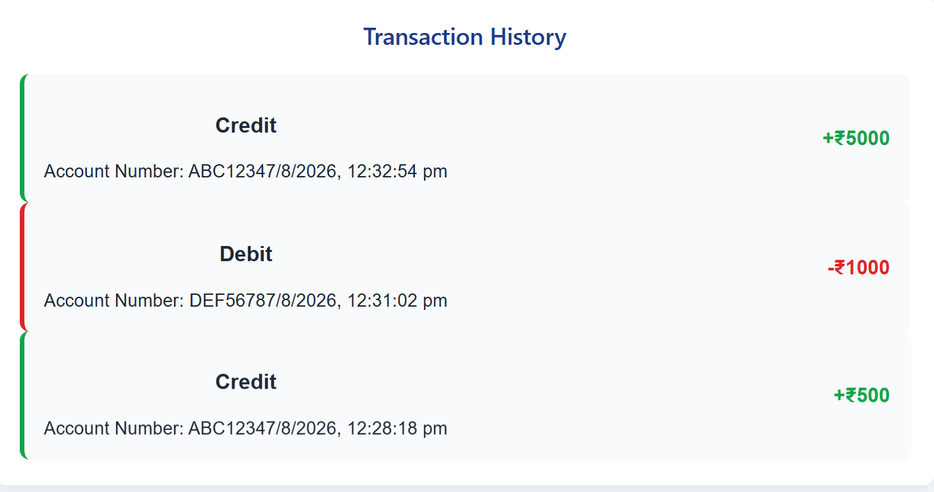

Step 8:
As you have already implemented state hooks..
Eg :useState - -> Declares a state variable and updater function.
const [count, setCount] = useState(0);
Can you try to implement one more state hook .. useReducer?
Like eg:
useReducer -> → Manages complex state logic with a reducer function.
const [state, dispatch] = useReducer(reducer, initialState);
function reducer(state: State, action: Action): State {
const updatedAccounts = state.accounts.map((account) => {
if (account.accountNumber === action.accountNumber) {
const newBalance =
action.type === 'CREDIT'
? account.balance + action.amount
: account.balance - action.amount

return {
...account,
balance: newBalance,
}
}

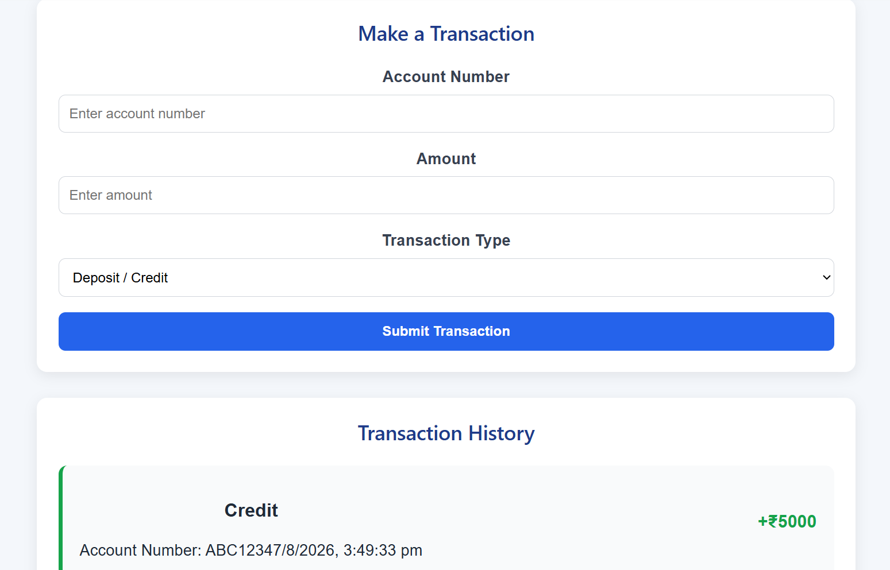
Step 9:
Effect Hooks:
useEffect → Handles side effects (API calls, subscriptions, DOM updates).
Like example
useEffect(() => {
document.title = `Count: ${count}`;
}, [count]);
import { useEffect, useReducer } from 'react'
import Accounts from './Accounts'
import TransactionForm from './TransactionForm'
import TransactionHistory from './TransactionHistory'
import './Dashboard.css'

// useEffect Hook
useEffect(() => {
document.title = `Transactions: ${state.transactions.length}`
}, [state.transactions])

Step 10:
useLayoutEffect → Runs before the browser repaints (for layout measurements).
useInsertionEffect → Used mainly by libraries to inject styles before DOM updates.
- useLayoutEffect is similar to useEffect, but it runs before the browser paints the updated UI. It is mainly useful when you need to measure or change the layout before the user sees it.

useLayoutEffect(() => {
if (dashboardRef.current) {
const height =
dashboardRef.current.offsetHeight

const width =
dashboardRef.current.offsetWidth

console.log(
`Dashboard Size: ${width}px x ${height}px`
)
}
}, [state.transactions])

- useInsertionEffect runs very early in React's update process, before layout effects. It is mainly intended for CSS-in-JS libraries that need to insert styles before the browser performs layout calculations.
useInsertionEffect(() => {
console.log(
'Styles are being prepared before layout effects.'
)
}, [])

Step 11:
Use contextHooks:
useContext → Accesses values from React Context without prop drilling.
Like eg
const theme = useContext(ThemeContext);
import {
createContext,
useContext,
useDebugValue,
useMemo,
type ReactNode,
} from 'react'

type BankContextValue = {
bankName: string
branch: string
currency: string
supportEmail: string
}

const defaultBankContext: BankContextValue = {
bankName: 'Banking App',
branch: 'Main Branch',
currency: '₹',
supportEmail: 'support@bankingapp.com',
}

export const BankContext = createContext<BankContextValue>(defaultBankContext)

type BankProviderProps = {
children: ReactNode
}

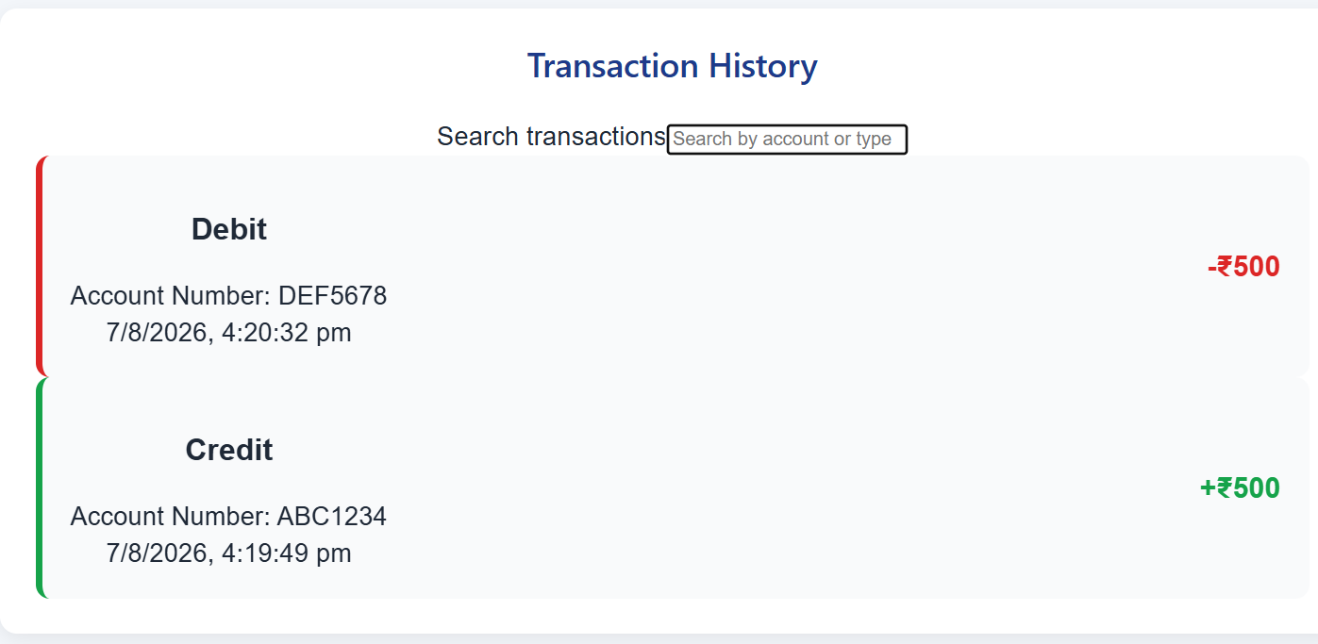
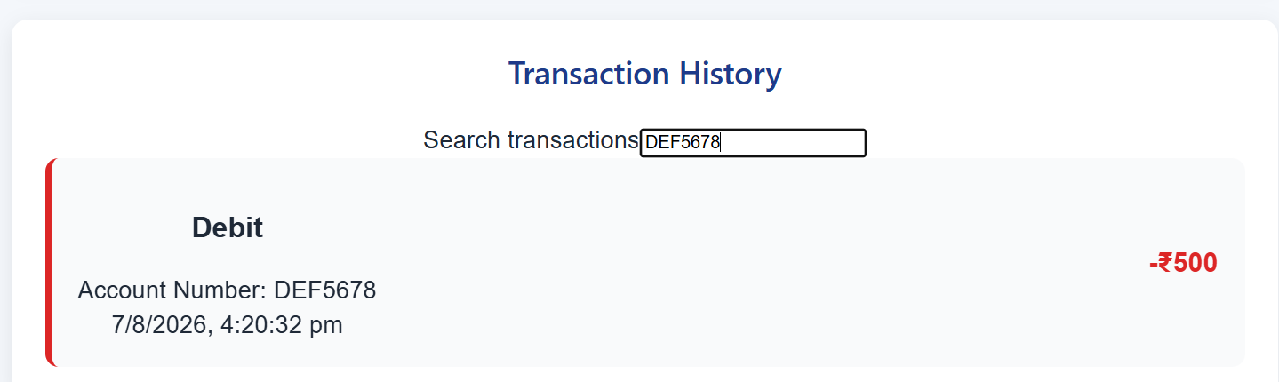

Step 12:
Ref Hooks:
useRef → Stores mutable values (like DOM nodes or timers) without causing re-renders.
const inputRef = useRef(null);
const inputRef = useRef<HTMLInputElement>(null)

Step 13:
Performance Hooks
useMemo → Memoizes expensive calculations.
useCallback → Memoizes functions to avoid unnecessary re-renders.
useTransition → Manages concurrent rendering for smoother UI.

useDeferredValue → Defers updating non-critical UI parts.
const bankValue = useMemo<BankContextValue>(
() => ({
bankName: 'BlueStone Bank',
branch: 'Downtown Branch',
currency: '₹',
supportEmail: 'support@bluestonebank.com',
}),
[]
)

Step 14:
useId → Generates unique IDs for accessibility.
useDebugValue → Labels custom hooks for debugging.
export const useBank = () => {
const bank = useContext(BankContext)

useDebugValue(bank, (value) => `${value.bankName} • ${value.branch}`)

return bank
}

