Day 31 - 27th Aug 2026
Task 1:
1. Application Security Fundamentals & OWASP Top 10
Q: How do the principles of least privilege and defense in depth complement each other in mitigating OWASP Top 10 vulnerabilities, and can you illustrate with a real-world example?
- Least privilege means giving users, applications, and services only the permissions they actually need.
- Defense in depth means using multiple security layers so that if one security control fails, another can still protect the system.
- These principles work together because least privilege limits the damage, while defense in depth reduces the chance of an attack succeeding.
- For example, in a SQL injection attack, using parameterized queries prevents malicious SQL from being executed.
- Even if an attacker manages to bypass that protection, a database account with limited permissions prevents them from accessing or modifying sensitive data.
- Therefore, using multiple security controls along with restricted permissions provides stronger protection against OWASP vulnerabilities.
2. Authentication vs. Authorization
Q: Why is it dangerous to conflate authentication with authorization in application design, and how might this oversight lead to privilege escalation in a Spring Boot application?
- Authentication verifies who the user is, such as checking a username, password, or JWT.
- Authorization determines what that authenticated user is allowed to access or perform.
- They should be treated as separate security checks because simply being logged in does not mean the user should have access to everything.
- For example, in a Spring Boot banking application, both an admin and a normal customer may successfully log in.
- If the application only checks authentication and does not check roles, the customer might access an admin endpoint such as deleting accounts or viewing sensitive information.
- This can lead to privilege escalation, where a user gains permissions beyond what they were assigned.
- Spring Security helps prevent this using role-based or permission-based authorization such as hasRole("ADMIN").
3. Spring Security Filter Chain & Token-Based Authentication
Q: Explain how the Spring Security filter chain processes a request carrying a JWT. Which filters are involved, and how does the chain differ when handling form-based login versus token-based authentication?
- The Spring Security filter chain processes incoming HTTP requests before they reach the controller.
- When a request contains a JWT, usually in the Authorization: Bearer <token> header, a JWT authentication filter extracts the token.
- The filter validates the JWT, checks its signature and expiration, and extracts information such as the username and roles.
- If the token is valid, an authenticated user is placed into the SecurityContext.
- Authorization filters then check whether that user has permission to access the requested endpoint.
- In form-based authentication, UsernamePasswordAuthenticationFilter processes the username and password and normally establishes a session.
- In JWT-based authentication, the server validates the token on each request and generally does not maintain a server-side login session.
- Therefore, form login is commonly session-based, while JWT authentication is generally stateless and token-based.
4. Secure Coding Practices & Input Validation
Q: What is the difference between input validation and output encoding in secure coding practices, and why must both be applied together to prevent injection and XSS attacks?
Answer: Input validation checks that user-provided data is valid and follows the expected format before it is processed by the application. Output encoding ensures that data is safely displayed by converting special characters into harmless text, preventing browsers from interpreting them as executable code. Input validation helps block malicious data from entering the system, while output encoding protects users when data is displayed. Using both together provides better protection against attacks such as SQL injection and Cross-Site Scripting (XSS).
5. Secrets Management & Dependency Scanning
Q: How does improper secrets management, such as hardcoding API keys, interact with dependency vulnerabilities to amplify risk in modern applications, and what strategies can be used to mitigate both simultaneously?
- Secrets management involves securely storing sensitive information such as API keys, database passwords, and authentication tokens.
- Hardcoding these secrets directly in source code is dangerous because they can accidentally be exposed through Git repositories, logs, or shared code.
- At the same time, applications often depend on third-party libraries, which may contain security vulnerabilities.
- If an attacker exploits a vulnerable dependency and also finds exposed credentials, they may gain access to databases, APIs, or other internal services.
- This means the combination of vulnerable dependencies + exposed secrets can make an attack much more damaging.
- To prevent this, secrets should be stored using environment variables or dedicated secret-management systems rather than source code.

Task 2:

.Application Security
📂 Project Structure
Code
spring-security-demo/
├── pom.xml
└── src/main/java/com/security/demo/
├── DemoApplication.java
├── config/
│ └── SecurityConfig.java
├── controller/
│ └── UserController.java
├── model/
│ └── User.java
├── service/
│ └── UserService.java
└── util/
└── JwtUtil.java

🔹 Step 1: Create Spring Boot Project
Use Spring Initializr (https://start.spring.io).
add dependencies: Spring Web, Spring Security, Spring Data JPA, H2 Database, Spring Boot Starter Validation, jjwt (for JWT).

🔹 Step 2: create Main Application

🔹 Step 3: for Security Configuration
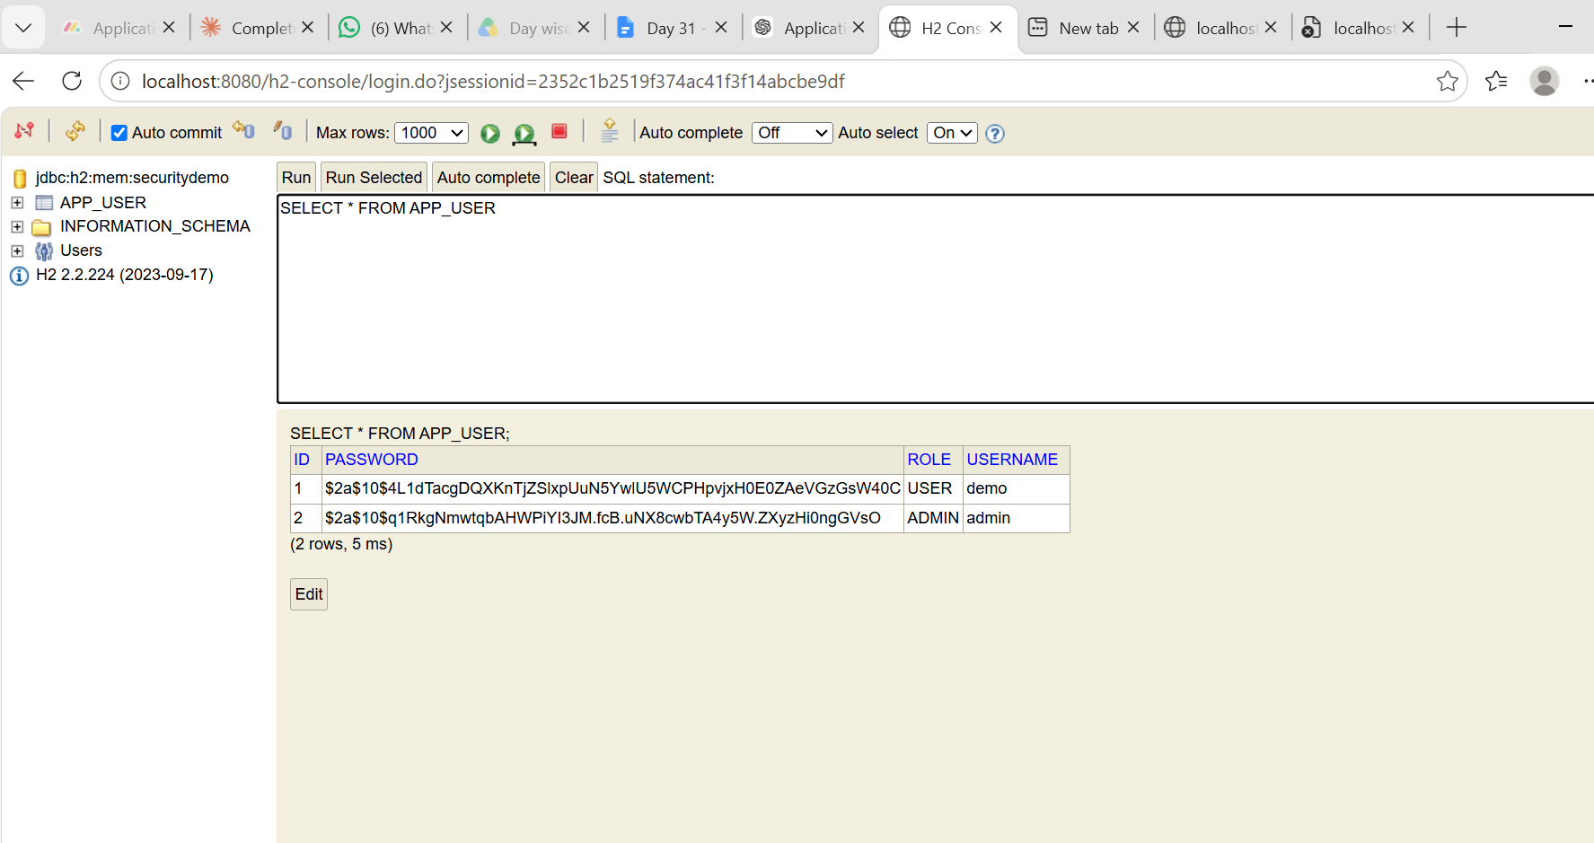



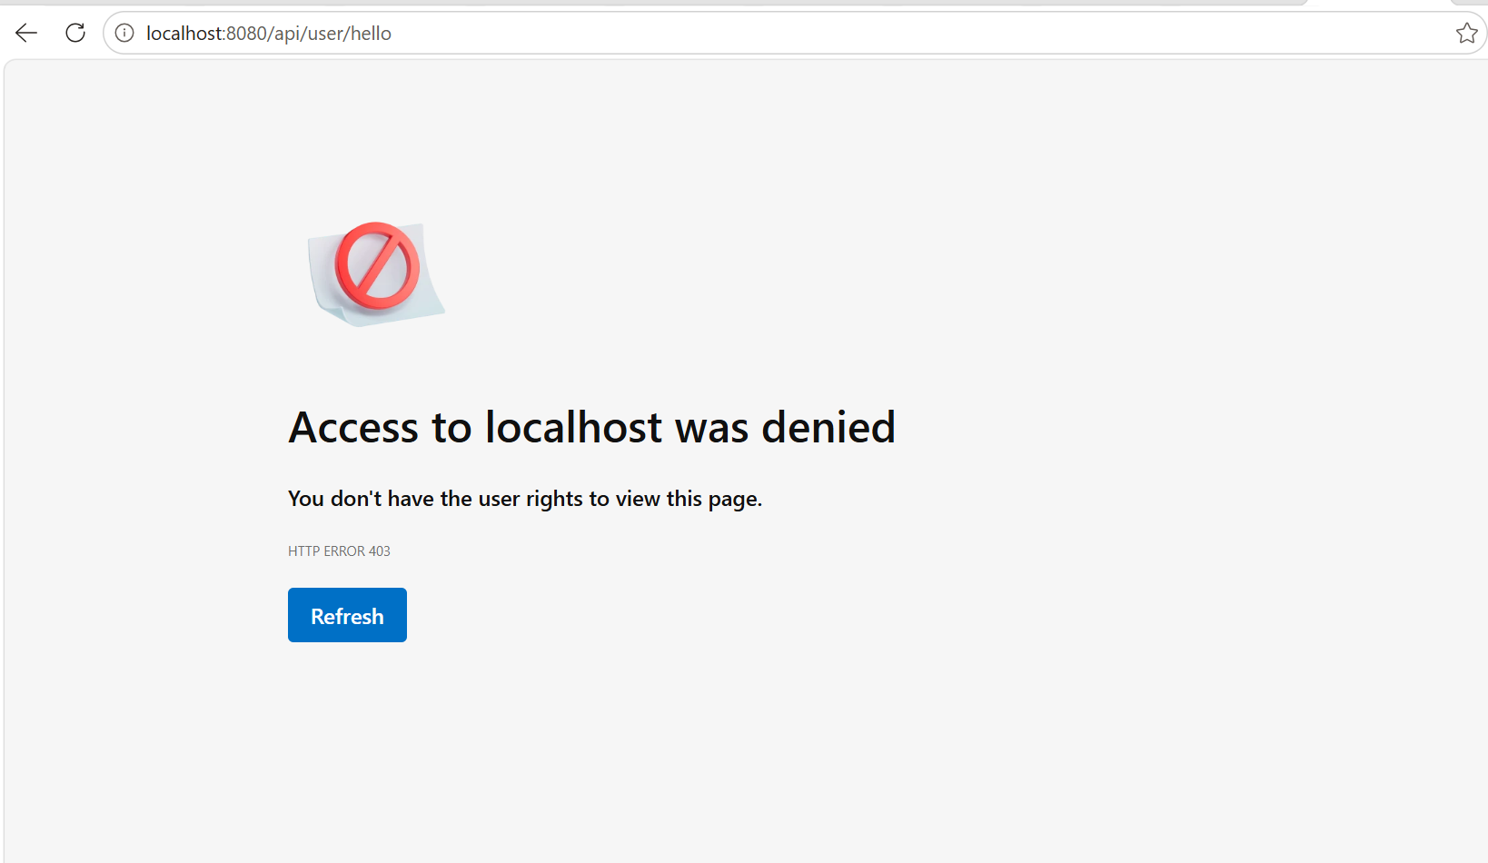

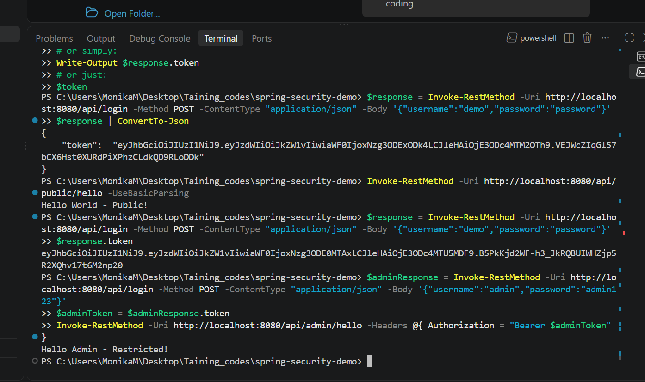

Task 4:
Cloud Computing Concepts
Q1: How does cloud computing differ from traditional on-premises IT infrastructure in terms of scalability and cost management?
Cloud computing allows businesses to scale resources up or down based on demand, without having to purchase and maintain physical servers. In traditional on-premises infrastructure, companies need to buy hardware in advance, which can be expensive and may leave resources unused. Cloud services generally follow a pay-as-you-use model, so we pay mainly for the resources we consume. This makes cloud computing more flexible and cost-effective, especially when application usage changes frequently.
Q2: Why is it important to deploy applications across multiple Availability Zones within a region?
Deploying an application across multiple Availability Zones improves availability and fault tolerance. If one Availability Zone experiences a hardware failure, power issue, or network problem, the application can continue running from another zone. This reduces downtime and helps provide a more reliable service to users.
Q3: What is the difference between IAM roles and IAM users, and when would you use each?
An IAM user represents a specific person or long-term identity that needs access to AWS resources. For example, a developer may have an IAM user to access AWS services. An IAM role is mainly used to provide temporary permissions to users, applications, or AWS services. For example, an EC2 instance can assume a role to access an S3 bucket without storing AWS access keys on the server. Roles are generally preferred for applications because they provide temporary and safer access.
Q4: How does Amazon EC2 enable elasticity in application deployment, and what role does Auto Scaling play?
Amazon EC2 allows us to create and remove virtual servers whenever required. This makes it possible to increase computing capacity when traffic is high and reduce it when demand decreases. Auto Scaling automates this process by monitoring demand and automatically adding or removing EC2 instances according to predefined rules. This helps maintain performance while avoiding unnecessary costs.
Q5: What makes Amazon S3 an object storage service, and how does it ensure durability of stored data?
Amazon S3 stores data as objects inside buckets, rather than storing it like files on a traditional disk. Each object contains the actual data, metadata, and a unique key. S3 is designed for very high durability by automatically storing data redundantly across multiple devices and facilities. This makes it suitable for storing backups, images, videos, documents, and application data.
Q6: Why would you place a database in a private subnet within a VPC instead of a public subnet?
A database is usually placed in a private subnet so that it cannot be accessed directly from the public internet. Application servers can communicate with the database internally, while users access the application through public-facing services. This reduces the attack surface and adds an extra layer of security to sensitive data.
Q7: How does Amazon RDS simplify database management compared to running a database on EC2?
Amazon RDS is a managed database service, so AWS handles many administrative tasks such as database setup, backups, software patching, monitoring, and maintenance. If we run a database on EC2, we have to manage the operating system, database installation, updates, backups, and other maintenance ourselves. RDS therefore allows developers to focus more on the application instead of database administration.
Q8: How do security groups function as virtual firewalls, and what is the principle of “least privilege” in configuring them?
Security groups act like virtual firewalls for AWS resources such as EC2 instances. They control which inbound and outbound network traffic is allowed based on rules such as protocol, port, and source or destination. The principle of least privilege means allowing only the access that is actually required. For example, instead of allowing a database to accept connections from the entire internet, we should allow connections only from the application's security group.
Q9: What are the advantages of using the AWS CLI over the AWS Management Console for managing cloud resources?
The AWS CLI allows us to manage AWS resources directly through command-line commands. It is useful for automation, scripting, and performing repetitive tasks quickly. Unlike the console, CLI commands can easily be saved and reused, which makes them useful for deployments and DevOps work. The console is easier for beginners and visual tasks, while the CLI is often more efficient for developers and administrators.

