Day 37 - 04th Sept 2026
Task 01:

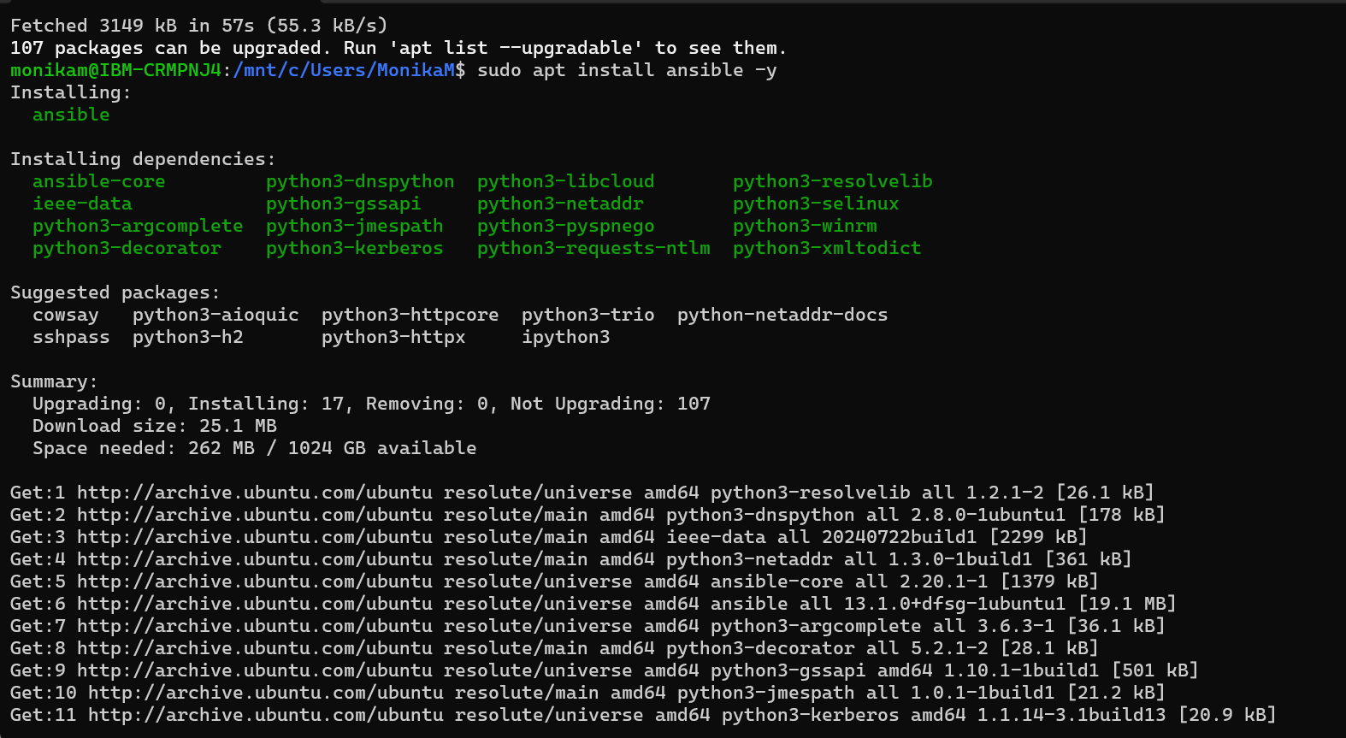

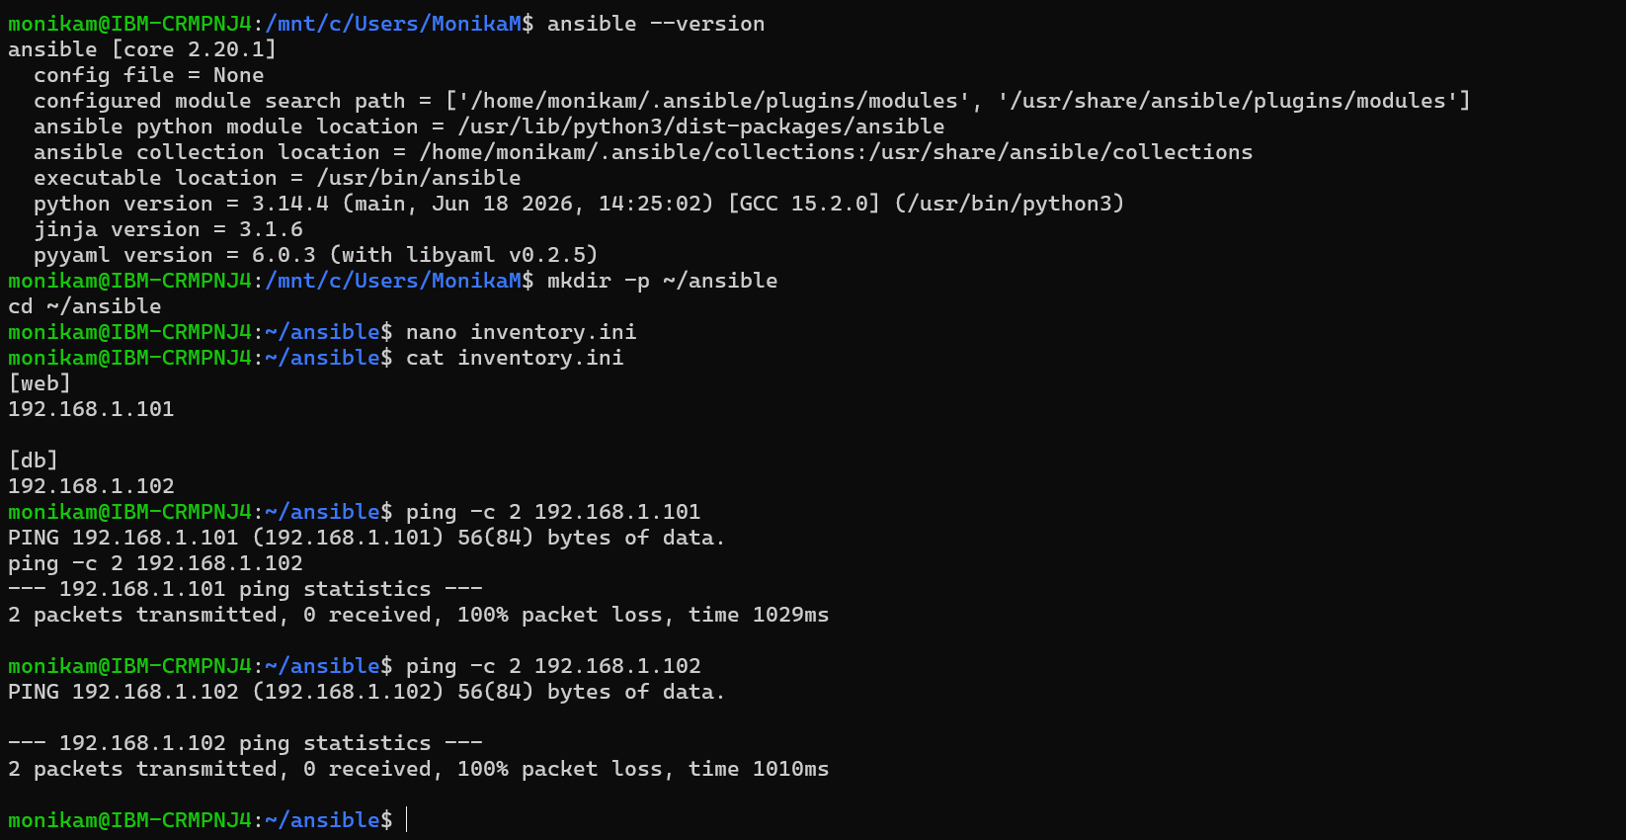

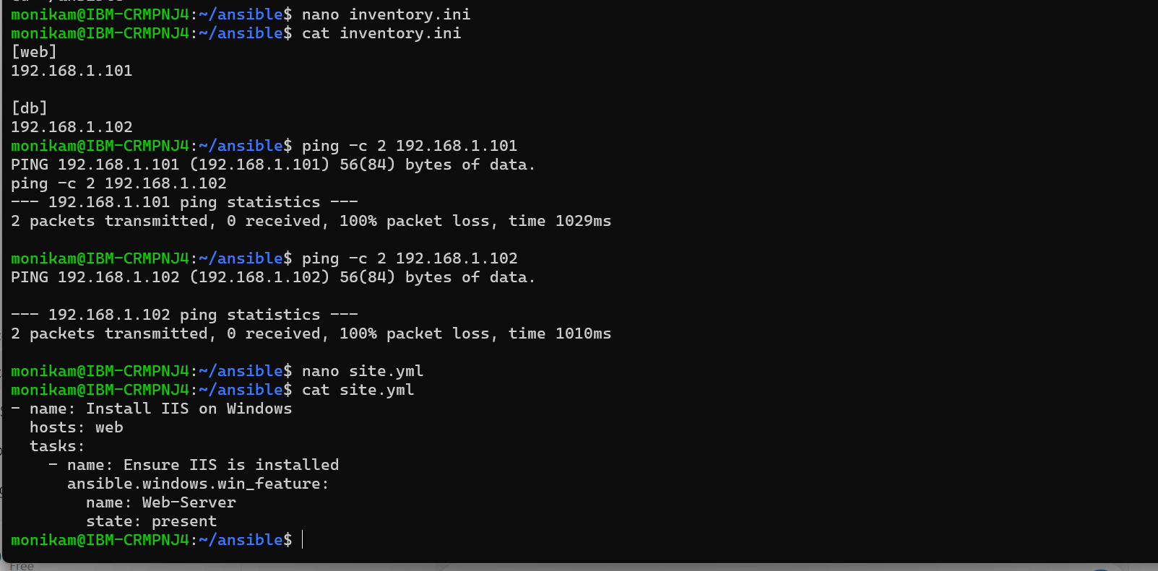
PS C:\windows\system32> winrm get winrm/config/service
Service
RootSDDL = O:NSG:BAD:P(A;;GA;;;BA)(A;;GR;;;IU)S:P(AU;FA;GA;;;WD)(AU;SA;GXGW;;;WD)
MaxConcurrentOperations = 4294967295
MaxConcurrentOperationsPerUser = 1500
EnumerationTimeoutms = 240000
MaxConnections = 300
MaxPacketRetrievalTimeSeconds = 120
AllowUnencrypted = true
Auth
Basic = true
Kerberos = true
Negotiate = true
Certificate = false
CredSSP = false
CbtHardeningLevel = Relaxed
DefaultPorts
HTTP = 5985
HTTPS = 5986
IPv4Filter = *
IPv6Filter = *
EnableCompatibilityHttpListener = false
EnableCompatibilityHttpsListener = false
CertificateThumbprint
AllowRemoteAccess = true
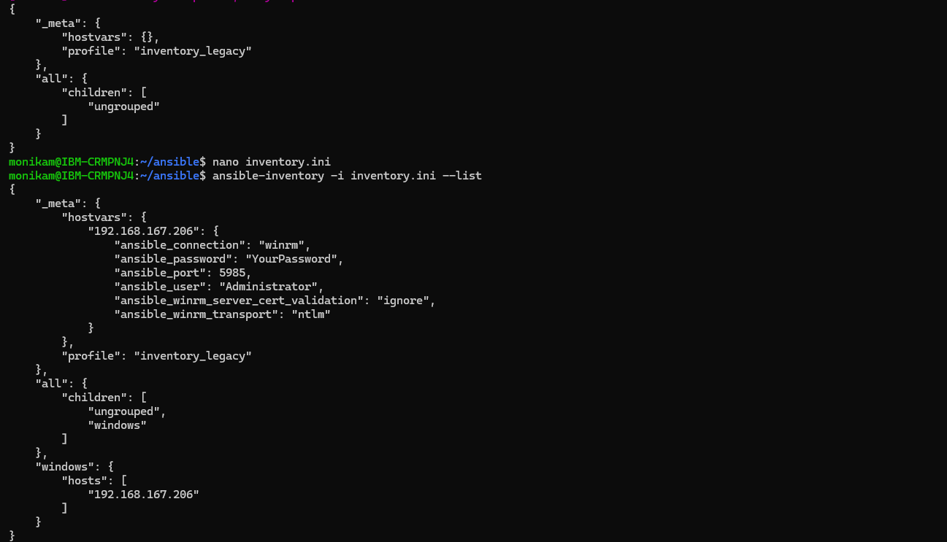
Task 2:
📂 Project Structure (Windows Automation)
Code
ansible-windows-project/
├── inventory.ini
├── site.yml
├── roles/
│ └── windows_iis/
│ ├── tasks/
│ │ └── main.yml
│ ├── vars/
│ │ └── main.yml
│ ├── handlers/
│ │ └── main.yml
│ ├── templates/
│ │ └── index.html.j2
│ └── files/
│ └── custom-config.xml
