Day 21 - 13th Aug 2026

HOMW TASK [DAY-20]

1. Difference Between Node.js and Traditional Web Servers (Apache/Nginx)
Node.js
- A JavaScript runtime environment used to build server-side applications.
- Uses an event-driven, non-blocking I/O model.
- Can handle many concurrent connections efficiently.
- Developers write application logic directly in JavaScript.
Apache/Nginx
- Traditional web servers primarily used to serve web pages and static content.
- Apache uses a process/thread-based model.
- Nginx uses an event-driven architecture but mainly acts as a web server, reverse proxy, and load balancer.
- Not designed as a general-purpose runtime like Node.js.

2. Event-Driven Architecture of Node.js
Node.js follows an event-driven architecture, where actions trigger events and event handlers respond to them.
Components:
- Event Emitter: Generates events.
- Event Queue: Stores pending events.
- Event Loop: Continuously checks for events and executes their callbacks.
Example:
When a client sends a request:
- Request arrives.
- Event is generated.
- Event loop detects it.
- Associated callback function executes.
This architecture helps Node.js efficiently manage multiple operations simultaneously.

3. How the Single-Threaded Model Handles Concurrency
Node.js runs JavaScript on a single main thread.
Instead of creating a new thread for each request:
- Request arrives.
- Long-running tasks (file access, database calls, network requests) are delegated to the OS or thread pool.
- Main thread continues processing other requests.
- Callback executes when the operation finishes.
This enables Node.js to handle thousands of concurrent connections with minimal resource usage.

4. Role of the V8 Engine in Node.js
V8 is Google's JavaScript engine used in Chrome.
Responsibilities:
- Converts JavaScript into machine code.
- Executes JavaScript efficiently.
- Performs memory management and garbage collection.
- Optimizes code execution for better performance.
Without V8, Node.js would not be able to run JavaScript outside the browser.

5. Why Node.js is Considered Non-Blocking
Node.js performs operations asynchronously.
Blocking Example:
JavaScript
const data = fs.readFileSync("file.txt");
console.log(data);
Show more lines
The program waits until the file is completely read.
Non-Blocking Example:
JavaScript
fs.readFile("file.txt", (err, data) => {
console.log(data);
});
console.log("Executing...");
Show more lines
Output:
Plain Text
Executing...
[file content]
Show more lines
Node.js does not wait for the file operation to finish before continuing execution.

6. Difference Between Callbacks, Promises, and Async/Await
Callbacks
A function passed as an argument and executed later.
JavaScript
fs.readFile("file.txt", (err, data) => {
console.log(data);
});
Show more lines
Pros: Simple for small tasks.
Cons: Can lead to "Callback Hell".

Promises
Represent the eventual completion or failure of an asynchronous operation.
JavaScript
fetchData()
.then(data => console.log(data))
.catch(err => console.log(err));
Show more lines
Pros: Better readability and error handling.

Async/Await
Built on top of promises and makes asynchronous code look synchronous.
JavaScript
async function getData() {
try {
const data = await fetchData();
console.log(data);
} catch (err) {
console.log(err);
}
}
Show more lines
Pros: Cleanest and easiest to maintain.

7. How the Event Loop Works and Its Phases
The Event Loop manages asynchronous tasks.
Phases of Event Loop:
- Timers
  - Executes setTimeout() and setInterval() callbacks.
- Pending Callbacks
  - Executes deferred I/O callbacks.
- Idle/Prepare
  - Internal Node.js processing.
- Poll
  - Retrieves new I/O events and executes callbacks.
- Check
  - Executes setImmediate() callbacks.
- Close Callbacks
  - Executes close events such as socket close.

8. Difference Between process.nextTick() and setImmediate()
process.nextTick()
- Executes immediately after the current operation finishes.
- Runs before the next event loop phase.
JavaScript
process.nextTick(() => {
console.log("nextTick");
});
Show more lines

setImmediate()
- Executes during the Check phase.
- Runs after I/O events are processed.
JavaScript
setImmediate(() => {
console.log("setImmediate");
});

9. How Node.js Handles I/O Operations Asynchronously
Node.js uses:
- Event Loop
- Operating System APIs
- Libuv Thread Pool
Process:
- Request for I/O operation arrives.
- Node.js delegates the task to Libuv or OS.
- Main thread continues execution.
- When operation completes, callback is queued.
- Event loop executes callback.
This architecture prevents the main thread from being blocked.

10. How the require() Function Works Internally
require() is used to import modules.
Internal Steps:
- Resolves module path.
- Checks module cache.
- Loads module if not cached.
- Wraps module in a function.
- Executes module code.
- Stores exports in cache.
- Returns exported object.
Example:
JavaScript
1
const math = require("./math");
Show more lines
Benefits:
- Module caching improves performance.
- Prevents repeated loading of the same module.

11. Purpose of package.json and package-lock.json
package.json
Contains project metadata and dependency information.
Example:
JSON
{"name": "my-app",
"version": "1.0.0",
"scripts": {
"start": "node app.js"
}
}
Show more lines
Uses:
- Project details
- Scripts
- Dependencies
- Version management

package-lock.json
Automatically generated by npm.
Uses:
- Stores exact dependency versions.
- Ensures consistent installations.
- Improves installation speed.

12. Difference Between dependencies and devDependencies
dependencies
Packages required in production.
Example:
Shell
npm install express
Show more lines
Stored as:
JSON
"dependencies": {
"express": "^4.18.2"
}
Show more lines
Examples:
- Express
- Mongoose
- Axios

devDependencies
Packages needed only during development.
Example:
Shell
npm install nodemon --save-dev
Show more lines
Stored as:
JSON
"devDependencies": {
"nodemon": "^3.0.0"
}
Show more lines
Examples:
- Nodemon
- ESLint
- Jest
- Prettier
Key Difference:
dependencies | devDependencies
Needed in production | Needed only in development
Installed on production servers | Usually not installed in production
Application runtime packages | Testing/building/linting tools

Day 21
Node JS
Task 01:
Create a common js module in nodejs to do some arithmetic operation.
9.05 to 9.08
Note:
Common Module JS.
- Key features:
  - Uses require() to import.
  - Uses exports or module.exports to export.
  - Each file is wrapped in its own function scope (variables are private).
  - Supports caching: once loaded, modules are cached for efficiency.
- File types treated as CommonJS:
  - .cjs files
  - .js files if package.json has "type": "commonjs" or no type specified.
- arithmetic.js
// arithmetic.js

// Private variable — not accessible outside this file (module scope)
const moduleName = "Arithmetic Module";

function add(a, b) {
return a + b;
}

function subtract(a, b) {
return a - b;
}

function multiply(a, b) {
return a * b;
}

function divide(a, b) {
if (b === 0) {
throw new Error("Cannot divide by zero");
}
return a / b;
}

// Export functions using module.exports
module.exports = {
add,
subtract,
multiply,
divide
};

- index.js

// index.js

// Import the module using require()
const arithmetic = require('./arithmetic');

const num1 = 20;
const num2 = 5;

console.log("Addition:", arithmetic.add(num1, num2));
console.log("Subtraction:", arithmetic.subtract(num1, num2));
console.log("Multiplication:", arithmetic.multiply(num1, num2));
console.log("Division:", arithmetic.divide(num1, num2));

OUTPUT
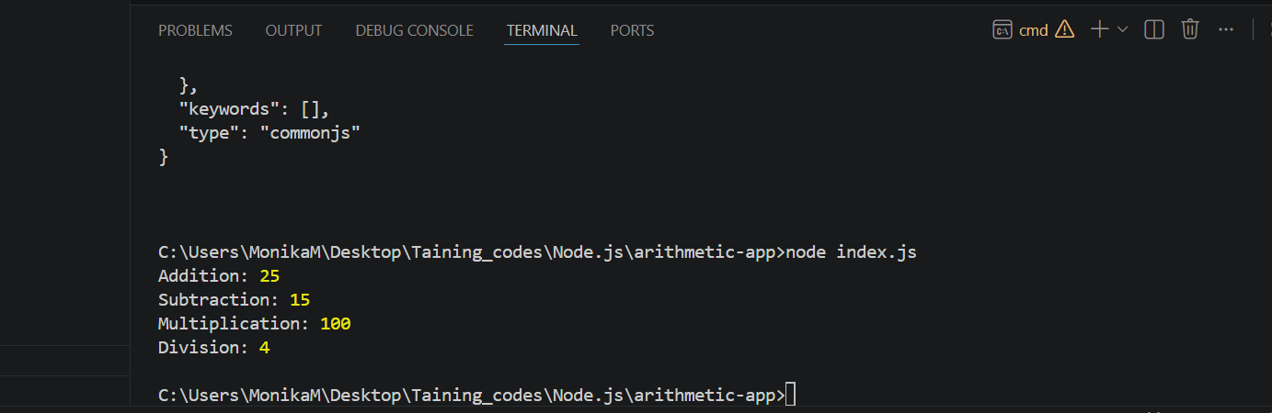

create a project folder
- mkdir arithmetic-esm-app
- cd arithmetic-esm-app
- code .
Initialize the Project
- npm init -y

//arithmetic.js
// arithmetic.js

// Private-ish (not exported) module-level variable
const moduleName = "Arithmetic Module (ESM)";

export function add(a, b) {
return a + b;
}

export function subtract(a, b) {
return a - b;
}

export function multiply(a, b) {
return a * b;
}

export function divide(a, b) {
if (b === 0) {
throw new Error("Cannot divide by zero");
}
return a / b;
}

// Default export (optional) — could also export an object
export default {
add,
subtract,
multiply,
divide

//index.js
// index.js

// Named imports using ES Module syntax
import { add, subtract, multiply, divide } from './arithmetic.js';

// Or import default export instead:
// import arithmetic from './arithmetic.js';

const num1 = 200;
const num2 = 50;

console.log("Addition:", add(num1, num2));
console.log("Subtraction:", subtract(num1, num2));
console.log("Multiplication:", multiply(num1, num2));
console.log("Division:", divide(num1, num2));

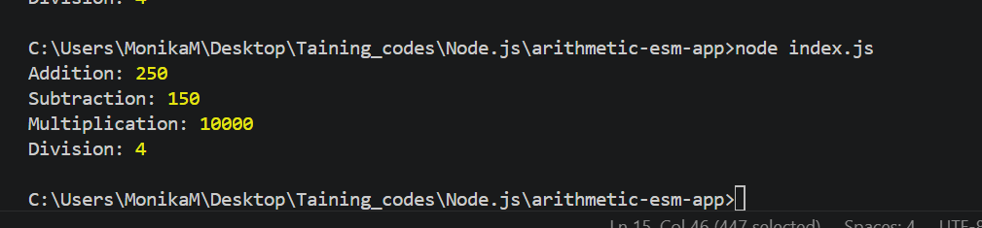

Task 4:
Given 2 files app.js and home.ejs
Can you let me know we are doing in this code.. Give comments for this code in your document.

App.js
const express = require('express')
const bodyParser = require('body-parser')
const notes = [{
noteId: 1,
noteContent: "Hey, Prasunamba you can add your important notes here."
}
]

const app = express()

app.set('view engine', 'ejs')

app.use(bodyParser.json());
app.use(bodyParser.urlencoded({
extended: true
}))

app.get("/", function (req, res) {
res.render("home", {
data: notes
})
})

app.post("/", (req, res) => {
const noteContent = req.body.noteContent
const noteId = notes.length + 1;

notes.push({
noteId: noteId,
noteContent: noteContent
})

res.render("home", {
data: notes
})
})

app.post('/update', (req, res) => {
var noteId = req.body.noteId;
var noteContent = req.body.noteContent;

notes.forEach(note => {
if (note.noteId == noteId) {
note.noteContent = noteContent;
}
})
res.render("home", {
data: notes
})
})

app.post('/delete', (req, res) => {
var noteId = req.body.noteId;

var j = 0;
notes.forEach(note => {
j = j + 1;
if (note.noteId == noteId) {
notes.splice((j - 1), 1)
}
})

res.render("home", {
data: notes
})
})

app.listen(3000, (req, res) => {
console.log("App is running on port 3000")
})

Home.ejs

<!DOCTYPE html>
<html>

<head>
<title>Note Keeper</title>
</head>

<body>
<h1>Note Keeper</h1>

<div style="display: flex;">

<% data.forEach(element=> { %>

<form action="/update" method="post">
<input type="number" style="display: none;"
name="noteId" value="<%= element.noteId %>">
<textarea type="text" rows="6" cols="30"
placeholder="Type Here..." name="noteContent"
value="<%= element.noteContent %>">
<%= element.noteContent %></textarea>
<br>
<button type="submit">Update</button>
</form>

<form action="/delete" method="post">
<input type="number" style="display: none;"
name="noteId" value="<%= element.noteId %>">
<button type="submit"
style="margin: 0px 4px;">&#10005</button>
</form>
<% }) %>
</div>

<h1>Add Note</h1>
<form action="/" method="post">
<input type="number" style="display: none;"
name="noteId">
<textarea type="text" rows="6" cols="30"
placeholder="Type Here..."
name="noteContent"></textarea>
<br>
<button type="submit">Add</button>
</form>
</body>

</html>

OUTPUT
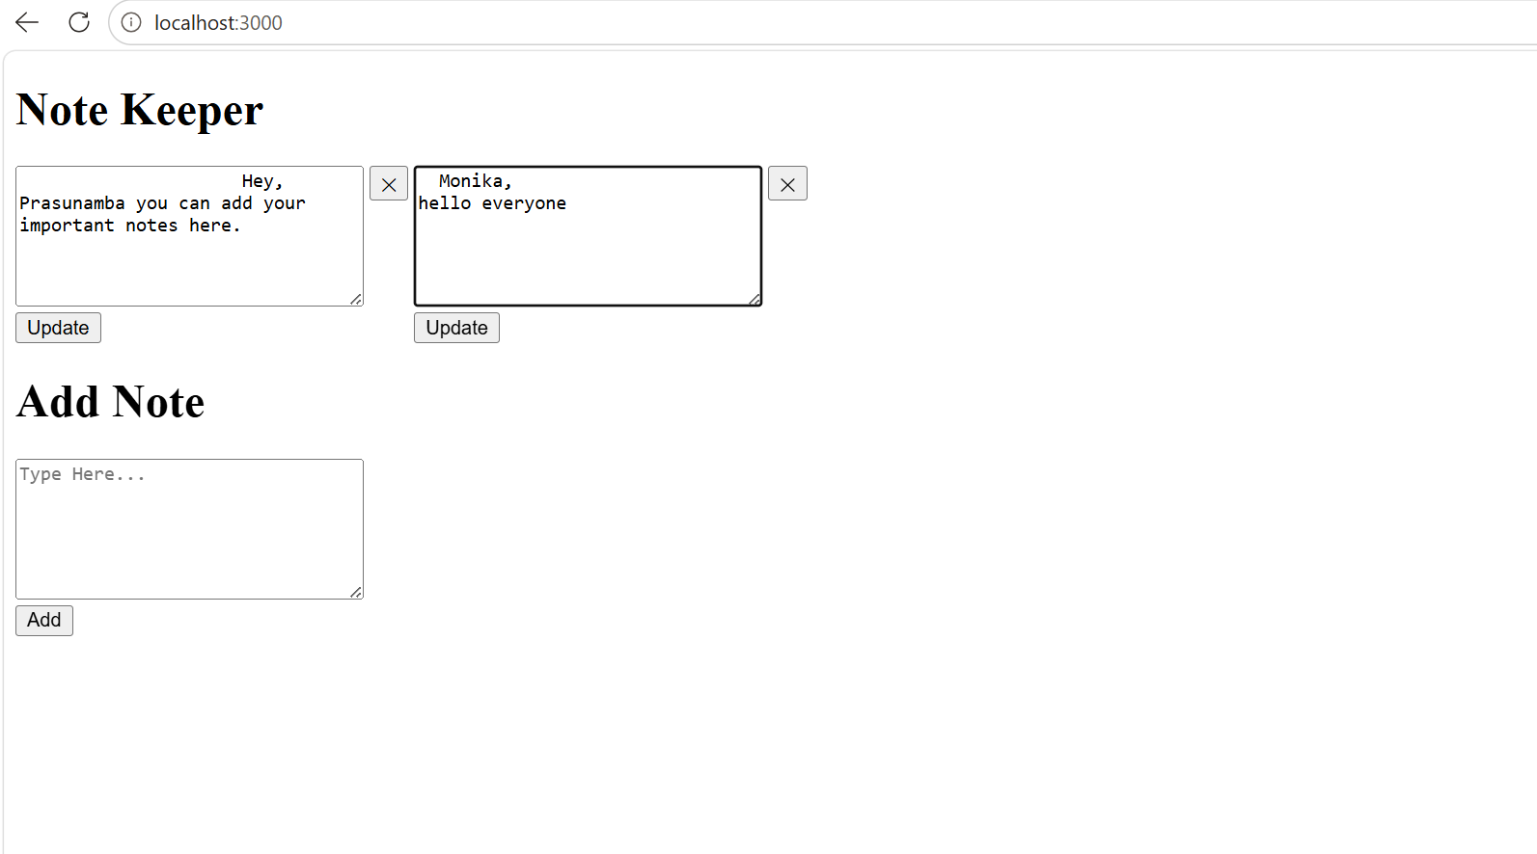
Task 5:
- Import all the required modules like express…
- Initialize the express app
- Create a async function for getting weather.
  - Use await Fetch for `https://api.openweathermap.org/data/2.5/weather?q=${city}&appid=${process.env.WEATHER_KEY}&units=metric`
And assign to response.
- Now convert response to json..
- Then return weather info like city , forecast. Temp…etc..
- Iff any error catch it in catch block
- Next call the web server route.

- Step 01:
mkdir weather-app
cd weather-app
code .
npm init -y

-App.js
// app.js

// Step 1: Import required modules
const express = require('express');
require('dotenv').config();

// Step 2: Initialize express app
const app = express();
const PORT = 3000;

// Step 3: Async function to fetch weather data
async function getWeather(city) {
try {
const response = await fetch(
`https://api.openweathermap.org/data/2.5/weather?q=${city}&appid=${process.env.WEATHER_KEY}&units=metric`
);

const data = await response.json();

if (data.cod !== 200) {
return { error: data.message || "City not found" };
}

return {
city: data.name,
country: data.sys.country,
temperature: data.main.temp,
feels_like: data.main.feels_like,
humidity: data.main.humidity,
pressure: data.main.pressure,
forecast: data.weather[0].description,
windSpeed: data.wind.speed
};

} catch (error) {
console.error("Error fetching weather:", error.message);
return { error: "Failed to fetch weather data" };
}
}

// Step 4: Web server route
app.get('/weather', async (req, res) => {
const city = req.query.city || "DELHI"; // default city
const weatherData = await getWeather(city); // async call
res.json(weatherData); // send JSON response
});

// Step 5: Start the server
app.listen(PORT, () => {
console.log(`Weather app running on port ${PORT}`);
});

.env
WEATHER_KEY=651e86f8a3fe516718b118568ce9ace9

OUTPUT
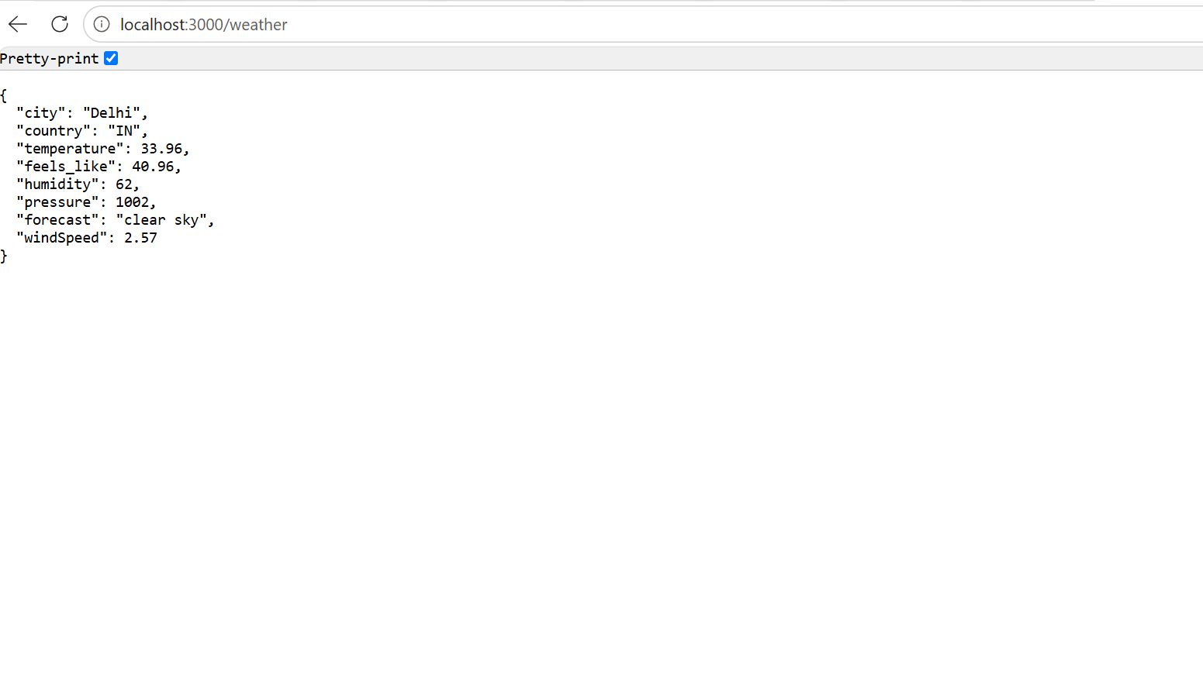
Task 6:
What is Mongoose? What are the key features?why do we use ?
What is Mongoose?
Mongoose is an Object Data Modeling (ODM) library for MongoDB and Node.js. It provides a schema-based solution to model application data and interact with MongoDB, sitting on top of the native MongoDB driver.
MongoDB itself is schema-less — Mongoose adds structure, validation, and an easier API on top of it.
Key Features
Feature | Description
Schema Definition | Define document structure — field names, types, rules
Models | Compiled schema used to perform CRUD operations
Validation | Built-in rules (required, min/max, unique, custom validators)
Type Casting | Automatically converts data to the schema's defined type
Middleware (Hooks) | Run logic before/after save, update, delete, etc.
Query Building | Clean, chainable methods (find(), sort(), limit())
Population | Reference & join related documents across collections
CRUD Methods | Simple built-in methods: create(), find(), updateOne(), deleteOne()
Connection Management | Handles DB connection, pooling, reconnection
Why Do We Use Mongoose?
- Adds structure to MongoDB's schema-less nature
- Provides built-in validation (no manual checks needed)
- Offers cleaner, readable syntax vs. raw MongoDB driver
- Reduces bugs through automatic type casting
- Simplifies relationships between collections via populate()
- Supports middleware for automation (e.g., password hashing)
- Speeds up development with less boilerplate code

Task 7:
Is this statement true or false?
Mongoose acts as a bridge between Node.js and MongoDB, giving you a structured way to manage your data.
True.
Mongoose acts as an ODM (Object Data Modeling) layer that sits between your Node.js application and MongoDB, translating JavaScript objects into MongoDB documents and vice versa.
It gives structure through:
- Schemas — define the shape and rules of your data
- Models — provide a structured interface to interact with the database
- Validation — enforces data integrity before saving
- Query methods — cleaner syntax than raw MongoDB driver calls

Task 8:
Task 8:
Now in your project
- Import mongoose
- Connect to mongodb
- Lets define a schema..
- Now create a model
- Insert a document

- Create a mongoose-app
App.js
// app.js

const mongoose = require('mongoose');
require('dotenv').config();

console.log("Mongo URL loaded:", process.env.MONGO_URL);

mongoose.connect(process.env.MONGO_URL)
.then(() => console.log('MongoDB connected successfully!'))
.catch(err => console.error('MongoDB connection error:', err.message));

const userSchema = new mongoose.Schema({
name: String,
age: Number,
email: { type: String, required: true }
});

const User = mongoose.model('User', userSchema);

const newUser = new User({
name: 'Monika',
age: 20,
email: 'monika@example.com'
});

newUser.save()
.then(() => console.log('User saved successfully!'))
.catch(err => console.error('Save error:', err.message));

- .env
MONGO_URL=mongodb://localhost:27017/mydb

OUTPUT
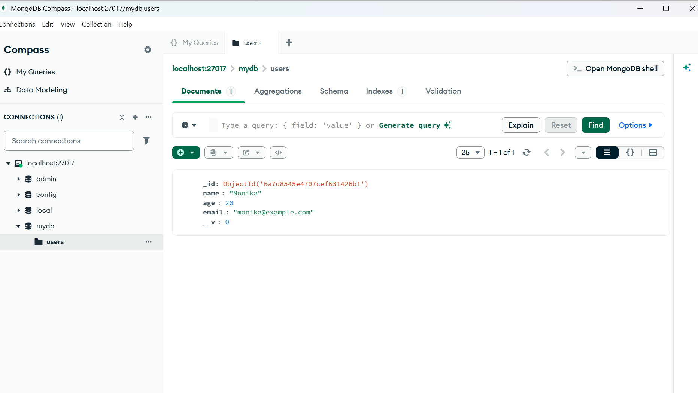

Task 9:
Create a project structure like this 👍 similar ..

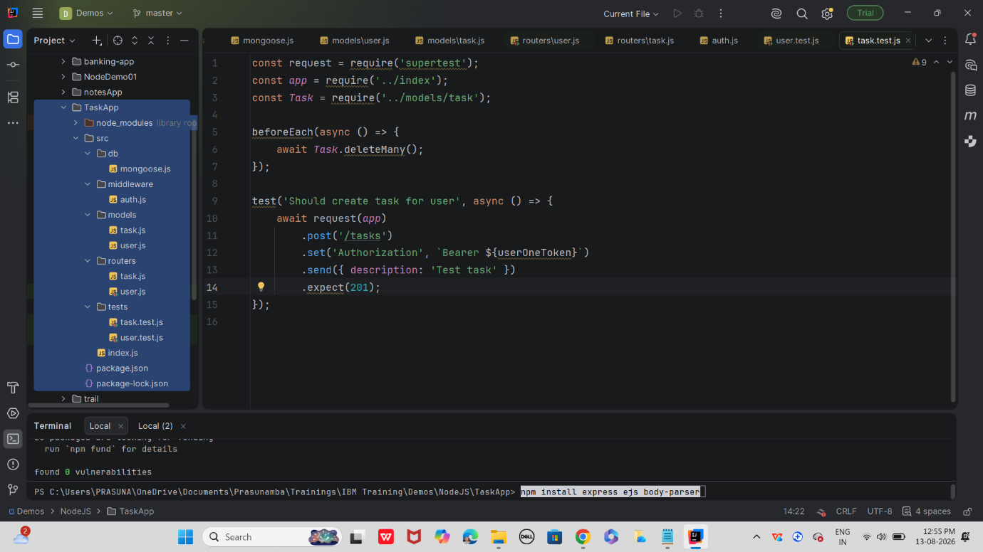

Install dependencies:
In bash
npm install express mongoose bcryptjs jsonwebtoken jest supertest

Start mongo
Start server.. src/index.js
Run tests.. Npm test

OUTPUT
