HOME TASK
Task 1: What are window functions in PostgreSQL?
Window functions are special functions that perform calculations across a set of rows related to the current row without grouping the data into a single result. They let you compare rows, calculate rankings, running totals, and averages while still displaying individual rows. They work using the OVER() clause.
Task 2: What are the keywords that we use in window functions?
The main keywords used in window functions are OVER(), PARTITION BY, ORDER BY, and ROWS/RANGE. OVER() defines the window, PARTITION BY divides data into groups, and ORDER BY defines the row sequence. ROWS and RANGE help specify the frame of rows used for calculations.
Task 3: What are the types of window functions in PostgreSQL?
Window functions are generally classified into three types: Ranking functions, Aggregate window functions, and Value functions. Ranking functions include RANK() and ROW_NUMBER(), aggregates include SUM() and AVG(), while value functions include LAG(), LEAD(), and FIRST_VALUE().
Task 4: What are the rules while working on window functions?
A window function must always be used with the OVER() clause. They are evaluated after the WHERE, GROUP BY, and HAVING clauses. Window functions can be used in the SELECT and ORDER BY clauses but cannot be directly used in the WHERE clause.
Task 5: Do we have JSON/JSONB data types in PostgreSQL? What is the difference between them?
Yes, PostgreSQL supports both JSON and JSONB data types. JSON stores data as plain text exactly as provided, while JSONB stores data in a binary format after parsing. JSONB offers faster querying, indexing support, and better performance, whereas JSON preserves the original formatting and key order.
Task 6: What is Full-Text Search in PostgreSQL? Explain briefly.
Full-Text Search (FTS) is a feature in PostgreSQL that helps search text efficiently within large amounts of data. It processes text by removing unnecessary words and reducing words to their root forms. This makes searches faster and more accurate than using simple LIKE queries.
Task 7: What do you understand by Full-Text Search in PostgreSQL?
Full-Text Search allows users to find relevant documents or records based on words and phrases. It uses components like tsvector and tsquery to index and search text data efficiently. It is commonly used in applications such as search bars, blogs, and document management systems.
Task 8: What does SAVEPOINT do in PostgreSQL?
A SAVEPOINT creates a checkpoint within a transaction. If an error occurs, you can roll back to the savepoint instead of undoing the entire transaction. This provides better control over transactions and helps preserve successful operations performed before the savepoint.

DAY 14
Task 01:
What do you understand by Git collaboration?
- Git collaboration is the process of multiple developers working together on the same project using Git.It helps team members track changes, share code, and combine their work without overwriting each other's updates.
- By using branches, commits, and pull requests, teams can work efficiently and maintain a well-organized project.
Task 02:
Why is collaboration necessary while working on git?
- Collaboration is necessary in Git because it allows multiple developers to work on the same project at the same time without interfering with each other's work.
- It helps keep track of all changes, making it easier to review, update, and fix code when needed.
- This improves teamwork, reduces errors, and ensures the project is developed efficiently.
Task 03:
What are the commands that we use while collaborating?
- git clone – Copies a remote repository to your local system.
- git pull – Fetches and merges the latest changes from the remote repository.
- git add – Stages changes before committing them.
- git commit -m "message" – Saves your changes with a meaningful message.
- git push – Uploads your committed changes to the remote repository.
- git branch – Creates, lists, or manages branches.
- git checkout or git switch – Switches between branches.
- git merge – Combines changes from one branch into another.
- git fetch – Downloads updates from the remote repository without merging them.
- git status – Shows the current status of your working directory and staged changes.
Task 04:
Can you show the typical work flow while working on Git?
A typical Git workflow looks like this:
- Clone the repository – Copy the project to your local machine using git clone.
- Make changes – Edit the project files as needed.
- Stage the changes – Add modified files using git add.
- Commit the changes – Save your work with git commit -m "Your message".
- Pull the latest updates – Use git pull to get any recent changes from the remote repository.
- Push your branch – Upload your changes using git push.
- Create a Pull Request (PR) – Request that your changes be reviewed and merged into the main branch.
- Review and merge – After approval, your branch is merged into the main project.
Workflow:
git clone → Create Branch → Make Changes → git add → git commit → git pull → git push → Pull Request → Merge
Task 05:
Give some to do practices that we need to follow while working on Git Repo on a daily basis.
Some good practices to follow while working on a Git repository every day:
- Pull the latest changes before starting your work to stay updated.
- Create a separate branch for every new feature or bug fix.
- Commit changes frequently with clear and meaningful commit messages.
- Push your work regularly to avoid losing progress.
- Review your code before creating a pull request.
- Resolve merge conflicts carefully and test your code afterward.
- Keep branches organized by deleting old branches after they are merged.
- Avoid committing sensitive information like passwords, API keys, or personal data.
- Test your changes before pushing them to the remote repository.
- Write descriptive commit messages so teammates can easily understand what was changed.
TYPESCRIPT
- DEMO_TYPESCRIPT
let message : string ='Hello';
console.log(message)
function sum( a:number, b:number): number{
return a+b;
}
console.log(sum(10,30));

Task 06:
Create a demo typescript file and execute it
let message : string ='Hello';
console.log(message)
function sum( a:number, b:number): number{
return a+b;
}
console.log(sum(20,30));
function greet(msg:string): string{
return msg;
}
console.log(greet("Good Morning"));

Task 7:
Create an interface and try it out?
interface User {
id: number;
name: string;
email: string;
isActive: boolean;
}
let user: User = {id: 1, name: "Monika", email: "monika@example.com", isActive: true,};

Task 08:
In the above code use optional variable ?
interface User {
id: number;
name: string;
email?: string;
isActive: boolean;
}
let user: User = {id: 1, name: "Monika", email: "monika@example.com",isActive: true,};
let user1: User = {id: 2, name: "Likitha", isActive: false,};
console.log(user);
console.log(user1);

Task 09:
Create a demo with constructor, default and with parameterised..
- parameterised
class Employee {
id: number;
name: string;
constructor(id: number, name: string) {
this.id = id;
this.name = name;
}
}
const emp = new Employee(101, "Monika");
console.log(emp.id); // 101
console.log(emp.name); // Monika

- Default
// Default Constructor Example
class Student {
id: number;name: string;
constructor() {
this.id = 0;
this.name = "Default Student";
}
display(): void {
console.log("ID:", this.id);
console.log("Name:", this.name);
}
}
const student1 = new Student();
console.log("Default Constructor Output:");
student1.display();

Task 10:
What are primitive and special data types in typescript?
- Primitive data types
These represent single, basic values.
Type | Description | Example
string | Text values | "Hello"
number | Integers and floating-point numbers | 42, 3.14
boolean | true or false | true
bigint | Very large integers | 12345678901234567890n
symbol | Unique identifiers | Symbol("id")
null | Intentional absence of a value | null
undefined | Variable declared but not assigned | undefined

let name1: string = "Alice";
let age: number = 25;
let isStudent: boolean = true;
let salary: bigint = 9007199254740992n;
let id: symbol = Symbol("id");
let value: undefined = undefined;
console.log(name1, age, isStudent,salary,value);

- Special data type
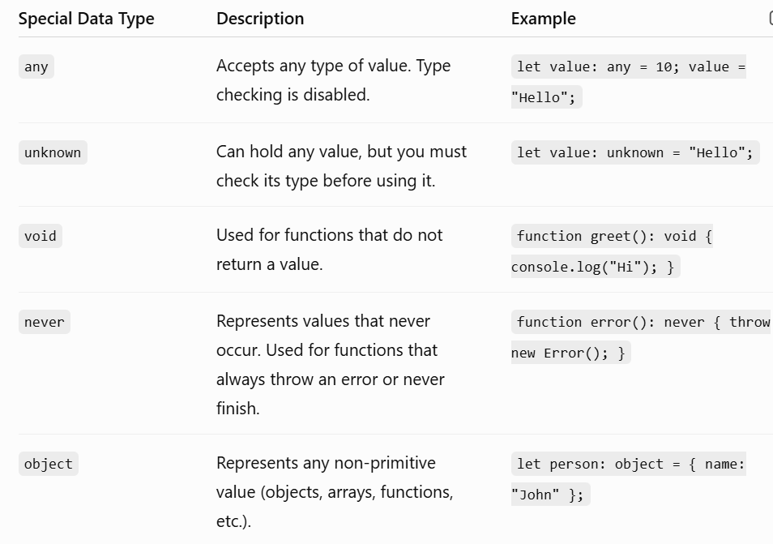
Task 11:
Create a class with access modifiers.
class Employee {
public id: number; // Accessible from anywhere
public name: string; // Accessible from anywhere
private salary: number; // Accessible only within this class
protected department: string; // Accessible within this class and its subclasses
constructor(
id: number,
name: string,
salary: number,
department: string
) {
this.id = id;
this.name = name;
this.salary = salary;
this.department = department;
}
public displayDetails(): void {
console.log("ID:", this.id);
console.log("Name:", this.name);
console.log("Salary:", this.salary);
console.log("Department:", this.department);
}
}
const emp = new Employee(101, "Monika", 50000, "IT");
console.log(emp.id); // 101
console.log(emp.name); // Monika
emp.displayDetails();

Task 12:
To create a typescript file and run it… what are the steps … that we need to follow.. (lets suppose if I am creating ts file for the first time in my sys).
Steps to Create and Run a TypeScript File
- Install Node.js on your system.
- Verify Node.js and npm installation using:
  - node -v
  - npm -v
- Install TypeScript globally:
  - npm install -g typescript
- Verify TypeScript installation:
  - tsc -v
- Create a project folder.
- Create a TypeScript file with the .ts extension (e.g., index.ts).
- Write the TypeScript code in the file.
- Compile the TypeScript file:
  - tsc index.ts
- A JavaScript file (index.js) will be generated automatically.
- Run the generated JavaScript file using Node.js:
  - node index.js
- View the output in the terminal/command prompt.
Task 13:
Create a demo and see how generics work in ts.
//Generic Function
function display<T>(value: T): T {
return value;
}
console.log(display<number>(100));
console.log(display<string>("Monika"));
console.log(display<boolean>(true));

Task 14:
What are type annotations in typescript?
- Type annotations in TypeScript are used to explicitly specify the type of a variable, function parameter, or object property. This helps catch errors early, improves code readability, and ensures type safety.
let name: string = "Monika";
let age: number = 22;
let isActive: boolean = true;
console.log(name);
console.log(age);
console.log(isActive);

Task 15:
What is the purpose of the any keyword in typescript?
- The any keyword in TypeScript is used to declare a variable that can hold a value of any data type. When a variable is assigned the any type, TypeScript disables type checking for that variable.
function display<T>(value: T): T {
return value;
}
console.log(display<number>(100));
console.log(display<string>("Monika"));
console.log(display<boolean>(true));
console.log(display<any>("vguj67" ));

Task 16:
Can you give an example to show the difference between any and unknown.
any
- The any type allows a variable to store a value of any data type.
- When a variable is declared as any, TypeScript disables type checking for that variable.
- It allows all operations, such as accessing properties, calling methods, and assigning different types of values.
let value1: any = "Hello TypeScript";
console.log(value1.toUpperCase()); // Allowed
value = 100;
console.log(value1.toUpperCase());

Unknown
- The unknown type also allows a variable to store a value of any data type.
- Unlike any, TypeScript does not allow operations on an unknown value without first checking its type.
- Type checking or type assertion is required before accessing properties or calling methods.
let value2: unknown = "Hello TypeScript";
if (typeof value2 === "string") {
console.log(value2.toUpperCase());
}
value2 = 100;

Task 17:
What is the tsconfig.json file used for ?
- The tsconfig.json file is a configuration file used by the TypeScript compiler (tsc). It specifies the compiler options and project settings for a TypeScript application.
Task 18:
Task 18:
Code
banking-app/
├── backend/
│ ├── src/
│ │ ├── index.ts
│ │ ├── routes/
│ │ │ └── accountRoutes.ts
│ │ ├── controllers/
│ │ │ └── accountController.ts
│ │ ├── models/
│ │ │ └── account.ts
│ │ └── services/
│ │ └── accountService.ts
└── frontend/
└── Angular project (ng new banking-ui)

- Index.ts

import { getAccount, deposit, withdraw } from "./services/accountService";

console.log("Initial Account:");
console.log(getAccount());

console.log("After Deposit:");
console.log(deposit(101, 1000));

console.log("After Withdraw:");
console.log(withdraw(101, 5000));

accountservice.ts
import type { Account } from "../models/account";

let account: Account = {
id: 101,
accountHolderName: "Monika",
accountNumber: "ACC1001",
balance: 50000
};

export function getAccount(): Account {
return account;
}

export function getAccounts(): Account[] {
return [account];
}

export function deposit(id: number, amount: number): Account | undefined {
if (id !== account.id) {
return undefined;
}

account.balance += amount;
return account;
}

export function withdraw(id: number, amount: number): Account | undefined {
if (id !== account.id) {
return undefined;
}

if (amount > account.balance) {
return undefined;
}

account.balance -= amount;
return account;
}

accountController.ts
import { Request, Response } from "express";
import * as accountService from "../services/accountService";

export const getAllAccounts = (_req: Request, res: Response) => {
res.json(accountService.getAccounts());
};

export const depositAmount = (req: Request, res: Response) => {
const { id, amount } = req.body;
const account = accountService.deposit(id, amount);
account ? res.json(account) : res.status(404).send("Account not found");
};

export const withdrawAmount = (req: Request, res: Response) => {
const { id, amount } = req.body;
const account = accountService.withdraw(id, amount);
account ? res.json(account) : res.status(400).send("Insufficient funds");
};

accountRouter.ts
import { Router } from "express";
import { getAllAccounts, depositAmount, withdrawAmount } from "../controllers/accountController";

const router = Router();

router.get("/", getAllAccounts);
router.post("/deposit", depositAmount);
router.post("/withdraw", withdrawAmount);

export default router;

OUTPUT
