Day 33 - 31st Aug 2026

VPC done by all — task 8
Cli based AWS task 9 —> still pending
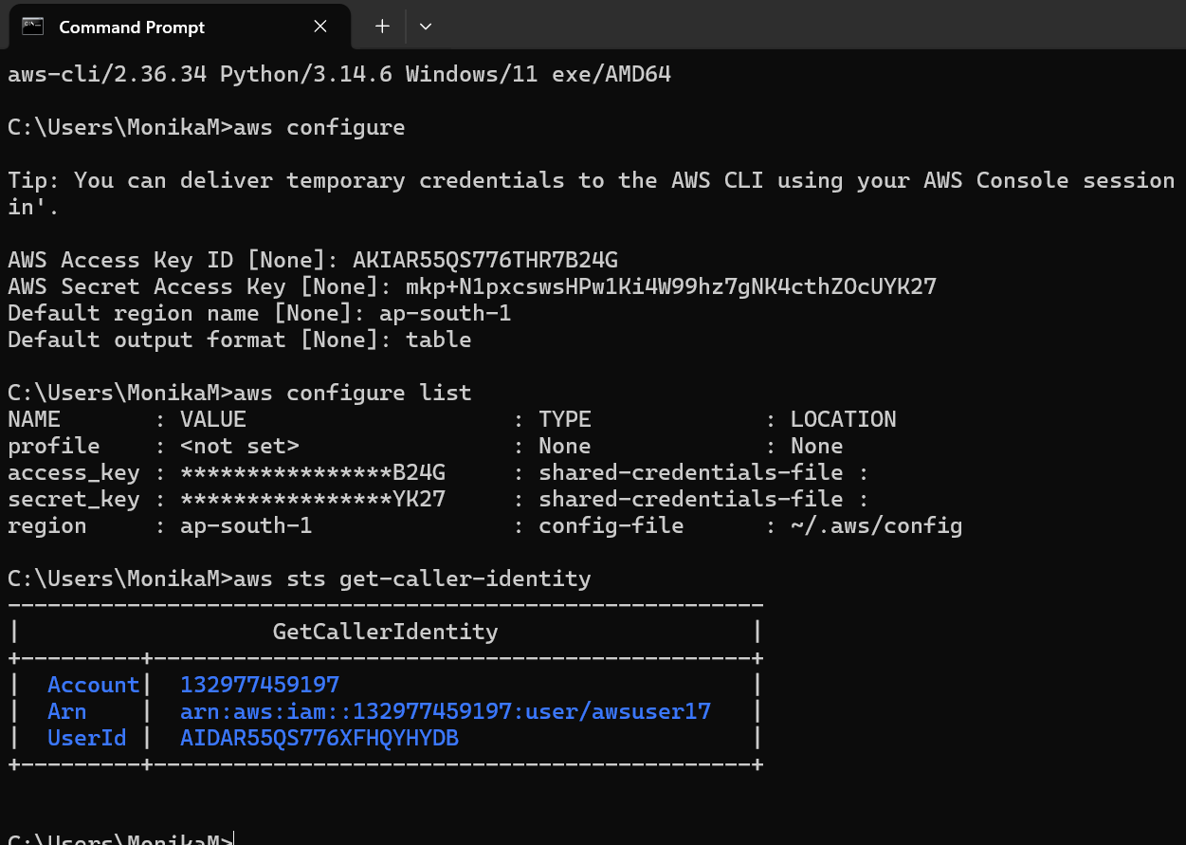

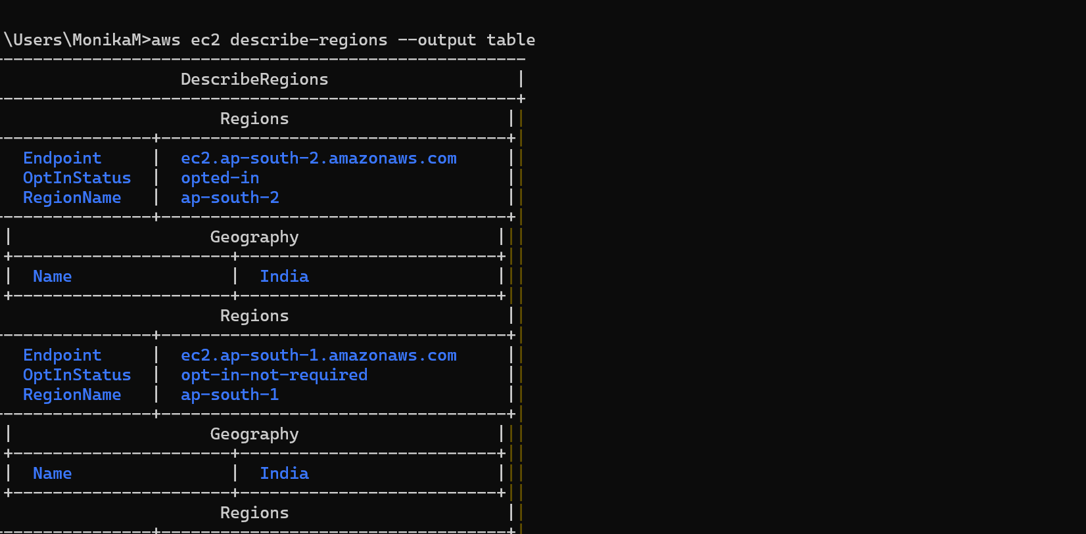
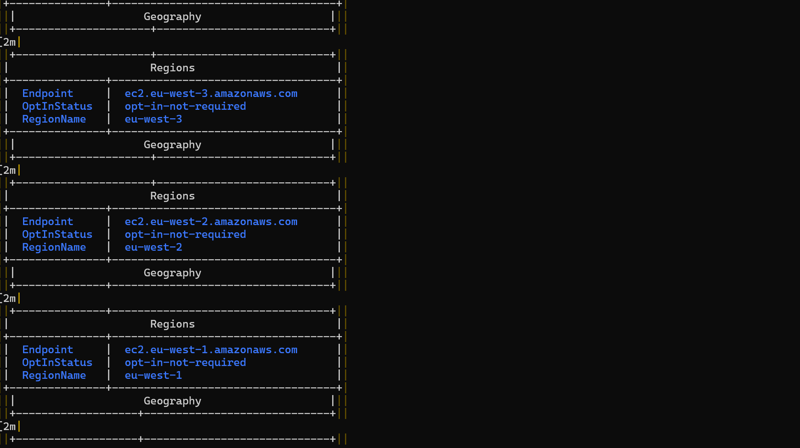
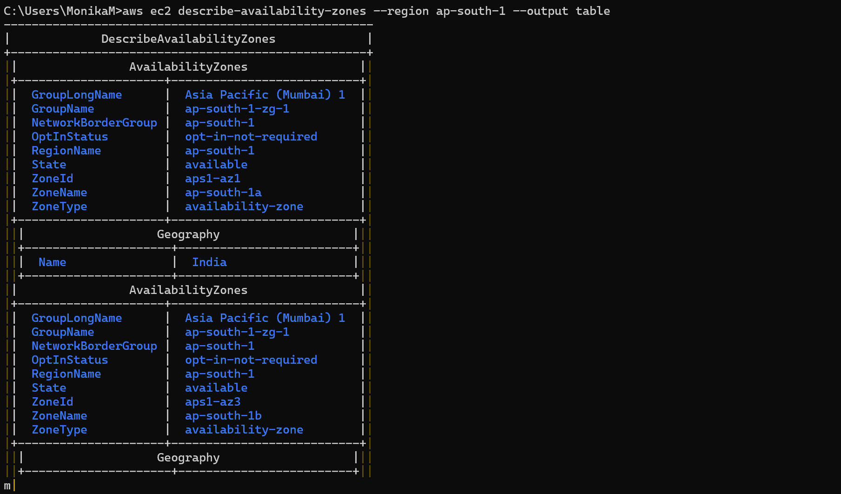
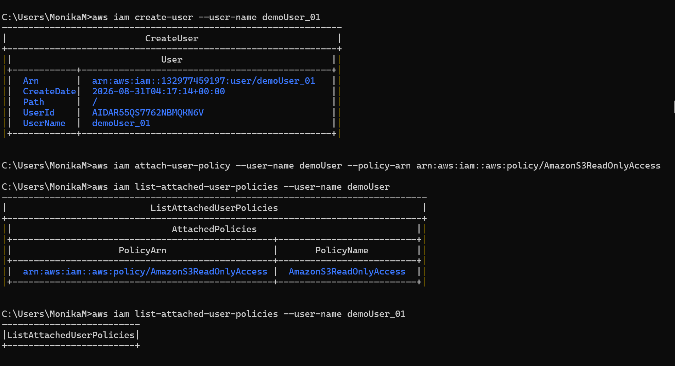
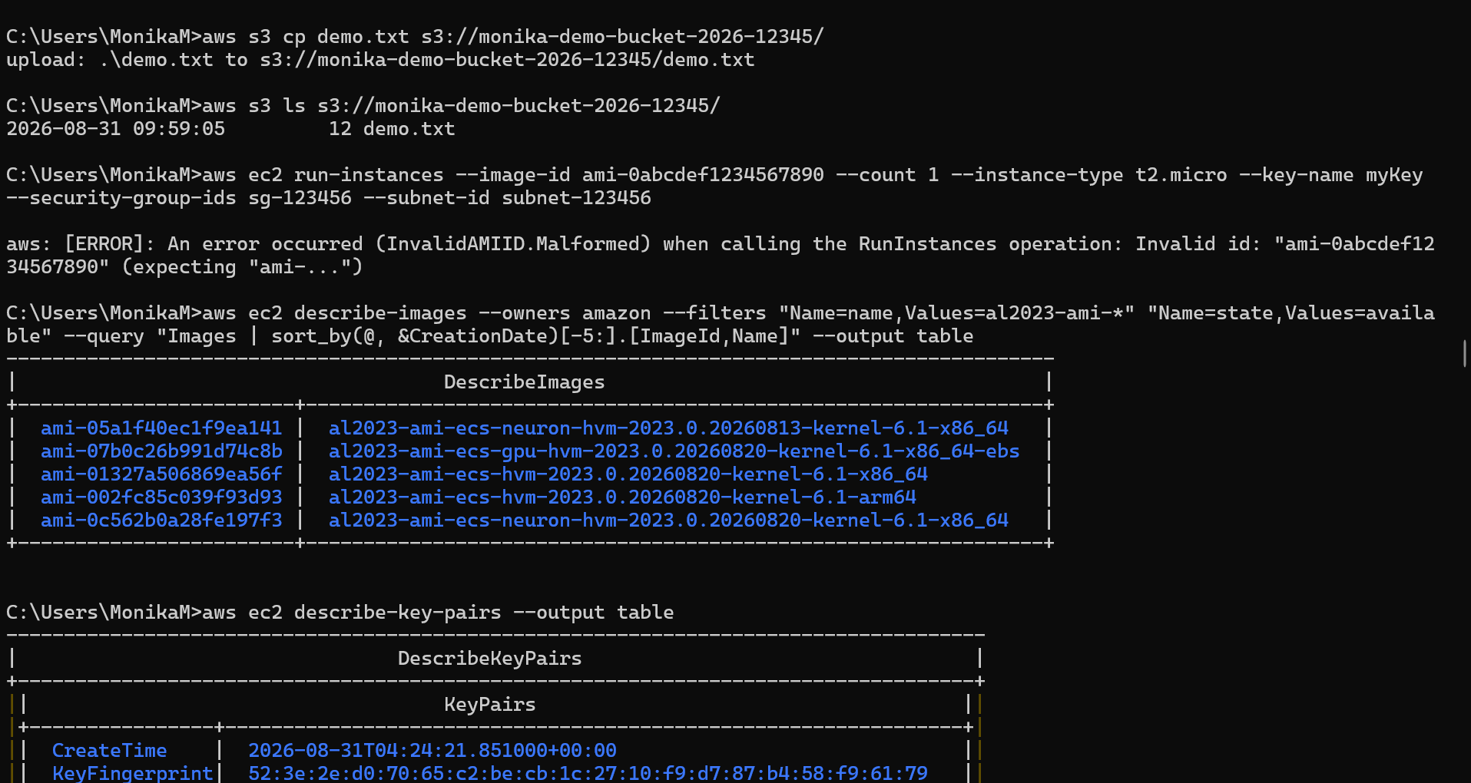

Task 1:

Amazon RDS (Relational Database Service) – a managed database instance (like MySQL) on AWS, connect to it, and test it.
Step 01:
Open RDS Service
RDS is AWS’s managed database service for MySQL, PostgreSQL, Oracle, SQL Server, and MariaDB.
AWS Console → Services → RDS
- Log in to AWS Console
- In the search bar, type RDS
- Click RDS to open the dashboard
Step 02:
Create Database Instance
Beginner Setup
You’ll launch a new managed database with free-tier options.
RDS Dashboard → Create database
- Choose Standard create
- Select MySQL (or PostgreSQL)
- Pick Free tier template
- Enter DB instance identifier (e.g., mydb-demo)
03
Configure Credentials
Set up the master username and password for database access.
- Enter Master username (e.g., admin)
- Enter a strong password
- Note these credentials — you’ll need them later
04
Choose Instance Size
Pick a small instance type suitable for beginners.
- Select db.t3.micro (free tier eligible)
- Keep storage defaults (20 GB)
- Disable autoscaling for demo
05
Set Connectivity
Configure how your database can be accessed.
- Select Default VPC
- Choose Public access → Yes (for demo)
- Pick or create a Security Group
- Add inbound rule: MySQL/Aurora (Port 3306) from your IP
06
Launch Database
AWS will now provision your managed DB instance.
- Click Create database
- Wait 5–10 minutes until status shows Available
07
Connect via EC2 or Local Client
Use the endpoint provided by RDS to connect.
- Copy the Endpoint from RDS instance details
- From EC2 or local MySQL client, run:
bash
mysql -h <endpoint> -u admin -p

- Enter password → you’re inside the DB
08
Test Database
Verify that your database is working.
- Run SHOW DATABASES;
- Create a sample DB: CREATE DATABASE demo;
- Confirm with SHOW DATABASES;
Now we created a managed MySQL database on AWS RDS, connected to it, and tested it with basic SQL commands. The beauty of RDS is that AWS handles backups, patching, and scaling for you — so you focus on using the database, not maintaining servers
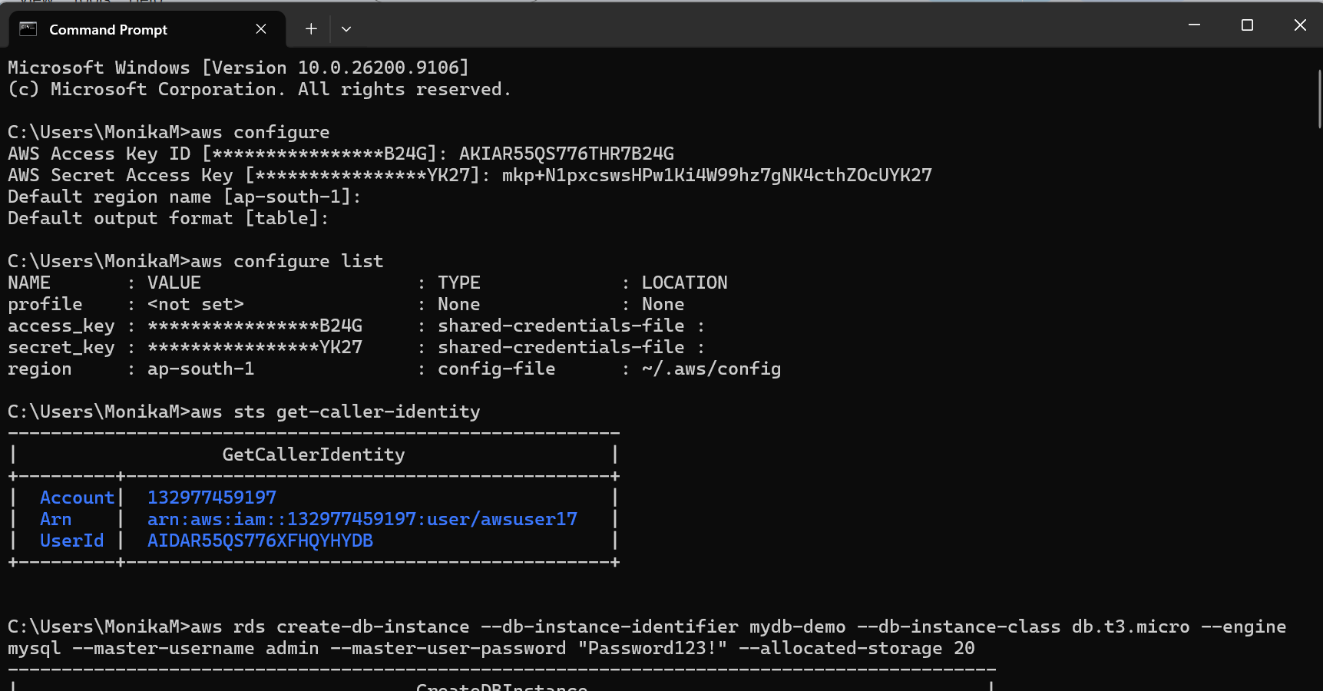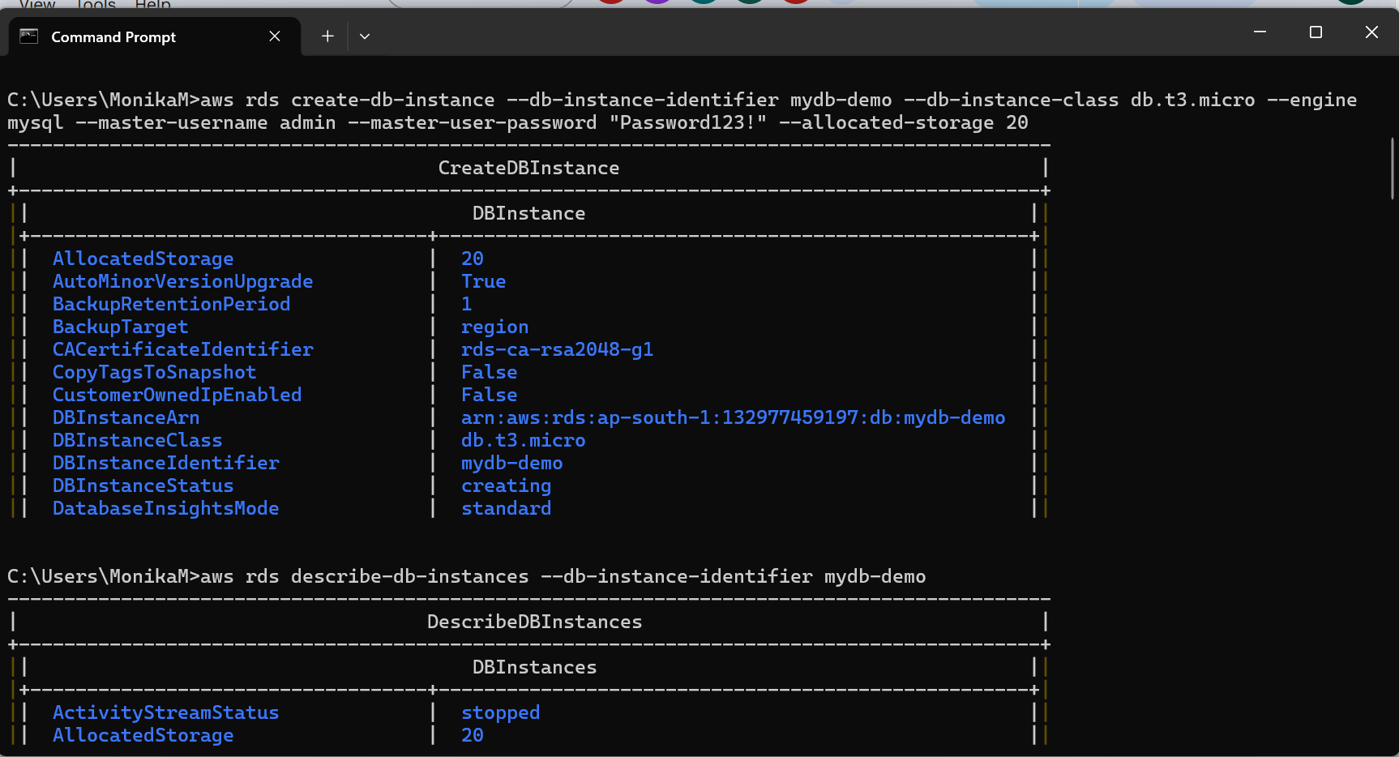
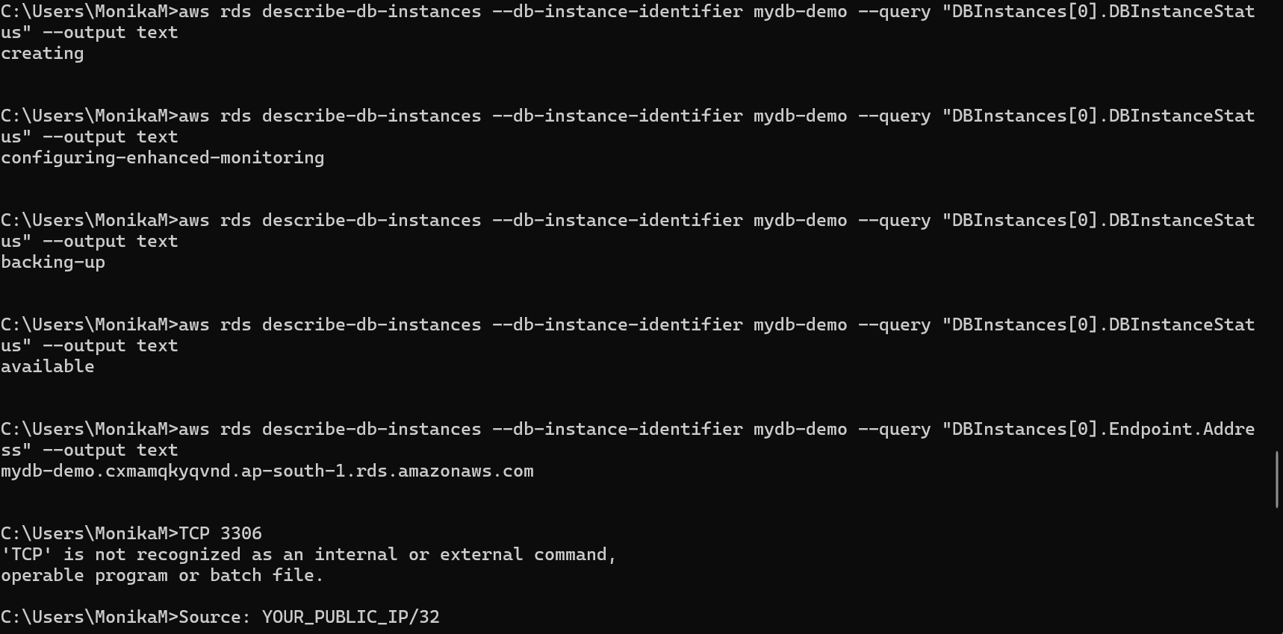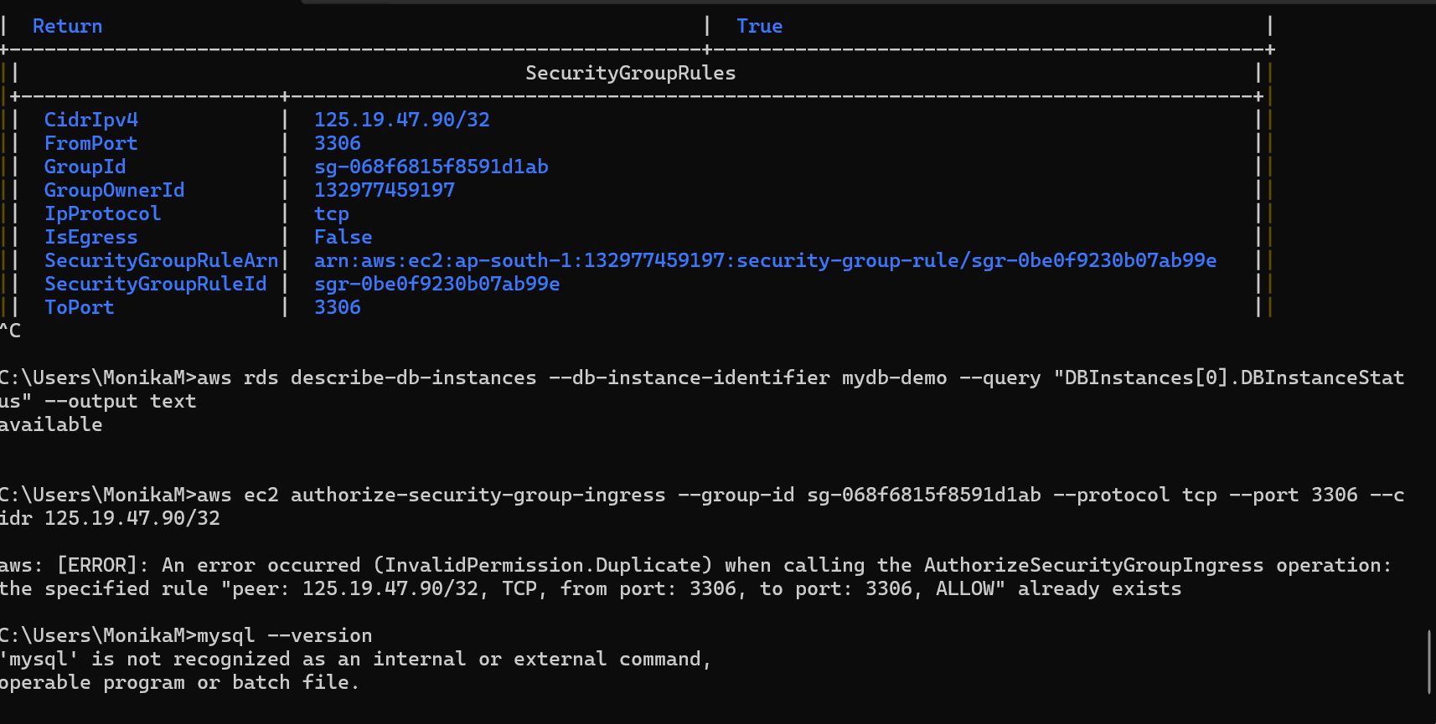
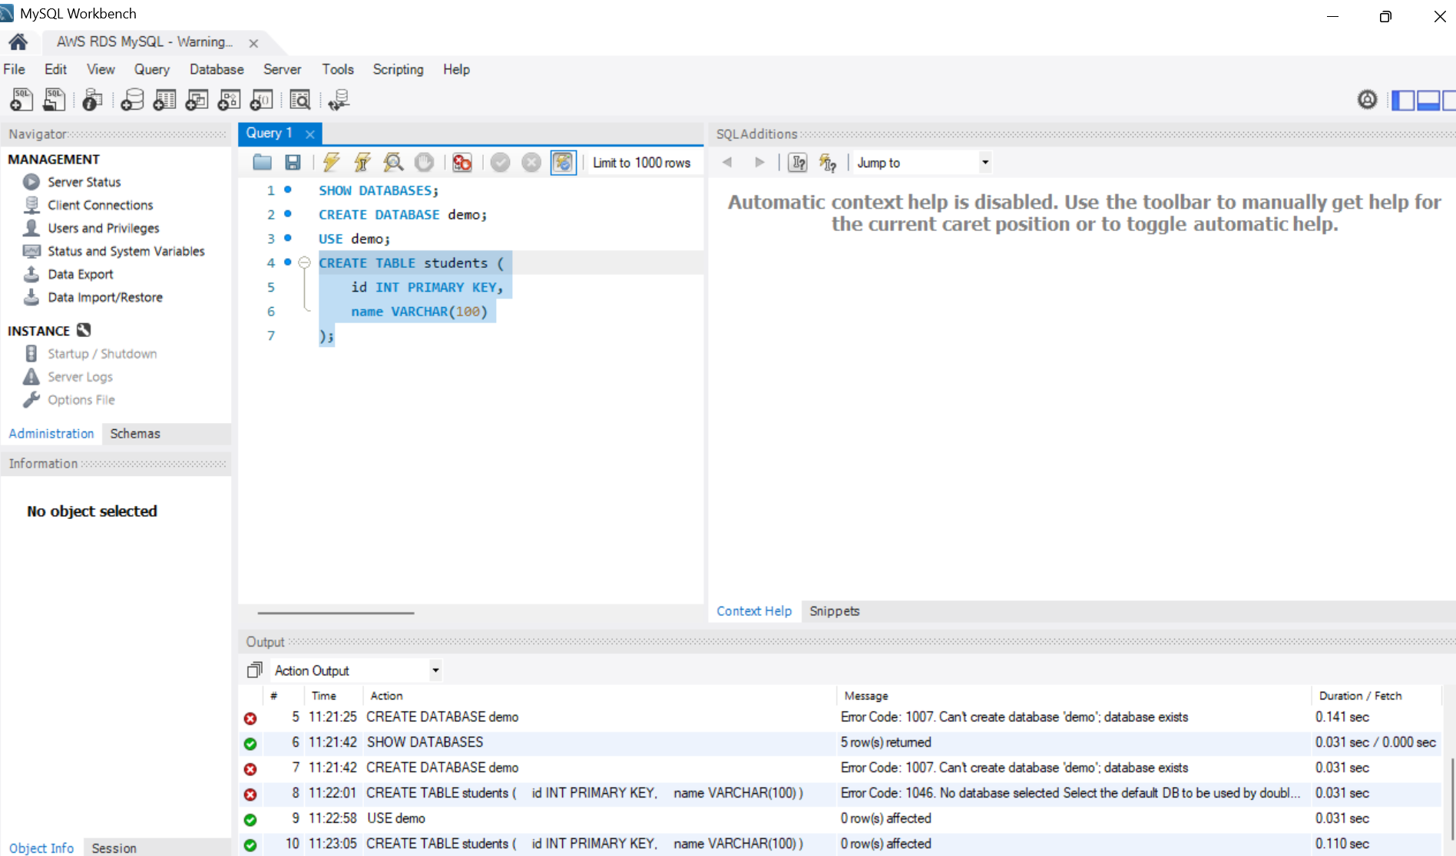
Task 02:
Once done with RDS above Tsk 1.. Connect spring boot application that you have created with the DB .. using cloud
Steps for your reference are give at the end..of this doc
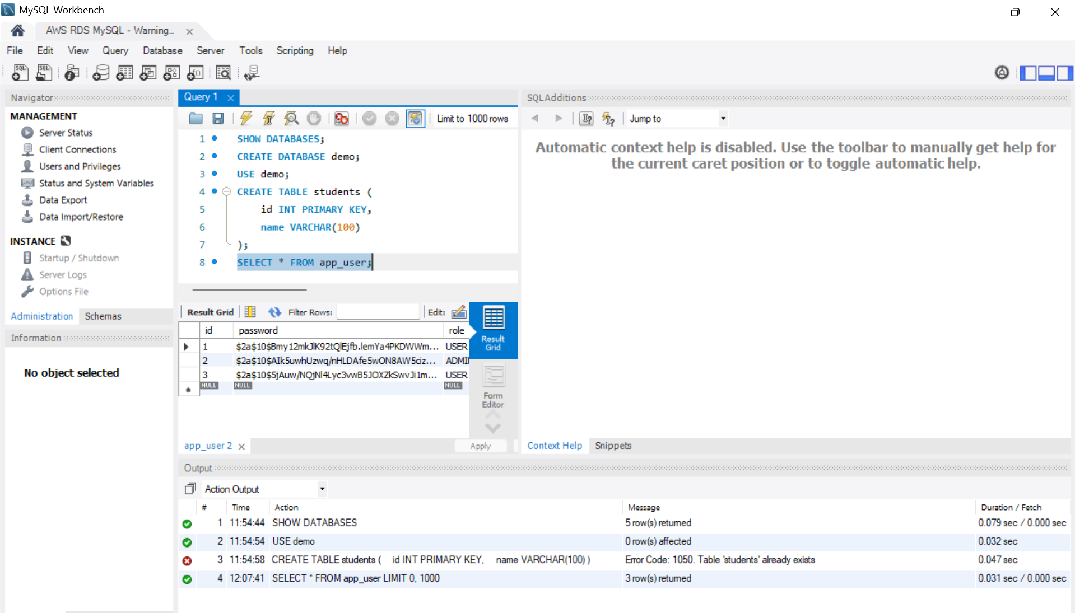
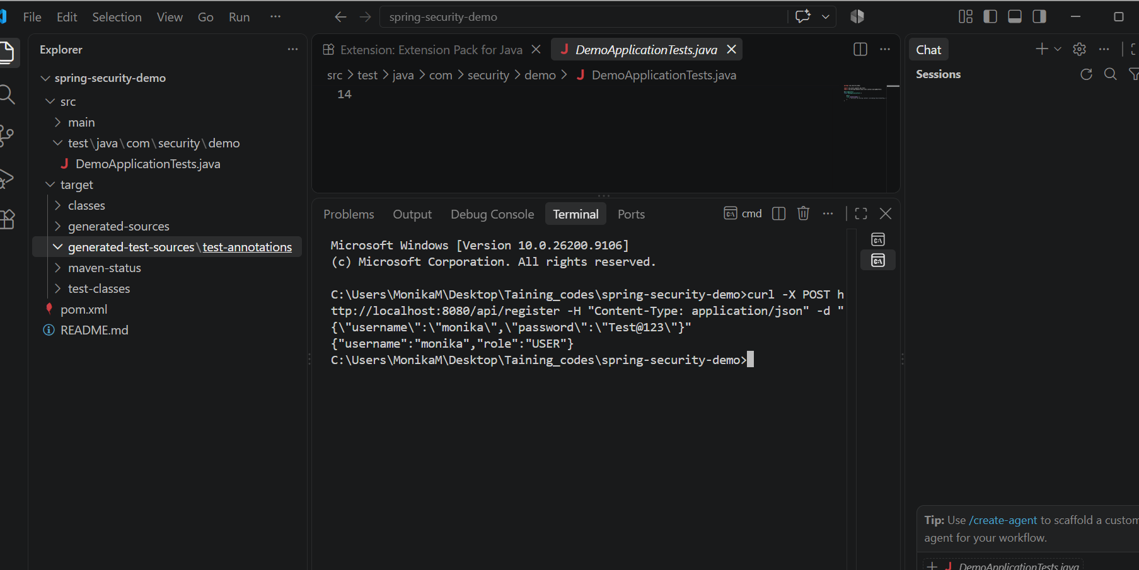
Task 03:
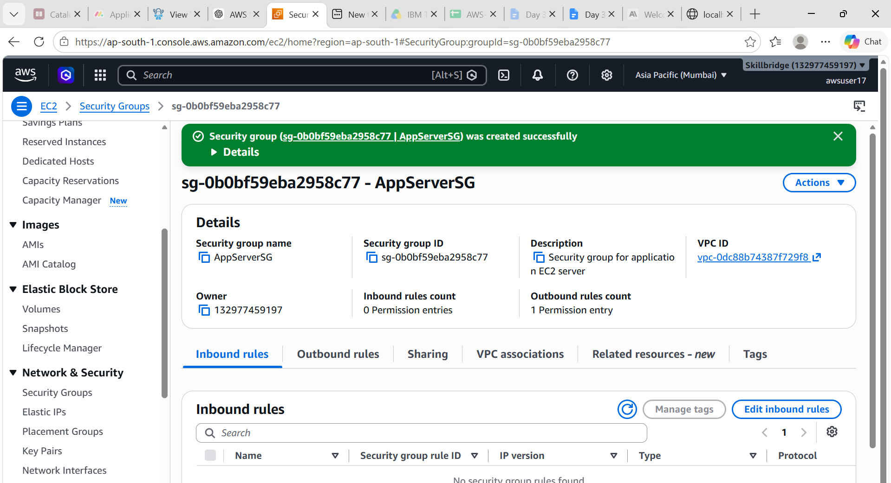

Task 04:

Now lets create a project Terraform

Terraform-aws-demo
Project structure
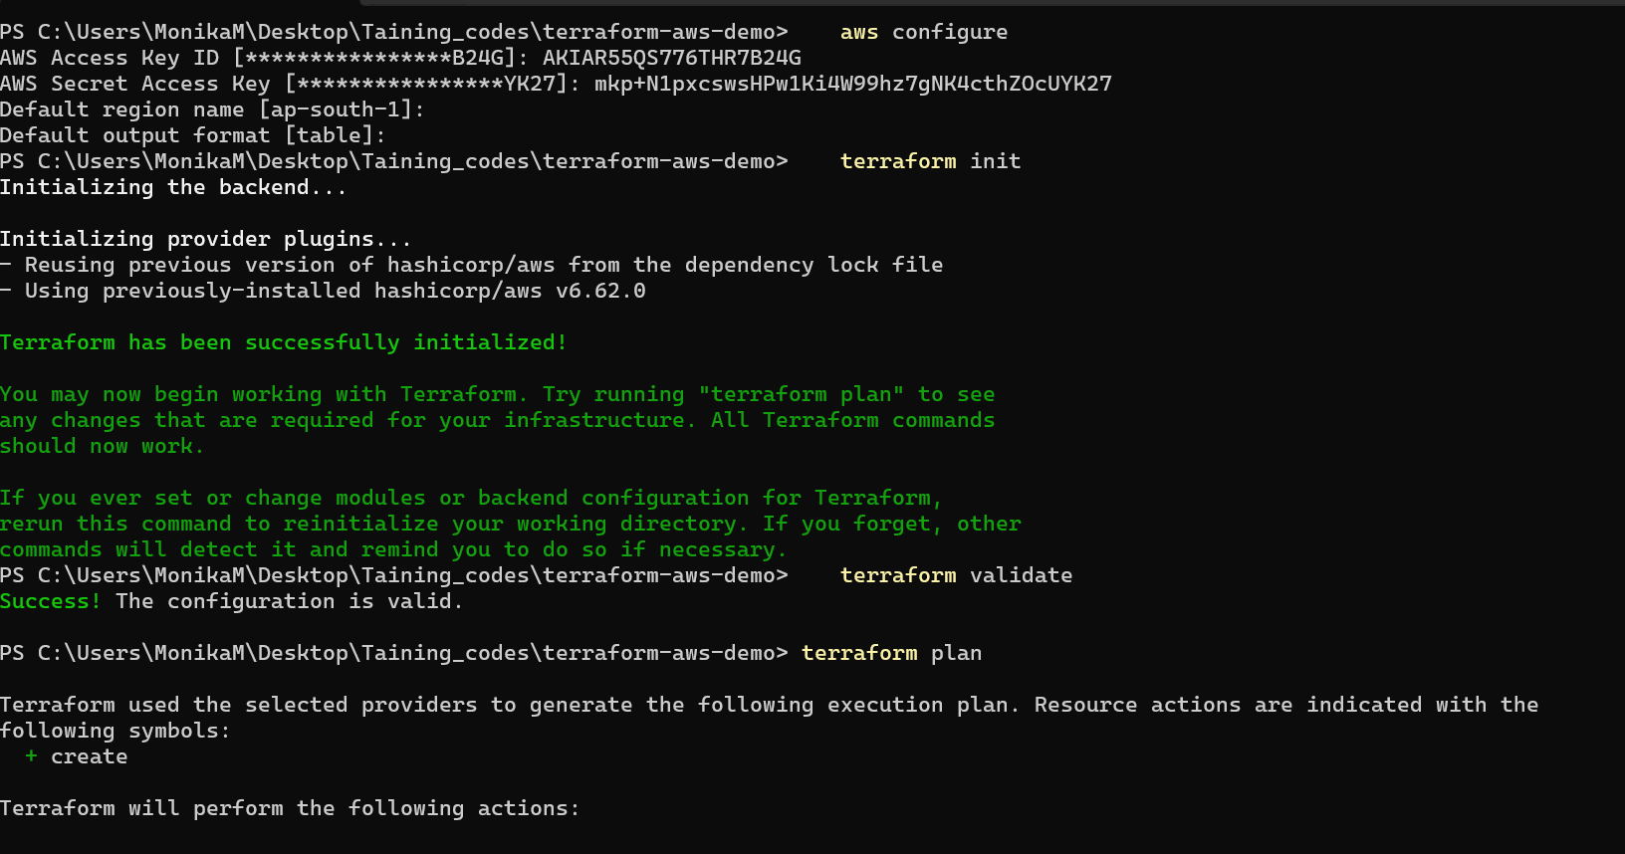
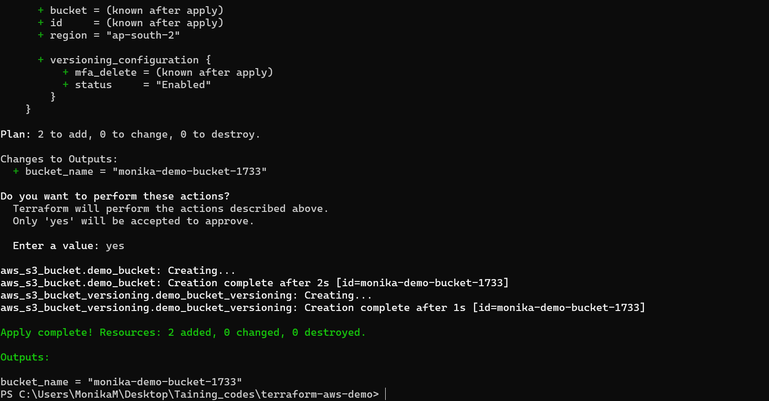
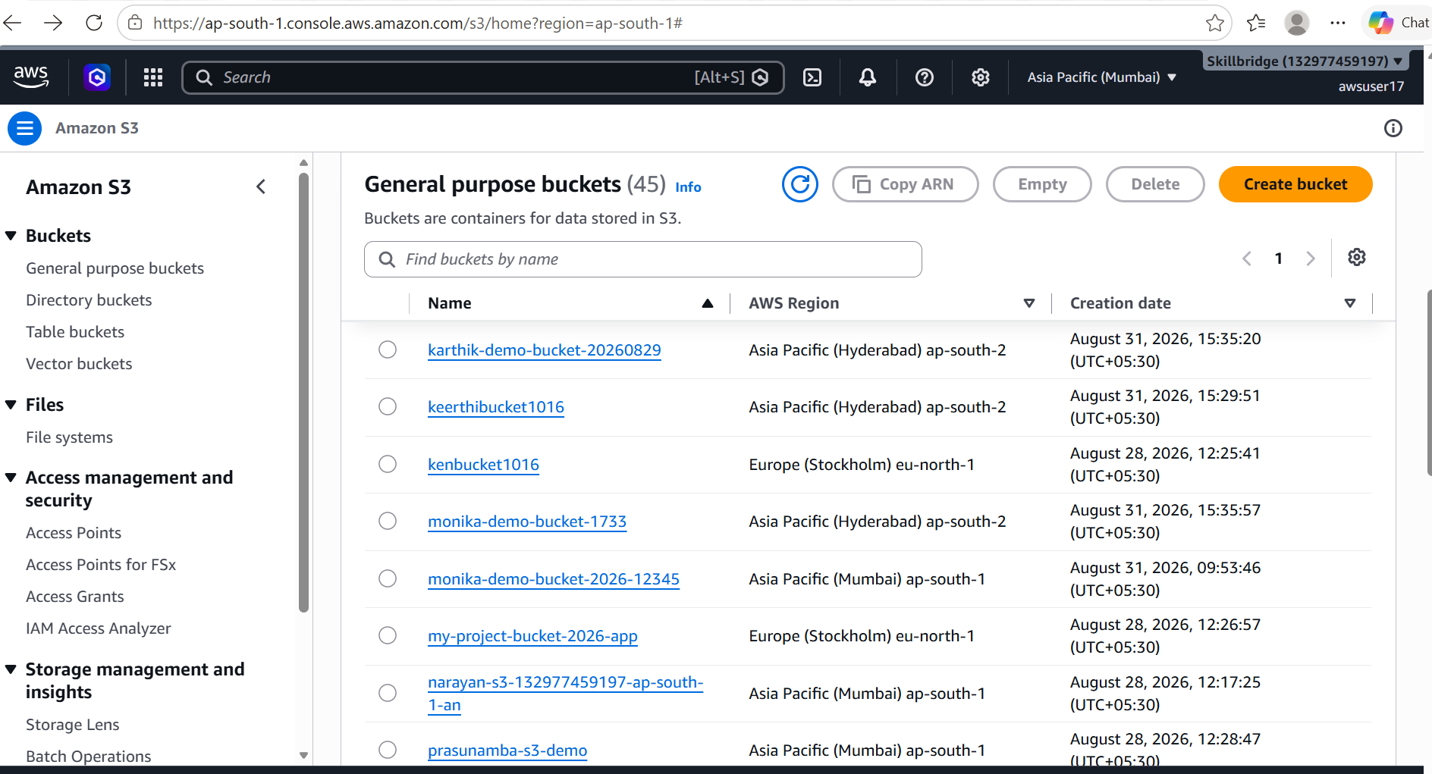

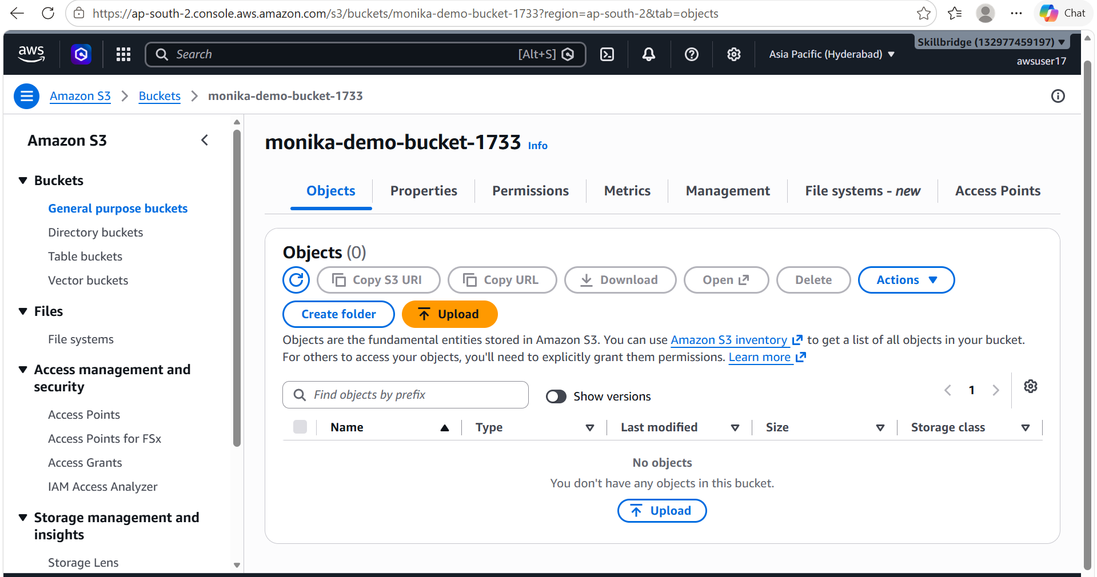

Task 5:
Next is adding Data Sources → aws_caller_identity.current, aws_region.current
In continuation with above project
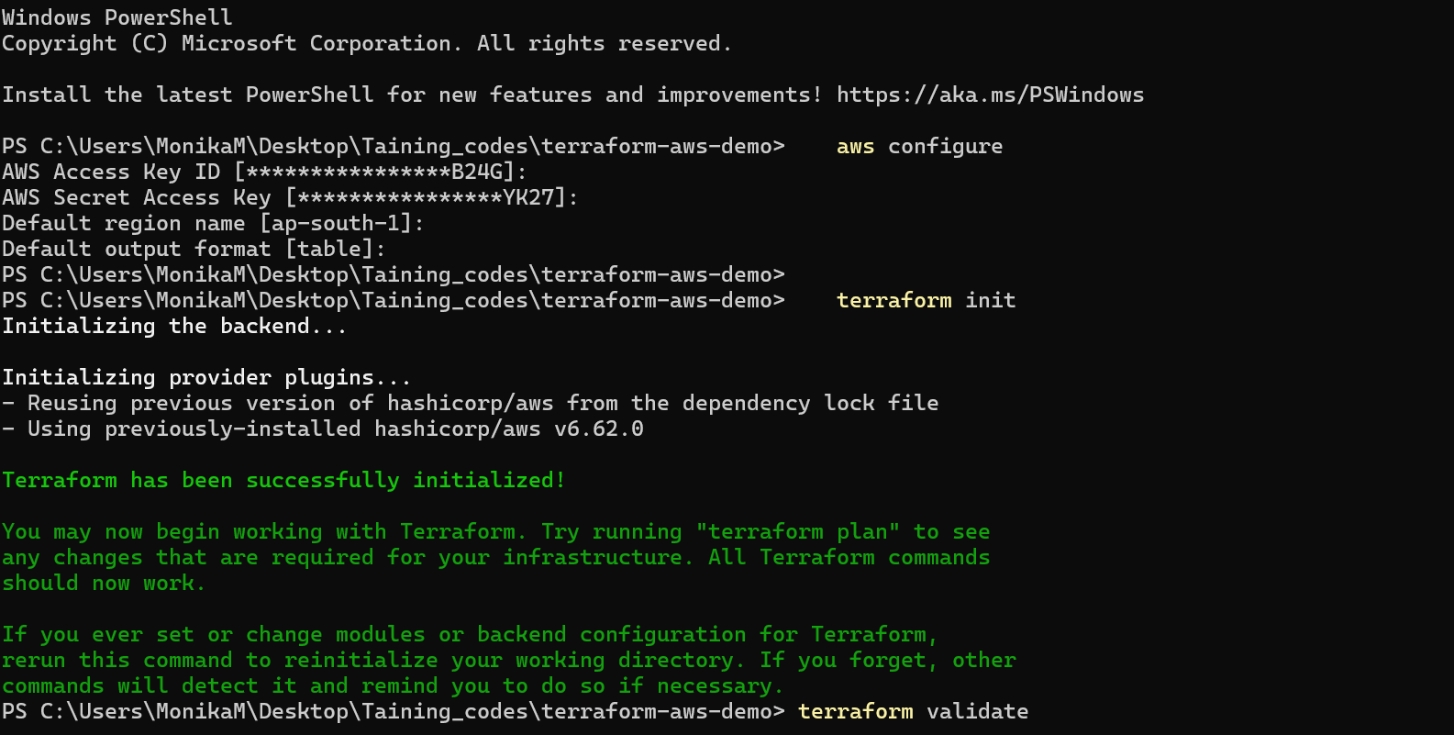
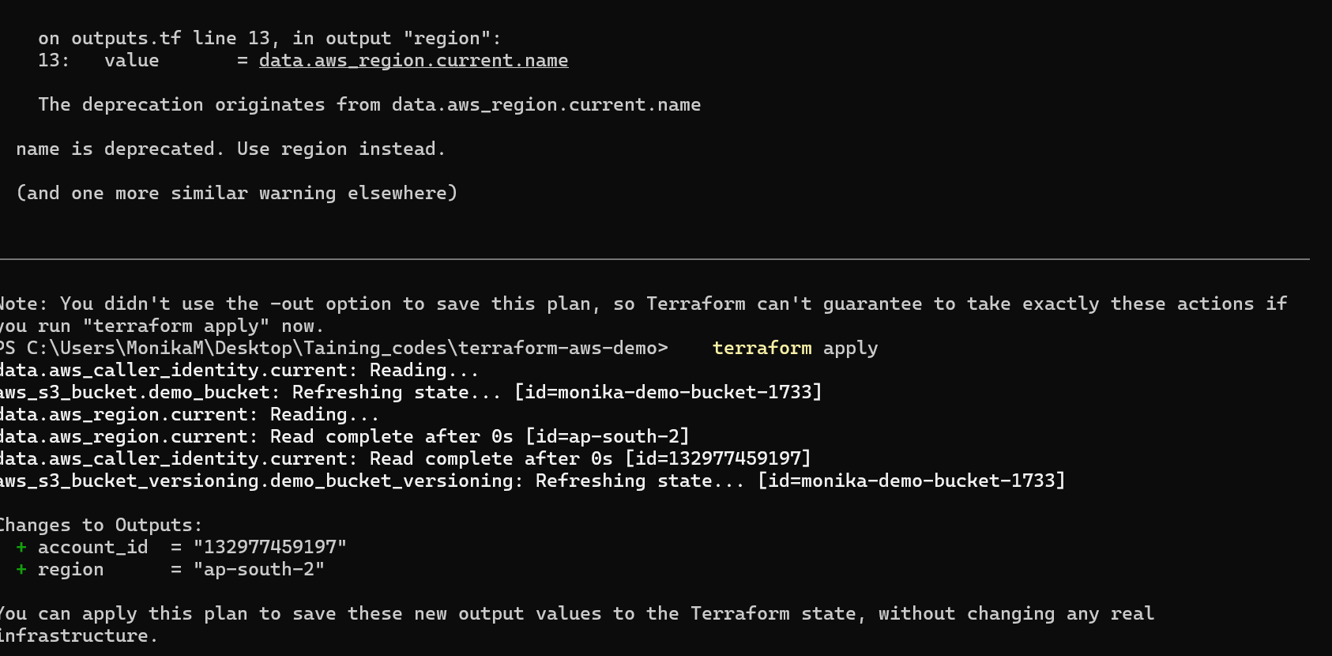
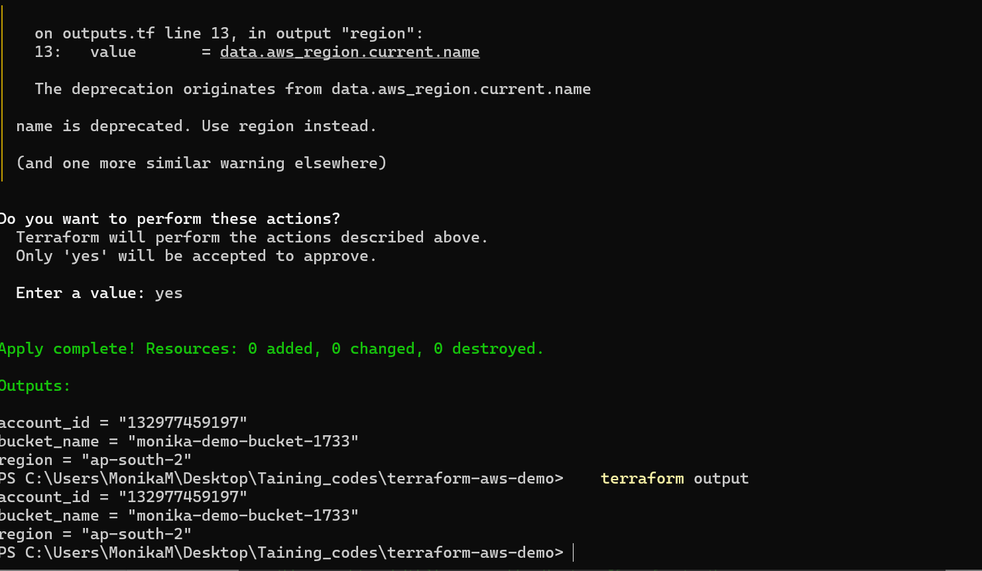
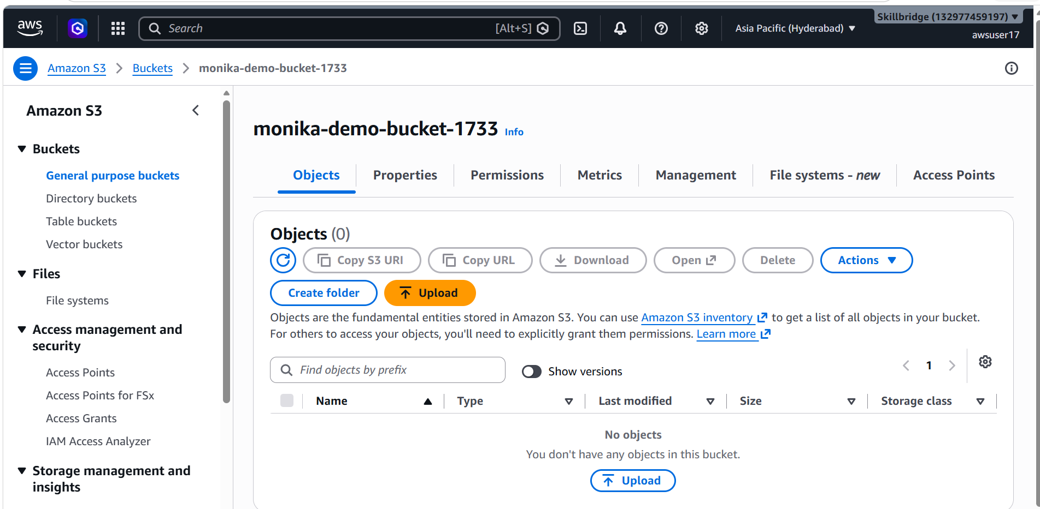j

