Day 24 - 18th Aug 2026
ORM Concepts and JPA
1.How does ORM bridge OOP and relational databases, and what role does JPA play?
ORM maps Java objects to database tables automatically, so a class becomes a table, its fields become columns, and object references become foreign keys. This lets developers work with objects and method calls instead of writing raw SQL for every operation.
JPA (Java Persistence API) is the standard specification for how this mapping should work in Java — it defines annotations like @Entity, @Id, @OneToMany, and a query language (JPQL). JPA itself doesn't do anything; it needs an implementation (like Hibernate) to actually execute the mapping and talk to the database.

Hibernate Fundamentals
2. Why is Hibernate a powerful JPA implementation, and how does caching help performance?
Hibernate is powerful because it handles the heavy lifting of JPA — SQL generation, dirty checking, lazy loading, and transaction management — while adding its own extra features beyond the JPA spec.
Its caching mechanism boosts performance in two layers:
- First-level cache (built-in, per-session): avoids hitting the DB twice for the same entity within one persistence context.
- Second-level cache (optional, e.g., Ehcache/Redis): shared across sessions, so frequently accessed data doesn't require repeated DB round-trips at all.
This reduces database load significantly in read-heavy applications.

3. Entity Mapping and Relationships (1:1, 1:N, N:M)
Q: How do different relationships affect database design and query complexity?
- One-to-One: Simple, usually a foreign key in one table (e.g., User ↔ Profile). Low query complexity.
- One-to-Many: Foreign key lives on the "many" side (e.g., Author → Books). Common source of the N+1 problem if not fetched carefully.
- Many-to-Many: Requires a join table to store the relationship. Adds complexity in queries and can bloat result sets if not managed with proper fetch strategies.
The more complex the relationship, the more careful you need to be with fetch types and join strategies to avoid performance issues.

JPQL, Criteria API, and Native Queries
4. Trade-offs between JPQL, Criteria API, and Native SQL?
Approach | Readability | Flexibility | Performance
JPQL | High (SQL-like, entity-based) | Good for most use cases | Good, DB-independent
Criteria API | Lower (verbose, programmatic) | Best for dynamic queries built at runtime | Similar to JPQL
Native SQL | Depends on SQL skill | Full DB-specific power (window functions, hints) | Can be fastest, but breaks DB portability
Rule of thumb: Use JPQL for standard queries, Criteria API when query conditions are built dynamically in code, and Native SQL only when you need DB-specific optimizations.

Spring Data JPA Repositories
5. How does Spring Data JPA simplify repositories, and what are the risks of derived query methods?
Spring Data JPA eliminates boilerplate — you just declare an interface like findByEmail(String email) and Spring auto-generates the implementation and SQL behind the scenes.
Risks of derived query methods:
- Method names get long and hard to read for complex conditions (findByNameAndAgeGreaterThanAndCityIn(...))
- Harder to debug what SQL is actually generated
- Not suitable for complex joins or aggregations — you'll need @Query (JPQL) or native queries instead
- Easy to accidentally trigger N+1 queries without noticing
6. LazyInitializationException if accessed outside transaction — during lazy or eager?
This exception occurs only during LAZY loading, never eager.
Reason:
- Lazy fields are loaded via a proxy — the actual SQL query fires only when the field is first accessed (e.g., .getBooks().size()).
- This requires an active Hibernate session. If the transaction has already closed by the time the field is accessed, there's no session left to run the query.
- Result: LazyInitializationException: could not initialize proxy - no Session
With EAGER loading, this never occurs — related data is fetched immediately while the session is still open, so nothing needs to be loaded later.
Common triggers:
- Accessing a lazy collection in the view layer after the transactional service method has returned
- Serializing an entity to JSON in a REST response after the session has closed
Fix (preferred over switching to EAGER):
- Use JOIN FETCH in JPQL for that specific query
- Use an Entity Graph to specify associations to load upfront
- Access the lazy field before the transaction ends

Transactions and Persistence Context
7. Why is the persistence context crucial, and how does it ensure consistency?
The persistence context is essentially a first-level cache and unit-of-work tracker — it keeps track of every entity loaded or modified during a transaction.
It ensures consistency by:
- Applying dirty checking: automatically detecting changed entities and syncing them to the DB at commit time
- Guaranteeing all changes within a transaction commit together (atomicity) or roll back together
- Avoiding duplicate DB reads for the same entity within one transaction
Without it, you'd have to manually track and flush every change — much more error-prone.

Lazy vs. Eager Loading and the N+1 Problem
8. How do lazy/eager loading affect performance, and why does N+1 happen?
- Lazy loading defers fetching related data until it's accessed — saves memory/queries if the data isn't always needed.
- Eager loading fetches everything upfront — safer but can pull unnecessary data.
N+1 problem: happens when you fetch a list of N parent entities (1 query), then lazily access a related collection/field on each one — triggering N additional queries. Example: loading 100 authors, then calling .getBooks() on each triggers 1 + 100 queries instead of a single optimized join.
Fix: use JOIN FETCH in JPQL, Entity Graphs, or batch fetching to load related data in one go.

Introduction to Database Schema Versioning
9. Why is schema versioning important, and how does it support CI/CD?
As applications evolve, database schemas change (new columns, tables, constraints). Schema versioning tracks these changes systematically, the same way Git tracks code changes.
This matters for CI/CD because it lets teams:
- Apply schema changes automatically and consistently across dev, staging, and production
- Roll back safely if a deployment fails
- Avoid manual, error-prone DB updates that cause environment drift

Flyway: Versioned and Repeatable Migrations
10. Difference between versioned and repeatable migrations in Flyway, and when to use each?
- Versioned migrations (V1__init.sql, V2__add_column.sql): run once, in strict numbered order, and are tracked permanently. Used for structural changes — creating tables, adding columns, altering constraints.
- Repeatable migrations (R__update_view.sql): re-run every time their checksum changes, regardless of version order. Used for things like views, stored procedures, or seed data that might need frequent updates.
Use versioned for schema structure changes; use repeatable for things you expect to redefine often.

Liquibase: Changelogs and Changesets
11. How do Liquibase changelogs and changesets provide flexibility across environments?
A changelog is the master file listing all database changes in order. Each changeset inside it is a single atomic change (e.g., add a column, create an index) with a unique ID and author, tracked individually.
This structure gives flexibility because:
- Changesets can be written in XML, YAML, JSON, or SQL — teams pick what fits their workflow
- Each changeset can include rollback instructions, making reversals safer
- Contexts and labels let you apply different changesets to different environments (e.g., seed data only in dev, not prod)
- Liquibase tracks applied changesets in a DATABASECHANGELOG table, so it knows exactly what's been run where

Task 1:
Step 1:
Open docker – running mode on
Step 2:
Keep redis ready
Step 3:
Pick any of your banking app demo .. to integrate redis in it
application.properties
# ===== H2 Database Config =====
spring.datasource.url=jdbc:h2:mem:customerdb
spring.datasource.driver-class-name=org.h2.Driver
spring.datasource.username=sa
spring.datasource.password=
spring.h2.console.enabled=true
spring.h2.console.path=/h2-console
spring.jpa.database-platform=org.hibernate.dialect.H2Dialect
spring.jpa.hibernate.ddl-auto=update
spring.jpa.show-sql=true
# ===== Redis Config =====
spring.data.redis.host=localhost
spring.data.redis.port=6379
# Enable Redis as cache provider
spring.cache.type=redis
# Optional TTL for cache entries (10 minutes in ms)
spring.cache.redis.time-to-live=600000

CustomerService.java
package com.example;
import org.springframework.beans.factory.annotation.Autowired;
import org.springframework.cache.annotation.CacheEvict;
import org.springframework.cache.annotation.CachePut;
import org.springframework.cache.annotation.Cacheable;
import org.springframework.stereotype.Service;
@Service
public class CustomerService {
@Autowired
private CustomerRepository customerRepository;
// Cache-Aside: First call hits DB, result stored in Redis
@Cacheable(value = "customers", key = "#customerId")
public Customer getCustomerDetails(Long customerId) {
System.out.println("Fetching from DB...");
return customerRepository.findById(customerId)
.orElseThrow(() -> new RuntimeException("Customer not found with id: " + customerId));
}
// Write-Through: Updates DB and Redis simultaneously
@CachePut(value = "customers", key = "#customer.id")
public Customer updateCustomer(Customer customer) {
return customerRepository.save(customer);
}
// Explicit Invalidation: Removes entry from Redis when deleted
@CacheEvict(value = "customers", key = "#customerId")
public void deleteCustomer(Long customerId) {
customerRepository.deleteById(customerId);
}
}

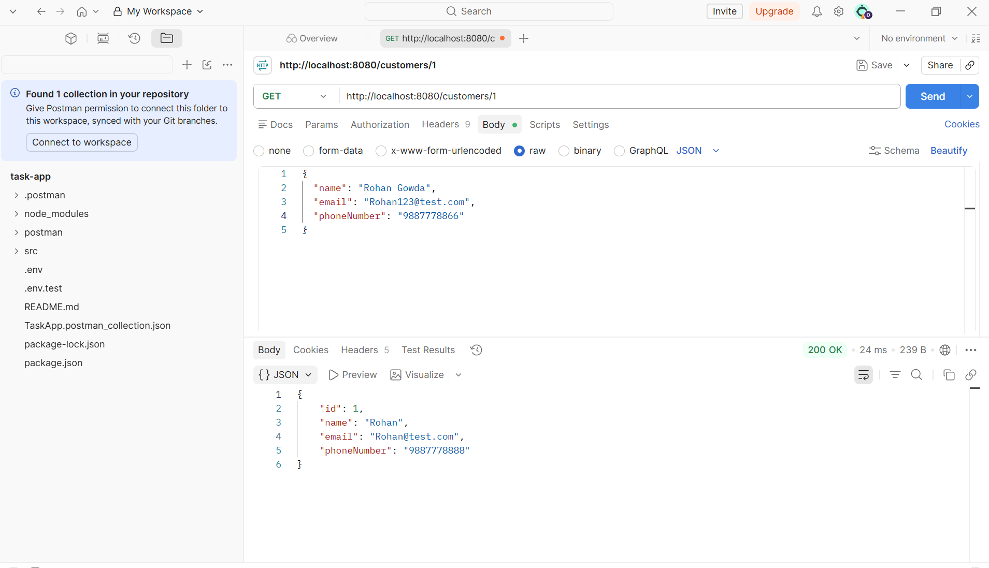
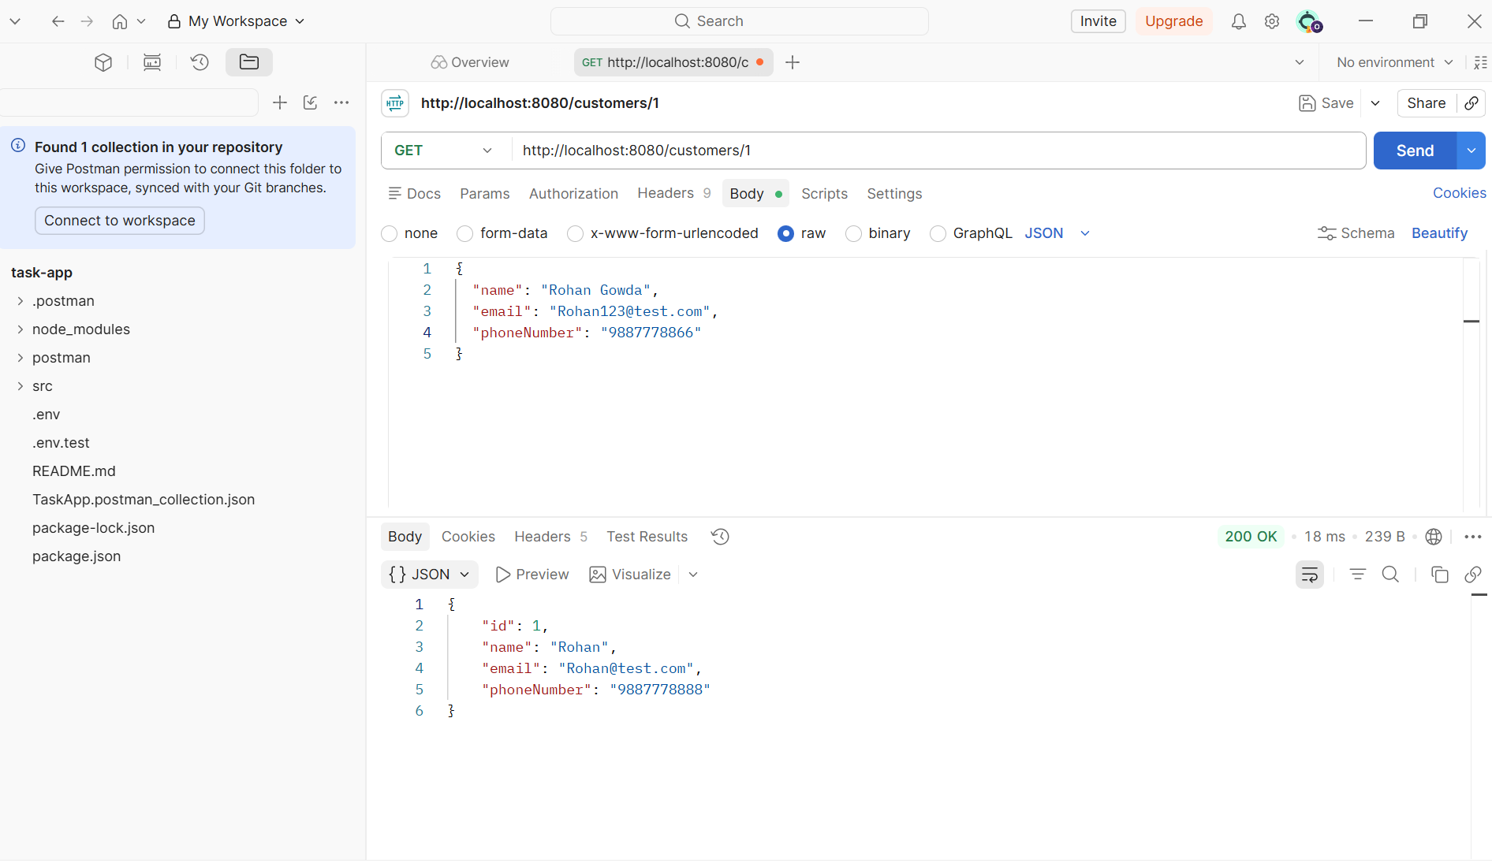

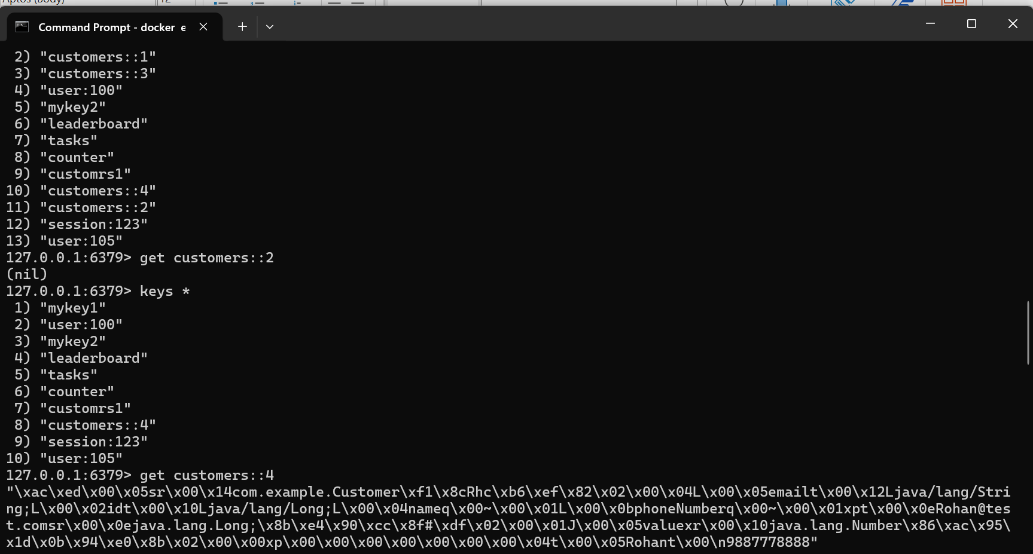

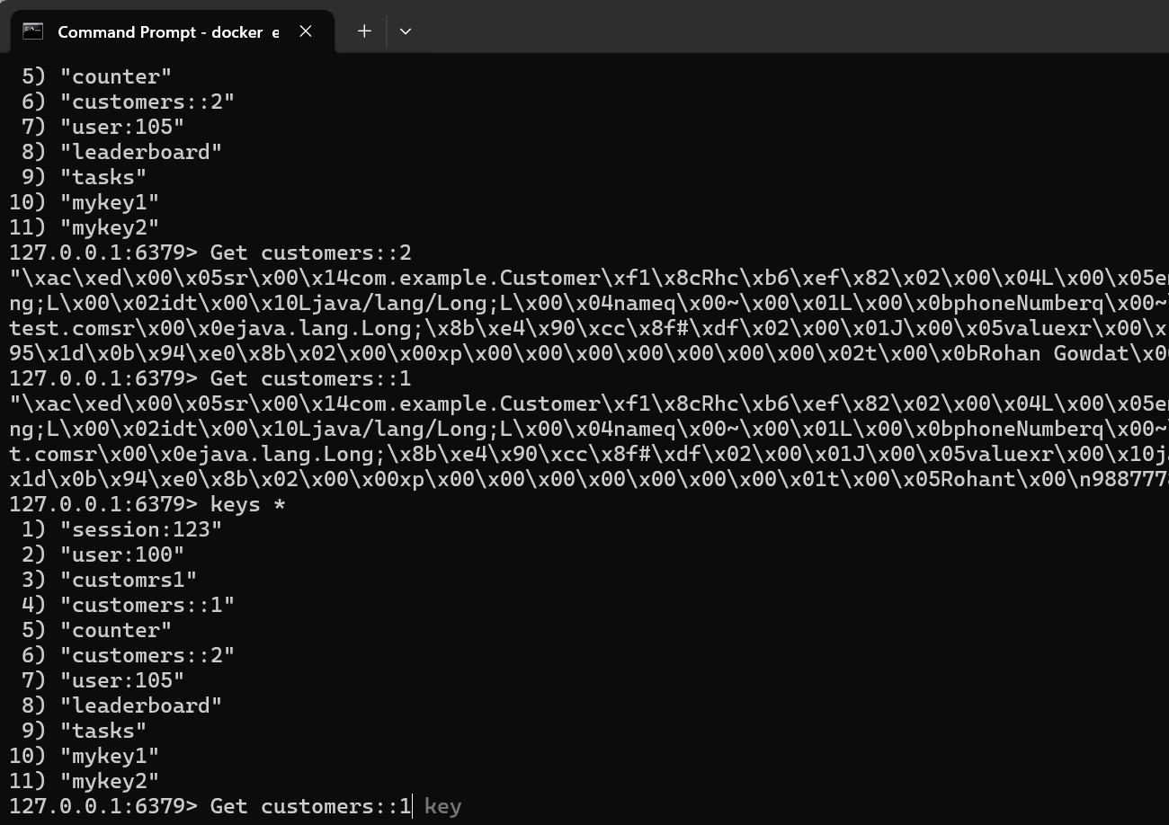

Task 02:
Distributed Caching Considerations
Q1: How does replication lag in a distributed Redis cluster affect consistency, and what strategies can mitigate its impact on read-heavy applications?
In a distributed Redis setup, data written to the primary node takes a small amount of time to propagate to replica nodes. This delay is called replication lag. If an application reads from a replica right after a write hits the primary, it might get stale data — a classic case of eventual consistency instead of strong consistency.
For read-heavy applications, this becomes risky in scenarios like:
- A user updates their profile, then immediately reloads the page and sees old data (if the read hit a lagging replica)
- Financial or inventory systems showing outdated balances/stock counts
Mitigation strategies:
- Read from primary for critical, just-written data — route reads that need up-to-date accuracy back to the primary node instead of replicas
- Use WAIT command — Redis's WAIT lets you block until a write has been acknowledged by a minimum number of replicas, trading some latency for consistency
- Session stickiness / read-your-writes pattern — route a specific user's reads to the same node they just wrote to, for a short window
- Monitor replication lag actively — track master_repl_offset vs replica offset and alert if lag crosses a threshold
- Accept eventual consistency where appropriate — for use cases like counters, likes, or view counts, slight staleness is often an acceptable trade-off for better performance

Task 03:
Redis for Session Management
Q2: Why is Redis preferred over traditional databases for session management in high-traffic web applications, and what risks arise if persistence is not configured?
Why Redis wins here:
- Speed — Redis is in-memory, so session reads/writes happen in microseconds, compared to disk-based databases which involve query parsing, indexing, and I/O overhead
- Built-in TTL support — sessions naturally expire after inactivity; Redis handles this natively via EXPIRE, no need for manual cleanup jobs
- High throughput — supports massive numbers of concurrent reads/writes, which is exactly the access pattern of session data (constantly read on every request, frequently updated)
- Horizontal scalability — Redis Cluster lets session storage scale out easily as traffic grows, without the schema/transaction overhead of a relational database
Risks if persistence isn't configured:
Redis is primarily an in-memory store — data only exists on disk if you explicitly enable persistence (RDB snapshots or AOF logs). If persistence is left off:
- Server restart or crash = total session loss. Every logged-in user gets instantly logged out, which is a poor user experience at scale
- No recovery point — there's no way to restore session state after a failure, since nothing was ever written to disk
- Cluster failover risk — if a primary node goes down before a replica catches up, unsaved session data is gone permanently
Recommendation: enable at least AOF (Append Only File) persistence for session stores, or accept that sessions are "soft state" the app can regenerate (e.g., forcing re-login), depending on how critical uninterrupted sessions are for the business.

Task 04:
Common Pitfalls: Stale Data & Cache Stampede
Q3: What is a cache stampede, and how can techniques like request coalescing or probabilistic early expiration help prevent it?
What it is:
A cache stampede (also called a "thundering herd") happens when a popular cache key expires, and suddenly many concurrent requests all experience a cache miss for that same key at once. Instead of one request going to the database, dozens or hundreds do — simultaneously overwhelming the database with identical, redundant queries, sometimes causing a cascading slowdown or outage.
Example: A cached product page for a flash sale expires at exactly 12:00:00 PM, right when 10,000 users are refreshing the page — all 10,000 requests hit the database at once instead of just one.
Mitigation techniques:
- Request Coalescing (a.k.a. "single-flight" pattern)
When multiple requests ask for the same missing key simultaneously, only the first request is allowed to query the database. The rest wait for that first request to finish and reuse its result, instead of all hitting the DB independently.
- Probabilistic Early Expiration
Instead of a hard expiry time, requests probabilistically decide to refresh the cache slightly before actual expiration — spreading refresh attempts out over time rather than all happening at the exact same instant. This smooths out the "everyone expires together" spike.
- Locking / Mutex on Cache Rebuild
When a cache miss occurs, the first request acquires a short-lived lock and rebuilds the cache; other concurrent requests either wait briefly or serve slightly stale data until the lock releases.
- Staggered TTLs (Jitter)
Add a small random offset to each key's expiration time (e.g., base TTL ± a few seconds), so that even bulk-cached keys don't all expire at the exact same moment.
- Serve Stale-While-Revalidate
Continue serving the old cached value to users while one background request refreshes the cache — users experience no interruption, and the database only gets one refresh query instead of many.

Task 05:
Database Migrations:
1. Why is it critical to apply the same migration scripts sequentially across Dev, Test, Staging, and Production, and what risks arise if environments drift?
Migrations build on each other — schema version 5 assumes version 4 already ran. If Dev, Test, Staging, and Prod drift (different scripts, different order, manual hotfixes in one place only), you get "works on my machine" at the database level. A migration that's fine on a clean Test DB can blow up in Prod because Prod has extra data, different indexes, or a skipped step from three releases ago. Drift also kills your ability to trust Staging as a dress rehearsal — if it doesn't mirror Prod's schema history, your last safety net is gone.
2. In what scenarios is a rollback preferable to a fix-forward approach, and how do tools like Liquibase and Flyway differ in supporting rollback strategies?
Rollback makes sense when the migration is destructive (dropped column, corrupted data), the blast radius is large, or you're early enough that reverting is cheap and clean. Fix-forward is better when rolling back would lose data written after the migration ran, or when the issue is minor and a quick patch is faster than a full revert.
Tooling-wise:
- Flyway (community edition) is intentionally rollback-light — it expects you to write forward-only migrations or pay for "undo" scripts in the paid tier. Philosophy: fix-forward by default.
- Liquibase has built-in rollback support for most changeset types (auto-generates reverse DDL for common operations) and lets you write custom rollback blocks. It's more forgiving if you know you'll need to back out changes.
3. How does the expand/contract pattern ensure application availability during schema evolution, and what are the trade-offs of delaying the contract phase?
Instead of changing a schema in one risky move, you split it into three phases:
- Expand — add the new column/table alongside the old one, app still uses old structure.
- Migrate — backfill data, deploy app code that can read/write both, then switch reads/writes to the new structure.
- Contract — once everything's confirmed stable, drop the old column/table.
This keeps the app running the whole time — no big-bang cutover, no downtime window. The trade-off of delaying contract: you're running with duplicate/legacy structures for longer, which means extra storage, more complex queries (sometimes syncing two columns), and a growing risk that someone builds new logic against the old structure — making cleanup harder the longer you wait.
4. What role does data validation (row counts, checksums, referential integrity) play in ETL-based migrations, and how can automation reduce human error?
Row counts catch the obvious stuff (data not fully loaded), checksums catch silent corruption (values transformed wrong even though the row count matches), and referential integrity checks catch broken relationships (orphaned foreign keys, orphaned child records). Manually eyeballing this at scale is a losing game — automation (validation scripts run as a pipeline step, not an afterthought) catches issues immediately, consistently, and before they reach production, instead of relying on someone remembering to spot-check.
5. Why is datatype mapping a critical challenge when migrating between heterogeneous database engines, and how can mismatches impact application performance?
Different engines don't agree on much: MySQL's TINYINT(1) vs Postgres BOOLEAN, Oracle's NUMBER vs SQL Server's DECIMAL/FLOAT, varying string encodings, date/time precision, and how NULLs or auto-increment fields behave. Get the mapping wrong and you don't always get an error — sometimes you get silent precision loss, truncated strings, or timezone shifts. Beyond correctness, wrong types can also tank performance: an oversized column type bloats storage and slows scans, and a mismatted type can quietly disable an index the query planner would otherwise use.
6. Beyond row count comparisons, what advanced techniques can be used to validate data integrity after migration, and why are application-level tests essential?
- Checksums/hashing per row or per table to catch value-level corruption.
- Aggregate checks — sums, min/max, distinct counts on key columns to confirm distributions match.
- Referential integrity checks — no orphaned foreign keys.
- Sampling + diffing — pull random rows from source and target and compare field by field.
- Reconciliation reports comparing business-critical metrics (e.g., total revenue) pre/post migration.

