COMIC CRAFT
AI Comic Story Creator using Gemini Models
Project Documentation
Submitted by: [Sathya.V, Monika.S, Kanimozhi.K]
Register / Roll No.: [2024503018, 2024503068, 2024503574]
Department / College: [Computer Technology , Anna University, MIT campus]
Date: October 2026

Table of Contents
1. Abstract 2
2. Introduction 2
3. Problem Statement 2
4. Objectives 2
5. Scope 3
6. System Requirements 3
6.1 Hardware requirements 3
6.2 Software requirements 3
7. Technology Stack 3
8. System Design 4
8.1 Architecture 4
8.2 Workflow 4
8.3 Module description 5
8.4 Data model 5
9. Implementation 5
9.1 Story generation with structured output 5
9.2 Panel image generation and character consistency 6
9.3 Layout engine 6
9.4 Reliability and error handling 6
9.5 User interface 7
10. Installation and Execution 7
10.1 Publishing the project on GitHub 7
11. Testing 8
11.1 Unit tests 8
11.2 System tests (with a Gemini API key) 8
12. Output Screenshots 8
13. Limitations 9
14. Future Enhancements 9
15. Conclusion 9
16. References 9

1. Abstract
Comic Craft is a web application that turns a short text idea into a finished multi-panel comic. The user describes a story, chooses a genre, tone, art style and number of panels, and the system does the rest. A Google Gemini text model writes a structured script containing the title, the characters with fixed visual descriptions, and a scene, narration and dialogue for every panel. A Gemini image model then draws each panel, using the character descriptions and the previous panel as a reference so that characters look consistent. Finally, a layout engine built with Pillow adds narration boxes and speech bubbles, arranges the panels into pages, and exports the comic as PNG images or a PDF.
The project shows how generative AI can lower the barrier to visual storytelling: a person with no drawing skills can produce a complete comic in minutes. It is implemented in Python with Streamlit for the interface and the google-genai SDK for model access.

2. Introduction
Comics are a powerful medium for teaching, entertainment and communication, but producing one normally needs three separate skills: writing, illustration and page design. This makes comic creation slow and out of reach for most students, teachers and small businesses.
Recent multimodal AI models can write coherent stories and generate images from text. Comic Craft combines both abilities in one pipeline. The application coordinates two kinds of Gemini models, one for language and one for images, and adds a deterministic layout stage so that the final output looks like a real comic page.

3. Problem Statement
Creating a comic requires storytelling ability, drawing skill and layout tools. Existing generic image generators produce single pictures, do not keep characters consistent from one image to the next, and often render unreadable text inside images. There is a need for a simple tool that converts one idea into a complete, readable, consistent comic.

4. Objectives
- Generate a structured comic script from a short idea using a Gemini text model.
- Generate one illustration per panel using a Gemini image model.
- Keep characters visually consistent across panels.
- Render narration and dialogue as clean text instead of relying on AI-drawn lettering.
- Let the user edit the script before the art is drawn.
- Export the result as PNG pages and a PDF.
- Handle API errors gracefully so a single failure does not break the whole comic.

5. Scope
In scope: single-user web application, English comics of 2 to 8 panels, six selectable art styles, seven genres, five tones, PNG and PDF export, runs locally with the user's own Gemini API key.
Out of scope: user accounts, cloud hosting, long multi-chapter comics, and animation or video.

6. System Requirements

6.1 Hardware requirements
Component | Minimum
Processor | Dual-core CPU, 2 GHz or above
Memory | 4 GB RAM (8 GB recommended)
Storage | 500 MB free space
Network | Stable internet connection (all AI processing happens in the cloud)

6.2 Software requirements
Software | Details
Operating system | Windows 10/11, macOS or Linux
Python | 3.10 or newer
Libraries | streamlit, google-genai, pydantic, Pillow, python-dotenv
Account | Google AI Studio account with a Gemini API key
Tools | Git and a GitHub account; any code editor such as VS Code

7. Technology Stack
Layer | Technology | Purpose
User interface | Streamlit | Interactive web UI with forms, progress bar and downloads
Story generation | Gemini text model via google-genai | Writes the comic script as validated JSON
Image generation | Gemini image model via google-genai | Draws each comic panel
Data validation | Pydantic | Defines and validates the Story, Character and Panel schema
Layout and export | Pillow | Text overlay, speech bubbles, page composition, PNG and PDF export
Configuration | python-dotenv | Loads the API key and model names from a .env file
Version control | Git and GitHub | Source code hosting

The default models are gemini-2.5-flash for the story and gemini-2.5-flash-image for the pictures. Because Google updates its model lineup regularly, both names can be changed from the application sidebar or from environment variables without editing any code.

8. System Design

8.1 Architecture
The system follows a three-stage pipeline. The user interface collects the idea; the story generator and the image generator communicate with the Gemini API; and the layout engine produces the final comic pages.
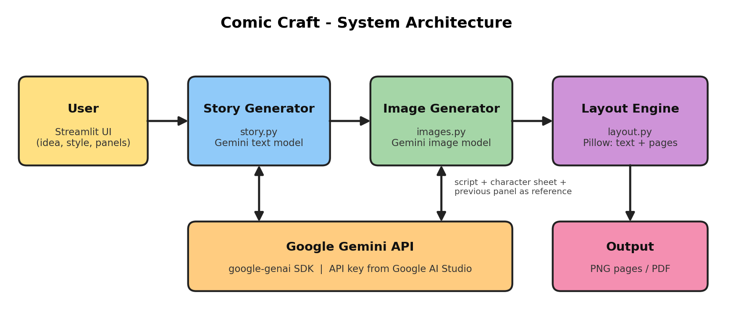
Figure 1: Comic Craft system architecture

8.2 Workflow
- The user enters a story idea and selects genre, tone, art style and number of panels.
- The story generator sends a structured prompt to the Gemini text model and receives a JSON script.
- The script is validated with Pydantic and shown to the user, who may edit scenes, narration and dialogue.
- The image generator draws panel 1, then draws every following panel with the character descriptions and the previous panel attached as a reference.
- The layout engine adds narration boxes and speech bubbles, arranges the panels into pages and shows the result.
- The user downloads the pages as PNG files or the whole comic as a PDF.

8.3 Module description
Module | File | Responsibility
User interface | app.py | Collects inputs, manages session state, shows the script and comic, provides downloads
Configuration | comiccraft/config.py | Loads the API key and model names, defines limits
Story generator | comiccraft/story.py | Builds the prompt, calls the text model, validates and normalises the script
Image generator | comiccraft/images.py | Builds panel prompts, calls the image model, extracts image bytes, handles failures
Layout engine | comiccraft/layout.py | Wraps text, draws captions and bubbles, composes pages, exports PNG and PDF
Utilities | comiccraft/utils.py | Retry with exponential backoff

8.4 Data model
The script returned by Gemini is parsed into three Pydantic models. Using a fixed schema forces the model to return predictable fields and lets the application detect malformed output.
Model | Field | Description
Story | title, art_style, characters, panels | Top-level comic description
Character | name, appearance | Fixed visual description reused in every panel prompt
Panel | number, scene, caption, dialogue | What to draw, narration text and one spoken line

9. Implementation

9.1 Story generation with structured output
The story generator asks the Gemini text model to respond with JSON that matches the Story schema. The request sets the response type to application/json and passes the Pydantic class as the response schema. The returned object is checked, extra panels are trimmed and panels are renumbered so that later stages can rely on the data.
response = client.models.generate_content(
model=model,
contents=prompt,
config=types.GenerateContentConfig(
response_mime_type="application/json",
response_schema=Story,
temperature=0.9,
),
)

9.2 Panel image generation and character consistency
Image models do not remember earlier images, so consistency has to be built into every request. For each panel the prompt contains the art style, the full character descriptions and the scene. From the second panel onward, the previous panel image is attached as a reference with an instruction to keep faces, hair, clothes and colours identical.
The prompt also tells the model not to draw any text. Letters produced by image models are frequently distorted, so all text is added later by the layout engine.

9.3 Layout engine
The layout engine crops every image to a square panel, draws a yellow narration box at the top and a rounded white speech bubble at the bottom, and adds a black border. Text is wrapped to fit using the measured pixel width of each word. Panels are arranged in a two-column grid with four panels per page; the first page carries the comic title. A grey placeholder tile is drawn if a panel image is missing.
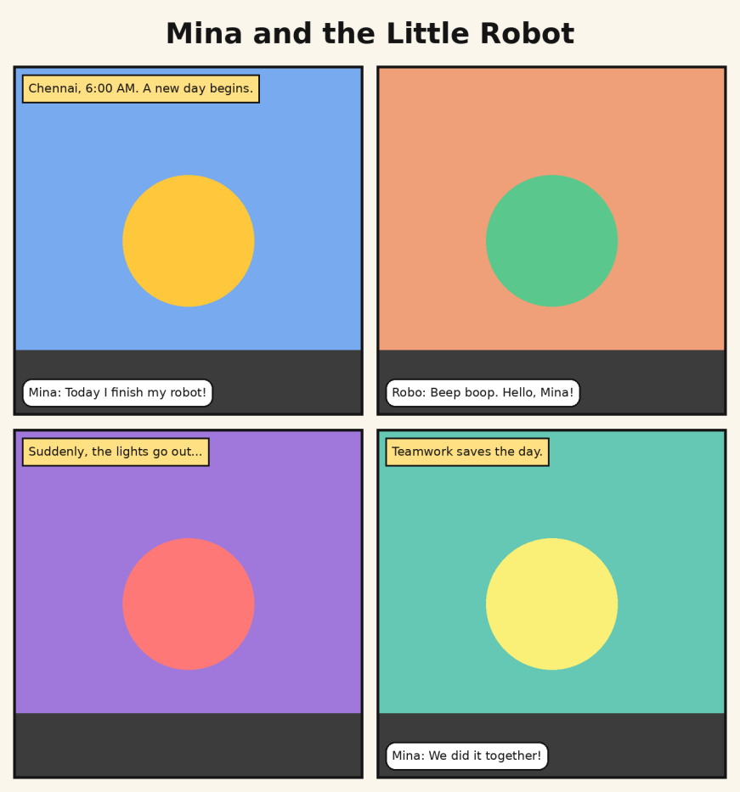
Figure 2: Layout engine output (demonstration with placeholder artwork instead of AI images)

9.4 Reliability and error handling
- Every Gemini call is wrapped in a retry helper with exponential backoff to survive temporary rate-limit or overload errors.
- If one panel fails after all retries, the run continues and a placeholder is shown; the user is warned and can draw again.
- A missing API key, an empty idea or an invalid model name produces a clear message in the interface instead of a crash.
- The API key is read from the sidebar or a .env file, and .env is excluded from Git so the key is never published.

9.5 User interface
The Streamlit interface has a sidebar for the API key, model names, number of panels, genre, tone and art style. The main page has two buttons: Write the story, and Draw the comic. The generated script is shown in expandable sections that can be edited. A progress bar reports panel-by-panel progress, and download buttons appear under the finished pages.

10. Installation and Execution
- Install Python 3.10 or newer and Git.
- Clone or download the project and open a terminal in the project folder.
- Create and activate a virtual environment.
- Install the dependencies with pip install -r requirements.txt.
- Copy .env.example to .env and paste your Gemini API key from Google AI Studio.
- Start the application with streamlit run app.py and open the address shown in the terminal.
python -m venv .venv
source .venv/bin/activate # Windows: .venv\Scripts\activate
pip install -r requirements.txt
cp .env.example .env # Windows: copy .env.example .env
streamlit run app.py

10.1 Publishing the project on GitHub
- Create an empty repository named comic-craft on github.com (do not add a README or .gitignore there).
- Run the commands below in the project folder, replacing your-username with your GitHub user name.
- Confirm that .env does not appear on GitHub. If a key is ever pushed by mistake, delete it in Google AI Studio and create a new one.
git init
git add .
git commit -m "Initial commit: Comic Craft AI comic creator"
git branch -M main
git remote add origin https://github.com/your-username/comic-craft.git
git push -u origin main

11. Testing

11.1 Unit tests
Nine automated unit tests cover the layout engine and the configuration module. They need no API key and run with python -m unittest discover -s tests -t . -v. All nine tests passed.
ID | Test case | Expected result | Result
UT-01 | Wrap long text to a maximum width | Every line fits inside the width | Pass
UT-02 | Wrap empty text | No lines returned | Pass
UT-03 | Render a panel with caption and dialogue | Square tile of the requested size | Pass
UT-04 | Render a panel with a missing image | Placeholder is used, size correct | Pass
UT-05 | Compose 5 panels at 4 per page | Two pages, title on the first | Pass
UT-06 | Compose with no panels | ValueError raised | Pass
UT-07 | Export PNG and PDF | Valid PNG and PDF signatures | Pass
UT-08 | Load settings without an API key | ValueError raised | Pass
UT-09 | Load settings defaults and overrides | Default and custom models applied | Pass

11.2 System tests (with a Gemini API key)
These tests exercise the live Gemini models. Run each one and record the outcome in the last column.
ID | Test case | Expected result | Result
ST-01 | Write a 4-panel story from a short idea | Title, characters and 4 panels shown
ST-02 | Draw the comic after writing the story | 4 panel images with captions and bubbles
ST-03 | Edit a dialogue line, then draw | Edited text appears in the comic
ST-04 | Use an invalid API key | Clear error message, no crash
ST-05 | Click Write the story with an empty idea | Message asking for an idea
ST-06 | Download the PDF and PNG files | Files open correctly

12. Output Screenshots
Insert screenshots of the running application below after executing the project with your API key.
- Figure 3: Home screen with sidebar settings and idea box [insert screenshot]
- Figure 4: Generated script with characters and editable panels [insert screenshot]
- Figure 5: Final comic page [insert screenshot]
- Figure 6: PDF download opened in a viewer [insert screenshot]

13. Limitations
- AI images can contain mistakes, and character consistency, although improved by references, is not perfect.
- Generation time and cost depend on the user's Gemini API quota and plan.
- The layout uses a fixed grid of square panels.
- The built-in font supports Latin text; other scripts need a suitable font file.
- An internet connection is required.

14. Future Enhancements
- Regenerate a single panel without redrawing the whole comic.
- Multiple page templates and speech bubbles with tails pointing at the speaker.
- Multi-language comics with Unicode fonts, including Tamil and Hindi.
- Saving and reopening projects, and a gallery of past comics.
- Cloud deployment so that users do not need to install Python.

15. Conclusion
Comic Craft demonstrates that a complete creative workflow, from idea to finished comic page, can be automated by combining a language model, an image model and a small amount of deterministic layout code. Structured JSON output keeps the pipeline reliable, repeated character descriptions and reference images keep the artwork consistent, and drawing text with Pillow keeps the lettering readable. The modular design makes it easy to swap models as Google releases new versions and to extend the application with new features.

16. References
- Google AI for Developers, Gemini API documentation: https://ai.google.dev/gemini-api/docs
- Google AI Studio (API keys): https://aistudio.google.com/apikey
- Streamlit documentation: https://docs.streamlit.io
- Pydantic documentation: https://docs.pydantic.dev
- Pillow documentation: https://pillow.readthedocs.io

