- Successful Execution
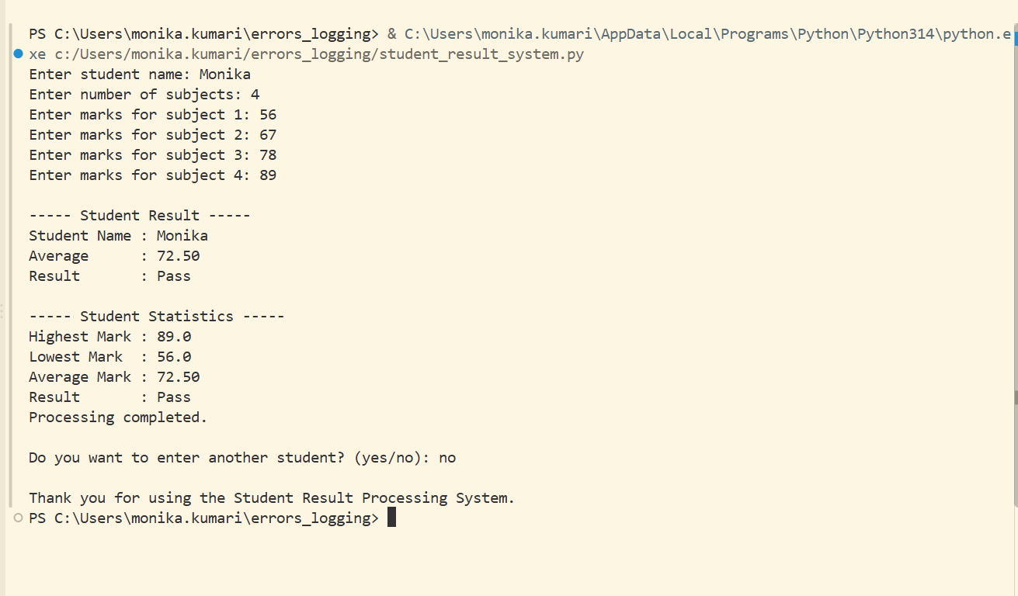

- Invalid input handling
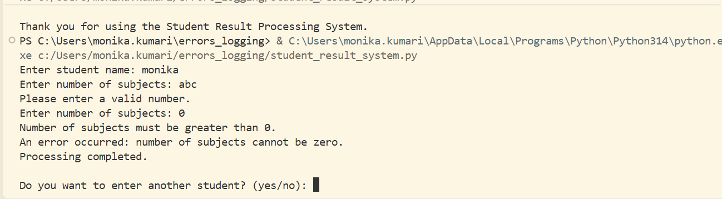

- Invalid Marks handling
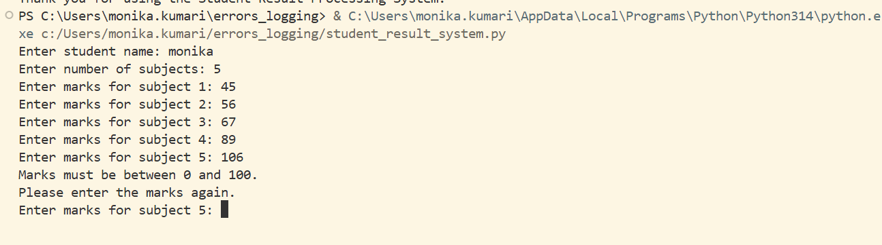

- Logging level set to Error
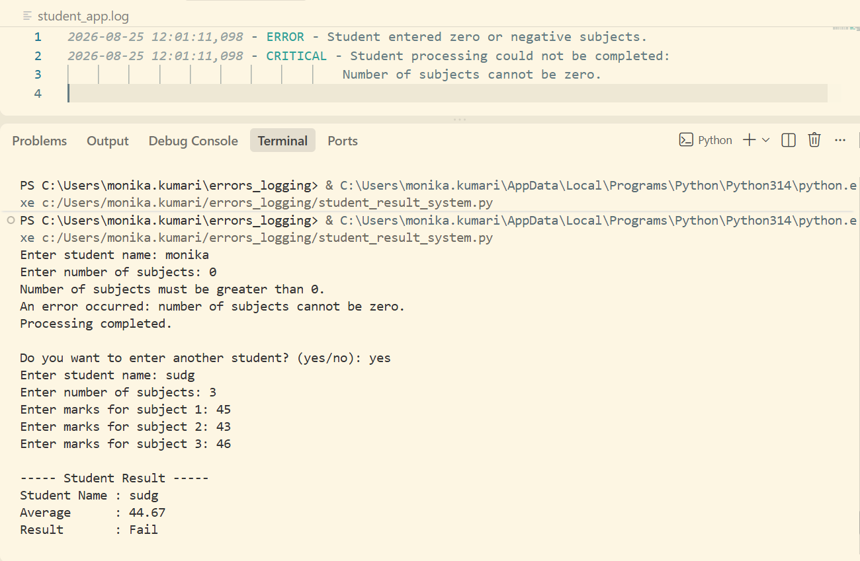

- Logging level set to DEBUG
