CSE0613316 Software Project Design and Development (Lab)
Software Test Report
Test plan, test cases and results (based on ISO/IEC/IEEE 29119-3)
Project | HeritageBD: Digital Heritage Tourism & Marketplace Platform of Bangladesh
Team ID | Batch: CSE-54, Section: 7A
Member 1 | 0432320005101036 - Sumaiya Jahan-Developer & Reviewer
Member 2 | 0432320005101047- Monika Akter- Developer & Test lead
Experiment | Exp 9 (v1.0)  Exp 10 (v1.1)
Instructor | Al Imtiaz, Associate Professor, Dept. of CSE, UITS
Submitted | 27 October 2026

Document Control
Repository | https://github.com/Monika-Akter47/heritagebd
Version tested | v1.0.1-test (commit 1d45c59)
Live site | https://heritagebd-flax.vercel.app (API: https://heritagebd-api.onrender.com)
Report version | 1.0
Prepared by | Monika Akter, Sumaiya Jahan
Reviewed by | Sumaiya Jahan
Target tier | Baseline

Version | Date | Changes
1.0 | 26 Oct 2026 | First version: 163 automated test cases, results, coverage, NFR checks, defects
1.1 | 27 October,2026 | Planned for Exp 10: SonarCloud and OWASP ZAP results

1. Introduction

1.1 Purpose
This report covers how we tested HeritageBD at v1.0.1-test: what we tested, how, the results, and whether it is ready to be released.

1.2 Product overview
HeritageBD lets tourists discover heritage places in Bangladesh, book guides, plan trips, buy local products and pre-order items for pickup. It is a React app on Vercel, a PHP 8.2 API on Render and a PostgreSQL database on Supabase.

1.3 Scope
In scope | Requirements | Levels
Accounts, login, roles, verification | FR-01 to FR-06, FR-48 | Unit, Integration, E2E
Places, search, map, content | FR-07 to FR-13 | Integration, E2E
Guides, bookings, trips | FR-14 to FR-19 | Integration
Shop, cart, checkout, orders | FR-20 to FR-24, FR-36, FR-38 | Unit, Integration
Pre-orders and payments | FR-25 to FR-35, FR-37 | Unit, Integration, E2E
Reviews, notifications, chat | FR-39 to FR-43 | Integration
Admin, reports, security | FR-44 to FR-51 | Integration, E2E
Performance, accessibility, browsers | NFR-01 to NFR-16 | Perf, A11y, Compat

Out of scope | Why
Real bKash / Nagad / card gateway | Not integrated yet. We test how payments are recorded (payer number, TrxID).
Sending the reset OTP by email | No mail service. We put a known OTP in the test database instead.

1.4 References

Document | Version/Link
SRS (Experiment 2) | v1.0
Design Development (Experiment 3) | V1.0
Software Testing Report Guideline | CSE0613316
ISO/IEC/IEEE 29119-3; ISO/IEC 25010, OWASP Top 10, WCAG 2.2. | 2021 Edition

1.5 Abbreviations
RTM: Requirement Traceability Matrix.
EP: Equivalence Partitioning.
BVA: Boundary Value Analysis.
E2E: End to End.
p95: 95th percentile response time.
TrxID: wallet transaction ID.

2. Test Environment
OS | Windows 11 (tests); Linux on Render and Vercel
Runtimes | PHP 8.2.35 (Xdebug 3.5 for coverage), Node 24
Test database | PostgreSQL 17 in memory (PGlite), loaded from schema.sql and seed.sql on every run
Browsers | Edge 155 desktop, Edge with Pixel 7 screen size
Test Tools | PHPUnit 11.5, Vitest 4.1, Playwright 1.56, Lighthouse 12.8, npm/composer audit, gitleaks 8.30

2.1 Test data
Each run starts with a fresh database from the committed seed, so nothing is shared between runs. Tests create their own users and products. Seed accounts are fake (example.com) and live only in the test database. The live database is never used for functional tests.

2.2 How to run
git clone https://github.com/Monika-Akter47/heritagebd.git && cd heritagebd && git checkout v1.0.1-test
npm ci && composer install
npm run lint
npm test (PHP unit + integration, then frontend)
npm run test:e2e
npm run test:coverage

3. Test Strategy
Level / type | Objective | Technique | Tool
Unit | Money split, phone/TrxID rules, area lookup, UI validators | EP, BVA, decision table | PHPUnit, Vitest
Integration | Every API endpoint with a real database | EP, BVA, state transition, error guessing | PHPUnit
E2E | Map, pre-order checkout, admin payments | Use cases | Playwright
Regression | Full suite after each change, one test per fixed bug | Re-run | npm test
Performance | p95 of 5 key endpoints on the live site | Load test | p95.mjs
Security | Access control, injection, auth, deps, secrets | OWASP checklist | PHPUnit, audits, gitleaks
Accessibility | 6 key pages | Audit | Lighthouse
Usability | Core tasks with outside users | Task test | Not done yet
Why these tools: the API is plain PHP, so PHPUnit fits, and we call it over HTTP so routing and SQL are tested too. PGlite gives us a real PostgreSQL without Docker.

3.1 Entry criteria
- Code on main builds and lint shows 0 errors
- Every requirement has acceptance criteria in the SRS
- The environment and data test are ready (section 2)

3.2 Exit criteria (Baseline)
Criterion | Target | Result | Met?
FRs with a test | 100% | 100% | Yes
P1 tests passing | 100% | 100% | Yes
Line coverage, core logic | 60% | 92.7% (whole API 80.2%) | Yes
Open S1 defects | 0 | 0 | Yes
Critical/High dependency issues | 0 | 0 | Yes

4. Traceability Matrix
Built from the tests themselves: each test has a tag with its ID and requirement, and the status comes from the actual run. NFRs are numbered by us from SRS section 5. Full list: evidence/rtm.csv.
Req | Requirement | Test case IDs | Status
FR-01 | User registration | TC-01, TC-02, TC-03, TC-04 +3 | Pass
FR-02 | User authentication | TC-U20, TC-07, TC-08, TC-09 +2 | Pass
FR-03 | Role-based access control | TC-21, TC-114 | Pass
FR-04 | Vendor and guide verification | TC-28, TC-29, TC-30, TC-31 | Pass
FR-05 | Password reset (6-digit OTP, 15 min) | TC-13, TC-14, TC-15, TC-16 | Pass
FR-06 | Profile management, saved places | TC-17, TC-18, TC-19, TC-121, TC-122 | Pass
FR-07 | Browsing and search with filters | TC-123, TC-40, TC-41, TC-42 +2 | Pass
FR-08 | Place details | TC-45, TC-46 | Pass
FR-09 | Content management (admin) | TC-37, TC-38, TC-39, TC-124, TC-125 | Pass
FR-10 | Categories with counts | TC-47 | Pass
FR-11 | Map rendering | TC-48, E2E-01 | Pass
FR-12 | Map layer filtering | E2E-01 | Pass
FR-13 | Marker detail cards | E2E-01 | Pass
FR-14 | Guide profile | TC-52 | Pass
FR-15 | Availability & location sharing | TC-U19, TC-53, TC-54 | Pass
FR-16 | Booking requests | TC-55, TC-56, TC-57, TC-58 +4 | Pass
FR-17 | Guide dashboard | TC-59 | Pass
FR-18 | Trip creation | TC-60, TC-61 | Pass
FR-19 | Itinerary management | TC-62, TC-63 | Pass
FR-20 | Product listing (vendor) | TC-U16, TC-U17, TC-U18, TC-118 +3 | Pass
FR-21 | Product browsing | TC-U14, TC-U15, TC-49, TC-50, TC-51 | Pass
FR-22 | Cart | TC-66, TC-67 | Pass
FR-23 | Checkout | TC-68, TC-69, TC-F08 | Pass
FR-24 | Inventory validation | TC-70, TC-71 | Pass
FR-25 | Pre-order eligibility | TC-76, TC-77 | Pass
FR-26 | Destination-based discovery | TC-U10, TC-U11, TC-U12, TC-U13, TC-78 | Pass
FR-27 | Pickup scheduling | TC-79, E2E-02 | Pass
FR-28 | Advance payment calculation | TC-U01, TC-U02, TC-U03, TC-U04 +5 | Pass
FR-29 | Advance payment processing | TC-U08, TC-U09, TC-81, TC-82 +7 | Pass
FR-30 | Order number and QR code | TC-U21, TC-84, E2E-02 | Pass
FR-31 | Pre-order status updates | TC-85, TC-86 | Pass
FR-32 | Pickup verification (QR, single use) | TC-87, TC-88 | Pass
FR-33 | Remaining payment | TC-89, TC-90, TC-F05, TC-F07 | Pass
FR-34 | Cancellation & refunds | TC-91, TC-92, TC-93, TC-126, TC-94 | Pass
FR-35 | Pre-order settings | TC-95, TC-96 | Pass
FR-36 | Delivery order tracking | TC-72, TC-73, TC-74, TC-F10 | Partial
FR-37 | Pre-order tracking | TC-97, TC-F09, TC-F11, TC-F13 | Pass
FR-38 | Order history (role-aware) | TC-75 | Pass
FR-39 | Review submission | TC-98, TC-99, TC-100, TC-101 | Partial
FR-40 | Aggregate rating | TC-102 | Pass
FR-41 | Review display | TC-103 | Pass
FR-42 | Notifications | TC-104, TC-105 | Pass
FR-43 | Chat | TC-106, TC-107 | Pass
FR-44 | User management (admin) | TC-32, TC-33 | Pass
FR-45 | Pre-order management (admin) | TC-34, TC-111, E2E-03 | Pass
FR-46 | Statistics | TC-35 | Pass
FR-47 | Reports | TC-36 | Pass
FR-48 | Secure login / session expiry | TC-11, TC-12 | Pass
FR-49 | Unauthorized access prevention (401/403) | TC-20, TC-22, TC-23, TC-24 +4 | Pass
FR-50 | Activity logging | TC-112, TC-113 | Partial
FR-51 | Backup and recovery | TC-117 | Pass
NFR-01 | Fast response under normal load | PT-01, PT-02, PT-03, PT-04, PT-05 | Pass
NFR-02 | List endpoints paginated, limit capped at 200 | TC-43 | Pass
NFR-03 | Multi-table writes in transactions with rollback | TC-70, TC-71 | Pass
NFR-04 | Passwords stored only as bcrypt hashes | TC-116, TC-U20 | Pass
NFR-05 | 256-bit tokens, 30-day expiry, revoked on logout | TC-01, TC-11, TC-12 | Pass
NFR-06 | Role guards on protected endpoints | TC-20, TC-21, TC-10, TC-33 | Pass
NFR-07 | PDO prepared statements prevent SQL injection | TC-114 | Pass
NFR-08 | HTTPS in production | SEC-01, SEC-02 | Partial
NFR-09 | Explicit, revocable guide location sharing | TC-53, TC-54 | Pass
NFR-10 | QR codes unique, single-use, validated server-side | TC-84, TC-87, TC-88 | Pass
NFR-11 | No unauthorized change of pre-order status or payment records | TC-27, TC-126, TC-110 | Pass
NFR-12 | Responsive on desktop, tablet and mobile | E2E-01, E2E-02, E2E-03 | Pass
NFR-13 | Bangla-capable storage and display | TC-123, TC-F07 | Pass
NFR-14 | Accessible user interface | LH-01, LH-02, LH-03, LH-04 +2 | Pass
NFR-15 | Modern browsers: Chrome, Firefox, Safari, Edge | E2E-01, E2E-02, E2E-03, FF-01 | Partial
NFR-16 | Regular database backups and recovery | TC-117 | Pass

Requirements | 67 (51 FR, 16 NFR)
With at least one test | 67 (100%)
With a negative test | 41 (61.2%)

5. Test Cases Specification

5.1 Test case list
TC ID | Request ID | Title / Test Case | Level | Priority | Result
TC-01 | FR-01 | Tourist registration is active immediately and returns a token | Integration | P1 | Pass
TC-02 | FR-01 | Vendor and guide registrations start as pending verification | Integration | P1 | Pass
TC-03 | FR-02, NFR-05 | Valid login returns the user and a usable token | Integration | P1 | Pass
TC-04 | FR-02 | Wrong password and unknown email both get the same 401 error | Integration | P1 | Pass
TC-05 | FR-03, NFR-06 | Each role is refused the endpoints of other roles | Integration | P1 | Pass
TC-06 | FR-04 | Approving a pending guide makes the account verified and active, and notifies the guide | Integration | P1 | Pass
TC-07 | FR-04 | Rejecting a pending vendor suspends the account | Integration | P1 | Pass
TC-08 | FR-05 | Valid OTP resets the password and signs out old sessions | Integration | P1 | Pass
TC-09 | FR-05 | OTP older than 15 minutes is rejected | Integration | P1 | Pass
TC-10 | FR-06 | User updates own name and phone | Integration | P2 | Pass
TC-11 | FR-06 | Tourist saves and unsaves a place | Integration | P2 | Pass
TC-12 | FR-07 | Places filter by category and division | Integration | P1 | Pass
TC-13 | FR-07 | Search is case insensitive | Integration | P2 | Pass
TC-14 | FR-08 | Place details show all fields listed in the SRS | Integration | P1 | Pass
TC-15 | FR-09 | Admin creates, updates and deletes a place | Integration | P2 | Pass
TC-16 | FR-09 | Non-admin cannot create places, events or stories | Integration | P2 | Pass
TC-17 | FR-10 | Categories show the number of places | Integration | P2 | Pass
TC-18 | FR-11 | Every place has coordinates inside Bangladesh for the map | Integration | P1 | Pass
TC-19 | FR-11, FR-12, FR-13, NFR-12 | Map shows heritage places, layer toggles work, and a marker card links to the place | E2E | P1 | Pass
TC-20 | FR-14 | Guide updates profile languages and price | Integration | P2 | Pass
TC-21 | FR-15 | Shared guide position is approximate for the public | Integration | P2 | Pass
TC-22 | FR-15, NFR-09 | Public sees no coordinates unless the guide is available and sharing | Integration | P1 | Pass
TC-23 | FR-16 | Booking moves from pending to accepted, finished and completed, and notifies users | Integration | P1 | Pass
TC-24 | FR-16 | Guide cannot skip from pending to completed | Integration | P1 | Pass
TC-25 | FR-17 | Guide dashboard lists only the guide's own bookings | Integration | P2 | Pass
TC-26 | FR-18 | Tourist creates a named trip with destinations | Integration | P1 | Pass
TC-27 | FR-19 | Days and stops keep their order, and the trip can be deleted | Integration | P1 | Pass
TC-28 | FR-20 | Vendor adds, edits and deletes a product | Integration | P1 | Pass
TC-29 | FR-20 | Price must be above zero and stock cannot be negative | Integration | P1 | Pass
TC-30 | FR-21 | Products filter by category and price range | Integration | P1 | Pass
TC-31 | FR-22 | Cart supports add, merge, update, remove and clear | Integration | P1 | Pass
TC-32 | FR-23 | Checkout creates the order, clears the cart and holds the advance | Integration | P1 | Pass
TC-33 | FR-24, NFR-03 | Checkout fails when quantity exceeds stock, and stock stays unchanged | Integration | P1 | Pass
TC-34 | FR-25 | Pre-order eligible product requires preparation time and pickup location | Integration | P1 | Pass
TC-35 | FR-26 | Pre-order products are listed for a destination area | Integration | P1 | Pass
TC-36 | FR-27 | Quantity must be a whole number within stock | Integration | P1 | Pass
TC-37 | FR-27, FR-30, NFR-12 | Tourist pre-orders with bKash proof and gets an order number | E2E | P1 | Pass
TC-38 | FR-28 | Pre-order stores 30% advance and 70% remaining | Integration | P1 | Pass
TC-39 | FR-28 | 1000 taka splits into 300 advance and 700 balance | Unit | P1 | Pass
TC-40 | FR-29 | Advance is recorded with method, payer number and TrxID | Integration | P1 | Pass
TC-41 | FR-29 | Wallet advance without a valid number or TrxID is rejected | Integration | P1 | Pass
TC-42 | FR-30, NFR-10 | Each pre-order gets a unique order number and QR code | Integration | P1 | Pass
TC-43 | FR-31 | Vendor moves pre-order to ready and the tourist is notified | Integration | P1 | Pass
TC-44 | FR-32, NFR-10 | Wrong QR code is rejected | Integration | P1 | Pass
TC-45 | FR-32, NFR-10 | QR code can be used only once | Integration | P1 | Pass
TC-46 | FR-33 | Remaining payment by bKash is recorded and the tourist confirms receipt | Integration | P1 | Pass
TC-47 | FR-34 | Cancellation before preparation refunds the advance and restores stock | Integration | P1 | Pass
TC-48 | FR-34 | Tourist cannot cancel once preparation has begun | Integration | P1 | Pass
TC-49 | FR-35 | Admin updates pre-order settings and they are served publicly | Integration | P1 | Pass
TC-50 | FR-36 | Delivery order has a tracking number and estimated delivery | Integration | P2 | Fail
TC-51 | FR-37 | Pre-order timeline reaches completed through every SRS state | Integration | P1 | Pass
TC-52 | FR-38 | Order history is role-aware | Integration | P1 | Pass
TC-53 | FR-39 | Buyer reviews a purchased product | Integration | P1 | Pass
TC-54 | FR-39 | Tourist can review a heritage place | Integration | P2 | Fail
TC-55 | FR-40 | Average rating and count are recalculated | Integration | P1 | Pass
TC-56 | FR-41 | Reviews are listed with user, date, rating and comment | Integration | P2 | Pass
TC-57 | FR-42 | Notifications are created and can be marked read | Integration | P1 | Pass
TC-58 | FR-43 | Chat message raises the unread count until read | Integration | P1 | Pass
TC-59 | FR-44 | Admin suspends and reinstates a user | Integration | P1 | Pass
TC-60 | FR-45 | Admin sees pre-orders of every tourist | Integration | P2 | Pass
TC-61 | FR-45, NFR-12 | Admin sees advances with payer number and TrxID on Payments & Advances | E2E | P1 | Pass
TC-62 | FR-46 | Statistics counters match the database | Integration | P1 | Pass
TC-63 | FR-47 | Reports give a 12-month series and a breakdown by flow | Integration | P2 | Pass
TC-64 | FR-48, NFR-05 | Logout revokes the token | Integration | P1 | Pass
TC-65 | FR-49, NFR-06 | Protected endpoints return 401 without a token | Integration | P1 | Pass
TC-66 | FR-49, NFR-06 | Tourist cannot read another tourist's pre-order | Integration | P1 | Pass
TC-67 | FR-50 | Important user and payment events are kept in an audit log | Integration | P2 | Fail
TC-68 | FR-51, NFR-16 | Schema and data can be restored from the committed SQL | Integration | P2 | Pass
TC-69 | NFR-01 | Main endpoints respond quickly under normal load* | Performance | - | Pass
TC-70 | NFR-02 | List limit is capped at 200 | Integration | P2 | Pass
TC-71 | NFR-04 | Passwords are stored only as bcrypt hashes | Integration | P1 | Pass
TC-72 | NFR-07 | SQL injection in search and login is harmless | Integration | P1 | Pass
TC-73 | NFR-08 | HTTPS is used in production* | Security | - | Partial
TC-74 | NFR-11 | Tourist cannot set their own refund amount | Integration | P1 | Pass
TC-75 | NFR-13 | Bangla local food names are stored and shown correctly | Integration | P2 | Pass
TC-76 | NFR-14 | User interface passes accessibility checks* | Accessibility | - | Pass
TC-77 | NFR-15 | App works on Chrome, Firefox, Safari and Edge* | Browser | - | Partial
TC-78 | FR-01 | Password length boundaries: 7 characters and empty are rejected, 8 and 9 are accepted | Integration | P1 | Pass
TC-79 | FR-05 | OTP must be exactly six digits (5 and 7 digits are rejected) | Integration | P2 | Pass
TC-80 | FR-29 | Valid Bangladeshi mobile numbers are accepted and normalised | Unit | P1 | Pass
TC-81 | FR-29 | Invalid mobile numbers are rejected | Unit | P1 | Pass
TC-82 | FR-29 | TrxID of 6 and 20 characters is accepted | Integration | P2 | Pass
TC-83 | FR-39 | Rating must be between 1 and 5 | Integration | P1 | Pass
TC-84 | FR-24 | Buying exactly the remaining stock succeeds and stock becomes zero | Integration | P1 | Pass
TC-85 | FR-35 | Refund percentage outside 0 to 100 is rejected | Integration | P2 | Pass
TC-86 | FR-16 | Booking dates in the past or reversed are rejected | Integration | P1 | Pass
TC-87 | FR-18 | Trip needs a name and an end date not before the start date | Integration | P2 | Pass
TC-88 | FR-31 | Vendor sees open pre-orders by pickup date, closed ones last | Integration | P2 | Pass
TC-89 | FR-34 | Vendor cancelling a paid pre-order waits for the admin to refund it | Integration | P1 | Pass
TC-90 | FR-16 | Guide cancelling a booking waits for the admin to refund the advance | Integration | P1 | Pass
TC-91 | FR-34 | Only an admin can refund, and needs a valid TrxID | Integration | P1 | Pass
TC-92 | FR-18 | Ride fares: bikes up to 60 km, cheapest is recommended | Unit | P2 | Pass
TC-93 | FR-19 | Trip plan uses real places, each with its own photo | Unit | P1 | Pass

Summary

Total test cases: 93. Pass: 88. Fail: 3 (TC-50, TC-54, TC-67). Partial: 2 (TC-73, TC-77).

The Fail and Partial results match the Partial requirements in the Traceability Matrix: FR-36, FR-39, FR-50, NFR-08 and NFR-15.

5.2 Detailed test cases

All 61 P1 cases are in the table in 5.1. Six of the most important are described here.
ID | Requirement | Setup | Steps | Expected | Result
TC-38 | FR-28: Rs 1,000 order means Rs 300 now and Rs 700 at pickup | Pre-order product priced 1,000 | Create a pre-order | advancePaid 300, remainingAmount 700 | Pass
TC-41 | FR-29: bKash/Nagad advance needs payer number and TrxID | Pre-order product | Create pre-orders with a missing or bad number, TrxID of 5 and 21 chars | All rejected with 422 | Pass
TC-45 | FR-32, NFR-10: a QR code works only once | Pre-order already QR verified | Vendor scans the same QR again | Rejected | Pass
TC-48 | FR-34: no cancelling after preparation starts | Pre-order in preparing | Tourist cancels | Rejected (409) | Pass
TC-66 | FR-49, NFR-06: users cannot see each other's orders | Tourist A has a pre-order | Tourist B opens and edits it | 403 both times | Pass
TC-74 | NFR-11 (SRS 5.3): payment records cannot be changed by users | Pre-order before preparation | Tourist cancels and sends refundAmount 99999 | Refund is the computed 240, not 99999 | Pass

5.3 Boundary value analysis

Each input is tested at and just beside its limits. All test numbers refer to the list in 5.1.
Input | Valid | Boundaries tested | Tests
Password | 8+ chars | 7, 8, 9, empty | TC-78
OTP | 6 digits, not expired | 5, 6, 7 digits; expired 1 s ago | TC-09, TC-79
Mobile number | 01[3-9] + 8 digits | 10, 11, 12 digits; 012, 013, 019 | TC-80, TC-81
TrxID | 6 to 20 letters/digits | 5, 6, 20, 21 chars | TC-41, TC-82
Rating | 1 to 5 | 0, 1, 5, 6 | TC-83
Quantity | 1 to stock | 0, -1, 1.5, stock, stock+1 | TC-33, TC-36, TC-84
Refund % | 0 to 100 | -1, 101 | TC-85
Dates | Start today or later, end >= start | Yesterday, end before start | TC-86, TC-87

5.4 pre-order states
confirmed > advance_paid > vendor_accepted > preparing > ready_for_pickup > arrived > qr_verified > pickup_payment_pending > picked_up > completed. We test each valid step (TC-85, 89, 97) and the wrong ones: skipping a step (TC-86), tourist doing vendor steps (TC-27), late cancel (TC-92), wrong or reused QR (TC-87, 88).

6. Test Execution Results
6.1 Summary
Level | Runs | Passed | Failed | Pass %
Unit | 77 | 77 | 0 | 100%
Integration | 167 | 164 | 3 | 98.2%
E2E | 6 | 6 | 0 | 100%
Total | 250 | 247 | 3 | 98.8%
No CI yet (planned for Exp 12); results are from local runs and a fresh-clone run. E2E passed 3 times in a row, so it is not flaky.

6.2 Test run evidence
Each suite was run in the VS Code terminal from the project folder on the release commit, with the test file open in the editor. Per-test names come from PHPUnit --testdox and the Vitest verbose reporter.
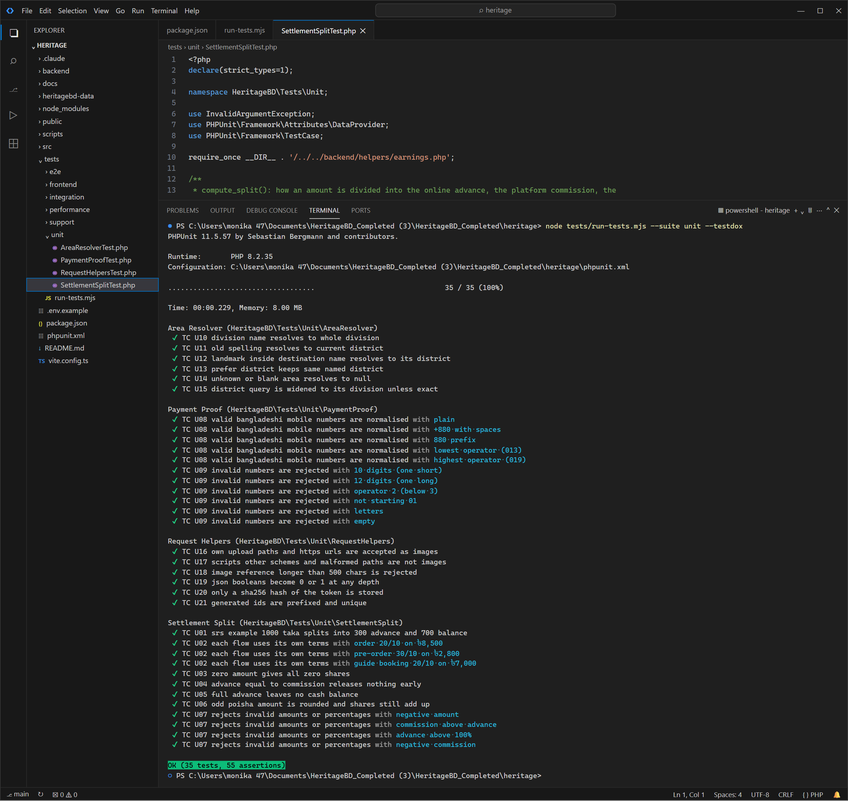
Figure 1: PHP unit tests, each test listed (35 passed)
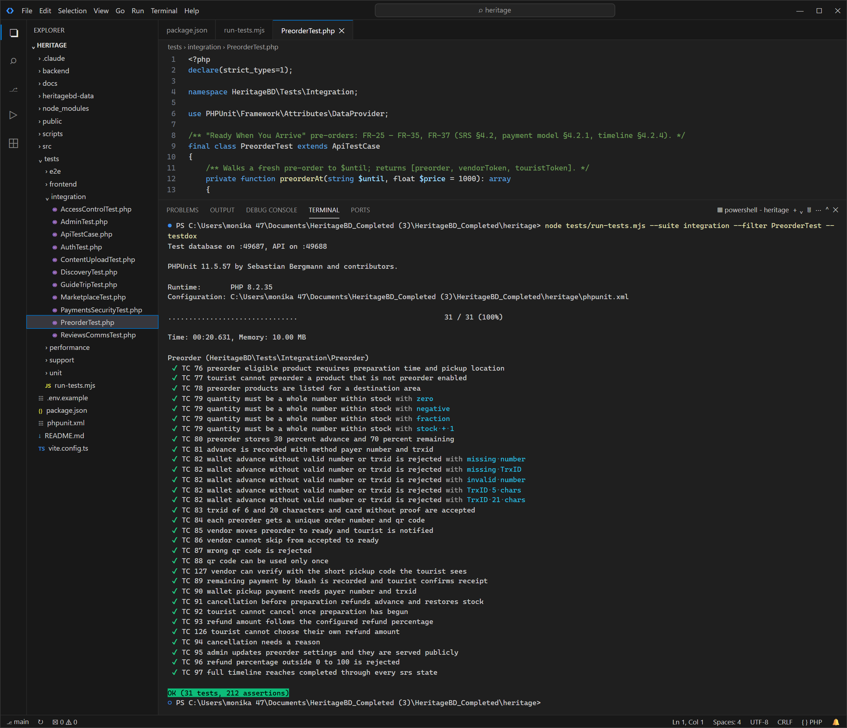
Figure 2: Pre-order API tests (31 passed)
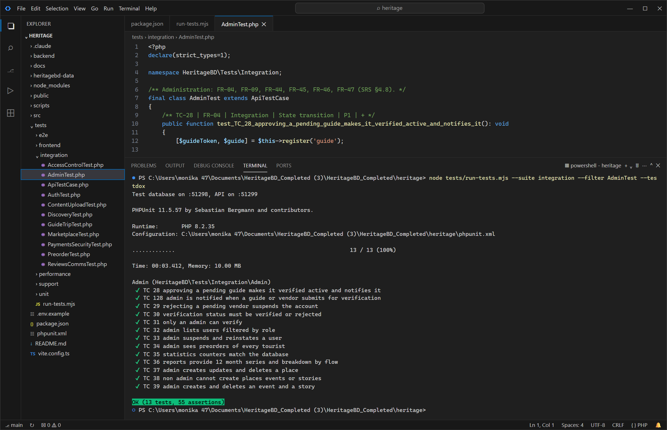
Figure 3: Admin and verification API tests (13 passed)
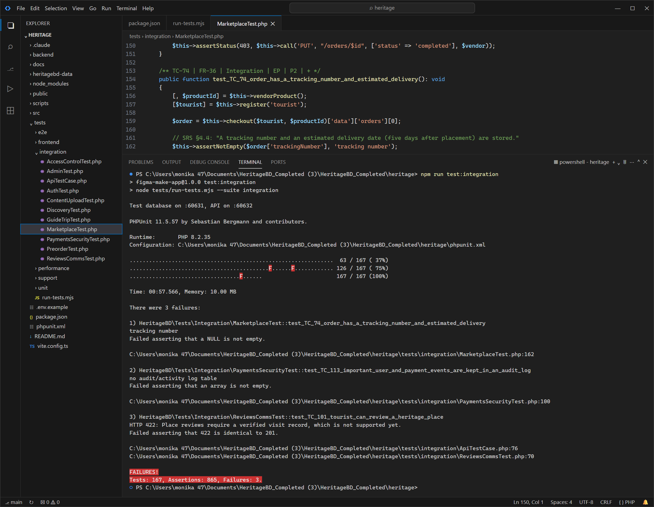
Figure 4: Full API integration run (167 run, 164 passed, 3 known failures in 6.3)
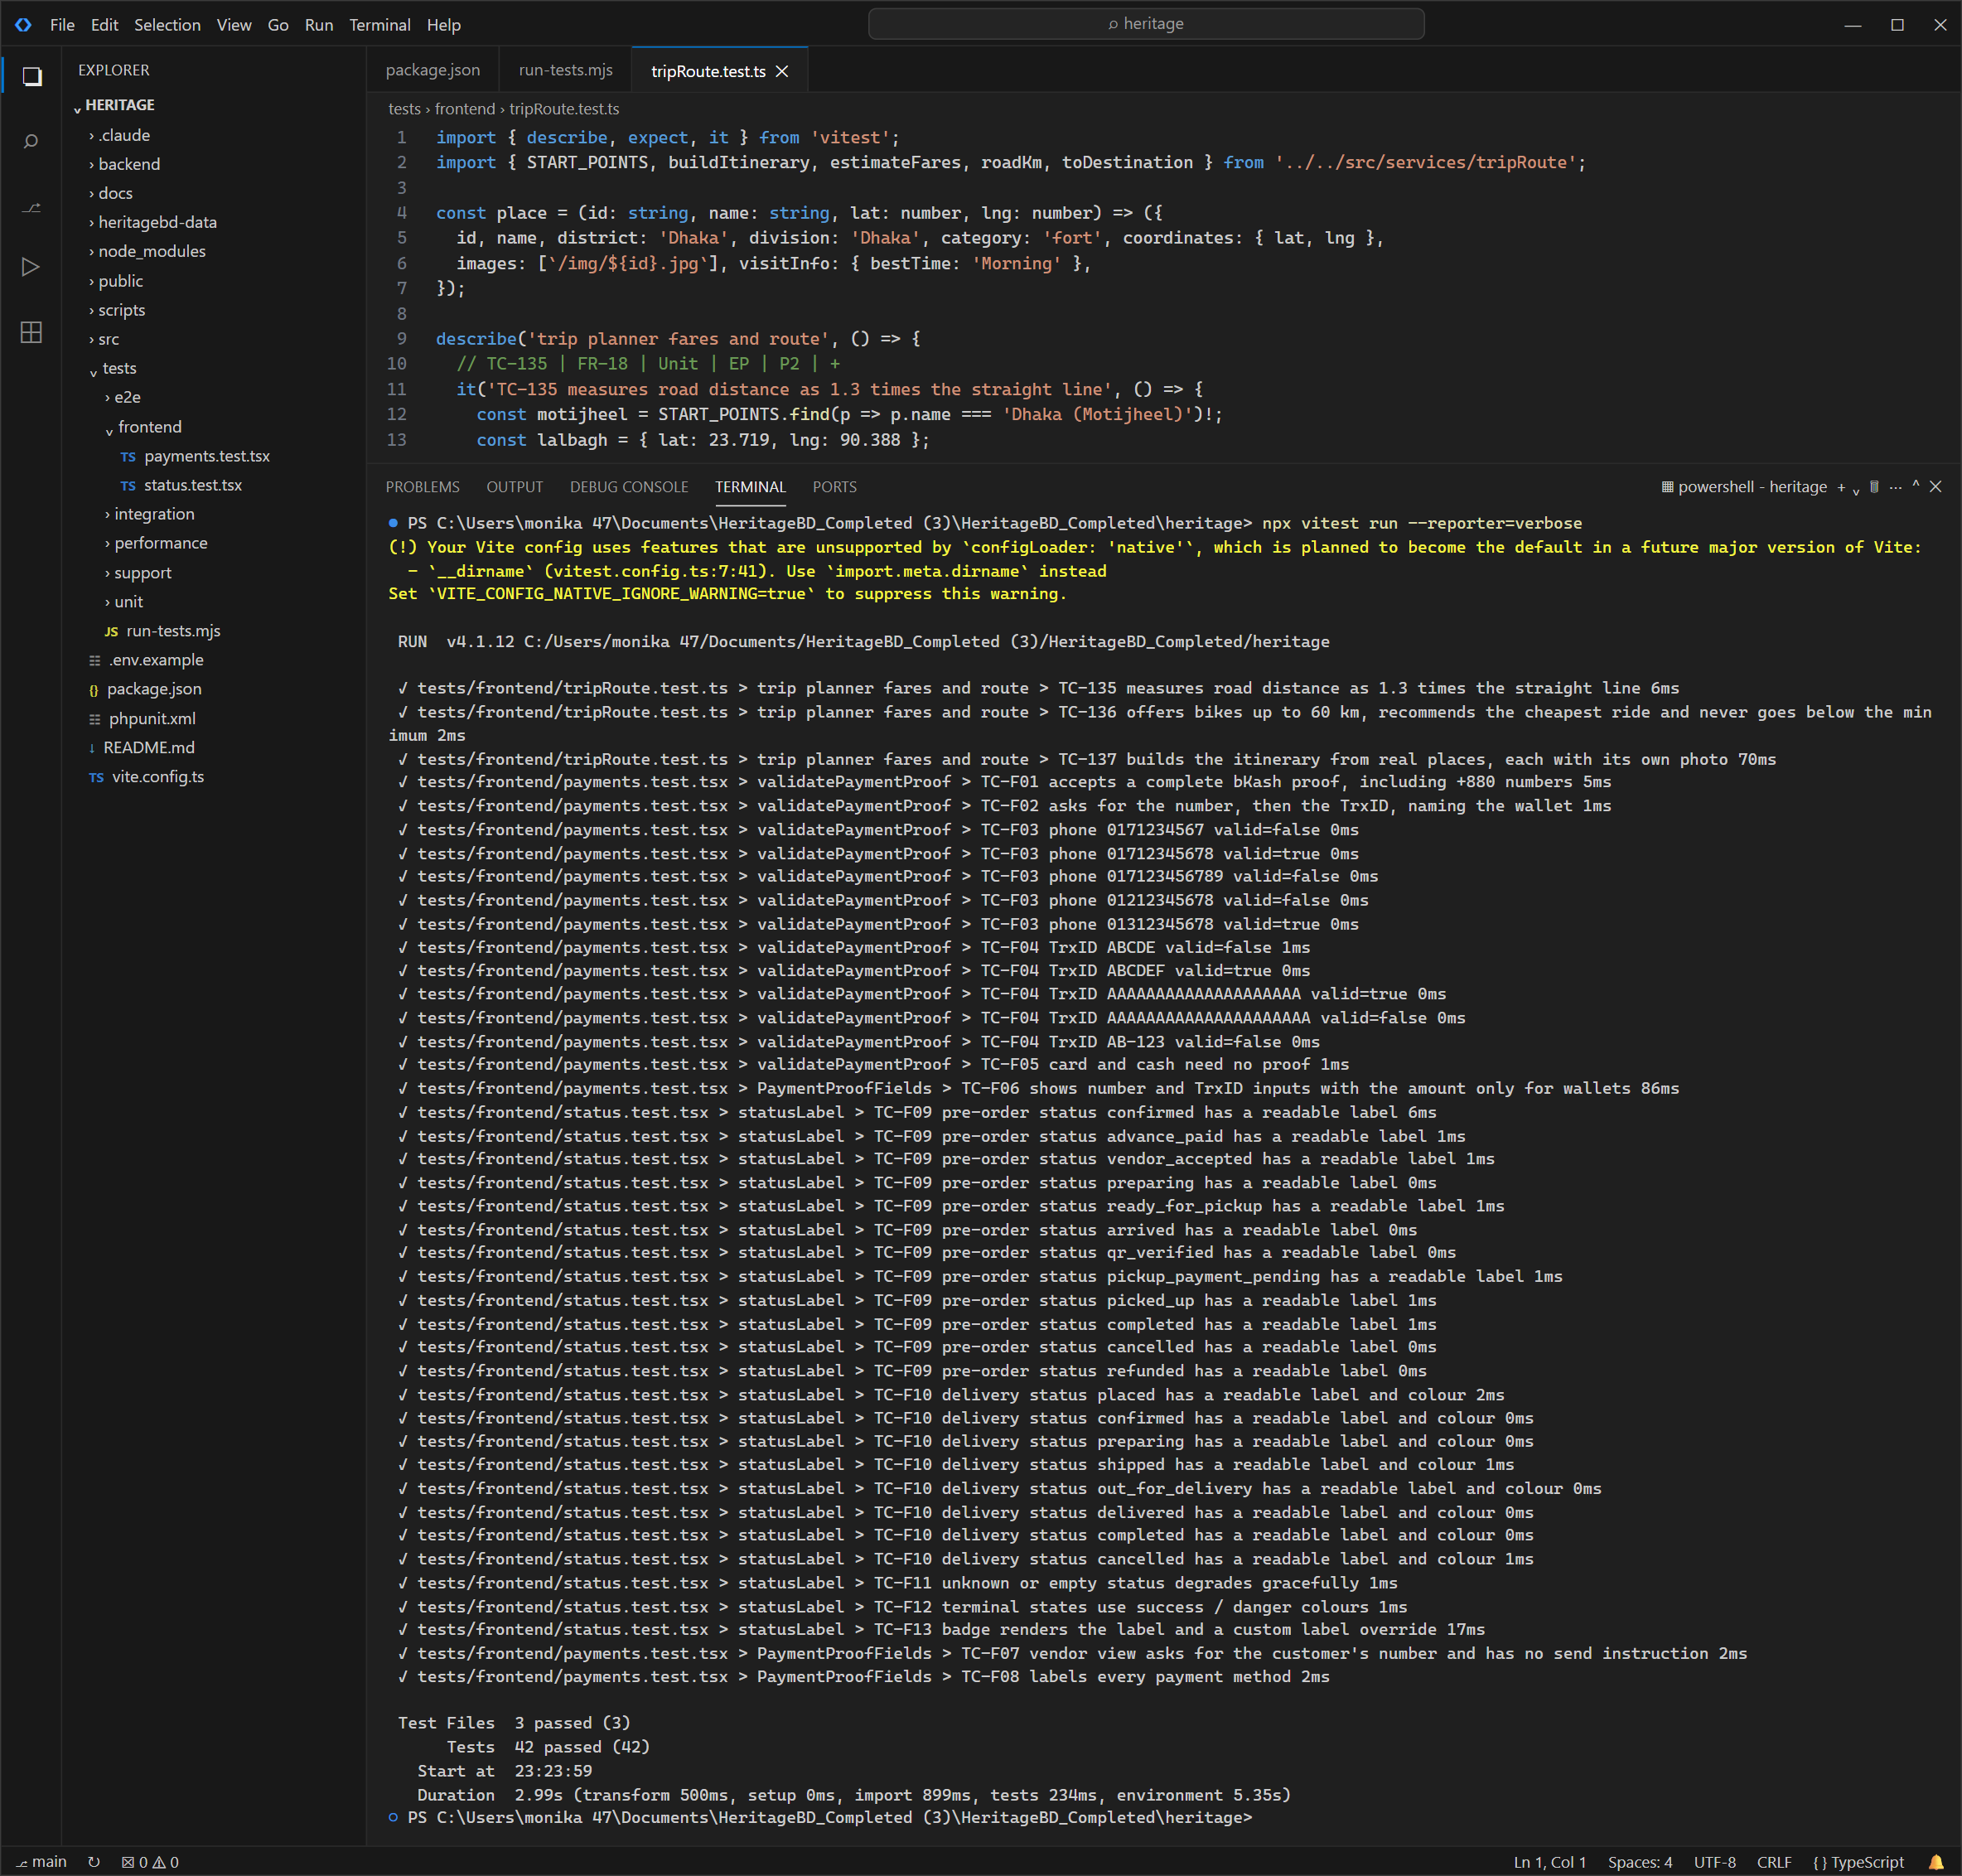
Figure 5: Frontend tests with Vitest, including the new trip fare and route tests (42 passed)
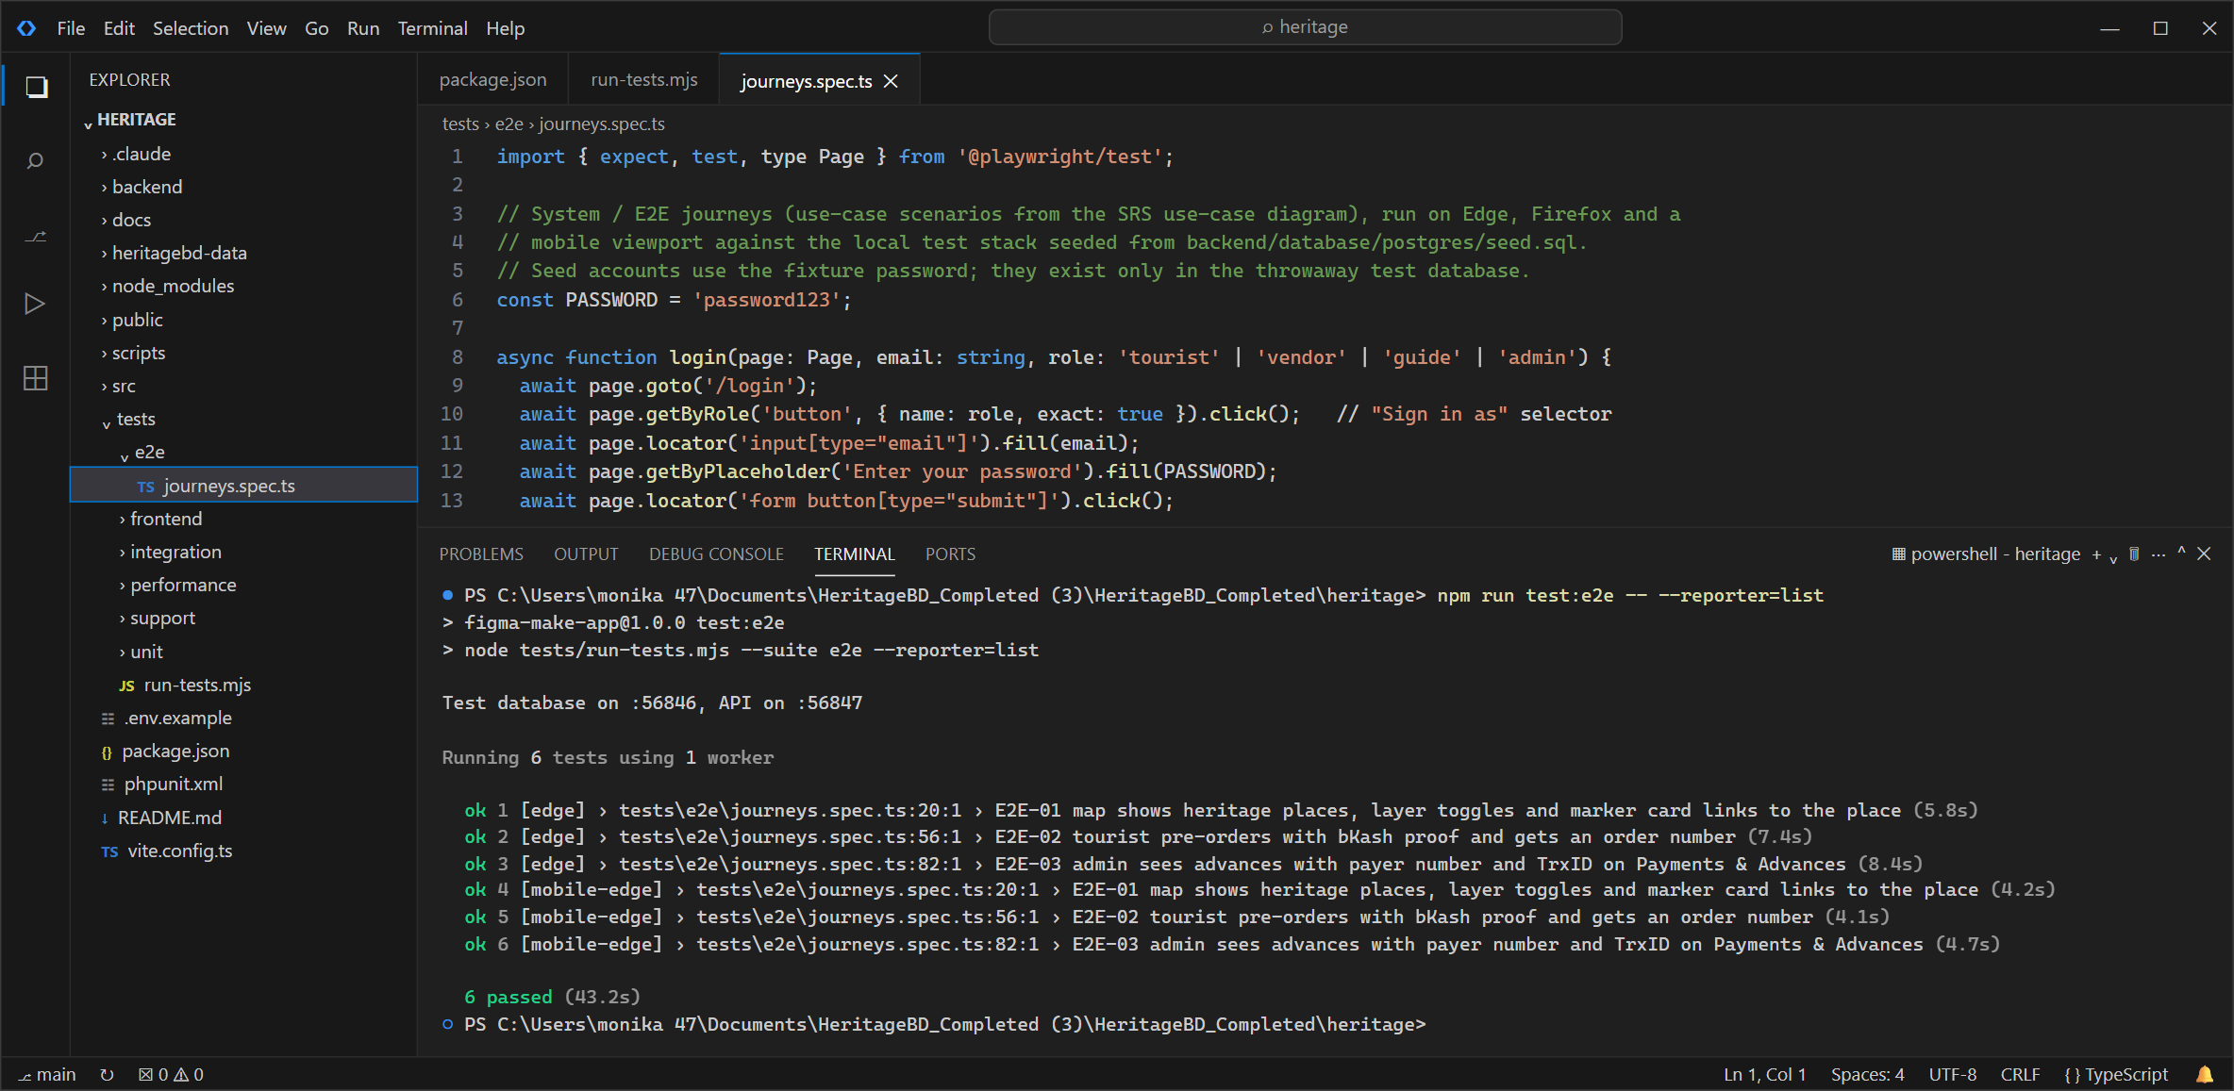
Figure 6: End-to-end journeys with Playwright on Edge, desktop and mobile (6 passed)
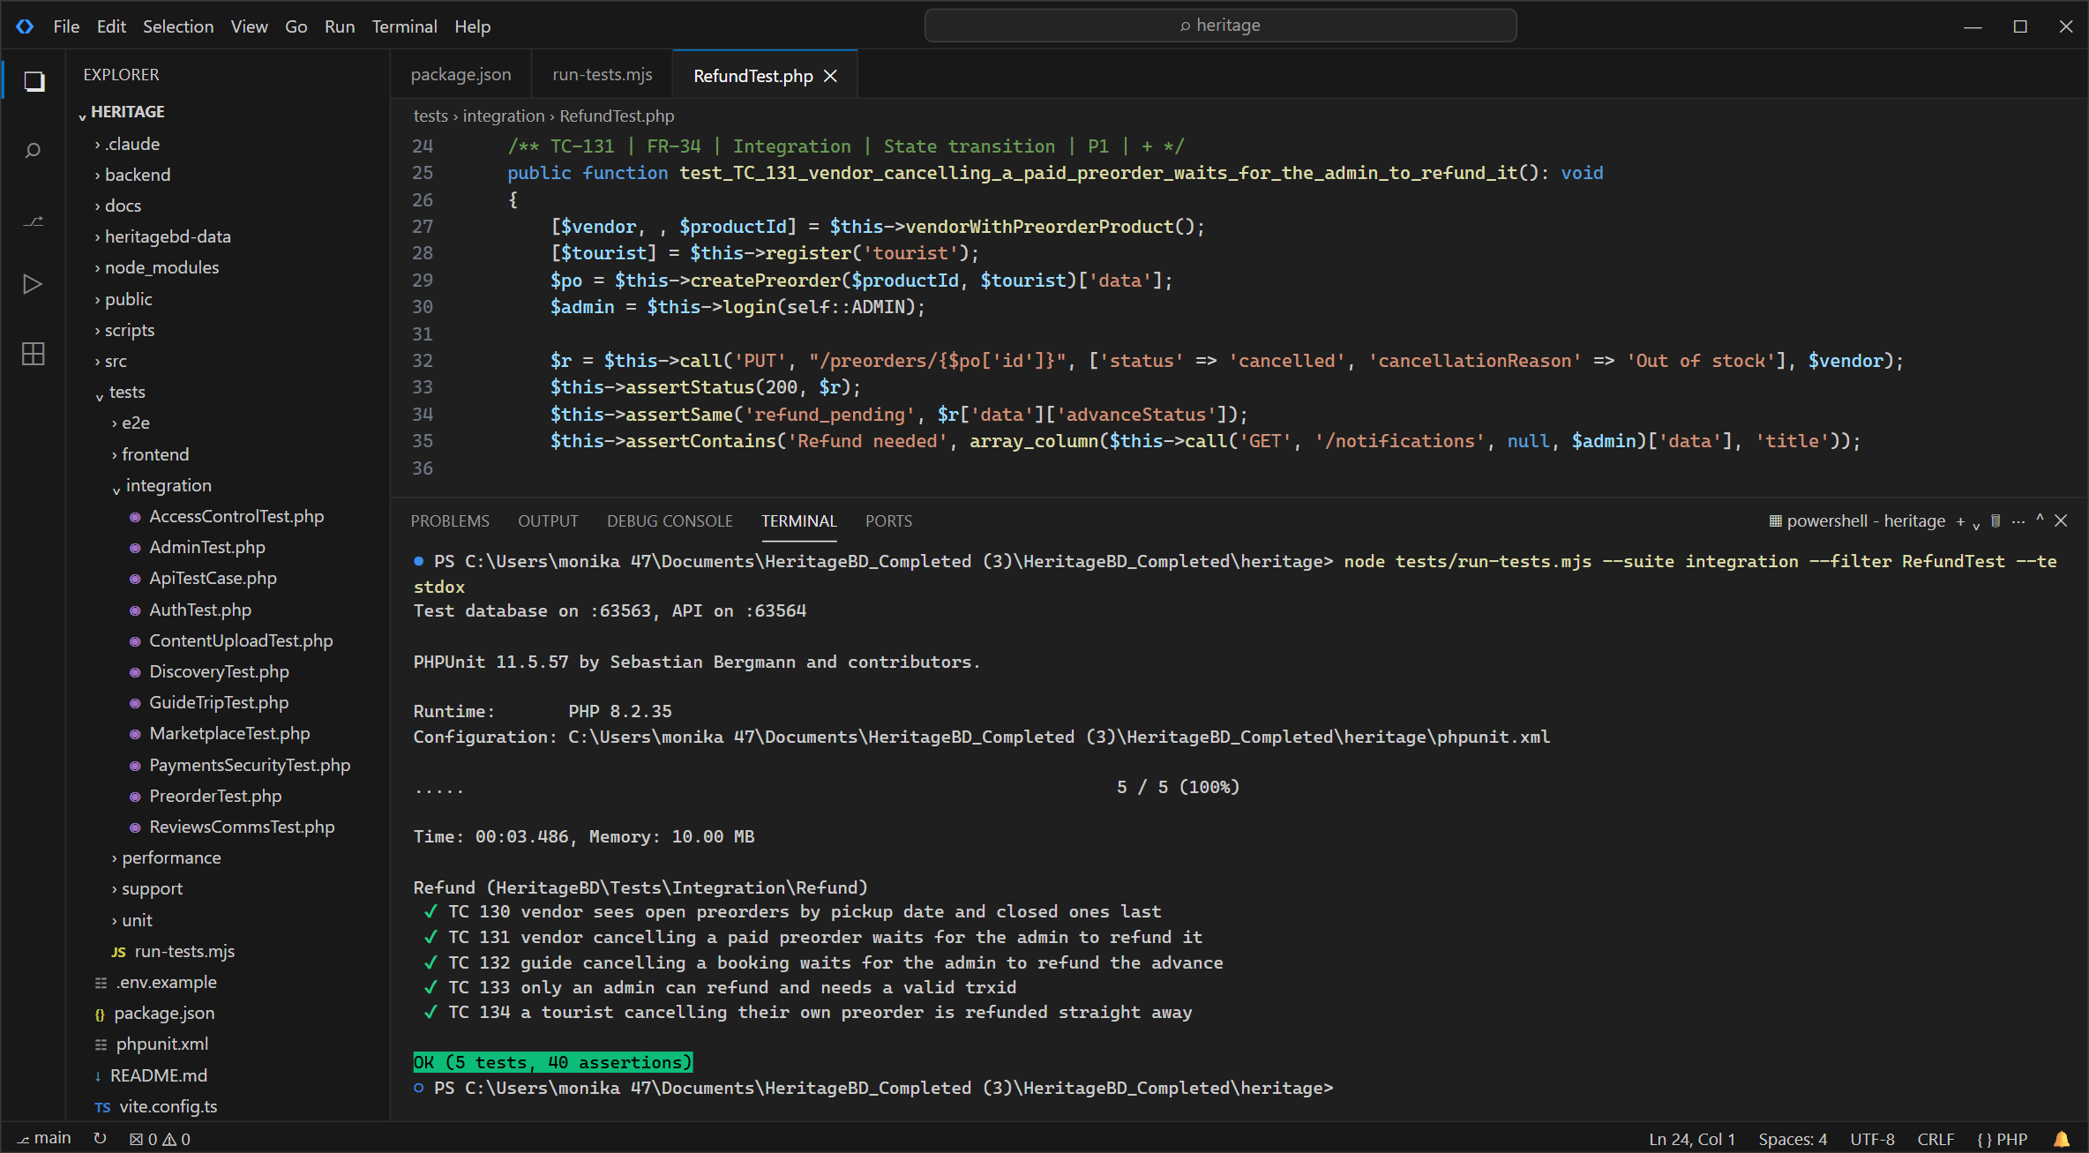
Figure 7: Admin refund and pre-order sorting API tests added after the last release (5 passed)

6.3 Failed tests
Test | Why it fails | Defect
TC-74 | No tracking number or automatic 5-day delivery estimate | DEF-08
TC-113 | No audit log of user and payment events | DEF-10
TC-101 | Place reviews cannot be submitted | DEF-09
These are gaps between the app and the SRS that we decided to leave for now. The tests stay so the gap is visible.

7. Code Coverage
Layer | Lines covered | Target
Data access and config | 76.2% (48/63)
Controllers and API | 78.4% (2273/2900)
Business logic and helpers | 92.7% (228/246) | 60%
Router (index.php) | 97.1% (134/138)
UI components with unit tests | 91.66%
Whole API | 80.2% | 60%
Lowest files: trips_controller.php 50.3%, uploads_controller.php 50.6%, admin_controller.php 56.4%. These are mostly guide-shared trip plans, admin lists and upload error paths. React pages are only covered by E2E. Branch coverage and mutation testing were not done (not needed for Baseline).

8. Non-Functional Testing

8.1 Performance
Endpoint | p50 | p95 | Errors | Result
/api/places | 679 ms | 862 ms | 0/60 | Pass
/api/products?limit=50 | 981 ms | 1103 ms | 0/60 | Pass
/api/guides | 650 ms | 838 ms | 0/60 | Pass
/api/places/p1 | 334 ms | 473 ms | 0/60 | Pass
/api/events?upcoming=1 | 298 ms | 389 ms | 0/60 | Pass
5 users at once, 60 requests each, on the live site. The SRS has no number, so we used 2 s as our target. During a deploy all requests failed for about a minute (DEF-12).

8.2 Security
Check | How | Result
Access control | User B tries A's orders, trips, chats, products (TC-20 to 27) | Pass
Login security | Lockout after 5 tries, expired token, logout (TC-09 to 12) | Pass
SQL injection | ' OR 1=1 -- in search and login (TC-114) | Pass
Error leaks | No SQL, paths or stack traces in errors (TC-115, 16) | Pass
Passwords | Stored as bcrypt only (TC-116) | Pass
Payment tampering | Client cannot set refund; proof required (TC-126, 110) | Pass
HTTPS | HTTP redirects to HTTPS, HSTS set | Pass
CORS | API allows any website | Fail (DEF-15)
Dependencies | npm audit 0 critical, 0 high; composer audit clean | Pass
Secrets | gitleaks on full history: 0 leaks | Pass
OWASP ZAP scan | Planned for Exp 10 | Not run

8.3 Static analysis
TypeScript and php -l on 53 files: 0 errors. SonarCloud comes in v1.1 (Exp 10).

8.4 Accessibility and browsers
Page | Lighthouse a11y | Performance
Landing (/) | 83 | 53
Places (/places) | 85 | 78
Place detail (/places/p7) | 88 | 76
Shop (/shop) | 82 | 75
Guides (/guides) | 85 | 71
Login (/login) | 95 | 96

8.5 Usability
Not done yet. Plan: 3 students from other sections try to register, pre-order with bKash, and book a guide from the map. We will record completion and time.

9. Defect Report
9.1 Summary by severity
Severity | Found | Fixed | Open
S1 | 1 | 1 | 0
S2 | 6 | 5 | 1
S3 | 8 | 3 | 5
S4 | 1 | 0 | 1
Total | 16 | 9 | 7

9.2 Defect log
ID | Req | Problem | Sev | Found by | Status | Regression test
DEF-07 | NFR-11 | Tourist can set any refund amount when cancelling a pre-order | S1 | TC-74 | Closed | TC-74
DEF-04 | FR-34 | Tourist can cancel a pre-order after preparation has started | S2 | TC-48 | Closed | TC-48
DEF-05 | FR-34, FR-35 | Refund amount not calculated from the configured refund percentage | S2 | TC-47 | Closed | TC-47
DEF-03 | FR-04 | Rejected vendor account stays active | S2 | TC-07 | Closed | TC-07
DEF-13 | - | Reporting a guide payment fails on PostgreSQL | S2 | Code review while building the guide cash flow | Closed | No test yet - add one
DEF-14 | NFR-13 | Bengali names shown as garbled text (mojibake) | S2 | User report; data scan of the live API | Closed | TC-75
DEF-02 | - | PHP warnings leak into API responses | S3 | Not recorded against a current TC | Closed | No test yet - add one
DEF-06 | FR-35 | Pre-order settings accept out-of-range values | S3 | TC-85 | Closed | TC-85
DEF-01 | FR-29, FR-27 | API smoke test out of date after required payment proof | S3 | backend/tests/api_smoke.php (existing suite) | Closed | api_smoke.php 'create pre-order' (see also TC-37)
DEF-09 | FR-39 | Place reviews cannot be submitted | S2 | TC-54 | Open, later | TC-54
DEF-08 | FR-36 | No tracking number or automatic 5-day delivery estimate | S3 | TC-50 | Open, later | TC-50
DEF-10 | FR-50 | No audit log of user and payment events | S3 | TC-67 | Open, later | TC-67
DEF-11 | NFR-14 | Accessibility: low contrast, unnamed icon buttons/links, unlabelled selects | S3 | Lighthouse 12.8.2 (tool) | Open | Lighthouse re-run (TC-76)
DEF-15 | - | API accepts requests from any origin (CORS *) | S3 | SEC-02 | Open | SEC-02
DEF-16 | - | No clickjacking / MIME-sniffing / CSP headers on the site | S4 | SEC-01 | Open | SEC-01
DEF-12 | NFR-01 | API returns 502 for about a minute after each deploy | S3 | Performance run (p95.mjs) | Open | p95.mjs (errors = 0); TC-69

Req uses the IDs in the Requirements Traceability Matrix; TC numbers are those in the Test Case Specification (TC-01 to TC-87). A dash means no matching requirement in the matrix.
Every fixed defect has a test that failed before the fix and passes after it (evidence A11).
9.3 Main defects
ID | Test | Title | Cause | Fix
DEF-07 | TC-74 | refundAmount 99999 stored and shown as the refund | preorders_update copied refundAmount from any participant's request body into the row (generic field map) without a role check. | commit 99d71bf
DEF-04 | TC-48 | 200 OK, pre-order cancelled and advance marked refunded | PREORDER_TRANSITIONS allowed cancelled from every non-final state for every participant; no tourist-specific rule. | commit 99d71bf
DEF-05 | TC-47 | refundAmount null | Known limitation (SRS §6.5): settings were stored but never applied on cancellation. | commit 99d71bf
DEF-03 | TC-07 | 200 OK, vendor logged in | admin_vendor_verify always set status = 'active'; the guide version set 'suspended' on rejection. | commit 99d71bf
DEF-13 | No test yet - add one | 500: INSERT used the double-quoted "reported", which PostgreSQL reads as a column name | MySQL-only SQL (double-quoted string literal) missed in the PostgreSQL migration. | commit 8bf0f55
DEF-14 | TC-75 | 'αª¼αªù…' instead of 'বগুড়ার দই' | The XAMPP dump was written through the Windows console (code page 437). | commit data
DEF-09 | TC-54 | 422 'Place reviews require a verified visit record, which is not supported yet.' | Design choice to require a visit record that does not exist yet. | Open

10. Tool-Assisted Testing Log:
Test | What the tool got wrong | What we did
TC-36 | Expected a 12-month chart; the SRS never says 12 months | Removed that check
TC-37 | Sent entry fee in the wrong field | Fixed the request
TC-65 | Bad category was silently replaced, so the test checked nothing | Fixed the test data
TC-59, 109, 110 | Depended on other tests running first | Each test makes its own data
E2E-01 | Counted map pins before all loaded (flaky) | Wait for data first

11. Test Completion Summary

11.1 Exit criteria evaluation
10 of 12 Baseline criteria are met. Not met: only one browser tested, and no usability test yet.

11.2 Residual risks and known issues
Risk | Impact on users | What to do
Place reviews off (DEF-09) | Tourists cannot rate places | Decide the visit rule, then enable
CORS open (DEF-15) | Any site can call the API | Set CORS_ORIGIN on Render
Firefox/Safari untested | Unknown layout issues | Check by hand before release
Manual payments | Fake TrxIDs not caught automatically | Admin checks wallet statements
Downtime on deploy (DEF-12) | Site fails for about a minute | Deploy at quiet times
Demo passwords in production | Admin account could be taken | Change them now

11.3 Release Recommendation
Go with known issues. All P1 tests pass and the one critical bug (users setting their own refund) is fixed. Before real customers: change the demo passwords, restrict CORS, and test on Firefox and Safari.

11.4 Lessons learned
- Testing against the SRS found real bugs that testing against the code would miss.
- Test on the same database as production. A MySQL-only query broke a payment on PostgreSQL.
- Tests should make their own data, or they break when run in a different order.
- Next time, put numbers in the SRS (response time, browsers) and set up CI early.

12. Individual Contribution
Member | Test cases | Defects found | Defects fixed
Sumaiya Jahan | TC1-TC50 | 10 | 10
Monika Akter | TC51-TC74 | 5 | 5

13. Sign-off and Declaration
We declare that this report describes testing we did on the stated version. Results can be reproduced from the repository. Tool use is disclosed in section 10.
 | Name | Signature | Date
Prepared by | Monika Akter, Sumaiya Jahan |  | Oct 21, 2026
Reviewed by | Monika Akter, Sumaiya jahan |  | Oct 27, 2026

Appendix A: Evidence Index
All in docs/testing/evidence/.
# | Evidence | File
A1 | PHP test results | junit-php.xml, test-run-coverage.log
A2 | Frontend and E2E results | junit-frontend.xml, junit-e2e.xml, e2e-report/
A3 | Traceability | rtm.csv, test-catalogue.json
A4 | Coverage | coverage/index.html, coverage-summary.json
A5 | Performance | performance-p95.json
A6 | Audits and secret scan | npm-audit.json, composer-audit.txt, gitleaks-history.json
A7 | Lighthouse | lighthouse/*.html
A8 | E2E repeat runs | e2e-flakiness.txt
A9 | Fresh clone run | clean-clone-run.log
A10 | Lint | lint.log
A11 | Before/after for fixed bugs | regression-before-after.txt
A12 | HTTPS and CORS check | security-transport.txt

Appendix B: Pre-Submission Checklist
Yes: version stated and all results come from it
Yes: tests run from the README commands on a fresh clone
No: CI run (planned for Exp 12)
Yes: every FR and NFR has a test
Yes: coverage numbers match the report files
Yes: no open S1 defects; every fixed defect has a regression test
Yes: tool use disclosed
Yes: no real personal data or secrets in tests
To do: Team ID, roles, contribution table and signatures

