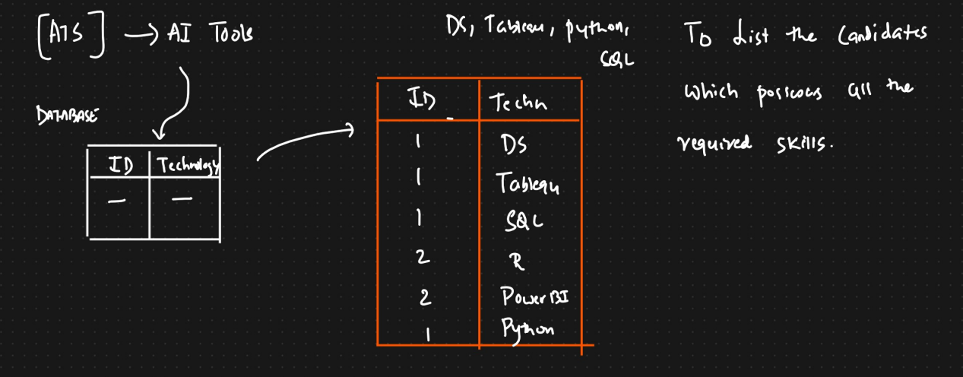

Query:

SELECT id FROM candidates WHERE

skill IN ('DS', 'Tableau', 'Python',’SQL’) GROUP BY id HAVING count(*) =4

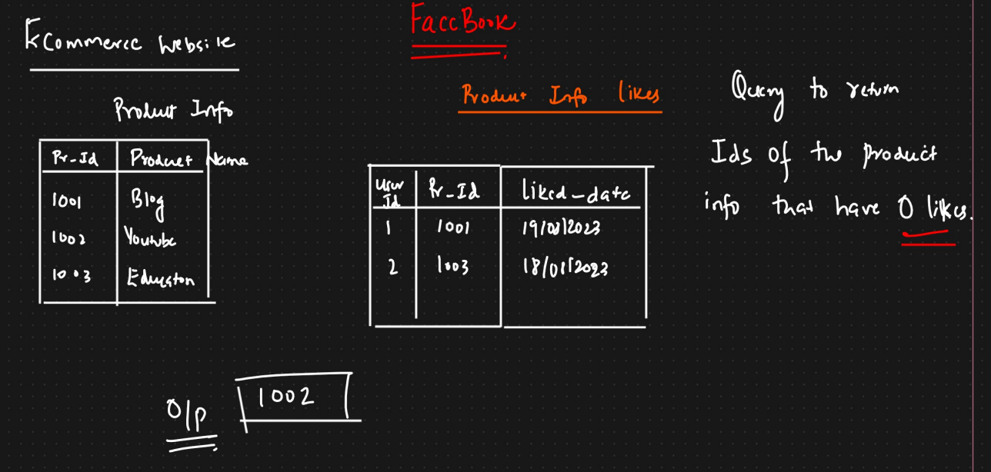

SELECT pg.page_id FROM product_info pg left JOIN product_likes lk

ON

pg.page_id=lk.page_id

WHERE lk.user_id is NULL

ORDER BY pg.page_id ASC