Clone and update:
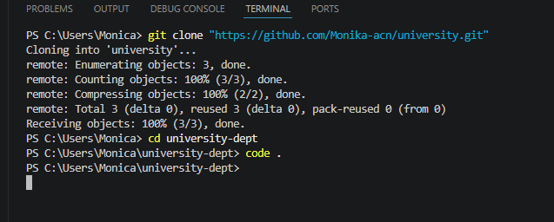

Worked pipeline script:
pipeline {
agent any

environment {
KUBECONFIG = 'C:\\Users\\Monica\\.kube\\config'
}

stages {

stage('Clone Repo') {
steps {
git branch: 'main', url: 'https://github.com/Monika-acn/university.git'
}
}

stage('Build Docker Image') {
steps {
bat 'docker build -t university-site .'
}
}

stage('Run Container') {
steps {
bat 'docker run -d -p 8085:80 university-site'
}
}

stage('Deploy to Kubernetes') {
steps {
bat '''
kubectl config current-context
kubectl get nodes
kubectl apply -f deployment.yaml
'''
}
}
}
}

Chatgpt:
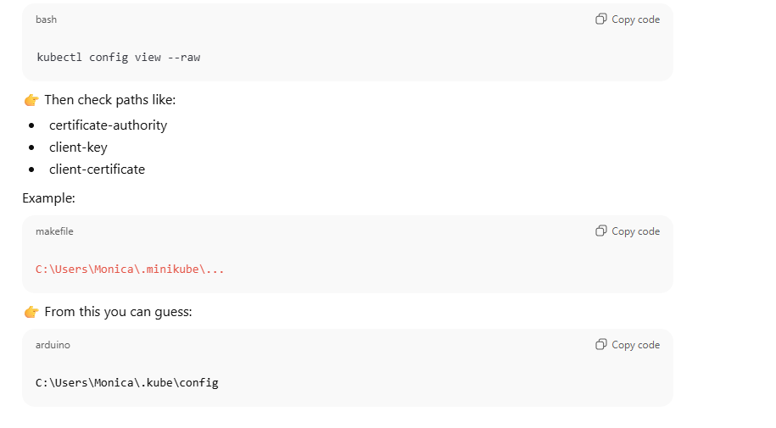

Important:
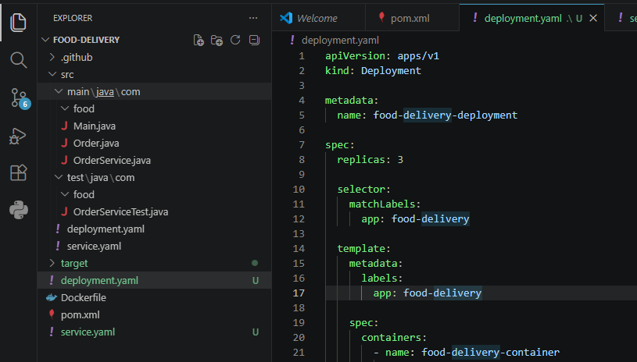

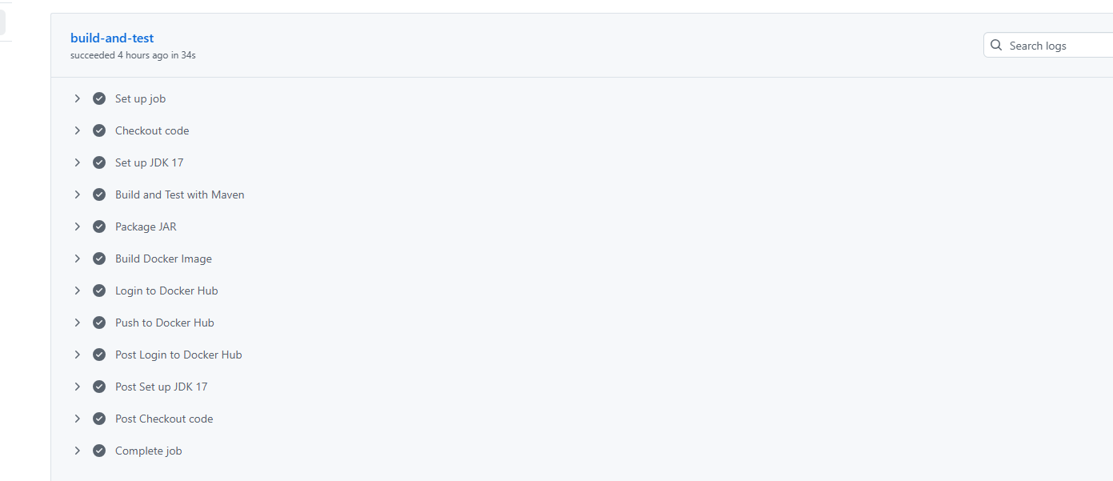

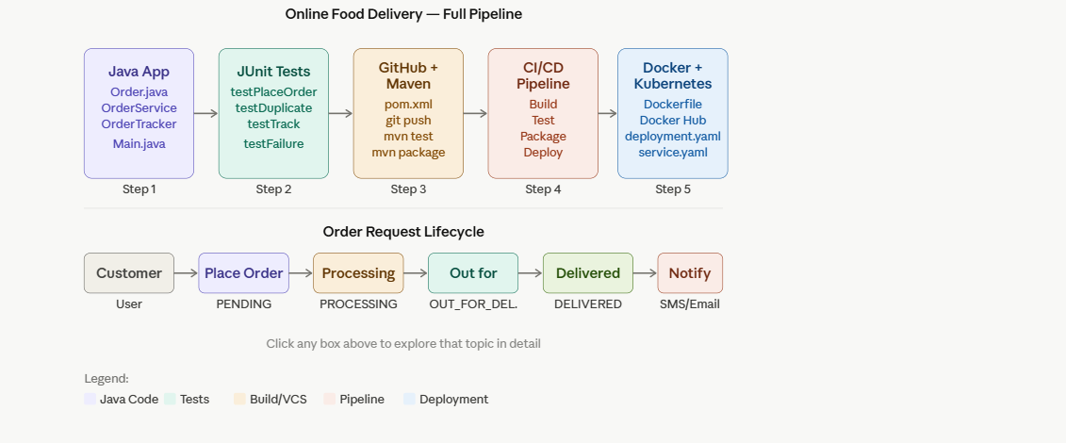

Click any box in the diagram to dive into that topic. Now let me teach you everything line by line — exactly how you need to answer in an exam.

STEP 1 — Java Program (Order Placement & Tracking Logic)

Why we write this first?
The Java program is the core business logic. Everything else (testing, CI/CD, Docker) wraps around it. In an exam, they want you to show you understand the system before automating it.
Order.java:
// WHY: This class represents one food order.
// It holds all the data (order ID, customer, food item, status).
// We use an enum for status so only VALID values are allowed.

public class Order {
private String orderId; // Unique ID for each order
private String customerName;
private String foodItem;
private String status; // PENDING, PROCESSING, DELIVERED

// Constructor: called when a new order is created
public Order(String orderId, String customerName, String foodItem) {
this.orderId = orderId;
this.customerName = customerName;
this.foodItem = foodItem;
this.status = "PENDING"; // Every order starts as PENDING
}

// Getters and Setters
public String getOrderId() { return orderId; }
public String getStatus() { return status; }
public void setStatus(String status) { this.status = status; }

@Override
public String toString() {
return "Order[" + orderId + ", " + customerName + ", " + foodItem + ", " + status + "]";
}
}

Main.java:
// WHY: This is where execution starts.
// It tests our logic manually before writing automated JUnit tests.

public class Main {
public static void main(String[] args) {
OrderService service = new OrderService();

// Test placing orders
System.out.println(service.placeOrder("ORD001", "Ravi", "Biryani"));
System.out.println(service.placeOrder("ORD002", "Priya", "Dosa"));

// Test duplicate → should return ERROR
System.out.println(service.placeOrder("ORD001", "Ravi", "Pizza"));

// Test tracking
System.out.println(service.trackOrder("ORD001"));

// Update status
System.out.println(service.updateStatus("ORD001", "PROCESSING"));
System.out.println(service.updateStatus("ORD001", "DELIVERED"));

// Track non-existent order
System.out.println(service.trackOrder("ORD999"));
}
}

STEP 2 — JUnit Testing

Why do we write tests?
JUnit tests automatically verify your code works. In CI/CD pipelines, tests run automatically on every code push. If a test fails, the deployment is stopped. This is called "fail fast" principle.

pom.xml — Maven Dependencies (add this first!)
<!-- WHY: pom.xml tells Maven what libraries to download.
JUnit 5 (Jupiter) is the testing framework we use. -->
<dependencies>
<dependency>
<groupId>org.junit.jupiter</groupId>
<artifactId>junit-jupiter</artifactId>
<version>5.10.0</version>
<scope>test</scope> <!-- WHY scope=test? Only needed during testing, not in final JAR -->
</dependency>
</dependencies>

<build>
<plugins>
<plugin>
<!-- WHY: Maven Surefire runs JUnit tests during 'mvn test' -->
<groupId>org.apache.maven.plugins</groupId>
<artifactId>maven-surefire-plugin</artifactId>
<version>3.1.2</version>
</plugin>
</plugins>
</build>

OrderServiceTest.java:
import org.junit.jupiter.api.*;
import static org.junit.jupiter.api.Assertions.*;

// WHY @TestMethodOrder? → Ensures tests run in a predictable order
@TestMethodOrder(MethodOrderer.OrderAnnotation.class)

public class OrderServiceTest {

// WHY static? → Same instance shared across all test methods
private static OrderService service;

// WHY @BeforeAll? → Runs ONCE before all tests. Set up shared resources here.
@BeforeAll
static void setup() {
service = new OrderService();
}

// TEST 1: Successful order placement
@Test
@org.junit.jupiter.api.Order(1)
void testPlaceOrderSuccess() {
String result = service.placeOrder("ORD001", "Ravi", "Biryani");
// WHY assertTrue with contains? → Check the success message
assertTrue(result.contains("SUCCESS"), "Order should be placed successfully");
}

// TEST 2: Duplicate order → must return ERROR
@Test
@org.junit.jupiter.api.Order(2)
void testDuplicateOrderPrevention() {
String result = service.placeOrder("ORD001", "Ravi", "Pizza"); // same ID
assertTrue(result.contains("ERROR"), "Duplicate order should return error");
}

// TEST 3: Track a valid order
@Test
@org.junit.jupiter.api.Order(3)
void testTrackOrderSuccess() {
String result = service.trackOrder("ORD001");
assertTrue(result.contains("STATUS"), "Should return order status");
}

// TEST 4: Track non-existent order → failure scenario
@Test
@org.junit.jupiter.api.Order(4)
void testTrackOrderFailure() {
String result = service.trackOrder("ORD999");
assertTrue(result.contains("ERROR"), "Non-existent order should return error");
}

// TEST 5: Update order status
@Test
@org.junit.jupiter.api.Order(5)
void testUpdateOrderStatus() {
String result = service.updateStatus("ORD001", "DELIVERED");
assertTrue(result.contains("DELIVERED"), "Status should update to DELIVERED");
}
}

STEP 3 — CI/CD Pipeline with GitHub Actions

Why CI/CD?
- CI (Continuous Integration) = every push to GitHub automatically builds and tests your code
- CD (Continuous Deployment) = after tests pass, automatically build Docker image and push to Docker Hub
- Why? → Catch bugs early, no manual deployment errors, consistent builds
food-delivery/
├── src/
│ ├── main/java/com/food/
│ │ ├── Order.java
│ │ ├── OrderService.java
│ │ └── Main.java
│ └── test/java/com/food/
│ └── OrderServiceTest.java
├── pom.xml
├── Dockerfile
└── .github/
└── workflows/
└── ci-cd.yml ← THIS IS THE PIPELINE FILE

.github/workflows/ci-cd.yml:
# WHY: This file defines the entire CI/CD pipeline.
# GitHub Actions reads this file and runs it automatically on every push.

name: Food Delivery CI/CD Pipeline

# WHY 'on: push'? → Trigger this pipeline whenever code is pushed to main branch
on:
push:
branches: [ main ]
pull_request:
branches: [ main ]

jobs:
build-and-test:
# WHY ubuntu-latest? → Free Linux runner provided by GitHub
runs-on: ubuntu-latest

steps:
# Step 1: Get the code from GitHub repository
- name: Checkout code
uses: actions/checkout@v3
# WHY: Without this, the runner has no code to work with

# Step 2: Set up Java environment
- name: Set up JDK 17
uses: actions/setup-java@v3
with:
java-version: '17'
distribution: 'temurin'
# WHY: The runner starts as a blank machine. We must install Java.

# Step 3: Build the project and run JUnit tests
- name: Build and Test with Maven
run: mvn clean test
# WHY 'mvn clean test'?
# 'clean' → removes old build files (fresh build)
# 'test' → compiles code + runs all JUnit tests
# If any test fails → this step fails → pipeline stops → no bad code deployed!

# Step 4: Package the app into a JAR file
- name: Package JAR
run: mvn package -DskipTests
# WHY -DskipTests? → Tests already ran in previous step, don't repeat

# Step 5: Build Docker image
- name: Build Docker Image
run: docker build -t yourdockerhubuser/food-delivery:latest .
# WHY: Creates a portable container with our app inside

# Step 6: Login to Docker Hub
- name: Login to Docker Hub
uses: docker/login-action@v2
with:
username: ${{ secrets.DOCKER_USERNAME }}
password: ${{ secrets.DOCKER_PASSWORD }}
# WHY secrets? → NEVER hardcode passwords in code. GitHub Secrets stores them safely.

# Step 7: Push Docker image to Docker Hub
- name: Push to Docker Hub
run: docker push yourdockerhubuser/food-delivery:latest
# WHY push? → Kubernetes will pull this image to deploy our app

How to set up GitHub Secrets (exam question!):
Go to GitHub repo → Settings → Secrets and variables → Actions → New repository secret → Add DOCKER_USERNAME and DOCKER_PASSWORD

STEP 4 — Docker

Why Docker?
Docker packages your app + Java + all dependencies into one container image. This guarantees "it works on my machine AND on the server AND in Kubernetes" — same environment everywhere.
Dockerfile:
# WHY FROM openjdk:17? → We need Java 17 to run our app.
# 'slim' version = smaller image size (faster download)
FROM openjdk:17-jdk-slim

# WHY WORKDIR? → Sets the working directory inside the container.
# All subsequent commands run from this path.
WORKDIR /app

# WHY COPY? → Copies our compiled JAR file into the container.
# Maven puts the JAR in target/ folder after 'mvn package'
COPY target/food-delivery-1.0.jar food-delivery.jar

# WHY EXPOSE 8080? → Documents that our app listens on port 8080.
# (Doesn't actually open the port — just documentation + Kubernetes uses this info)
EXPOSE 8080

# WHY ENTRYPOINT? → The command that runs when container starts.
# java -jar runs our JAR file.
ENTRYPOINT ["java", "-jar", "food-delivery.jar"]

Build and push commands (run these locally or in CI/CD):
# Build the JAR first
mvn clean package

# Build Docker image
# WHY -t? → Tags (names) the image so we can reference it
docker build -t yourdockerhubuser/food-delivery:latest .

# Login to Docker Hub
docker login

# Push to Docker Hub
# WHY push? → Makes image available online so Kubernetes can pull it
docker push yourdockerhubuser/food-delivery:latest

# Test it locally first
docker run -p 8080:8080 yourdockerhubuser/food-delivery:latest

STEP 5 — Kubernetes

Why Kubernetes (K8s)?
Docker runs ONE container. Kubernetes manages many containers across many servers:
- Auto-restart if a container crashes
- Scaling — run 3 copies (replicas) for high traffic
- Load balancing — distribute traffic across replicas
- Rolling updates — deploy new version with zero downtime

deployment.yaml
# WHY apiVersion apps/v1? → Specifies which Kubernetes API version handles Deployments
apiVersion: apps/v1

# WHY kind: Deployment? → Tells K8s this file describes a Deployment (not a Service, Pod, etc.)
kind: Deployment

metadata:
name: food-delivery-deployment # Name of this deployment

spec:
# WHY replicas: 3? → Run 3 copies of our container for high availability.
# If one crashes, 2 others still serve requests.
replicas: 3

# WHY selector? → Links this Deployment to the Pods it manages.
# Must match the labels in the Pod template below.
selector:
matchLabels:
app: food-delivery

template:
metadata:
labels:
app: food-delivery # Label that selector above matches

spec:
containers:
- name: food-delivery-container
# WHY this image path? → K8s pulls the image from Docker Hub
image: yourdockerhubuser/food-delivery:latest

# WHY imagePullPolicy: Always? → Always download the latest image on each deploy
imagePullPolicy: Always

ports:
- containerPort: 8080 # Port inside the container

# WHY resources? → Prevents one pod from consuming all server resources
resources:
requests:
memory: "256Mi" # Minimum memory guaranteed
cpu: "250m" # 250 millicores = 0.25 CPU core
limits:
memory: "512Mi" # Maximum memory allowed
cpu: "500m" # Maximum CPU allowed

service.yaml:
# WHY a Service? → A Deployment creates Pods, but Pods have random IP addresses.
# A Service gives a STABLE endpoint to reach those pods.
# Without this, you can't access your app from outside Kubernetes!

apiVersion: v1
kind: Service

metadata:
name: food-delivery-service

spec:
# WHY selector? → This Service routes traffic to Pods with label app=food-delivery
selector:
app: food-delivery

ports:
- protocol: TCP
port: 80 # Port that the Service exposes externally
targetPort: 8080 # Port inside the container (must match containerPort above)

# WHY LoadBalancer? → Creates an external IP address (used in cloud like AWS/GCP/Azure)
# For local testing use: NodePort
type: LoadBalancer

Kubernetes commands:
# WHY kubectl apply? → Sends YAML instructions to Kubernetes cluster to create/update resources
kubectl apply -f deployment.yaml
kubectl apply -f service.yaml

# Check if pods are running (should show 3 pods)
kubectl get pods

# Check the service (get the external IP)
kubectl get service food-delivery-service

# See logs of a pod (for debugging)
kubectl logs <pod-name>

# Scale up to 5 replicas (no downtime!)
kubectl scale deployment food-delivery-deployment --replicas=5

