Databricks ETL (Extract, Transform and Load) Airflow Orchestration Implementation steps:
Airflow with Databricks:
Install Docker:
Steps:
- Download python-3.8.10 installer on your machine or VM by using below link for 64bit Windows OS and install python and set system path environment variable for python. (if already have pyhton3.8.10 then no need to install)
https://www.python.org/downloads/release/python-3810/
- To install docker your machine should have at least 4GB RAM.
- Download Docker for windows on your machine so that it can create container and run airflow. Please refer below link for the same:

https://www.docker.com/get-started/

- Execute Docker Desktop installer.
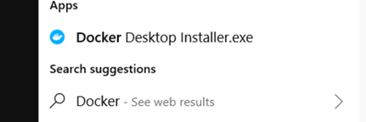

it will show the configuration page select Use WSL2 instead of Hyper-V(recommended).
- Click on OK, then restart your machine.
- Open Docker Desktop to view the container after performing Airflow containers setup.
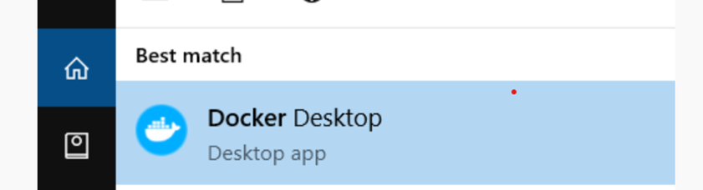

Docker container setup for airflow:

Steps:

- Open command prompt and create a folder ex: “airflow-docker” on the location where you want to setup all airflow related containers.
mkdir $DirPath <dir_name>
- Change the directory for the created folder:

cd <dir_name>
- Run below command to pull docker-compose.yaml file from specific URL:

curl -LfO https://airflow.apache.org/docs/apache-airflow/2.6.1/docker-compose.yaml
Above command will download docker-compose.yaml file inside airflow-docker (inside the newly created directory) directory.

- Run below command to initialize airflow containers inside docker:

docker compose run airflow-worker airflow info
After running above command config, dags, logs and plugins folders will be created inside the directory.
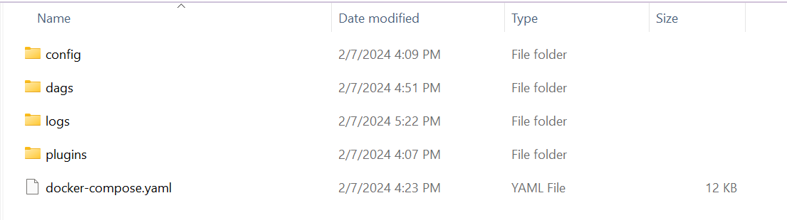

- Trigger below command to run all container services:

docker compose up

- Once all services started, we can run below command to check the running instances:

docker ps
we will get the output like below screenshot:
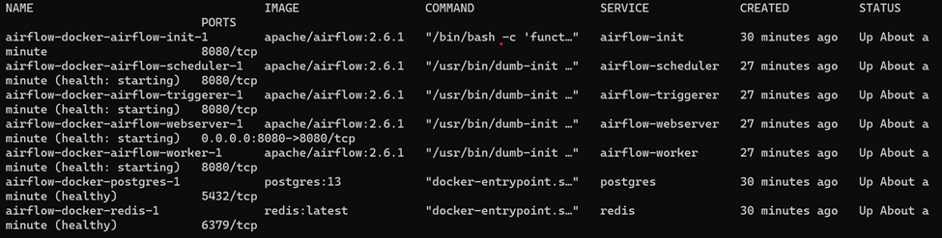

- Install apache-airflow-providers-databricks library in scheduler, webserver, and worker containers after connecting by using below command:
docker exec -u root -it <container_id> bash
Run below command after connecting the container:
pip install apache-airflow-providers-databricks
- Create the databricks connection in airflow using Admin -> connection option.

- Click on create connection button or + tab and fill the details like connection id, type should be Databricks, then host should be Databricks URL and password should be token which will get invisible after clicking on save button.

- Once installation is done then restart all the services by using below command
Docker-compose restart

- Copy below URL and paste it in browser (ex: Google chrome, Internet Explorer) to login Airflow UI:
http://localhost:8080
- Login by using default username and password -> airflow (both username and password is airflow).
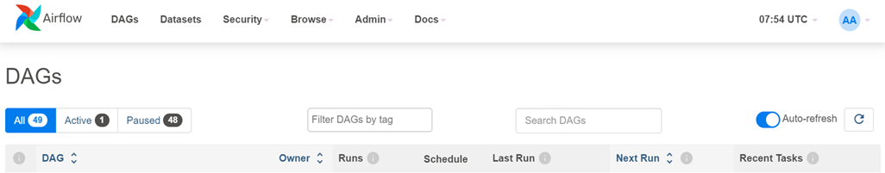
- To create Databricks connection go to Admin -> Connection.
- Create a connection by giving connection id and select connection type as Databricks then provide Host by giving the Databricks URL and password is token.
- Test the connection by clicking test button, if successful then click on save button.

Metadata Driven Approach:

ETL Orchestration
Steps:

- To add metadata as configurations in a file and use it in Databricks ETL code within Apache Airflow, we can employ a combination of Airflow's parameter passing mechanisms and Databricks libraries.

Sample code for config file creation:

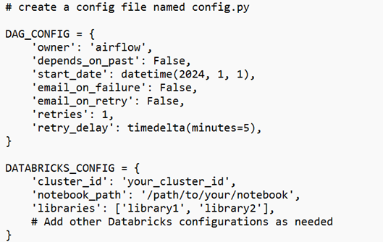

We can add all the required configuration for execution here in databricks config.

- To access these configurations in Airflow DAG: Import the configurations from the config.py file and use them within Airflow DAG definition. Pass relevant parameters to Databricks operator.

Sample code to import libraries:

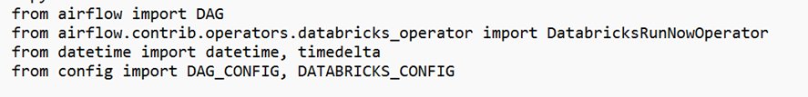

- To access Configurations in Databricks Notebook: In Databricks notebook, we can access the parameters passed from Airflow using the dbutils library:

Sample code:

By following above steps, we can centralize metadata and configurations in a separate config file and use them both within our Airflow DAG definition and Databricks ETL code. This allows for easier management and updates of configurations across Airflow workflows.

- Define all required functions/task to perform extract, transform and load. Follow the below sample code for the same:

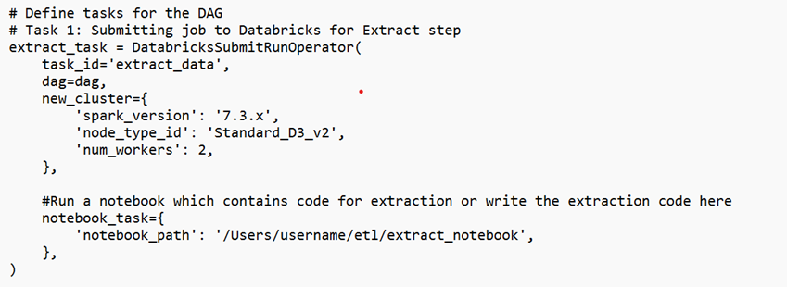
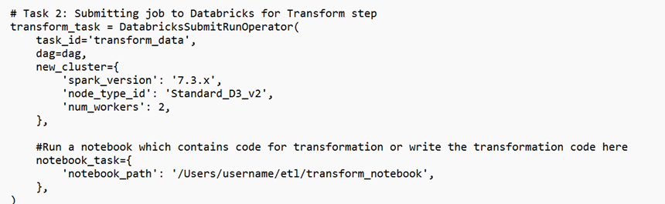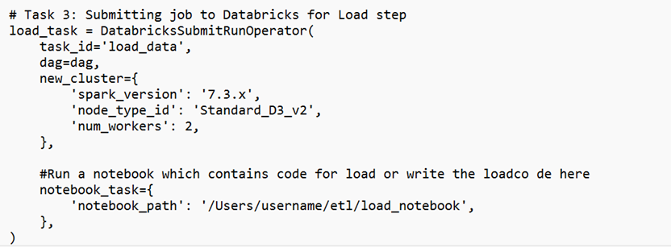

Define three tasks: extract_data, transform_data, and load data. Each task submits a job to a Databricks cluster with a specific notebook for extraction, transformation, and loading, respectively.

Set task dependencies:

- Task dependencies are defined using the >> operator, ensuring that tasks run sequentially. Use the set_upstream() or >> operator to define dependencies between tasks. This ensures that a task only executes after its dependencies have successfully completed.

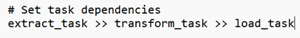

Restartability:

- To handle restart-ability and ensuring data consistency in Airflow DAG involves the concept of task retries, task IDs, and sensor operators. We can modify the DAG to incorporate these features by using below sample code:

DAG configuration:

Define check:

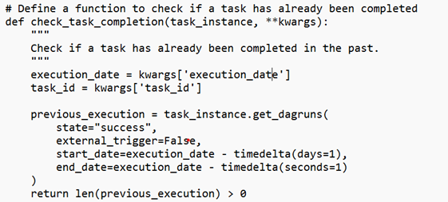
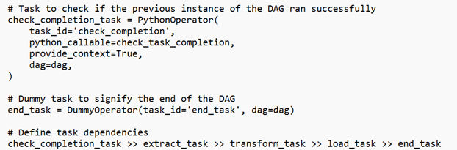

We have added a Python function check_task_completion that checks if the previous instance of a task has been completed successfully within the same DAG run date.

We use a PythonOperator to execute the check_task_completion function before starting the extraction task.
By checking the previous completion status, we ensure that tasks are not re-executed unnecessarily if the previous run was successful.

This approach provides a robust way to ensure restartability and data consistency in your Airflow DAG while minimizing unnecessary re-execution of tasks.

Databricks Job DAG Execution in Airflow:

To see the Databricks job running DAG inside Airflow, we need to follow below steps:

- Create a notebook in Databricks, write ETL code inside notebook
- Go to workflows and create a job for this notebook by clicking on Task, provide Task name, Type -> Notebook, path -> select your notebook path, Cluster -> select a cluster to run this notebook job.
- Create a DAG file (python file) like below sample code:
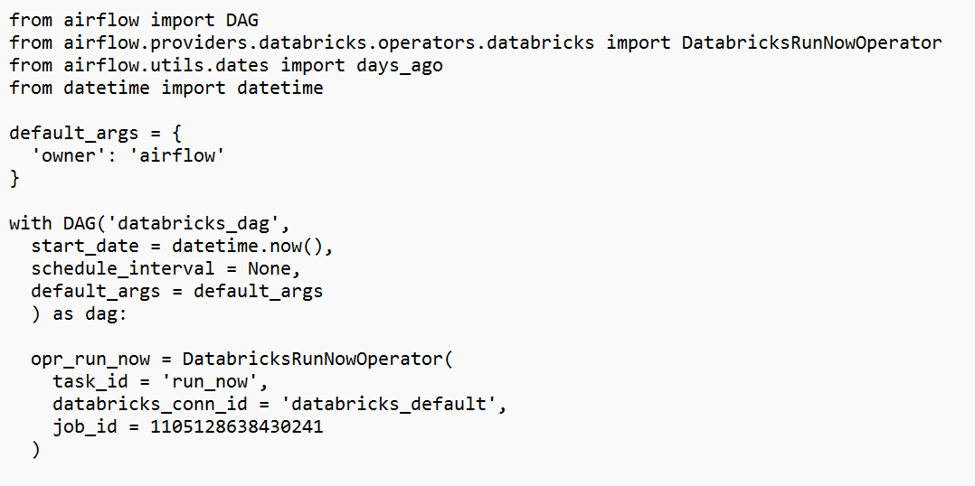

- Pass the job id in above python file and databricks connection id which we have configured in airflow.
- Paste this file in dag folder of the directory like below:
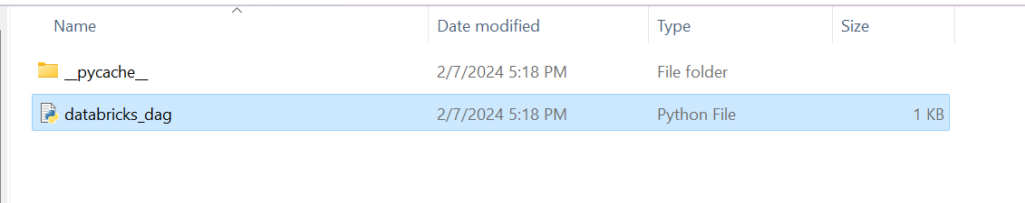

- Refresh Airflow UI and dag will be visible for the databricks job. Click on the Dag id and run it.

