Question 1 – Predict the price of a house

Objective – Predict the price of a house using different ML algorithm and check which algorithm is better as compare to other.

Algorithm Compared –

I have used the following to compare –

1. Support Vector Regression
2. Gradient Boosting Regression
3. Random Forest Regression
4. Bagging Regression
5. K Neighbors Regression

I have fitted the above algorithm on the given house prices data and calculated the Root Mean squared error and plotted them on a graph. Below is that graph.

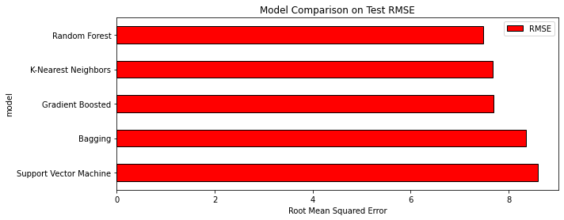

Conclusion-

We can conclude the Random Forest has least RMSE so it seemed to be better algorithm for this data.