BIG DATA ANALYSIS USING PYSPARK
Objective
The objective of this project is to perform big data analysis using PySpark on a large sales dataset and generate meaningful business insights.

Tools & Technologies Used
- Python
- PySpark
- Pandas
- Matplotlib
- Google Colab

Dataset Used
Superstore Sales Dataset
The dataset contains:
- Sales information
- Customer details
- Product categories
- Profit and regional sales data

Steps Performed
- Installed PySpark in Google Colab
- Created Spark Session
- Loaded the dataset using Pandas
- Converted dataset into Spark DataFrame
- Displayed dataset and schema
- Counted total rows
- Performed category-wise sales analysis
- Performed region-wise sales analysis
- Generated data visualization using Matplotlib

Output Summary
- Total rows processed: 9994
- Technology category generated highest sales
- West region contributed highest revenue
- Sales analysis was successfully performed using PySpark

Conclusion
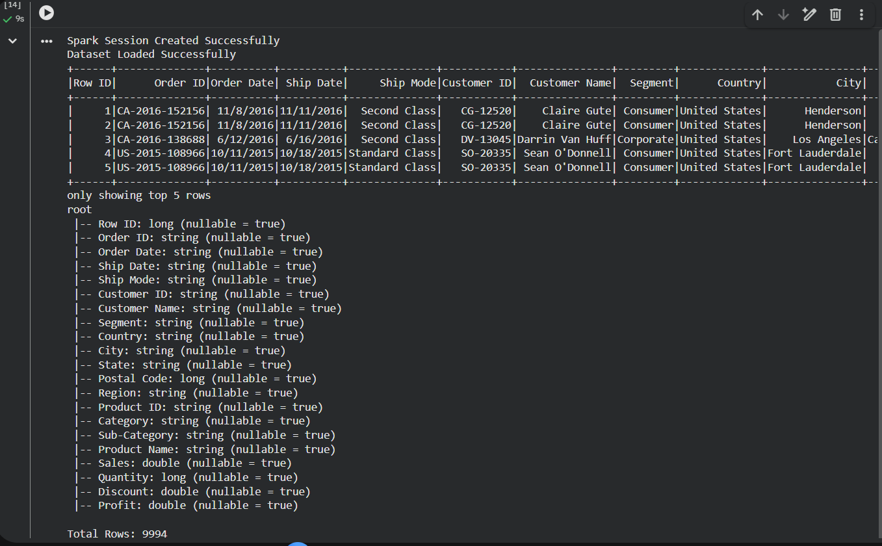
This project successfully demonstrated big data analysis using PySpark. The dataset was processed efficiently and meaningful business insights were generated using scalable data processing techniques.
