Topic: smart City gardening system

Introduction:

* Plants play a major role in maintaining the natural cycle of a food chain pyramid and thus to maintain the plant’s proper growth a great deal of monitoring is required. Hence the aim of making a plant monitoring system is using Internet of Things (IOT) technology.
* This project highlights various features such as smart decision making based on monitoring the plant and its environment using soil moisture sensor along with the help of temperature and humidity sensor.

Problem statement:

* Improvement in agriculture as well as in horticulture.

Motivation:

* farmers require a digital support in their fields to solve big challenges
* The use of sensors can help them in solving day to day by checking soil condition which would help them to start a better growth of a plant.

Objective:

●To design a prototype for a plant monitoring system using Arduino Uno and Internet of things(Iot).

●To develop a system for real Time applications.

Required tools:

1. Arduino Uno: It is a microcontroller used to implement the control unit, the setup uses the temperature sensor, humidity sensor, and soil moisture sensor which measures the approximate temperature,moisture and humidity in the soil.
2. Temperature and humidity sensor: temperature and humidity sensors monitor environmental conditions in crop fields every day.

Humidity checks the change in temperature in air .

1. Soil moisture sensor: Soil moisture sensor measures water content in soil. The sensor reminds the user to water their plants and also monitors water content in soil.
2. Led:it shows the water content level helping the user to refill the amount of water required to hydrate plants.
3. Ldr:it indicates the presence or absence of light or to measure the light intensity.

Methodology:

This project shows the new source for watering the plants in the farms which is reducing the main power.

The system will ensure that plants will be monitored with sensors like Ldr for light sensing ,moisture sensor for soil moisture content ,dht11 for humidity and temperature sensing.

This shows we can implement the IOT technology to make our planting smart and reliable with time.It may support water usage and wastage of water.

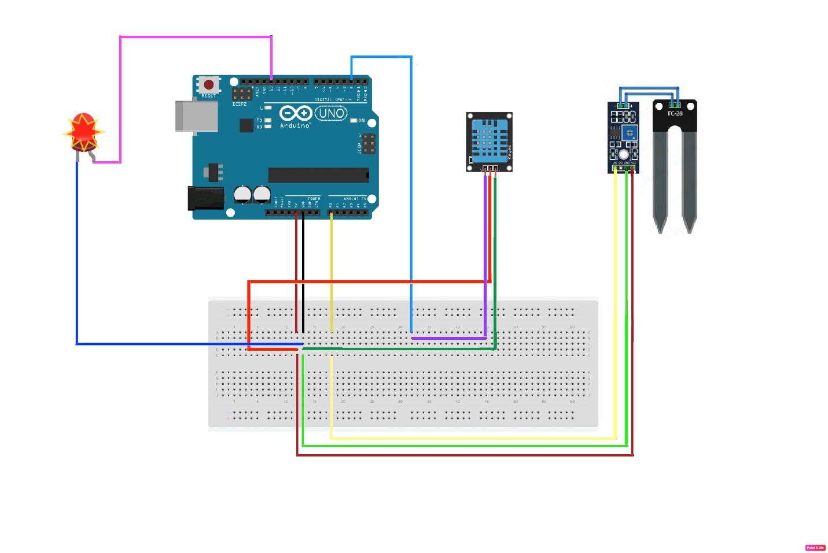

Conclusion:

●Improvement in agriculture for rural and urban areas with the help of IOT.

●This system will optimize resources in crop fields.