**Cloud-Based Digital Signage Solution with AWS Elemental Media-Live**

*A Course Project Report Submitted in partial fulfillment of the course requirements for the award of grades in the subject of*

**CLOUD BASED AIML SPECIALITY**

**(22SDCS07A)**

by

**Akasapu Monika**

**2210030430**

*Under the esteemed guidance of*

**Ms. P. Sree Lakshmi**

Assistant Professor,

Department of Computer Science and Engineering



**DEPARTMENT OF COMPUTER SCIENCE AND ENGINEERING**

**K L Deemed to be UNIVERSITY**

*Aziznagar, Moinabad, Hyderabad,*

*Telangana, Pincode: 500075*

April 2025

**K L Deemed to be UNIVERSITY**

**DEPARTMENT OF COMPUTER SCIENCE AND ENGINEERING**

*Certificate*

This is Certified that the project entitled **“Cloud-Based Digital Signage Solution with AWS Elemental MediaLive”** which is a experimental & theoretical & Simulation& hardware work carried out by Akasapu Monika in partial fulfillment of the course requirements for the award of grades in the subject of **CLOUD BASED AIML SPECIALITY**, during the year **2024-2025**. The project has been approved as it satisfies the academic requirements.

**Ms.P.Sree Lakshmi Dr. Arpita Gupta**

**Course Coordinator Head of the Department**

**Ms. P. Sree Lakshmi**

**Course Instructor**

**CONTENTS**

1. Introduction

2. AWS Services Used as part of the project

3. Steps involved in solving project problem statement

4. Stepwise Screenshots with brief description

5. Learning Outcomes

6. Conclusion

7. References

**1. INTRODUCTION**

*Mini Project Title*

Cloud-based digital signage is an innovative solution that enables the distribution of multimedia content to multiple display devices over the internet. This project focuses on leveraging AWS Elemental Media-Live along with other AWS services to create a scalable and efficient digital signage solution while ensuring it remains within the AWS free-tier limitations. The primary services used include AWS Elemental Media-Live for real-time video encoding, AWS S3 for storing video content, AWS Cloud-Front for content delivery, AWS Media-Package for media preparation, AWS IAM for access management, and AWS Cloud-Watch for monitoring and logging.

The implementation begins with setting up an AWS account and configuring IAM roles to grant appropriate permissions. An S3 bucket is created to store media files, followed by the setup of AWS Elemental Media-Live for real-time video streaming. Next, AWS Media-Package is configured to prepare content for distribution, while AWS Cloud-Front ensures global delivery with optimized performance. Finally, AWS Cloud-Watch is used to monitor and analyze streaming performance. Screenshots should be included for each of these steps to illustrate the configuration process. These include IAM role creation, S3 bucket setup, Media-Live channel configuration, Media-Package endpoint setup, Cloud-Front distribution settings, and Cloud-Watch monitoring dashboard.

Through this project, valuable skills are gained in cloud-based media streaming, AWS service integration, security best practices using IAM roles, and performance monitoring using Cloud-Watch. By successfully implementing this solution, we demonstrate the effectiveness of AWS Elemental Media-Live in delivering high-quality streaming content. This project provides an understanding of cloud-based digital signage and its practical applications. The references for this project include AWS documentation for Media-Live, Media-Package, and Cloud-Front, ensuring a thorough understanding of each service utilized. The implementation highlights the advantages of cloud-based media streaming, offering a cost-effective, scalable, and real-time solution for digital signage applications.

**2. AWS SERVICES USED AS PART OF THE PROJECT**

1. **AWS Elemental Media-Live** – A real-time video processing service that encodes live video streams, making them suitable for broadcasting to various digital platforms.
2. **AWS S3 (Simple Storage Service)** – Used to store video files, thumbnails, and related assets required for digital signage.
3. **AWS Cloud-Front** – A content delivery network (CDN) that ensures efficient distribution of video content globally, reducing latency and improving performance.
4. **AWS Media-Package** – Prepares video streams for distribution by ensuring compatibility across different devices and network conditions.
5. **AWS IAM (Identity and Access Management**) – Manages security policies and access permissions for AWS resources, ensuring only authorized users can make changes.
6. **AWS Cloud-Watch** – Monitors AWS services, collects logs, and provides insights into system performance to optimize streaming efficiency.
7. **AWS Elemental Media-Convert** – A file-based video transcoding service that converts media files into different formats to ensure compatibility across various devices and platforms.

**3. STEPS INVOLVED IN SOLVING PROJECT PROBLEM STATEMENT**

1. **Creating an S3 Bucket** – An Amazon S3 bucket was created to store media files required for digital signage. Input sources were defined, and encoding settings were configured to optimize video quality.
2. **Uploading Media Files** – Video files and related assets were uploaded to the S3 bucket for processing and streaming.
3. **Setting Up AWS Elemental MediaLive** – A MediaLive channel was created to encode video streams in real-time. Input sources were defined, and encoding settings were configured to optimize video quality.
4. **Creating a MediaLive Input** – Configured an input source, such as an S3 file or live video feed, to be used in the MediaLive channel.
5. **Configuring AWS Elemental MediaPackage** – A MediaPackage channel was set up to package and prepare video streams for smooth playback on different devices.

1. **Generating Endpoints in MediaPackage** – Created MediaPackage endpoints to distribute content efficiently across multiple devices.
2. **Integrating AWS CloudFront** – A CloudFront distribution was configured to ensure fast and reliable delivery of digital signage content globally.
3. **Setting Up IAM Roles and Permissions** – IAM roles were created and assigned to services to manage access control and security policies.
4. **Monitoring and Logging with CloudWatch** – CloudWatch metrics and logs were enabled to track the performance of video streaming and identify potential issues.

**4.** **STEPWISE SCREENSHOTS WITH BRIEF DESCRIPTION**

**Step 1:** Create General Purpose S3 Bucket. Upload the video files and index.html into the S3 bucket. The listed files include MOV video files, an M3U8 playlist file, an HTML file, and an output folder. These files are essential for media processing and streaming using AWS services like MediaLive and MediaPackage.

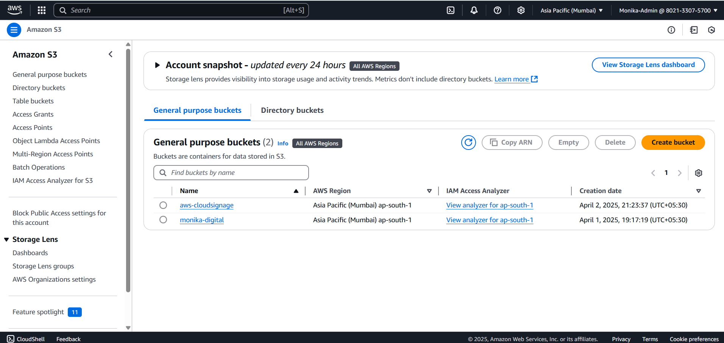

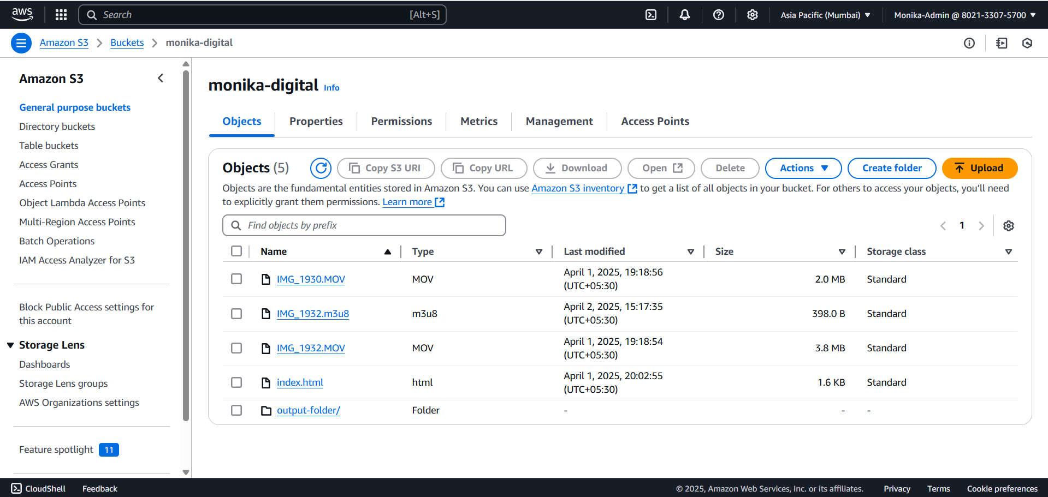

Step 2: Update the bucket policy

"Sid": "PublicReadGetObject",

"Effect": "Allow",

"Principal": "*",

"Action": "s3:GetObject",

"Resource": "arn:aws:s3:::monika-digital/*"

Step 3: Create a job to convert MOV video files to HLS to display the video .This job creates the HLS files in the S3 output-folder .

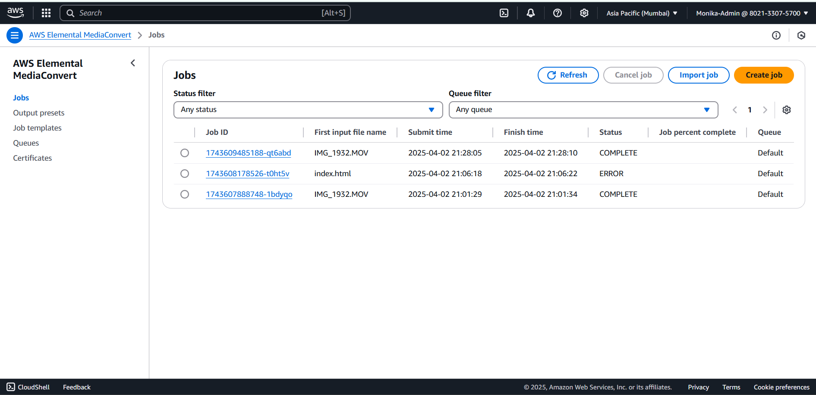

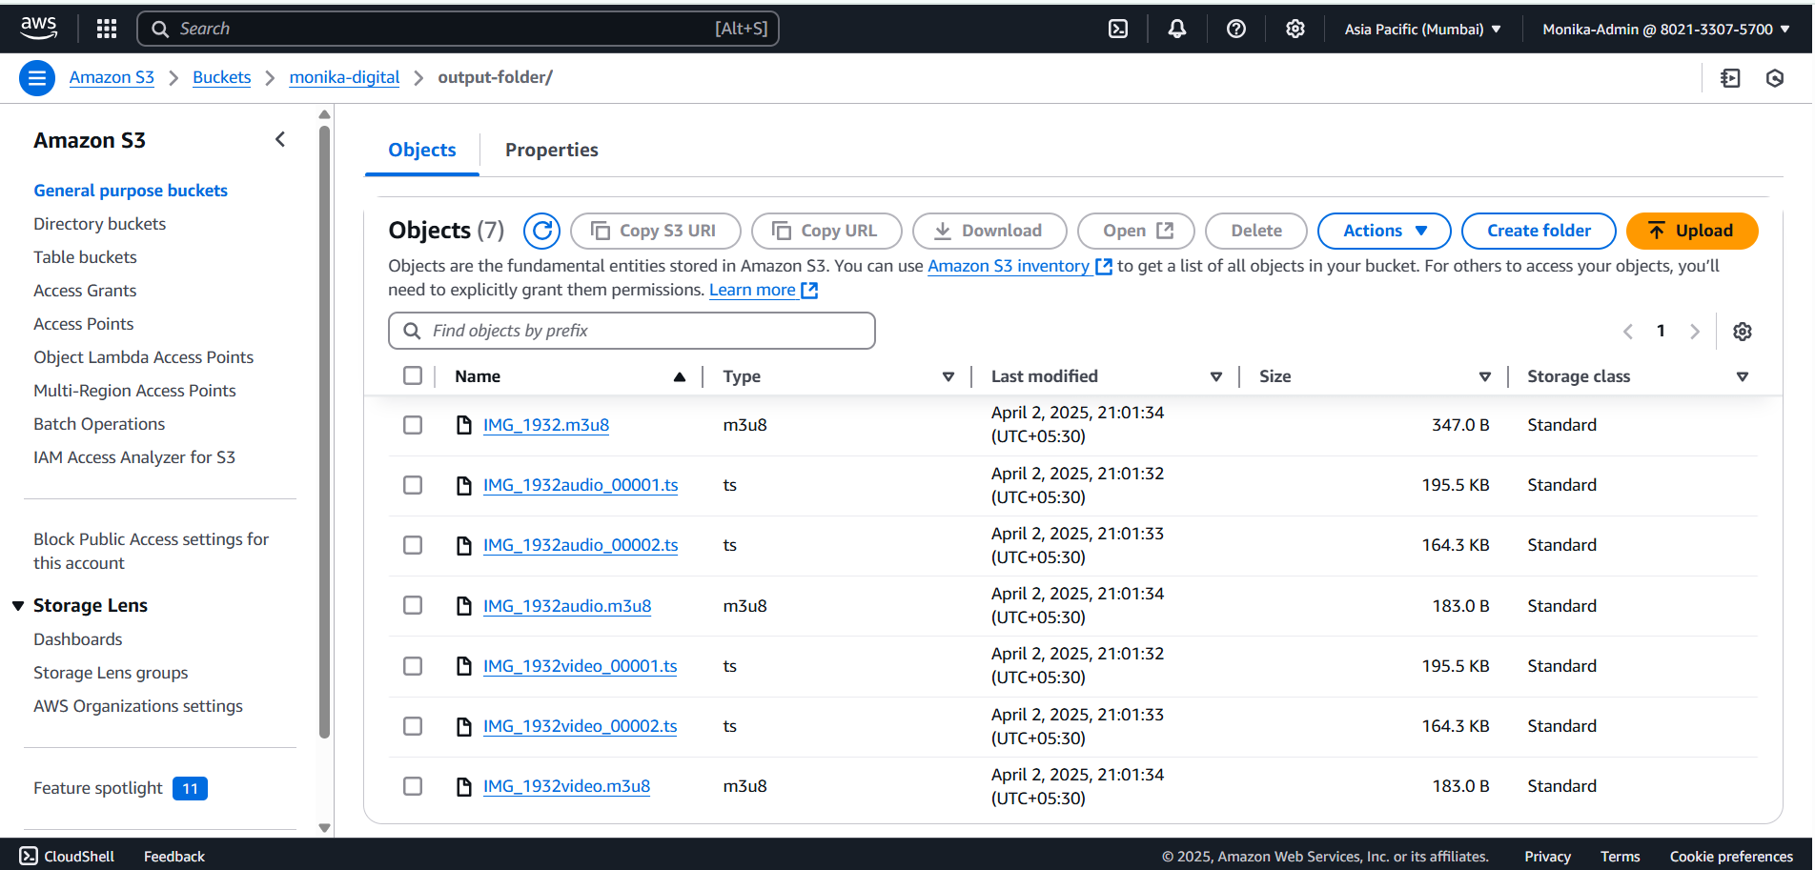

Step 4: The MOV video is converted to HLS and stored in S3 bucket, later the object URL is used for board-cast.

<https://aws-cloudsignage.s3.ap-south-1.amazonaws.com/output-folder/IMG_1932audio1.m3u8>

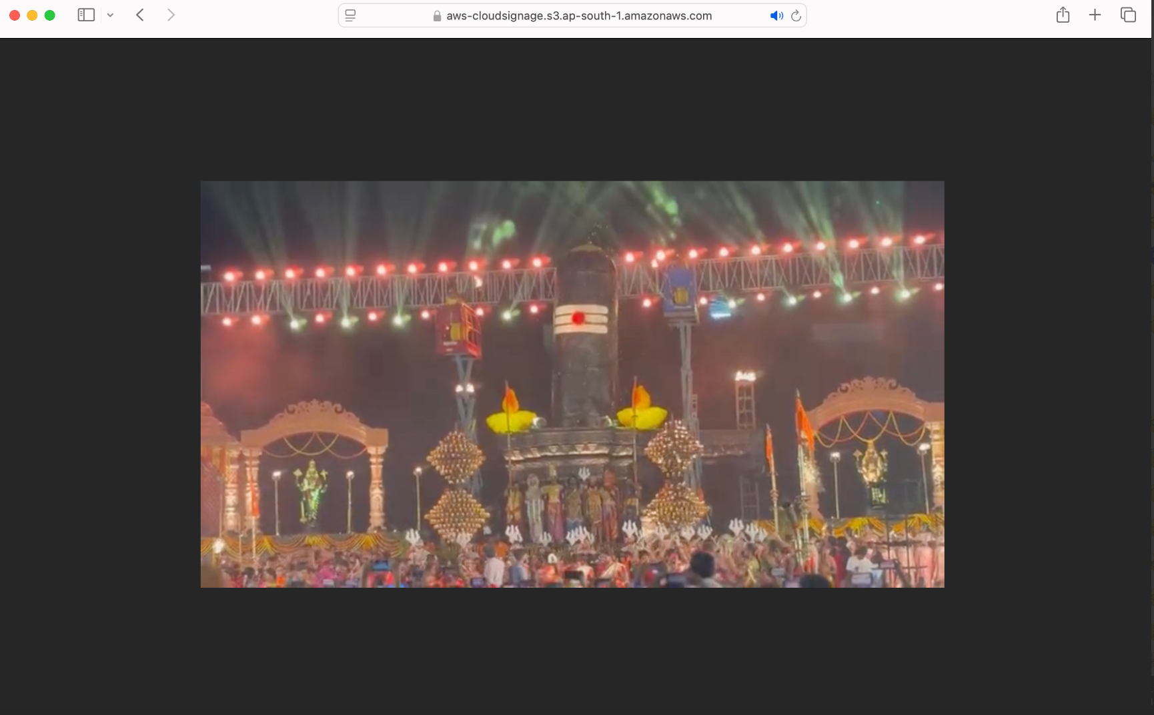

Step 5: CloudFront is used for the Content Distribution among different users.

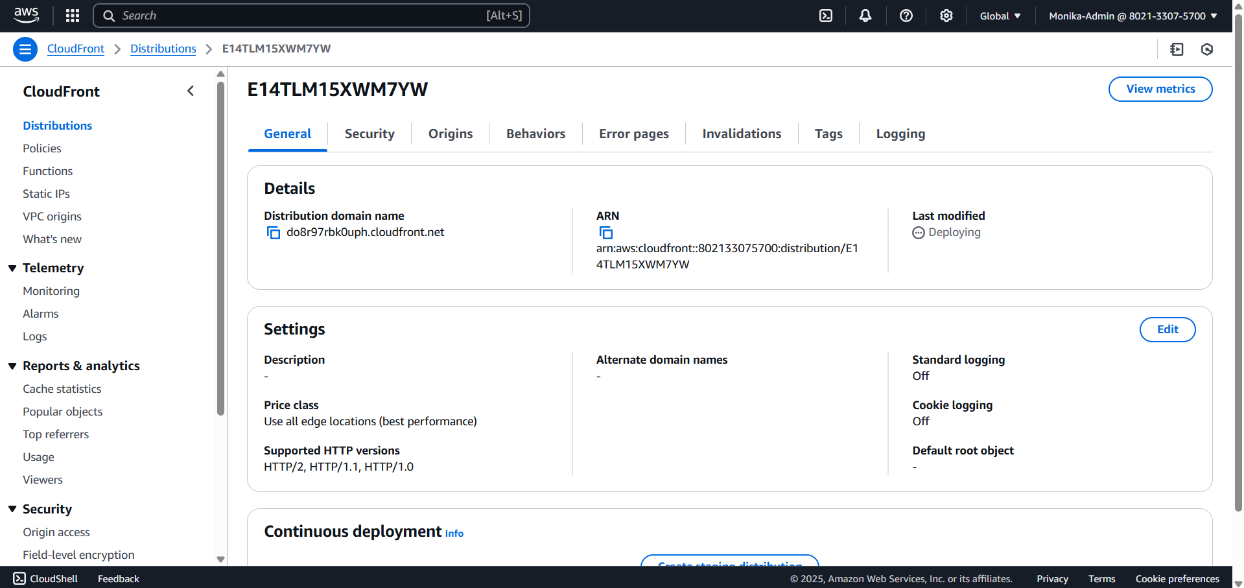

<https://do8r97rbk0uph.cloudfront.net/index.html> ,this link is used for content distribution.

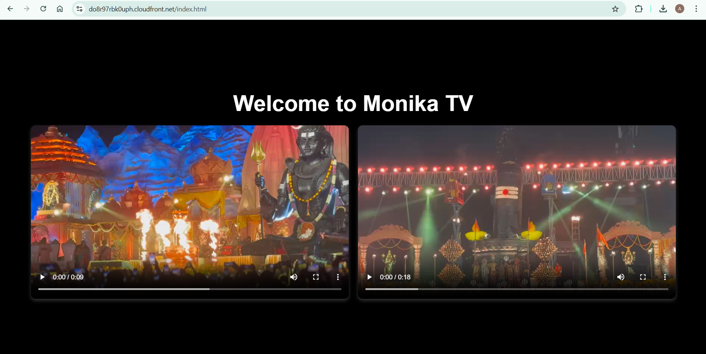

Step 6: AWS Elemental MediaLive is a video service that lets you easily create live outputs for broadcast and streaming delivery.

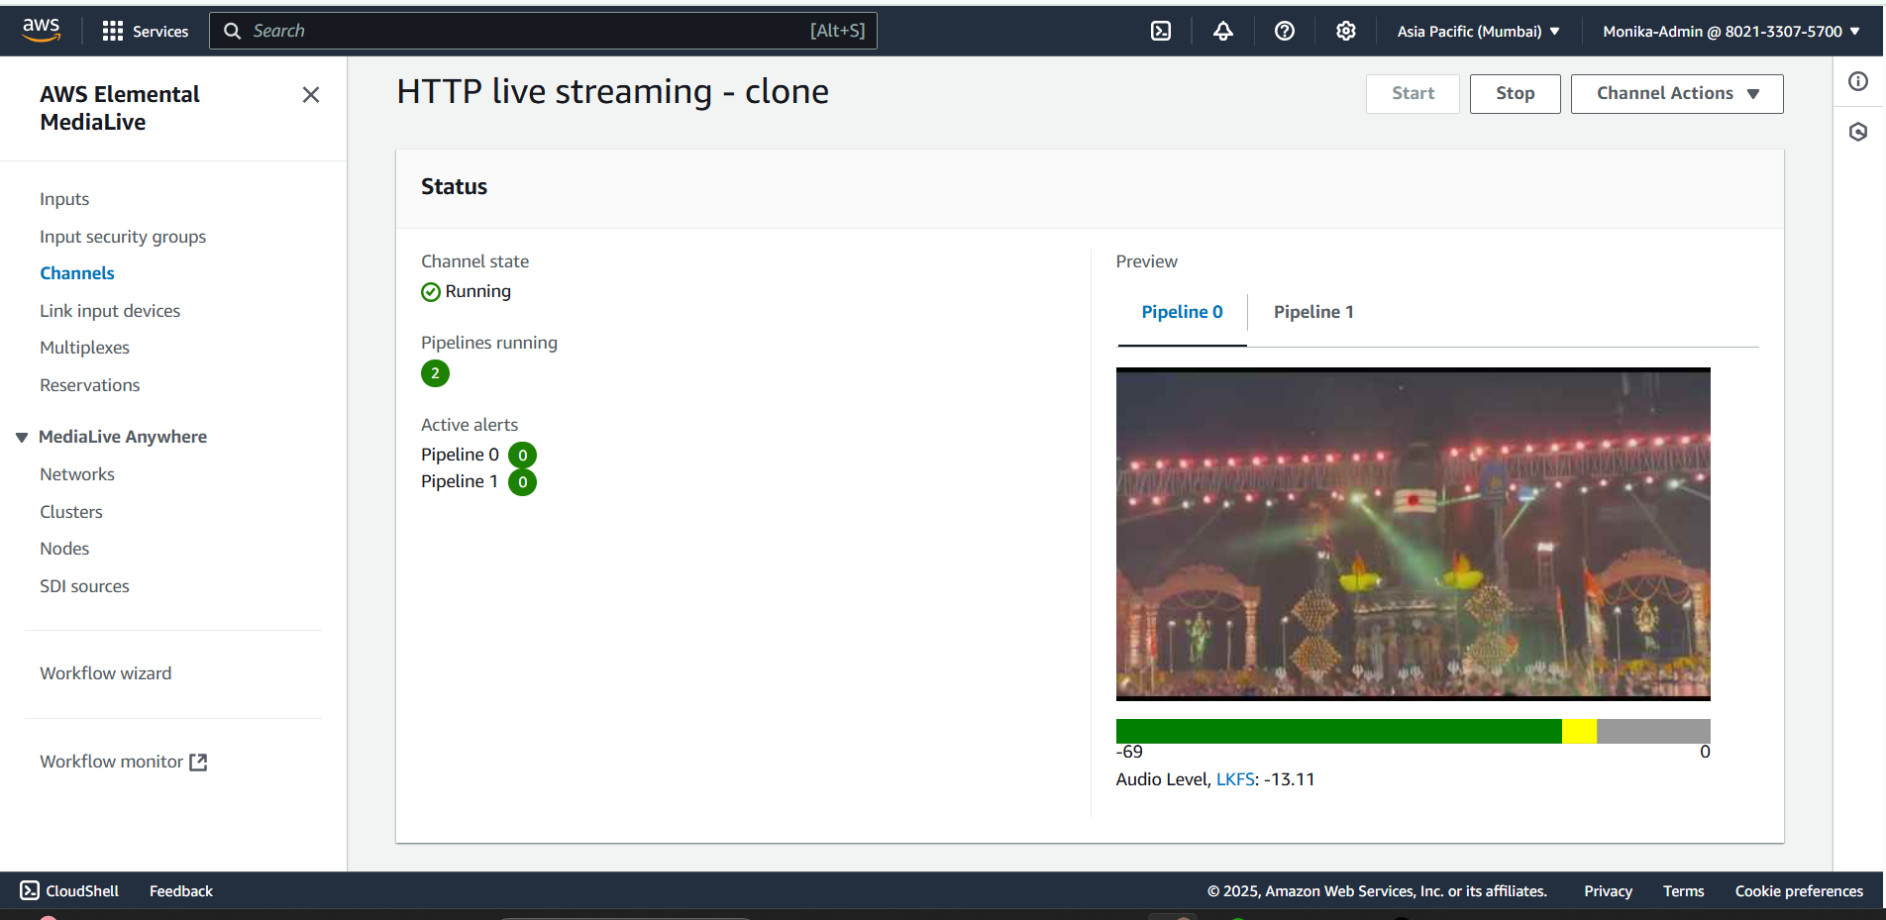

**5. LEARNING OUTCOMES**

Through this project, I gained hands-on experience with AWS Media Services such as MediaLive, MediaPackage, and MediaConvert, which are essential for video processing and streaming. I also learned the importance of Amazon CloudFront in ensuring fast content delivery with minimal latency. Understanding how Amazon S3 functions as a scalable and reliable storage solution for media files was another key takeaway. Additionally, working with IAM roles and permissions helped me grasp the significance of cloud security and access control in managing AWS resources effectively.

Moreover, I explored AWS CloudWatch for real-time monitoring, allowing me to track system performance and troubleshoot issues efficiently. The project also provided insights into workflow automation by integrating multiple AWS services for seamless media content delivery. Managing costs while utilizing AWS Free Tier services was another crucial aspect, reinforcing best practices for cloud resource optimization. Overall, this experience strengthened my ability to build, deploy, and manage a cloud-based digital signage system while improving scalability and performance efficiency.

Additionally, I learned how to optimize media streaming by leveraging AWS Elemental MediaConvert to transcode videos into different formats suitable for various devices. Understanding the role of MediaConvert in ensuring compatibility across different streaming platforms was a valuable aspect of the project. This enhanced my knowledge of adaptive bitrate streaming, which improves user experience by adjusting video quality based on network conditions.

Finally, this project reinforced my ability to work with cloud-based architectures and services, preparing me for real-world applications in media streaming and content delivery. It also strengthened my problem-solving skills, as I had to troubleshoot issues related to video playback, permissions, and distribution settings. By completing this project, I developed a deeper understanding of AWS services and their role in modern cloud computing solutions.

**6. CONCLUSION**

This project successfully demonstrated the potential of AWS cloud services in implementing an efficient and scalable digital signage system. By integrating MediaLive, MediaPackage, and CloudFront, I was able to create a seamless media streaming workflow. The ability to store and manage media assets using Amazon S3 further reinforced my understanding of cloud storage solutions. The experience of configuring IAM roles and security policies also highlighted the importance of access control and data security in cloud environments.

Furthermore, the implementation of AWS Elemental MediaConvert allowed me to optimize media content for diverse playback scenarios, ensuring compatibility with multiple devices and network conditions. The use of CloudWatch for monitoring system performance helped in identifying and troubleshooting potential issues efficiently. These insights are essential in real-world cloud-based applications, where performance, scalability, and security play a critical role.

The project also emphasized the significance of automation in cloud-based solutions. By integrating various AWS services, I streamlined content delivery without requiring extensive manual intervention. Understanding the principles of adaptive bitrate streaming and CDN integration through CloudFront further enriched my knowledge of optimizing digital media delivery across different geographies.

In conclusion, this project provided valuable practical exposure to AWS cloud services and their application in media streaming. It strengthened my problem-solving skills and deepened my technical expertise in cloud computing. Moving forward, I can leverage these learnings in future projects involving cloud-based content distribution and large-scale media processing.

**7. REFERENCES**

[1] Davies, Nigel, Sarah Clinch, and Florian Alt (2014) "Pervasive displays: understanding the future of digital signage." Synthesis Lectures on Mobile and Pervasive Computing 8 (1): 11 28.

[2] Bauer, Christine, Paul Dohmen, and Christine Strauss (2011) "Interactive Digital Signage: an Innovative Service and its Future Strategies." Proceedings of the 1st International Workshop on Frontiers in Service Transformations and Innovations (FSTI 2011), in conjunction with the 2nd International Conference on Emerging Intelligent Data and Web Technologies (EIDWT 2011), 137 142.

[3] Bauer, Christine, Paul Dohmen, and Christine Strauss (2012) "A Conceptual Framework for Backend Services of Contextual Digital Signage." Journal of Service Science Research, 4 (2): 271 297.

[4] Garaus, Marion and Udo Wagner (2018) "Let me entertain you Reducing perceived waiting time through digital signage." Proceedings of the 47th EMAC Annual Conference (EMAC 2018).

[5] **Amazon Web Services (AWS).** (2023). AWS Elemental MediaLive Anywhere: Cloud-Controlled Live Video Encoding

[6] **Dennis, Charles, J. Joško Brakus, Suraksha Gupta, and Eleftherios Alamanos (2014)** – “The Effect of Digital Signage on Shoppers' Behavior: The Role of the Evoked Experience.”