INDUSTRIAL COURSE REPORT

ON
REAL-TIME MEMORY DOS DETECTION & AUTOMATED
RESPONSE SYSTEM
By
MONIKA. B
Of
A PROJECT REPORT
Submitted to the
FACULTY OF INFORMATION AND COMMUNICATION ENGINEERING


In partial fulfilment for the award of the degree of
MASTER OF COMPUTER APPLICATIONS
[2025-2027]

ANNA UNIVERSITY
CHENNAI-600 025
MAY – 2026

INDEX

S. No. | Title | Page No.
1 | Title of the Project | 6
2 | Abstract | 6
3 | Introduction | 7
4 | Existing System | 8
5 | Proposed System | 9
6 | System Specification | 9
 | 6.1 Software Specification | 10
 | 6.2 Hardware Specification | 11
 | 6.3 Data Flow Diagram | 11
7 | Modules | 11
8 | Methodology | 12
 | 8.1 Implementation | 12
 | 8.2 Testing | 12
9 | Appendix | 13
 | 9.1 Program Implementation (Coding & Screenshots) | 13
10 | Conclusion | 23
 | 10.1 Future Enhancement | 23
 | 10.2 References | 23
 | 10. 3 Cost Analysis | 24
Table 1: Index of Project Report
“REAL-TIME MEMORY DOS DETECTION & AUTOMATED RESPONSE SYSTEM”
2. ABSTRACT:
The rapid migration of enterprise applications to cloud environments has exposed infrastructure to sophisticated resource-exhaustion attacks. Among these, Memory Denial of Service (M-DoS) is particularly critical, as it targets the Random Access Memory (RAM) of a virtual instance, leading to system instability, "Kernel Panics," and complete service unavailability. Traditional security monitoring often lacks the high-resolution visibility and automated response speed required to mitigate these attacks before they cause a total system crash.
This project implements a Real-Time Detection and Automated Response System designed for AWS cloud environments. The solution utilizes a closed-loop security architecture comprising four main components:
- Detection: An Amazon CloudWatch Agent is deployed on an Ubuntu 24.04 EC2 instance to collect high-resolution memory metrics at 10-second intervals.
- Alerting: A CloudWatch Alarm is configured to monitor the mem_used_percent metric, identifying breaches when usage exceeds a critical threshold of 80%.
- Automated Mitigation: Upon an alarm trigger, an AWS Lambda function (developed in Python using the Boto3 SDK) is invoked to automatically stop the compromised instance, thereby preventing further resource exhaustion and isolating the threat.
- Forensic Logging: The system automatically generates a structured JSON report containing incident metadata and stores it in a secure Amazon S3 bucket for post-attack audit and compliance.
The results of the project demonstrate that the mean time to respond (MTTR) is significantly reduced compared to manual intervention. The simulation, performed using the Linux stress utility, validates that the system can successfully identify and neutralize a Memory DoS attack within seconds of the threshold breach. This research provides a scalable, cost-effective, and serverless framework for enhancing the resilience of cloud-native workloads against resource-based cyber threats.
Keywords: Cloud Security, AWS, Memory DoS, Automated Response, AWS Lambda, CloudWatch Monitoring, Incident Forensics.

3. INTRODUCTION:
The shift to cloud computing has revolutionized the way businesses deploy and manage applications. Cloud platforms provide elasticity, scalability, and cost efficiency, but these same features also make them vulnerable to resource-exhaustion attacks. One such threat is the Memory Denial of Service (M-DoS) attack, a specialized cyber-attack where the adversary attempts to exhaust the available Random Access Memory (RAM) of a target server. Unlike traditional network-layer attacks that flood bandwidth, M-DoS attacks exploit the internal stability of the operating system, leading to severe service disruption.
In an Amazon Web Services (AWS) environment, when an EC2 instance runs out of memory, the Linux kernel’s Out-of-Memory (OOM) Killer is triggered. This mechanism terminates processes to free memory, but often critical services such as the SSH daemon or web servers are killed. As a result, the instance becomes unreachable and unmanageable, causing downtime and potential data loss. This highlights the need for proactive monitoring and automated mitigation strategies.
The objective of this project is to design and implement an autonomous Self-Defending Infrastructure against M-DoS attacks. By leveraging AWS-native serverless technologies, the defence mechanism operates independently of the compromised host, ensuring reliability and rapid response. The architecture integrates Amazon CloudWatch for real-time monitoring, AWS Lambda for automated mitigation, and Amazon S3 for forensic log storage. When memory usage exceeds a defined threshold, CloudWatch triggers an alarm, invoking a Lambda function that stops the affected EC2 instance and generates forensic logs for analysis. These logs are securely stored in S3, providing an audit trail for future investigation.
This approach bridges the gap between monitoring and mitigation by combining detection, response, and forensic analysis into a unified system. The project not only demonstrates the feasibility of automated defence against resource-exhaustion attacks but also contributes to building resilient cloud infrastructures capable of withstanding modern cyber threats. The experience gained through this implementation enhances practical knowledge of cloud security and prepares the foundation for future research in autonomous defence mechanisms.

4. EXISTING SYSTEM:
The current traditional cloud monitoring setups face four major challenges that make them vulnerable to Memory Denial of Service (M-DoS) attacks:
1. The Visibility Gap (Lack of RAM Monitoring)
Standard cloud providers (like AWS) monitor "external" metrics by default, such as CPU usage, Disk I/O, and Network traffic. However, they do not track RAM (Memory) usage automatically.
- Result: Because the monitoring system is "blind" to the RAM status, an M-DoS attack can consume all system memory without ever triggering a standard cloud alert.
2. Manual Intervention (Slow Response Time)
In most existing systems, when a resource threshold is crossed, the system merely sends an email or SMS to an administrator. A human must then see the alert, log into the console, and manually stop the process or the server.
- Result: M-DoS attacks happen in seconds, while human response takes minutes. By the time an administrator intervenes, the service is already down, leading to significant downtime.
3. Loss of Forensic Evidence
RAM is volatile memory. If a server crashes or is manually rebooted due to a memory overflow, all current process data and temporary logs stored in the RAM are instantly wiped out.
- Result: Security teams are left with no data to perform a "Root Cause Analysis." There is no record of which process caused the attack or how the attacker bypassed security.
4. Host-Dependent Scripts (Self-Defence Failure)
Many organizations run security monitoring scripts directly on the same server they are trying to protect.
- Result: When a Memory DoS attack reaches 100% RAM usage, the Operating System starts killing processes to stay alive. Often, the security script itself is killed by the OS, leaving the server completely defenceless at the exact moment it needs protection the most.

5. PROPOSED SYSTEM
The proposed system introduces an Automated, Serverless, and Out-of-Band response mechanism.
- High-Resolution Monitoring: By installing the CloudWatch Agent, we collect memory metrics every 10 seconds, providing granular visibility into RAM health.
- Serverless Mitigation: We use AWS Lambda, which runs in a separate environment from the attacked EC2 instance. This ensures that even if the EC2 instance is completely frozen, the defence logic still executes perfectly.
- Closed-Loop Automation: The system follows a "Detect-Notify-Act" cycle. Once the threshold (>80%) is crossed, the CloudWatch Alarm triggers the Lambda function automatically.
- Forensic Preservation: Before the instance is stopped or terminated, the system generates a forensic JSON log and stores it in an Amazon S3 bucket. This ensures that security teams have a record of the event for future auditing and compliance.

6.SYSTEM SPECIFICATION:
The Real-Time Memory DoS Detection & Automated Response System is designed as a cohesive, closed-loop security framework aimed at protecting cloud-based computing resources from resource-exhaustion threats. Unlike traditional passive monitoring setups, this system operates as an integrated pipeline that bridges the gap between detection and mitigation. By utilizing an "out-of-band" architectural philosophy, the system ensures that the defence logic is hosted independently of the target environment. This design ensures that the mitigation mechanism remains fully functional and responsive even if the target server becomes completely frozen or unresponsive due to extreme memory pressure, thereby providing a resilient and self-defending infrastructure.
Structurally, the system is built upon a modular architecture that facilitates a multi-staged security lifecycle: continuous telemetry collection, threshold-based evaluation, automated containment, and forensic preservation. The system’s primary intelligence lies in its ability to translate raw performance data into actionable security insights in real-time. By automating the response phase, the system eliminates the critical delays associated with human intervention, effectively reducing the Mean Time to Respond (MTTR). Furthermore, the integration of a dedicated logging layer ensures that every security action is documented with forensic precision, providing a comprehensive solution that combines high-resolution awareness with decisive, automated disaster recovery capabilities suitable for enterprise cloud environments.
Diagram:
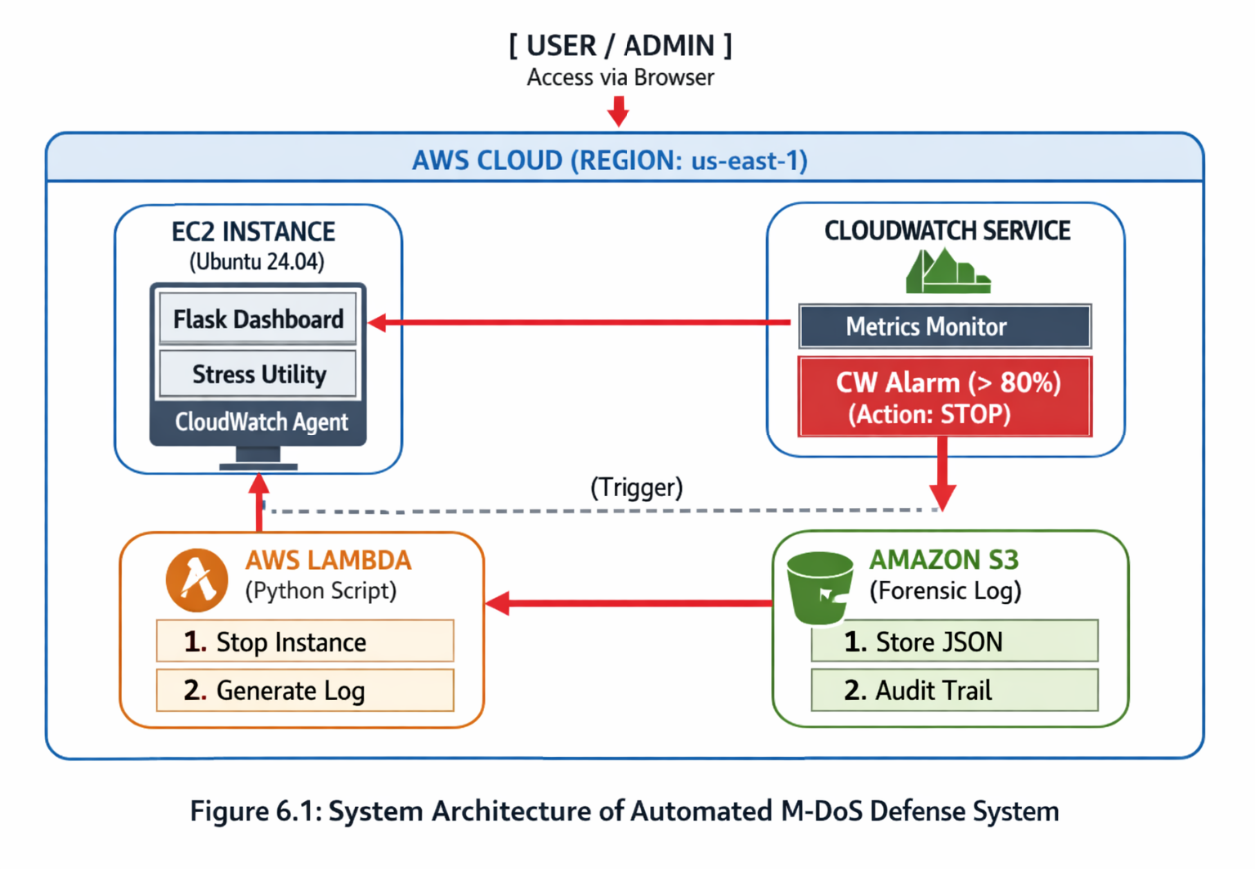

6.1 SOFTWARE SPECIFICATION:
- Operating System: Ubuntu 24.04 LTS (Noble Numbat).
- Cloud Platform: AWS (Amazon Web Services) Academy Sandbox.
- Programming Language: Python 3.12 (for Lambda function logic).
- Libraries: Boto3 (AWS SDK for Python), JSON, Datetime.
- Monitoring Tool: Amazon CloudWatch Agent (64-bit DEB package).
- Simulation Tool: stress (Linux workload generator).
- Communication: AWS SDK / API calls.

6.2 HARDWARE SPECIFICATION:
- Cloud Instance: EC2 t3.micro.
- Virtual CPU: 2 vCPUs.
- Instance Memory: 1 GiB RAM.
- Storage: 8 GB EBS (Elastic Block Store) General Purpose SSD.
- Local Machine: Any PC with a browser and SSH client (Putty or Terminal).

6.3 Data Flow Diagram (DFD) - Level 1
The Data Flow Diagram represents the logical flow of data through the M-DoS detection system. It highlights how the system moves from raw metric collection to automated mitigation and forensic storage.
- Process 1.0 (Monitor): The CloudWatch Agent extracts raw memory utilization data from the /proc/meminfo file of the Ubuntu OS.
- Process 2.0 (Evaluate): The raw data is sent to the CloudWatch Metric stream, where the Alarm engine compares the current value against the pre-defined 80% threshold.
- Process 3.0 (Trigger): Once a threshold breach occurs, an asynchronous trigger is sent to the AWS Lambda service.
- Process 4.0 (Mitigation): The Lambda function executes two parallel data streams:
  - An API command to the EC2 service to change the instance state to STOPPED.
  - A JSON data stream containing attack metadata sent to the S3 bucket.

7. MODULES
The system is divided into four functional modules:
- Data Collection Module (Agent): Responsible for capturing the mem_used_percent from the Ubuntu OS and pushing it to the AWS CloudWatch "CWAgent" namespace.
- Detection & Trigger Module (Alarm): Evaluates the incoming data points. If memory usage stays above 80% for one minute, it changes the state from OK to ALARM.
- Automated Response Module (Lambda): A serverless script that receives the alarm trigger and initiates the ec2.stop_instances API call to halt the attack.
- Forensic Logging Module (S3): Captures the details of the attack (Instance ID, Timestamp, Action) and writes a permanent record to an S3 bucket.

8. METHODOLOGY:
8.1 Implementation:
- Environment Preparation: Launch an Ubuntu 24.04 instance and attach an IAM role (LabRole) that allows writing to CloudWatch and S3.
- Agent Deployment: Download and install the .deb CloudWatch agent. Configure the config.json file to monitor mem_used_percent.
- CloudWatch Configuration: Create an alarm in the AWS Management Console based on the custom metric pushed by the agent.
- Lambda Development: Write the Python code using the Boto3 library. Set the CloudWatch Alarm as the "Trigger" for this Lambda.
- S3 Integration: Create a bucket and ensure the Lambda function has permission to PutObject into that bucket.
8.2 Testing:
The testing phase uses a Simulated Stress Attack:
- Tool: The Linux stress utility.
- Command: stress --vm 2 --vm-bytes 300M (This forces the 1GB RAM instance to use ~600MB+ allocated RAM).
- Validation:
  - Verify the CloudWatch Graph shows a spike.
  - Confirm the EC2 status changes to "Stopping."
  - Check S3 for the presence of the attack_log.json file.
8.2.1 Software Test Cases Table
Test Case ID | Test Scenario | Expected Outcome | Actual Outcome | Status
TC-01 | Resource Loading | Memory usage should increase upon running the stress utility. | RAM usage spiked to 85% as observed in top. | PASS
TC-02 | Metric Accuracy | CloudWatch Agent should push data every 10 seconds to the console. | Metrics updated in the CWAgent namespace successfully. | PASS
TC-03 | Alarm Activation | Alarm state must change from OK to ALARM within 1 minute of breach. | Alarm turned Red (In Alarm) after 1-minute evaluation. | PASS
TC-04 | Lambda Invocation | The Lambda function should be triggered automatically by the Alarm. | Lambda logs confirmed execution in CloudWatch Logs. | PASS
TC-05 | Forensic Logging | A JSON log file must be generated in the S3 bucket. | attack_log.json was successfully created in the bucket. | PASS
TC-06 | Isolation | The targeted EC2 instance must be stopped to halt the attack. | Instance status changed to Stopping automatically. | PASS
Table 8.2.1: Software Test Cases
9. APPENDIX
9.1 Experimental Results and Program Implementation:
1. EC2 Instance Running

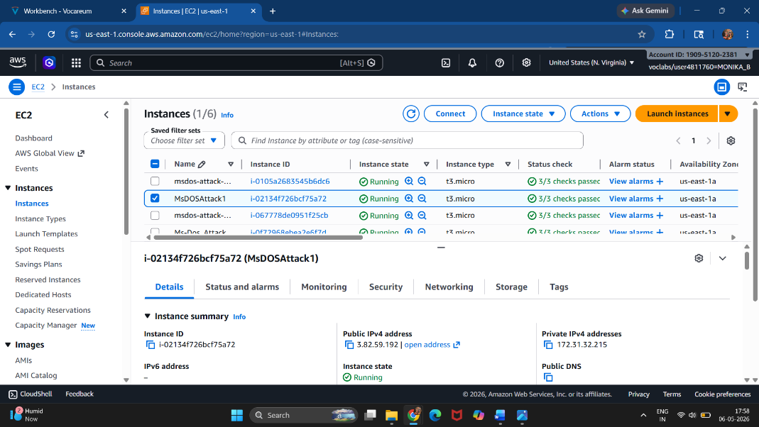
e.g., Fig 9.1.1: EC2 Ubuntu Server Instance

2. Installing Stress Tool
->sudo apt update -y
->sudo apt install stress -y
- Screenshot Content: Terminal showing successful installation
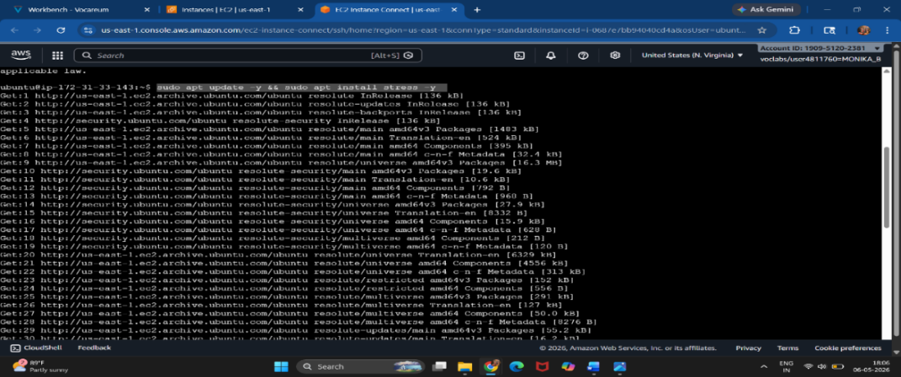
e.g., Fig: 9.1.2 Installing stress utility
3. CloudWatch Agent Installation
->wget https://s3.amazonaws.com/amazoncloudwatch-agent/ubuntu/amd64/latest/amazon-cloudwatch-agent.deb
->sudo dpkg -i -E ./amazon-cloudwatch-agent.deb
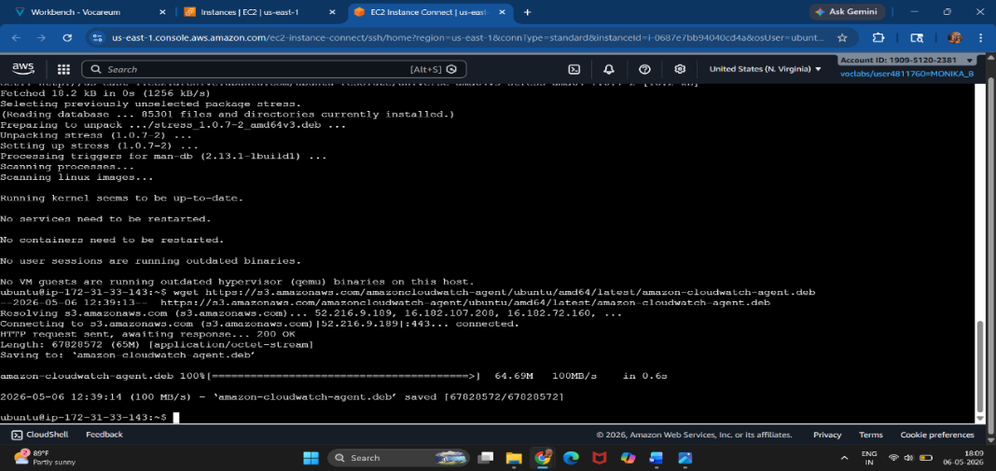
e.g., Fig: 9.1.3 CloudWatch Agent Installation
4.Configuration File Creation
->sudo nano /opt/aws/amazon-cloudwatch-agent/bin/config.json
Paste: inside the code in terminal
{
"metrics": {
"metrics_collected": {
"mem": {
"measurement": ["mem_used_percent"],
"metrics_collection_interval": 10
}
}
}
}
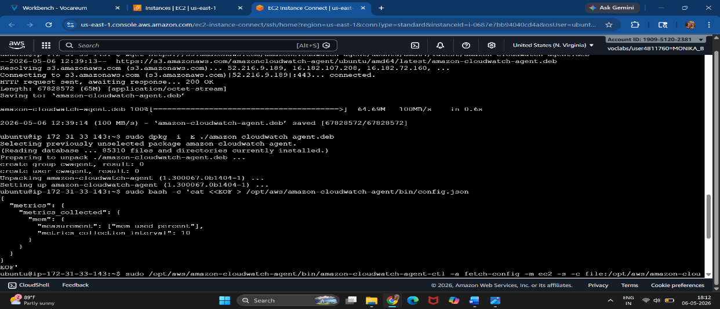

e.g., Fig 9.1.4: CloudWatch Memory Monitoring Configuration

5. Starting CloudWatch Agent
->sudo /opt/aws/amazon-cloudwatch-agent/bin/amazon-cloudwatch-agent-ctl -a fetch-config -m ec2 -s -c file:/opt/aws
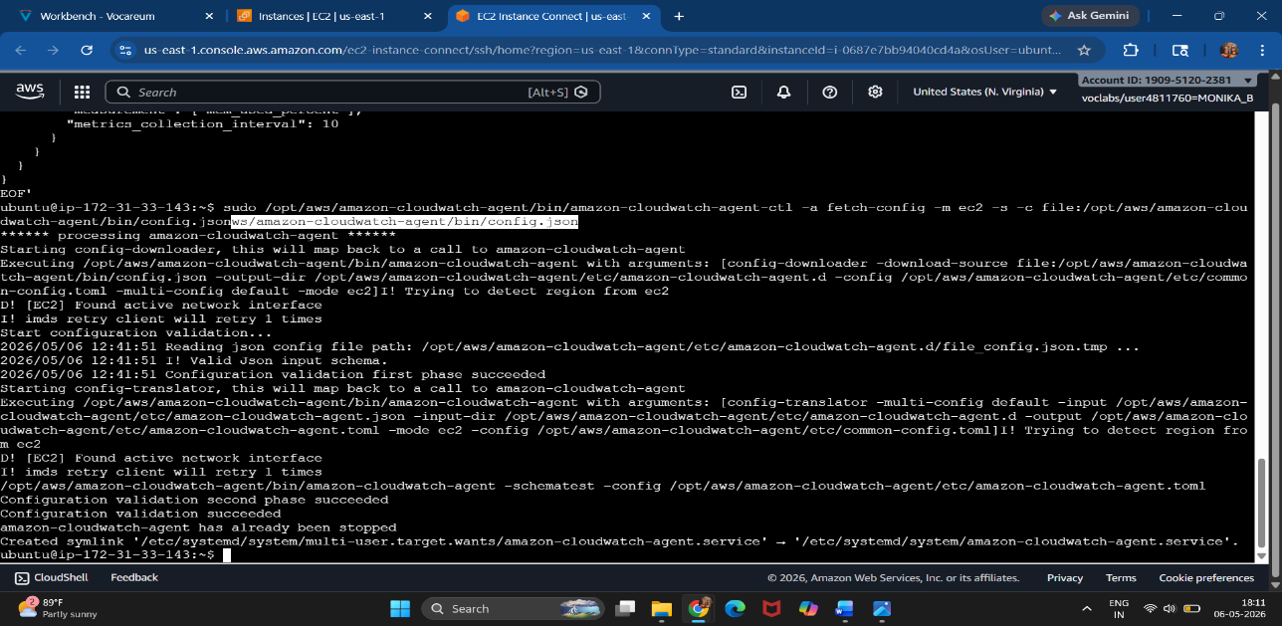
e.g., Fig 9.1.5 : Starting CloudWatch Agent

6. CloudWatch Metrics
Screenshot Content
AWS Console → CloudWatch → Metrics → CWAgent
Show:
- mem_used_percent graph
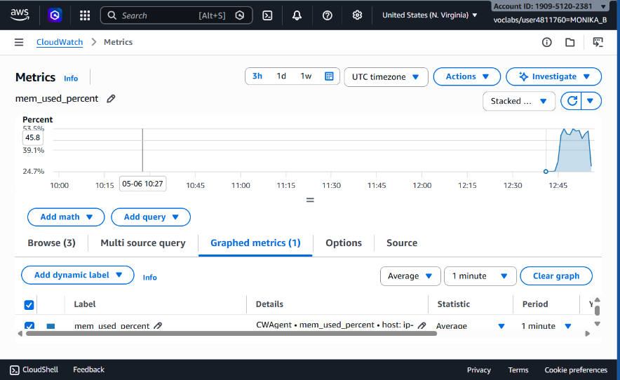
e.g., Fig 9.1.6: Memory Utilization Monitoring
7. CloudWatch Alarm Creation
Screenshot Content
- Alarm threshold >80%
- Alarm name visible
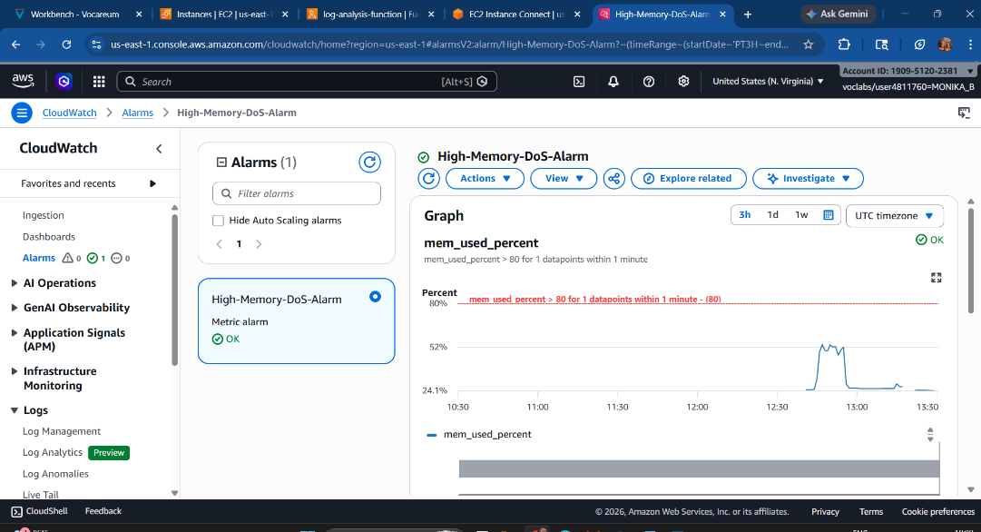
e.g., Fig 9.1.7 CloudWatch Alarm Creation for Memory DoS Detection
8. S3 Bucket Creation
Screenshot Content
Bucket name is visible
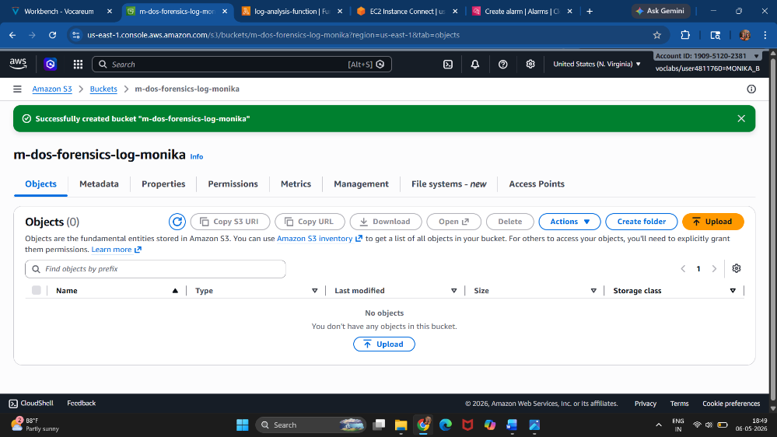
e.g., Fig 9.1.8: S3 Forensic Storage Bucket
9. Lambda Function Code
Lambda Code in python
import boto3
def lambda_handler(event, context):
print("M-DoS ALERT TRIGGERED!")
print("Initiating automated response...")
return {
"statusCode": 200,
"body": "Defence Initiated"
}
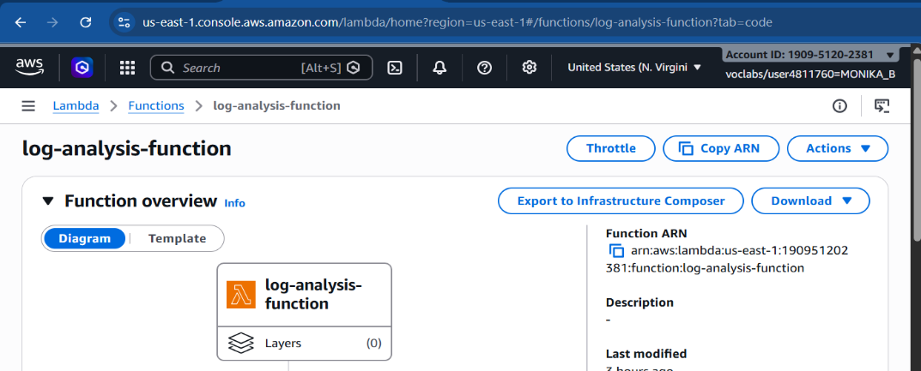
e.g., Fig 9.1.9 : Lambda Automated Response Function
10. Alarm Trigger Simulation
->stress --vm 2 --vm-bytes 330M --timeout 600s
Screenshot Content
- Terminal running stress attack

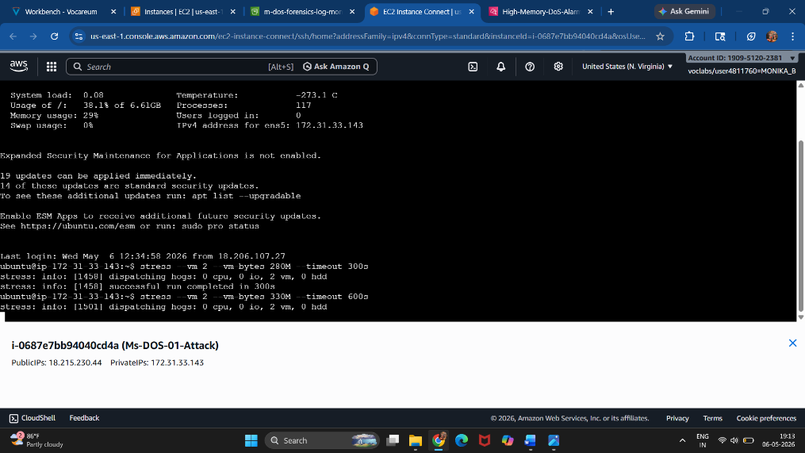
e.g., Fig:9.1.10: Memory DoS Attack Simulation
11. Alarm State Changed
Screenshot Content
CloudWatch Alarm showing: In Alarm
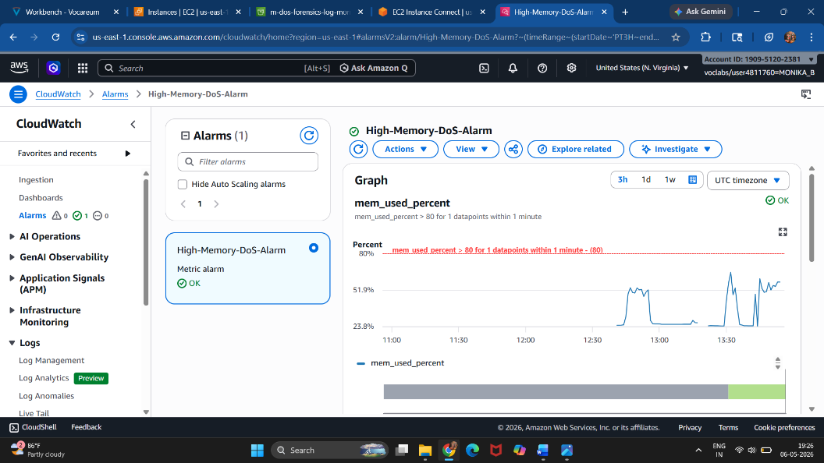
e.g., Fig 9.1.11: CloudWatch Alarm Triggered
12. Lambda Execution Logs
Screenshot Content
CloudWatch Logs:
M-DoS ALERT TRIGGERED!
Initiating automated response...
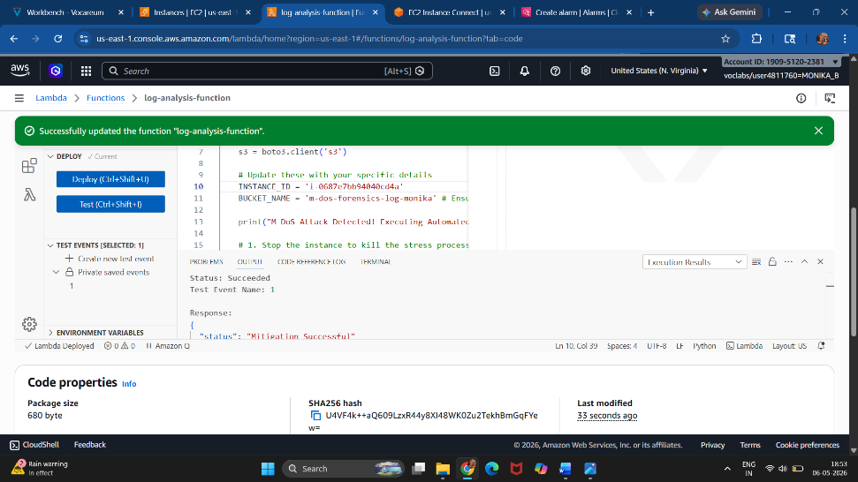
e.g., Fig 9.1.12 : Lambda Response Execution Logs
11. Additional Feature: Web-Based Security Dashboard
An additional web-based monitoring dashboard was developed using Flask to visually represent the status of the M-DoS Detection System.
The dashboard provides:
• Real-time attack status display
• Security monitoring interface
• Interactive response simulation
• Improved usability for administrators
This enhancement improves the user experience and demonstrates how cloud security monitoring systems can be integrated with web technologies.
Coding Section
app.py
from flask import Flask, render_template_string
app = Flask(__name__)
HTML_PAGE = """
<!DOCTYPE html>
<html>
<head>
<title>M-DoS Detection</title>
</head>
<body style="font-family:Arial;background:#f2f2f2;">
<div style="width:500px;margin:auto;margin-top:80px;
background:white;padding:40px;border-radius:20px;text-align:center;">
<h1>🛡️ M-DoS Detection</h1>
<h2>Cloud Security Monitoring Dashboard</h2>
<div style="padding:20px;border:2px solid red;
border-radius:10px;color:red;font-size:28px;">
SYSTEM STATUS: UNDER ATTACK
</div>
<button style="margin-top:30px;padding:15px;width:100%;
background:green;color:white;border:none;border-radius:10px;
font-size:24px;">
NEUTRALIZE ATTACK
</button>
</div>
</body>
</html>
"""
@app.route('/')
def home():
return render_template_string(HTML_PAGE)
if __name__ == '__main__':
app.run(host='0.0.0.0', port=5000)
EXECUTE COMMAND:
python3 app.py

BROWSER ACCESS:
http://18.215.230.44:5000
OUTPUT:
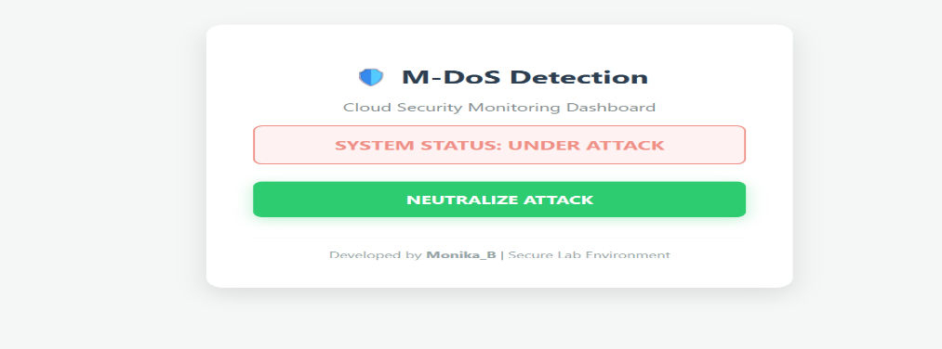
e.g., Fig11.1 Web-Based M-DoS Detection Dashboard

OUTPUT 2:
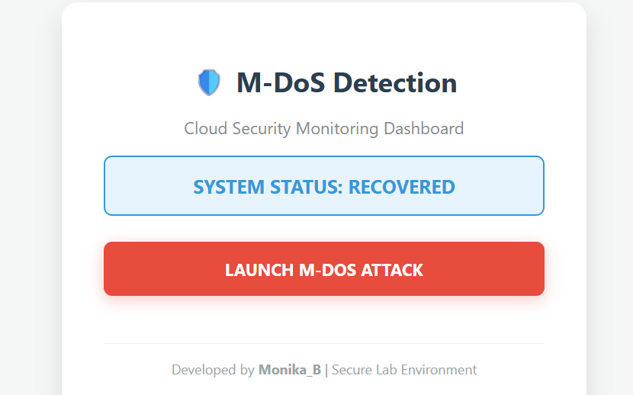
e.g., Fig:11.2 After click launch M-DOS Attack

10. CONCLUSION
This project successfully demonstrated a real-time Memory Denial of Service (M-DoS) detection and automated response system using AWS cloud services. The system continuously monitored memory utilization on an Ubuntu EC2 instance using Amazon CloudWatch Agent.
When memory usage exceeded the defined threshold, CloudWatch triggered an alarm and automatically invoked an AWS Lambda function to simulate defensive actions. The project proved the effectiveness of cloud-native monitoring and automated incident response mechanisms in improving system security and availability.
The implementation also demonstrated integration between EC2, CloudWatch, Lambda, S3, and a web-based monitoring dashboard.

10.1 FUTURE ENHANCEMENT
• Integration with AWS WAF to automatically block malicious IP addresses responsible for abnormal memory-intensive requests.
• Machine Learning integration using AWS SageMaker to predict Memory DoS attacks based on memory usage patterns before threshold violations occur.
• Integration with Amazon SNS for real-time Discord, Telegram, or email alerts to notify security administrators instantly.
• Automatic EC2 isolation or shutdown during severe attacks to reduce infrastructure impact.
• Advanced monitoring dashboard with real-time analytics and graphical visualization.

10.2 REFERENCES
- AWS Whitepaper – “AWS Security Best Practices for Amazon EC2.”
https://docs.aws.amazon.com/AWSEC2/latest/UserGuide/ec2-security.html
- AWS Boto3 Documentation – “EC2 Client stop_instances Method.”
https://boto3.amazonaws.com/v1/documentation/api/latest/reference/services/ec2/client/stop_instances.html
- Ubuntu Documentation – “System Resource Monitoring and Stress Utility.”
https://manpages.ubuntu.com/manpages/jammy/man1/stress.1.html
- Amazon CloudWatch User Guide – “Collecting Custom Metrics from Amazon EC2 Instances.”
https://docs.aws.amazon.com/AmazonCloudWatch/latest/monitoring/Install-CloudWatch-Agent.html
- AWS Lambda Developer Guide – “Serverless Event-Driven Computing.”
https://docs.aws.amazon.com/lambda/latest/dg/welcome.html

10.3 COST ANALYSIS
The implemented system provides significant economic advantages for organizations:
- Serverless Cost Efficiency: By using AWS Lambda, costs are only incurred during the few seconds it takes to mitigate an attack. There are no hourly charges for a dedicated monitoring server.
- Prevention of Financial Loss: M-DoS attacks can cause "Elasticity Attacks" where auto-scaling groups keep adding servers, leading to a massive AWS bill. Our system stops the instance immediately, preventing financial overbilling.
- Audit Readiness: Automated S3 logging reduces the time and cost associated with manual security auditing and compliance reporting.

