**Main information about Eclipse Dirigible:**

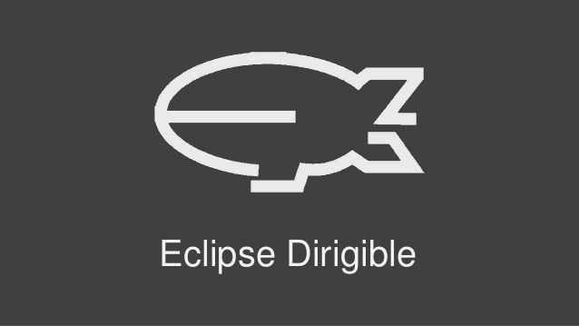Dirigible is a cloud development toolkit providing both development tools and runtime environment. It supports full development life-cycle of on-demand applications by leveraging in-system programming models and rapid application development techniques.

Eclipse Dirigible provides capabilities for end-to-end development process from database modeling and management, through RESTful services authoring using various dynamic languages, to pattern-based user interface generation, role based security, external services integration, testing, debugging, operations, and monitoring.

**Motivation for using Eclipse Dirigible:**

* ***For Education:***

You can develop student projects, test different technologies and scenarios, learn popular programming languages.

## *For Business:*

You can easily develop, document, and monitor your business applications, taking full advantage of the diverse selection of features and services offered by Eclipse Dirigible.

## *IT IS FREE:*

All the Eclipse Dirigible project's source code and sample applications are licensed under [Eclipse Public License - v 1.0](https://www.eclipse.org/legal/epl-v10.html) and maintained at [GitHub](https://github.com/eclipse/dirigible).

## *For Developers:*

Eclipse Dirigible provides everything you need for your development project:

* Application server
* Content repository
* Web IDE
* 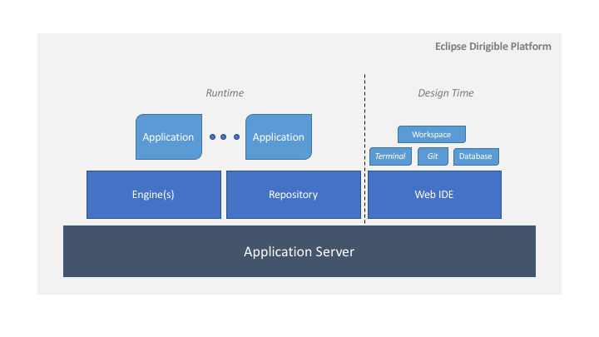Variety of features

**EXAMPLE of an application, made on Eclipse Dirigible:**

[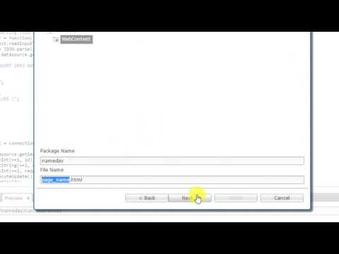](https://www.youtube.com/watch?v=0a1t2BsO8XA)

Mobile application – *“Register for nameday”.*

Here is a video tutorial that describes in details our example.