Research

IKIGAI

Definition IKIGAI – Wikipedia

*Ikigai* (生き甲斐, lit. 'a reason for being') is a Japanese concept referring to something that gives a person a sense of purpose, a reason for living. (<https://en.wikipedia.org/wiki/Ikigai>)

Explanation IKIGAI – Website: Japanese Up Close

Ikigai or 生き甲斐 is a Japanese philosophical term that breaks into “iki” meaning “alive” and “gai” meaning “worth”. These phrases together refer to what gives your life value, meaning, or purpose. The concept of ikigai has evolved from traditional Japanese medicine's essential health and wellness concepts.

History of Ikigai:

The ancient Japanese philosophical term” Ikigai” originated in the Heian period. It is said to be famous as a culture in the Okinawa Islands of Japan. It is becoming popular among the elderly and the new generation in Japan and across the world.

Four Pillars of Ikigai:

It's worth noting that, while traditional Japanese philosophy focuses on achieving your bliss, western interpretations have used ikigai to locate your dream job which includes the following:

* What you love: is there any activity you love or can’t seem to get enough of?
* What you are good at: What is your passion?
* What you can be paid for: Do you make enough for a living?
* What the world needs: Is your field of work desirable or in high demand?

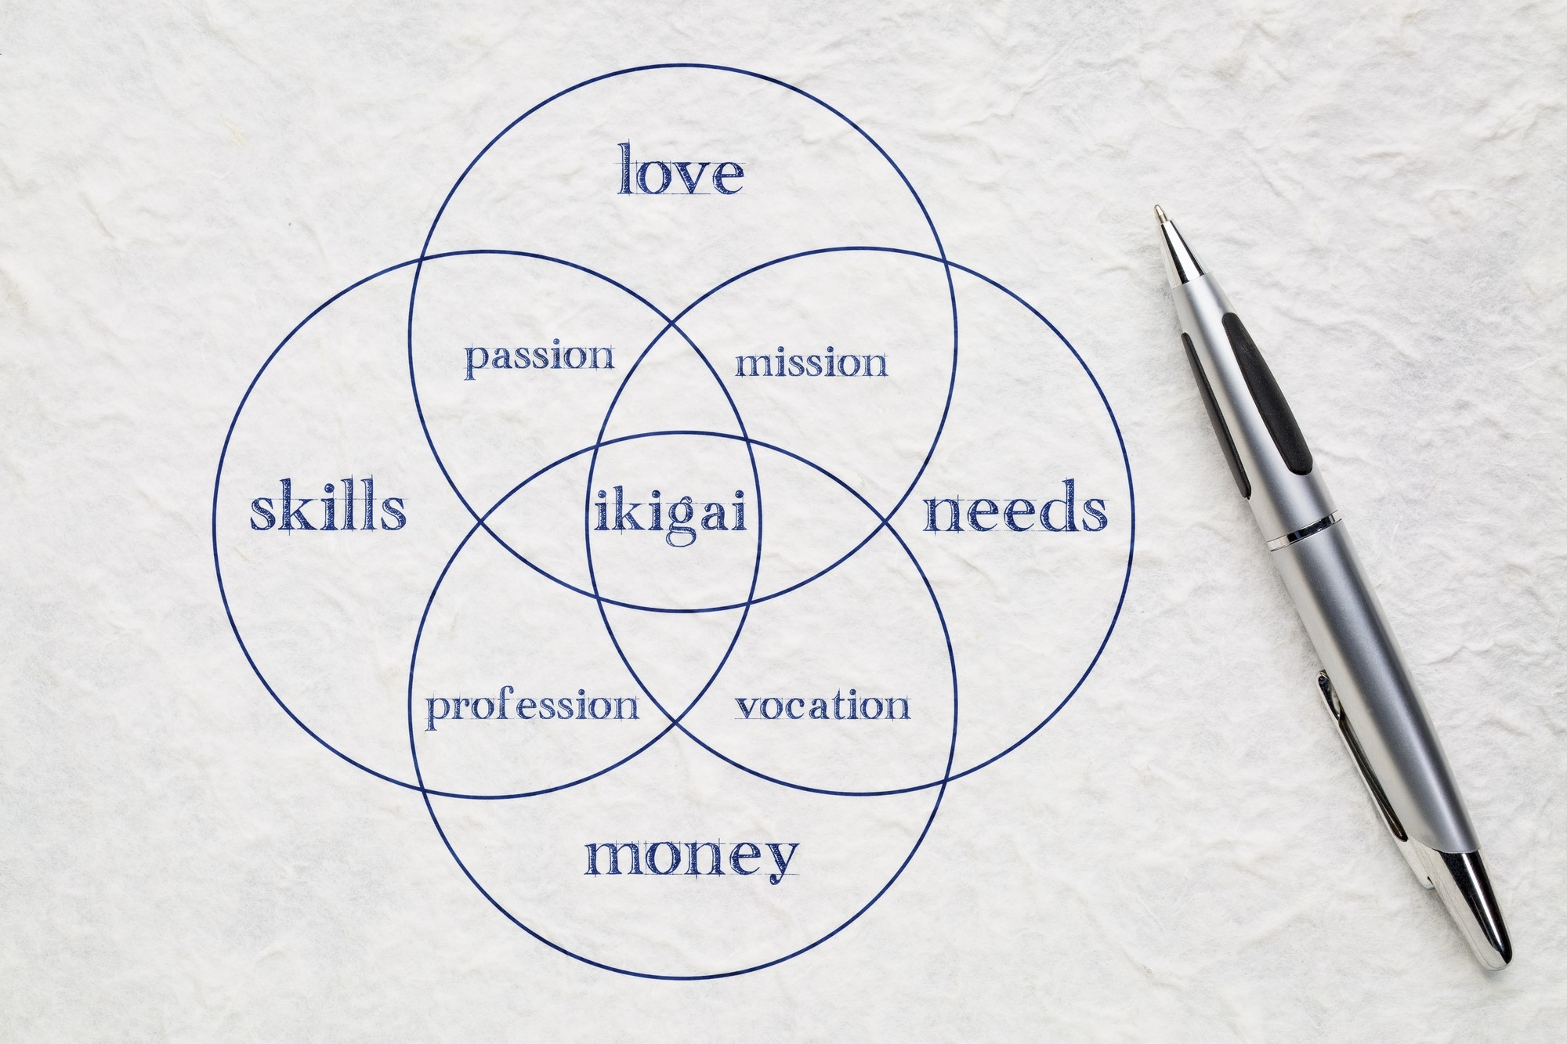

The term Ikigai in this venn diagram depicts something you are passionate about or love doing , or something you are also skilled at, that the world needs right now, and for which you will get paid. Ikigai is not restricted to career goals, but it could also involve raising a family or being deeply engaged in something you have always fantasized about. Many people, whether consciously or unconsciously, are searching for ikigai, one's reason for existing, or waking up cheerfully each morning. Even while people's ideas about ikigai differ, there is widespread agreement that finding this compelling purpose in life is related to better contentment and pleasure.

Source: <https://japanupclose.web-japan.org/techculture/c20230609_1.html>

IKIGAI Die japanische Lebenskunst – Ken Mogi

Die fünf Säule des Ikigai aus dem Buch nach einer hierarchischen Reihenfolge:

= entscheidende Grundlage des Igikai, Wegweiser des Lebens, Sinn des Lebens, Alltagsdinge oder Erfolge und Ziele

1. Klein anfangen
2. Loslassen lernen
3. Harmonie und Nachhaltigkeit leben
4. Die Freude an kleinen Dingen entdecken
5. Im Hier und Jetzt sein