RL-Experiment-1
Code:

import random
class Environment:
def __init__(self):
self.state=0
def reset(self):
self.state=0
return self.state
def step(self,action):
self.state+=action
if self.state==5:
reward=10
done=True
else:
reward=0
done=False

return self.state,reward,done
class Agent:
def __init__(self):
self.actions=[-1,+1]
def select_action(self):
return random.choice(self.actions)
env=Environment()
agent=Agent()

state=env.reset()
done=False
step_count=0
print("Starting Episode:")
while not done:
action=agent.select_action()
next_state,reward,done=env.step(action)
print(f"{step_count}:state={state},Action={action},Next State={next_state},Reward={reward}")
state=next_state
step_count+=1
print("Episode finished")

Output:
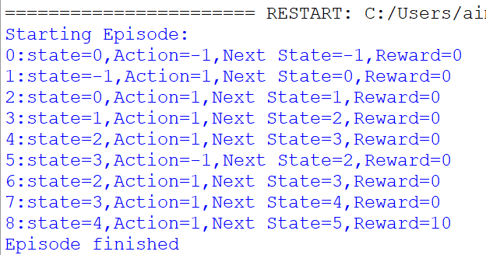

Code 2:

import random
class Environment:
def __init__(self):
self.state=0

def reset(self):
self.state=0
return self.state
def step(self,action):
self.state+=action
if self.state==10:
reward=20
done=True
else:
reward=0
done=False

return self.state,reward,done
class Agent:
def __init__(self):
self.actions=[-1,+1]
def select_action(self):
return random.choice(self.actions)
env=Environment()
agent=Agent()

state=env.reset()
done=False
step_count=0
print("Starting Episode:")
while not done:
action=agent.select_action()
next_state,reward,done=env.step(action)
print(f"{step_count}:state={state},Action={action},Next State={next_state},Reward={reward}")
state=next_state
step_count+=1
print("Episode finished")

Output:

