Day 1

Tensor Flow

Keras

Colab

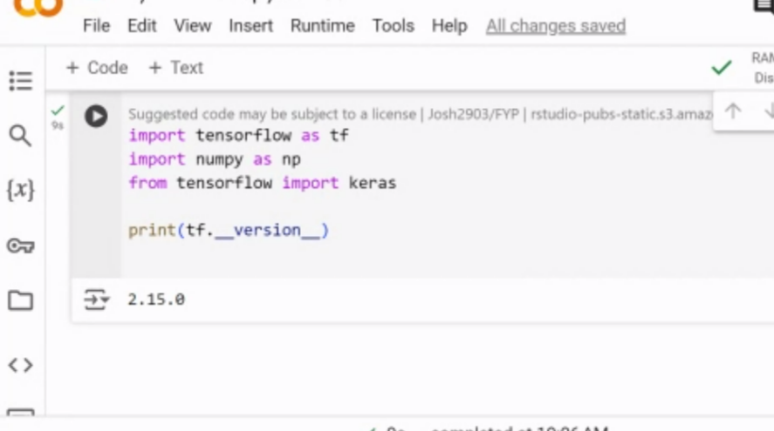



My file: 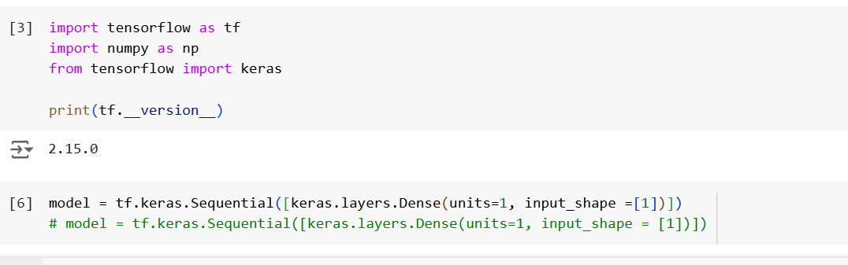

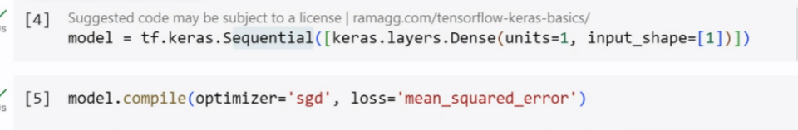

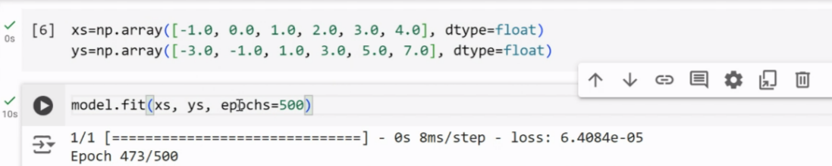

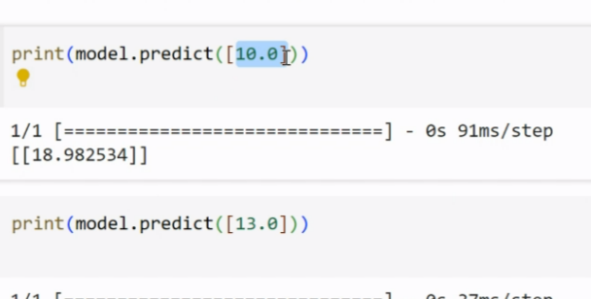

Image classification

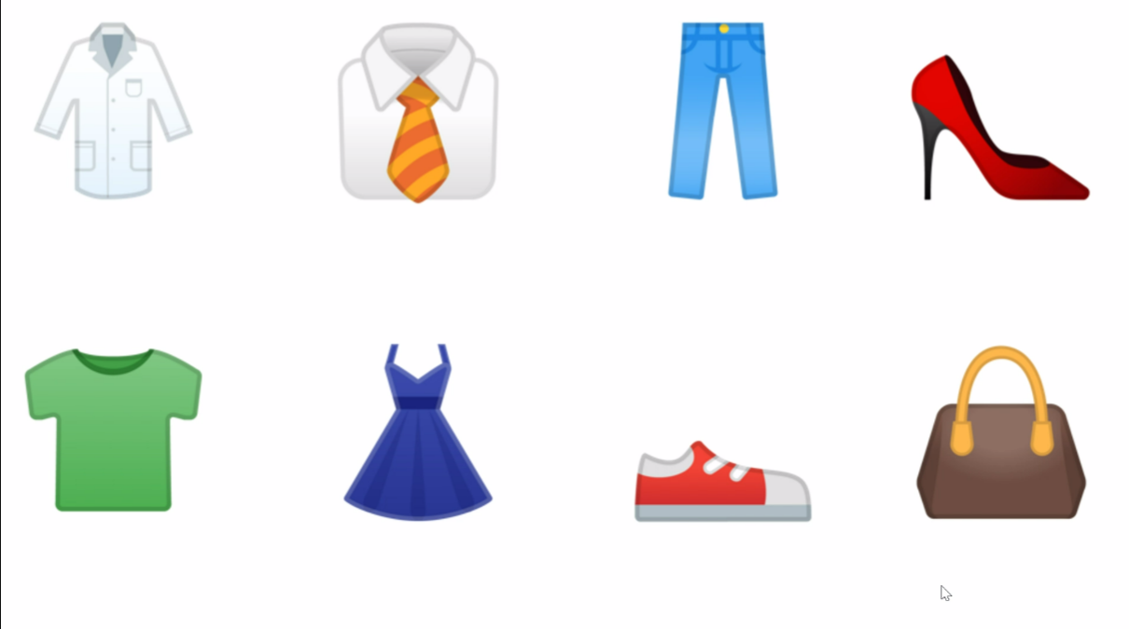

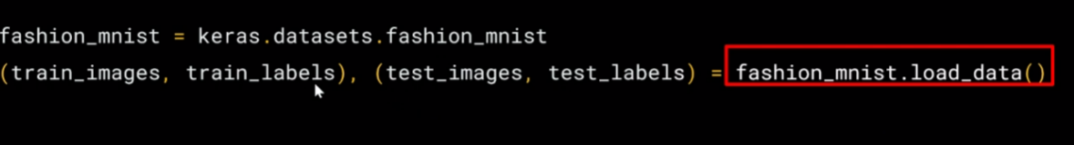

import numpy as np  
import matplotlib.pyplot as plt

index = 0  
np.set_printoptions(linewidth=320)  
print(f'LABEL:{training_labels[index]}')  
print(f'\nIMAGE PIXEL ARRAY:\n{training_images[index]}')  
plt.imshow(training_images[index])  
training_images = training_images / 255.0  
test_images = test_images / 255.0