Day 1

Tensor Flow

Keras

Colab

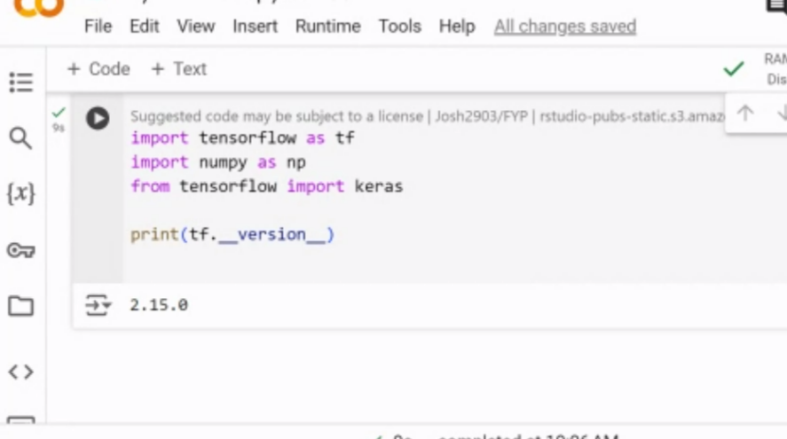



My file: 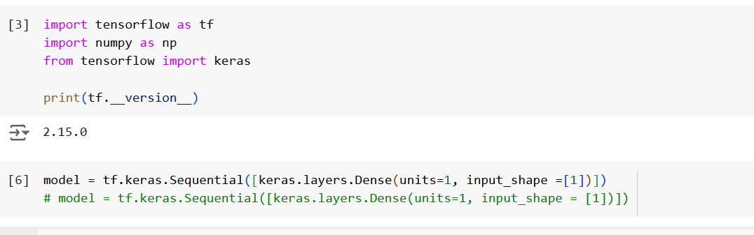

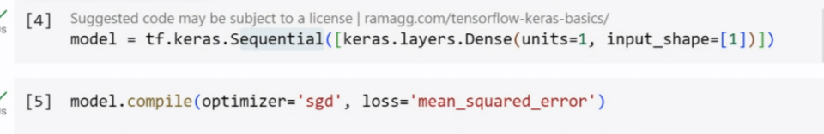

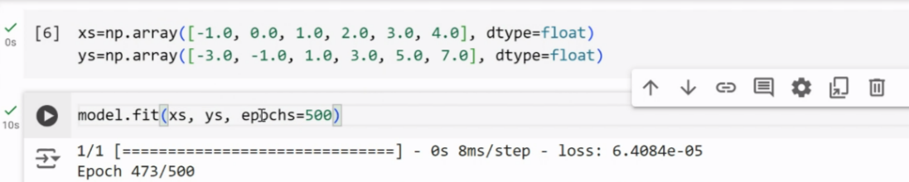

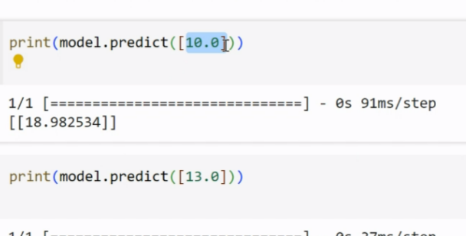

Image classification

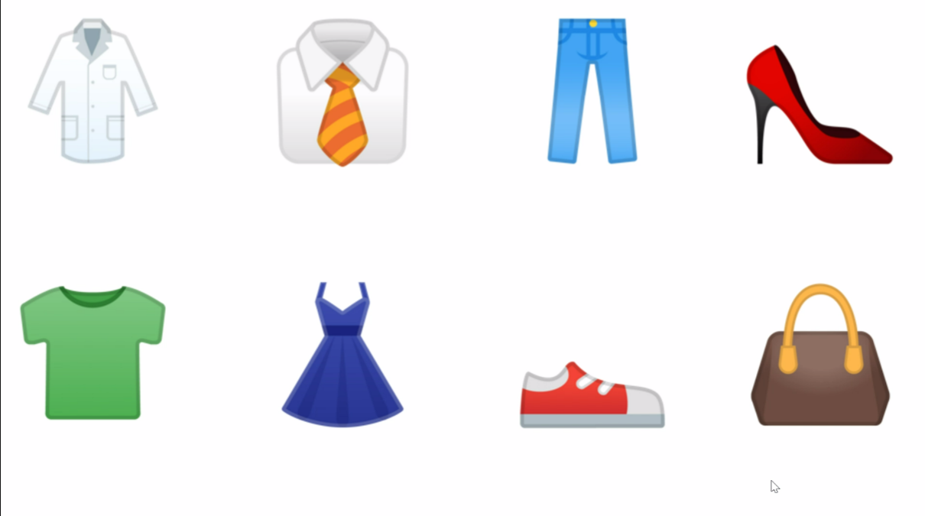

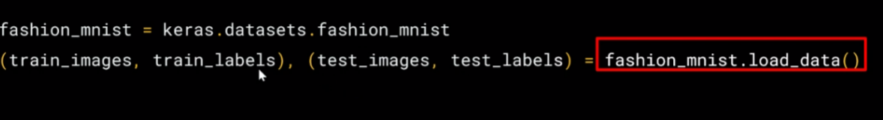

import numpy as np  
import matplotlib.pyplot as plt

index = 0  
np.set_printoptions(linewidth=320)  
print(f'LABEL:{training_labels[index]}')  
print(f'\nIMAGE PIXEL ARRAY:\n{training_images[index]}')  
plt.imshow(training_images[index])  
training_images = training_images / 255.0  
test_images = test_images / 255.0

import tensorflow as tf  
print(tf.**version**)   
fmnist= tf.keras.datasets.fashion_mnist  
(training_images, training_labels), (test_images, test_labels) = fmnist.load_data()  
import numpy as np  
import matplotlib.pyplot as plt  
index = 0  
np.set_printoptions(linewidth=320)  
print(f'LABEL:{training_labels[index]}')  
print(f'\nIMAGE PIXEL ARRAY:\n{training_images[index]}')

plt.imshow(training_images[index])  
training_images = training_images / 255.0  
test_images = test_images / 255.0

Second Poll

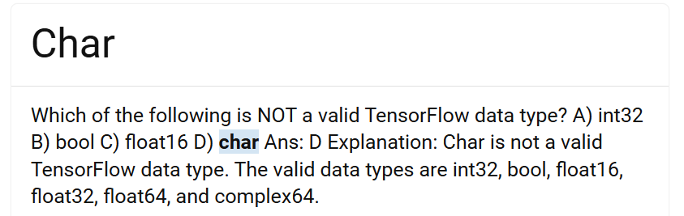

[TensorFlow MCQs and Answers With Explanation (freshersnow.com)](https://www.freshersnow.com/tensorflow-mcqs-and-answers-with-explanation/#:~:text=Which%20of%20the%20following%20is%20NOT%20a%20valid,are%20int32%2C%20bool%2C%20float16%2C%20float32%2C%20float64%2C%20and%20complex64.)

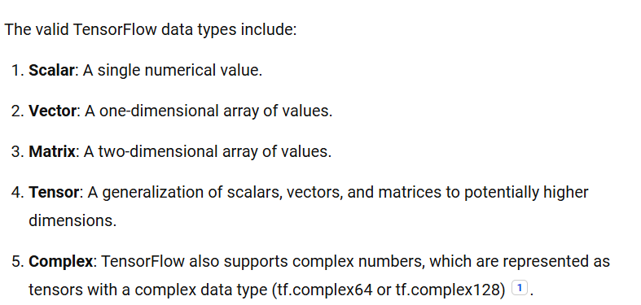

**DAY 2**

model=tf.keras.models.Sequential([tf.keras.layers.flatten(),  
tf.keras.layers.Dense(128,activation=tf.nn.relu(),)]  
tf.keras.layers.Dense(10,activation=tf.nn.softmax())])

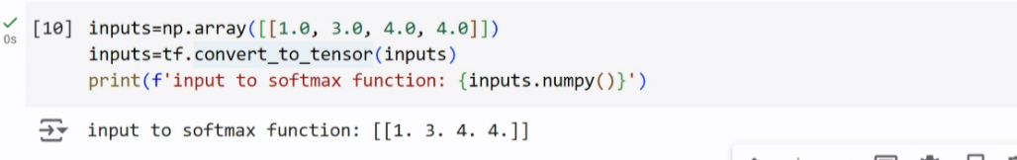

inputs=np.array([1.0,3.0,4.0,4.0])  
inputs=tf.convert_to_tensor(inputs)  
print(f'input to softmax:{inputs.numpy()}')

outputs=tf.keras.activations.softmax(inputs)  
print(f'output of softmax function: {outputs.numpy()}')

model.compile(optimizer=tf.optimizers.Adam(),  
              loss='sparse_categorical_crossentropy',  
              metrics=['accuracy'])

model.fit(training_images, training_labels, epochs=5)

**Evaluating model on unseen DATA**

#Load the Fashion MNIST dataset  
fmnist = tf.keras.datasets.fashion_mnist

# Load the training and test split of the Fashion MNIST dataset

(training_images, training_labels), (test_images, test_labels) = fmnist.load_data()  
##print a training image (both as an image and a numpy array), and a training label to see:  
  
import numpy as np  
import matplotlib.pyplot as plt

# You can put between 0 to 59999 here

index = 0

# Set number of characters per row when printing

np.set_printoptions(linewidth=320)

# Print the label and image

print(f'LABEL: {training_labels[index]}')  
print(f'\nIMAGE PIXEL ARRAY:\n {training_images[index]}')

# Visualize the image

plt.imshow(training_images[index])

# Normalize the pixel values of the train and test images

training_images = training_images / 255.0  
test_images = test_images / 255.0

# Build the classification model

model = tf.keras.models.Sequential([tf.keras.layers.Flatten(),  
tf.keras.layers.Dense(128, activation=tf.nn.relu),  
tf.keras.layers.Dense(10, activation=tf.nn.softmax)])

# Declare sample inputs and convert to a tensor

inputs = np.array([[1.0, 3.0, 4.0, 2.0]])  
inputs = tf.convert_to_tensor(inputs)  
print(f'input to softmax function: {inputs.numpy()}')

# Feed the inputs to a softmax activation function

outputs = tf.keras.activations.softmax(inputs)  
print(f'output of softmax function: {outputs.numpy()}')

# Get the sum of all values after the softmax

sum = tf.reduce_sum(outputs)  
print(f'sum of outputs: {sum}')

# Get the index with highest value

prediction = np.argmax(outputs)  
print(f'class with highest probability: {prediction}')  
  
##compiling it with an optimizer and loss function  
model.compile(optimizer = tf.optimizers.Adam(),  
loss = 'sparse_categorical_crossentropy',  
metrics=['accuracy'])  
  
## train it by calling [model.fit](https://model.fit)()  
model.fit(training_images, training_labels, epochs=5).

# Evaluate the model on unseen data

model.evaluate(test_images, test_labels)

**QUES:** Let's now look at the layers in your model. Experiment with different values for the dense layer with 512 neurons. What different results do you get for loss, training time etc? Why do you think that's the case?

**Call back:**

import tensorflow as tf

# Instantiate the dataset API

fmnist = tf.keras.datasets.fashion_mnist

# Load the dataset

(x_train, y_train),(x_test, y_test) = fmnist.load_data()

# Normalize the pixel values

x_train, x_test = x_train / 255.0, x_test / 255.0

# Creating a Callback class

class myCallback(tf.keras.callbacks.Callback):  
def on_epoch_end(self, epoch, logs={}):  
'''  
Halts the training after reaching 60 percent accuracy  
  
Args:  
epoch (integer) - index of epoch (required but unused in the function definition below)  
logs (dict) - metric results from the training epoch  
'''  
  
# Check accuracy  
if(logs.get('loss') < 0.4):  
  
# Stop if threshold is met  
print("\nLoss is lower than 0.4 so cancelling training!")  
self.model.stop_training = True

# Instantiate class

callbacks = myCallback()

# Define and compile the model

# Define the model

model = tf.keras.models.Sequential([  
tf.keras.layers.Flatten(input_shape=(28, 28)),  
tf.keras.layers.Dense(512, activation=tf.nn.relu),  
tf.keras.layers.Dense(10, activation=tf.nn.softmax)  
])

# Compile the model

model.compile(optimizer=tf.optimizers.Adam(),  
loss='sparse_categorical_crossentropy',  
metrics=['accuracy'])  
#Train the model

# Train the model with a callback

model.fit(x_train, y_train, epochs=10, callbacks=[callbacks])

Optional Challenge: Modify the code to make the training stop when the accuracy metric exceeds 60%.

DAY 3

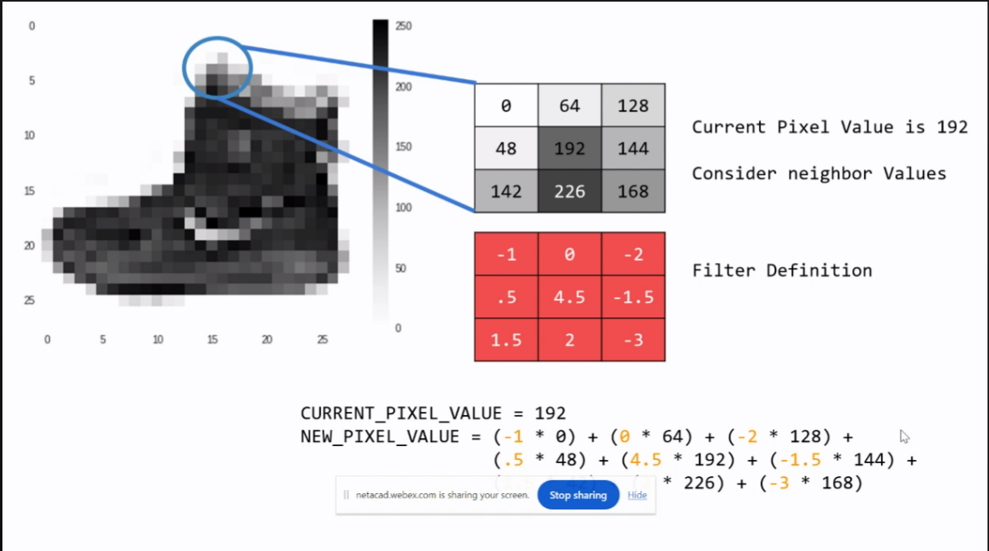

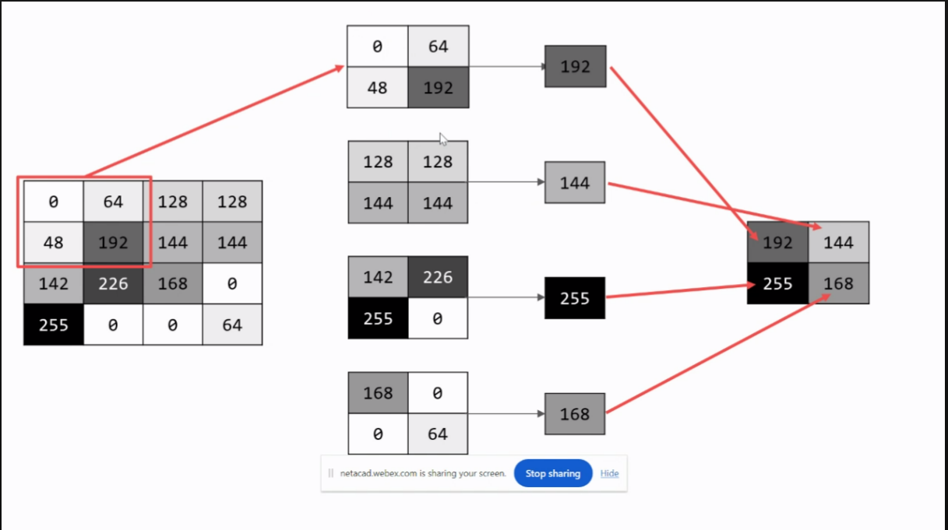

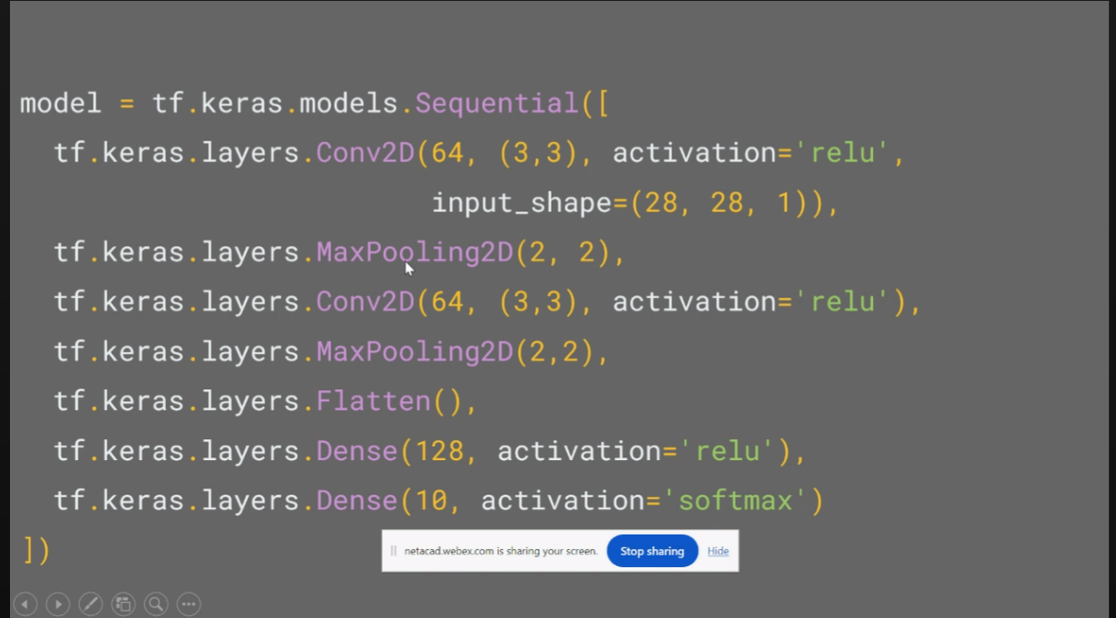

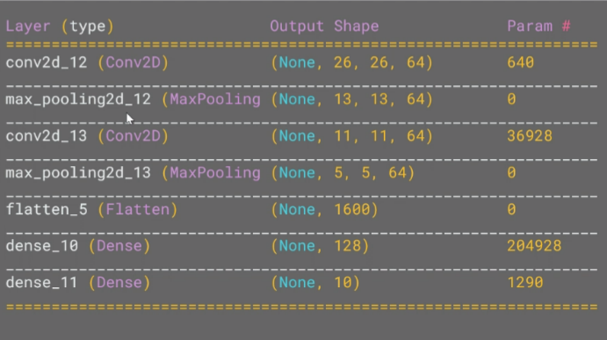

Adil yousuf 27-06-2024 10:04 •

import tensorflow as tf

# Load the Fashion MNIST dataset

fmnist = tf.keras.datasets.fashion_mnist  
(training_images, training_labels), (test_images, test_labels) = fmnist.load_data()

# Normalize the pixel values

training_images = training_images / 255.0  
test_images = test_images / 255.0

# Define the model

model = tf.keras.models.Sequential([  
tf.keras.layers.Flatten(),  
tf.keras.layers.Dense(128, activation=tf.nn.relu),  
tf.keras.layers.Dense(10, activation=tf.nn.softmax)  
])

# Setup training parameters

model.compile(optimizer='adam', loss='sparse_categorical_crossentropy', metrics=['accuracy'])

# Train the model

print(f'\nMODEL TRAINING:')  
model.fit(training_images, training_labels, epochs=5)

# Evaluate on the test set

print(f'\nMODEL EVALUATION:')  
test_loss = model.evaluate(test_images, test_labels)

Adil yousuf 27-06-2024 10:08 •

# Define the model

model = tf.keras.models.Sequential([  
  
# Add convolutions and max pooling  
tf.keras.layers.Conv2D(32, (3,3), activation='relu', input_shape=(28, 28, 1)),  
tf.keras.layers.MaxPooling2D(2, 2),  
tf.keras.layers.Conv2D(32, (3,3), activation='relu'),  
tf.keras.layers.MaxPooling2D(2,2),  
  
# Add the same layers as before  
tf.keras.layers.Flatten(),  
tf.keras.layers.Dense(128, activation='relu'),  
tf.keras.layers.Dense(10, activation='softmax')  
])

# Print the model summary

model.summary()

# Use same settings

model.compile(optimizer='adam', loss='sparse_categorical_crossentropy', metrics=['accuracy'])

# Train the model

print(f'\nMODEL TRAINING:')  
model.fit(training_images, training_labels, epochs=5)

# Evaluate on the test set

print(f'\nMODEL EVALUATION:')  
test_loss = model.evaluate(test_images, test_labels)  
#Visualizing the Convolutions and Pooling  
print(test_labels[:100])  
import matplotlib.pyplot as plt  
from tensorflow.keras import models  
  
f, axarr = plt.subplots(3,4)  
  
FIRST_IMAGE=0  
SECOND_IMAGE=23  
THIRD_IMAGE=28  
CONVOLUTION_NUMBER = 1  
  
layer_outputs = [layer.output for layer in model.layers]  
activation_model = tf.keras.models.Model(inputs = model.input, outputs = layer_outputs)  
  
for x in range(0,4):  
f1 = activation_model.predict(test_images[FIRST_IMAGE].reshape(1, 28, 28, 1))[x]  
axarr[0,x].imshow(f1[0, : , :, CONVOLUTION_NUMBER], cmap='inferno')  
axarr[0,x].grid(False)  
  
f2 = activation_model.predict(test_images[SECOND_IMAGE].reshape(1, 28, 28, 1))[x]  
axarr[1,x].imshow(f2[0, : , :, CONVOLUTION_NUMBER], cmap='inferno')  
axarr[1,x].grid(False)  
  
f3 = activation_model.predict(test_images[THIRD_IMAGE].reshape(1, 28, 28, 1))[x]  
axarr[2,x].imshow(f3[0, : , :, CONVOLUTION_NUMBER], cmap='inferno')  
axarr[2,x].grid(False)

**Exercise:**

1. Try editing the convolutions. Change the 32s to either 16 or 64. What impact will this have on accuracy and/or training time.
2. Remove the final Convolution. What impact will this have on accuracy or training time?
3. How about adding more Convolutions? What impact do you think this will have? Experiment with it.

[MCQs | Convolutional Neural Networks | AIMCQs](https://aimcqs.com/convolutional-neural-networks)

DAY 4

IMAGE DATA GENERATION

!wget https://storage.googleapis.com/tensorflow-1-public/course2/week3/horse-or-human.zip

import zipfile

# Unzip the dataset

local_zip = './horse-or-human.zip'  
zip_ref = zipfile.ZipFile(local_zip, 'r')  
zip_ref.extractall('./horse-or-human')  
zip_ref.close()

import os

# Directory with our training horse pictures

train_horse_dir = os.path.join('./horse-or-human/horses')

# Directory with our training human pictures

train_human_dir = os.path.join('./horse-or-human/humans')

train_horse_names = os.listdir(train_horse_dir)  
print(train_horse_names[:10])  
   
train_human_names = os.listdir(train_human_dir)  
print(train_human_names[:10])

print('total training horse images:', len(os.listdir(train_horse_dir)))  
print('total training human images:', len(os.listdir(train_human_dir)))

Adil yousuf 28-06-2024 10:16 •

%matplotlib inline  
  
import matplotlib.pyplot as plt  
import matplotlib.image as mpimg

# Parameters for our graph; we'll output images in a 4x4 configuration

nrows = 4  
ncols = 4

# Index for iterating over images

pic_index = 0

# Now, display a batch of 8 horse and 8 human pictures. You can rerun the cell to see a fresh batch each time:

# Set up matplotlib fig, and size it to fit 4x4 pics

fig = plt.gcf()  
fig.set_size_inches(ncols * 4, nrows * 4)  
  
pic_index += 8  
next_horse_pix = [os.path.join(train_horse_dir, fname)  
for fname in train_horse_names[pic_index-8:pic_index]]  
next_human_pix = [os.path.join(train_human_dir, fname)  
for fname in train_human_names[pic_index-8:pic_index]]  
  
for i, img_path in enumerate(next_horse_pix+next_human_pix):  
# Set up subplot; subplot indices start at 1  
sp = plt.subplot(nrows, ncols, i + 1)  
sp.axis('Off') # Don't show axes (or gridlines)  
  
img = mpimg.imread(img_path)  
plt.imshow(img)  
  
[plt.show](https://plt.show)()

import tensorflow as tf

model = tf.keras.models.Sequential([  
# Note the input shape is the desired size of the image 300x300 with 3 bytes color  
    # This is the first convolution  
tf.keras.layers.Conv2D(16, (3,3), activation='relu', input_shape=(300, 300, 3)),  
tf.keras.layers.MaxPooling2D(2, 2),  
    # The second convolution  
tf.keras.layers.Conv2D(32, (3,3), activation='relu'),  
tf.keras.layers.MaxPooling2D(2,2),  
    # The third convolution  
tf.keras.layers.Conv2D(64, (3,3), activation='relu'),  
tf.keras.layers.MaxPooling2D(2,2),  
    # The fourth convolution  
tf.keras.layers.Conv2D(64, (3,3), activation='relu'),  
tf.keras.layers.MaxPooling2D(2,2),  
    # The fifth convolution  
tf.keras.layers.Conv2D(64, (3,3), activation='relu'),  
tf.keras.layers.MaxPooling2D(2,2),  
    # Flatten the results to feed into a DNN  
tf.keras.layers.Flatten(),  
# 512 neuron hidden layer  
tf.keras.layers.Dense(512, activation='relu'),  
# Only 1 output neuron. It will contain a value from 0-1 where 0 for 1 class ('horses') and 1 for the other ('humans')  
tf.keras.layers.Dense(1, activation='sigmoid')  
])

model.summary()

rom tensorflow.keras.optimizers import RMSprop  
   
model.compile(loss='binary_crossentropy',  
optimizer=RMSprop(learning_rate=0.001),  
              metrics=['accuracy'])

Adil yousuf 28-06-2024 10:31 •

from tensorflow.keras.preprocessing.image import ImageDataGenerator

# All images will be rescaled by 1./255

train_datagen = ImageDataGenerator(rescale=1/255)

# Flow training images in batches of 128 using train_datagen generator

train_generator = train_datagen.flow_from_directory(  
'./horse-or-human/', # This is the source directory for training images  
target_size=(300, 300), # All images will be resized to 300x300  
batch_size=128,  
# Since we use binary_crossentropy loss, we need binary labels  
class_mode='binary')

import numpy as np  
from google.colab import files  
from keras.preprocessing import image  
   
uploaded = files.upload()  
   
for fn in uploaded.keys():  
  
  # predicting images  
path = '/content/' + fn  
img = image.load_img(path, target_size=(300, 300))  
x = image.img_to_array(img)  
x /= 255  
x = np.expand_dims(x, axis=0)  
   
images = np.vstack([x])  
classes = model.predict(images, batch_size=10)  
print(classes[0])  
      
if classes[0]>0.5:  
    print(fn + " is a human")  
else:  
    print(fn + " is a horse")

UPLOAD ANY IMAGE AND CHECK FOR ACCURACY

import numpy as np  
import random  
from tensorflow.keras.preprocessing.image import img_to_array, load_img

# Define a new Model that will take an image as input, and will output

# intermediate representations for all layers in the previous model after

# the first.

successive_outputs = [layer.output for layer in model.layers[1:]]  
visualization_model = tf.keras.models.Model(inputs = model.input, outputs = successive_outputs)

28-06-2024 11:29 •

# Prepare a random input image from the training set.

horse_img_files = [os.path.join(train_horse_dir, f) for f in train_horse_names]  
human_img_files = [os.path.join(train_human_dir, f) for f in train_human_names]  
img_path = random.choice(horse_img_files + human_img_files)  
  
img = load_img(img_path, target_size=(300, 300)) # this is a PIL image  
x = img_to_array(img) # Numpy array with shape (300, 300, 3)  
x = x.reshape((1,) + x.shape) # Numpy array with shape (1, 300, 300, 3)

# Scale by 1/255

x /= 255

# Run the image through the network, thus obtaining all

# intermediate representations for this image.

successive_feature_maps = visualization_model.predict(x)

# These are the names of the layers, so you can have them as part of the plot

layer_names = [layer.name for layer in model.layers[1:]]

**Display the representations**

for layer_name, feature_map in zip(layer_names, successive_feature_maps):  
if len(feature_map.shape) == 4:  
  
# Just do this for the conv / maxpool layers, not the fully-connected layers  
n_features = feature_map.shape[-1] # number of features in feature map  
  
# The feature map has shape (1, size, size, n_features)  
size = feature_map.shape[1]  
  
# Tile the images in this matrix  
display_grid = np.zeros((size, size * n_features))  
for i in range(n_features):  
x = feature_map[0, :, :, i]  
x -= x.mean()  
x /= x.std()  
x *= 64  
x += 128  
x = np.clip(x, 0, 255).astype('uint8')  
  
# Tile each filter into this big horizontal grid  
display_grid[:, i * size : (i + 1) * size] = x  
  
# Display the grid  
scale = 20. / n_features  
plt.figure(figsize=(scale * n_features, scale))  
plt.title(layer_name)  
plt.grid(False)  
plt.imshow(display_grid, aspect='auto', cmap='viridis')

import os, signal

os.kill(os.getpid(),signal.SIGKILL)

DAY 5

**Download the training set**

!wget <https://storage.googleapis.com/tensorflow-1-public/course2/week3/horse-or-human.zip>

# Download the validation set

!wget <https://storage.googleapis.com/tensorflow-1-public/course2/week3/validation-horse-or-human.zip>

import zipfile

# Unzip training set

local_zip = './horse-or-human.zip'  
zip_ref = zipfile.ZipFile(local_zip, 'r')  
zip_ref.extractall('./horse-or-human')

# Unzip validation set

local_zip = './validation-horse-or-human.zip'  
zip_ref = zipfile.ZipFile(local_zip, 'r')  
zip_ref.extractall('./validation-horse-or-human')  
  
zip_ref.close()

29-06-2024 09:22 •

import os

# Directory with training horse pictures

train_horse_dir = os.path.join('./horse-or-human/horses')

# Directory with training human pictures

train_human_dir = os.path.join('./horse-or-human/humans')

# Directory with validation horse pictures

validation_horse_dir = os.path.join('./validation-horse-or-human/horses')

# Directory with validation human pictures

validation_human_dir = os.path.join('./validation-horse-or-human/humans')

import os

# Directory with training horse pictures

train_horse_dir = os.path.join('./horse-or-human/horses')

# Directory with training human pictures

train_human_dir = os.path.join('./horse-or-human/humans')

# Directory with validation horse pictures

validation_horse_dir = os.path.join('./validation-horse-or-human/horses')

# Directory with validation human pictures

validation_human_dir = os.path.join('./validation-horse-or-human/humans')

train_horse_names = os.listdir(train_horse_dir)  
print(f'TRAIN SET HORSES: {train_horse_names[:10]}')  
   
train_human_names = os.listdir(train_human_dir)  
print(f'TRAIN SET HUMANS: {train_human_names[:10]}')  
   
validation_horse_names = os.listdir(validation_horse_dir)  
print(f'VAL SET HORSES: {validation_horse_names[:10]}')  
   
validation_human_names = os.listdir(validation_human_dir)  
print(f'VAL SET HUMANS: {validation_human_names[:10]}')

Adil yousuf 29-06-2024 09:24 • print(f'total training horse images: {len(os.listdir(train_horse_dir))}')  
print(f'total training human images: {len(os.listdir(train_human_dir))}')  
print(f'total validation horse images: {len(os.listdir(validation_horse_dir))}')  
print(f'total validation human images: {len(os.listdir(validation_human_dir))}')

%matplotlib inline  
  
import matplotlib.pyplot as plt  
import matplotlib.image as mpimg

# Parameters for our graph; we'll output images in a 4x4 configuration

nrows = 4  
ncols = 4

# Index for iterating over images

pic_index = 0

**Set up matplotlib fig, and size it to fit 4x4 pics**

fig = plt.gcf()  
fig.set_size_inches(ncols * 4, nrows * 4)  
  
pic_index += 8  
next_horse_pix = [os.path.join(train_horse_dir, fname)  
for fname in train_horse_names[pic_index-8:pic_index]]  
next_human_pix = [os.path.join(train_human_dir, fname)  
for fname in train_human_names[pic_index-8:pic_index]]  
  
for i, img_path in enumerate(next_horse_pix+next_human_pix):  
# Set up subplot; subplot indices start at 1  
sp = plt.subplot(nrows, ncols, i + 1)  
sp.axis('Off') # Don't show axes (or gridlines)  
  
img = mpimg.imread(img_path)  
plt.imshow(img)  
  
[plt.show](https://plt.show)()

Building a Small Model from Scratch

Adil yousuf 29-06-2024 09:29 • Building a Small Model from Scratch

import tensorflow as tf  
   
model = tf.keras.models.Sequential([  
# Note the input shape is the desired size of the image 300x300 with 3 bytes color  
    # This is the first convolution  
tf.keras.layers.Conv2D(16, (3,3), activation='relu', input_shape=(300, 300, 3)),  
tf.keras.layers.MaxPooling2D(2, 2),  
    # The second convolution  
tf.keras.layers.Conv2D(32, (3,3), activation='relu'),  
tf.keras.layers.MaxPooling2D(2,2),  
    # The third convolution  
tf.keras.layers.Conv2D(64, (3,3), activation='relu'),  
tf.keras.layers.MaxPooling2D(2,2),  
    # The fourth convolution  
tf.keras.layers.Conv2D(64, (3,3), activation='relu'),  
tf.keras.layers.MaxPooling2D(2,2),  
    # The fifth convolution  
tf.keras.layers.Conv2D(64, (3,3), activation='relu'),  
tf.keras.layers.MaxPooling2D(2,2),  
    # Flatten the results to feed into a DNN  
tf.keras.layers.Flatten(),  
# 512 neuron hidden layer  
tf.keras.layers.Dense(512, activation='relu'),  
# Only 1 output neuron. It will contain a value from 0-1 where 0 for 1 class ('horses') and 1 for the other ('humans')  
tf.keras.layers.Dense(1, activation='sigmoid')  
])

**Model summary**

model.summary()

from tensorflow.keras.optimizers import RMSprop  
   
model.compile(loss='binary_crossentropy',  
optimizer=RMSprop(learning_rate=0.001),  
             metrics=['accuracy'])

from tensorflow.keras.preprocessing.image import ImageDataGenerator

# All images will be rescaled by 1./255

train_datagen = ImageDataGenerator(rescale=1/255)  
validation_datagen = ImageDataGenerator(rescale=1/255)

# Flow training images in batches of 128 using train_datagen generator

train_generator = train_datagen.flow_from_directory(  
'./horse-or-human/', # This is the source directory for training images  
target_size=(300, 300), # All images will be resized to 300x300  
batch_size=128,  
# Since you use binary_crossentropy loss, you need binary labels  
class_mode='binary')

# Flow validation images in batches of 128 using validation_datagen generator

validation_generator = validation_datagen.flow_from_directory(  
'./validation-horse-or-human/', # This is the source directory for validation images  
target_size=(300, 300), # All images will be resized to 300x300  
batch_size=32,  
# Since you use binary_crossentropy loss, you need binary labels  
class_mode='binary')

Traininghistory = [model.fit](https://model.fit)(  
      train_generator,  
steps_per_epoch=8,   
epochs=15,  
verbose=1,  
      validation_data = validation_generator,  
validation_steps=8)

import numpy as np  
from google.colab import files  
from keras.preprocessing import image  
   
uploaded = files.upload()  
   
for fn in uploaded.keys():  
  
  # predicting images  
path = '/content/' + fn  
img = image.load_img(path, target_size=(300, 300))  
x = image.img_to_array(img)  
x /= 255  
x = np.expand_dims(x, axis=0)  
   
images = np.vstack([x])  
classes = model.predict(images, batch_size=10)  
print(classes[0])  
if classes[0]>0.5:  
    print(fn + " is a human")  
else:  
    print(fn + " is a horse")

Adil yousuf 29-06-2024 10:45 •

# Define a new Model that will take an image as input, and will output

# intermediate representations for all layers in the previous model after

# the first.

successive_outputs = [layer.output for layer in model.layers[1:]]  
visualization_model = tf.keras.models.Model(inputs = model.input, outputs = successive_outputs)

# Prepare a random input image from the training set.

horse_img_files = [os.path.join(train_horse_dir, f) for f in train_horse_names]  
human_img_files = [os.path.join(train_human_dir, f) for f in train_human_names]  
img_path = random.choice(horse_img_files + human_img_files)

img = load_img(img_path, target_size=(300, 300)) # this is a PIL image  
x = img_to_array(img) # Numpy array with shape (300, 300, 3)  
x = x.reshape((1,) + x.shape) # Numpy array with shape (1, 300, 300, 3)

# Scale by 1/255

x /= 255

Adil yousuf 29-06-2024 10:46 •

# Run the image through the network, thus obtaining all

# intermediate representations for this image.

successive_feature_maps = visualization_model.predict(x)

# These are the names of the layers, so you can have them as part of the plot

layer_names = [layer.name for layer in model.layers[1:]]

# Display the representations

for layer_name, feature_map in zip(layer_names, successive_feature_maps):  
if len(feature_map.shape) == 4:  
  
# Just do this for the conv / maxpool layers, not the fully-connected layers  
n_features = feature_map.shape[-1] # number of features in feature map  
  
# The feature map has shape (1, size, size, n_features)  
size = feature_map.shape[1]  
  
# Tile the images in this matrix  
display_grid = np.zeros((size, size * n_features))  
for i in range(n_features):  
x = feature_map[0, :, :, i]  
x -= x.mean()  
x /= x.std()  
x *= 64  
x += 128  
x = np.clip(x, 0, 255).astype('uint8')  
  
# Tile each filter into this big horizontal grid  
display_grid[:, i * size : (i + 1) * size] = x  
  
# Display the grid  
scale = 20. / n_features  
plt.figure(figsize=(scale * n_features, scale))  
plt.title(layer_name)  
plt.grid(False)  
plt.imshow(display_grid, aspect='auto', cmap='viridis')

29-06-2024 10:47 •

import numpy as np  
import random  
from tensorflow.keras.preprocessing.image import img_to_array, load_img

# Define a new Model that will take an image as input, and will output

# intermediate representations for all layers in the previous model after

# the first.

successive_outputs = [layer.output for layer in model.layers[1:]]  
visualization_model = tf.keras.models.Model(inputs = model.input, outputs = successive_outputs)

Adil yousuf  
[adil@ictacademy.in](mailto:adil@ictacademy.in)  
[aadilyousuf112@gmail.com](mailto:aadilyousuf112@gmail.com)  
9622668330