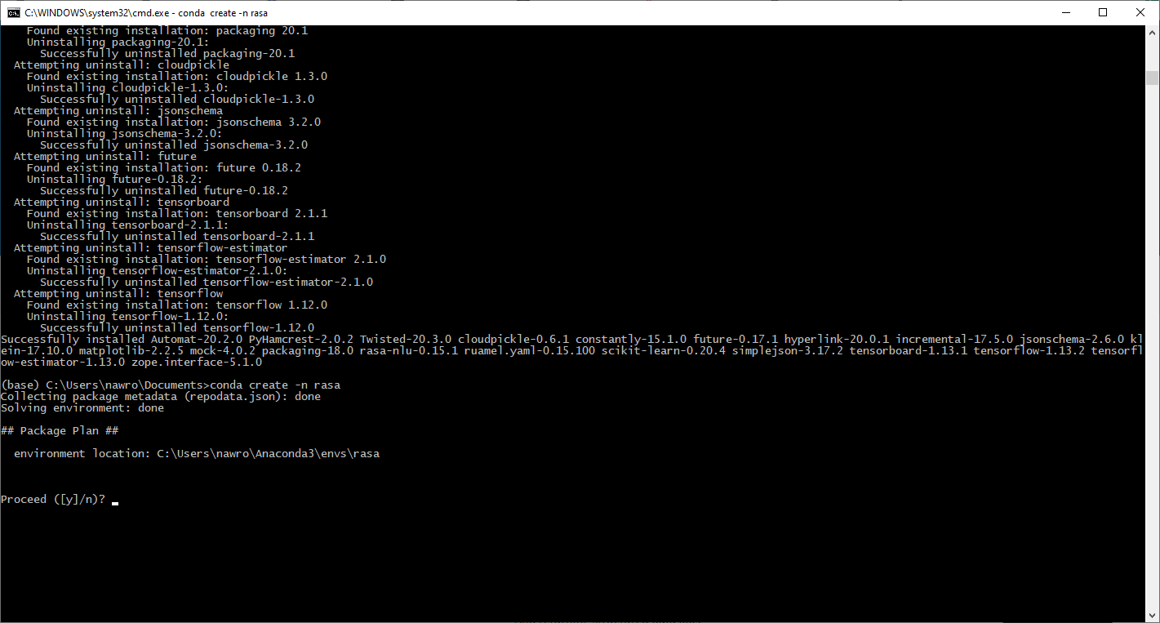

conda create -n rasa_dev python=3.6.10

conda activate rasa_dev

conda install pip

conda list

pip install rasa

conda list

cond deactivate