
SYSTEM DEVELOPMENT
LIFE CYCLE

SDLC proceed in following four steps. Each step is an input to other step. Since a detailed report is being presented before so in this report only design phase is taken into consideration.

Analysis

Design

Test

Code

Fig: The Linear Sequential Model

In the presented software I am going to present the software as an iterative enhancement model.

Design 1
Implement 1
1
Analysis 1
Design 0
Implement
0
Analysis 0
Design n
Implement n
n
Analysis n

---------------

Fig: The Iterative Enhancement Model

The basic idea is that the software should be developed in Increments, each increment adding some functionality capability to the system until the full system is completed.

PROBLEM DEFINITION

In any Pizza Shop where there are number of customers . Each department has to maintain the different kinds of records in different registers for each customer record.
To store and keep record of each customer is manually a tough job. A number of files are to be maintained it may cause data redundancy and data inconsistency of data and improper, unorganized way of maintaining records. This may cause wrong information to both the customers as well as customers. So it is important to maintain a clear and organized data for accurate information of customers.
For this purpose we have to automate Pizza Restaurant Website by making it computerized.
Pizza Shop needs to keep and maintain details of customers along with their personal details and Pizza they are purchasing. Pizza Shop manager also needs to view orders.
REQUIREMENT ANALYSIS

Requirements analysis is a software engineering task that bridges the gap between system-level software allocation and software design. Software Requirements analysis involves five areas of effort:

- Problem Recognition,
- Evaluation and Synthesis,
- Modeling,
- Specification and Review.

Requirement analysis task is a process of discovering, refining modeling and specifying on the basis of problem understanding, employee interviews and observations of the problem task to analyze the requirements.
Requirement analysis is concerned with identifying with the basic functions of the software component in a H/W and S/W system. Emphasis is placed on what the software is to do and the constraints under which it will perform its functions.
A need was felt for a website that should be configured in the near future with the changing needs of the Pizza Shop. The system should also provide flexibility to configure its components without much extra effort and the system should have cleared defined interfaces.

Feasibility Study

A feasibility study is conducted to select the best system that meets performance requirements. This entails an identification description, an evaluation of the candidate systems, and the selection of the best system for the job.

Before the commencement of the development of any application and carrying out its requirement analysis there are some points, which are to be considered for their feasibility analysis, important points are:

Economic Feasibility:
It is important that the system that should be built in place of the existing system. It is to be modified then it must not incur costs so high that its feasibility becomes a distant dream. It should be built keeping in view that it should cover most of the user needs and with minimum expenditure. If the application that we are going to develop requires lot of financial support then it is possible that we may have to drop the project.
Technical Feasibility:
When we develop any project it should be made clear what type of software and hardware support will be required and will it be available. It can happen that at some moment during the development of our project we may require some sort of software which is not provided to us then one gets into dilemma. So before starting any project we must check its technical feasibility.
Operational Feasibility:
By operationally feasible we want to make clear whether the requirements of the user can be put into our application then does it give us accurate results and meet the standards that have been specified in requirements specifications.

System Analysis

System analysis means reduction of entire system by studying the various operations performed and their relationships within the system, an examination of a business activity with a view to identifying problem area & recommending alternative solutions.

Existing System

In the Pizza Shop the management has to keep record of customers that are to be managed properly. To keep manual record of various departments is a tough job. A number of files are to maintain. It may cause redundancy and inconsistency of data. Moreover, it may lead to improper and an unorganized way of maintaining records. So it is required to maintain a clear and organized data for the accurate information of the customers.
To understand the entire working of the existing system followed two-way approach. It was:
- Studying the documents and the tables that are generated.
- Discussing with concerned persons.
On the basis of collected information and documents, general direction of flow of data and information has been carried out. The system study comprised of detailed investigations regarding each and every aspect of the procedures being carried out.

To be precise, the whole process gives rise to considerable errors and results in redundancy, inconsistency, a delay in the making reports due to manual procedures.

Drawbacks in the Existing System

 Reliability: Since the database may span large volume, so the information fetched manually is less reliable.
Response time: Retrieving information is a time consuming process. Manual record searching is a slow process and consumes a lot of time.
Maintenance: It is difficult to maintain a large amount of information on paper and very difficult to have consistent data that lead to redundancy.
Updating: Since records are maintained in different files, problem of data updating arises. It is very difficult and time consuming to update the data stored at various places in different registers as the information related to various customers are stored in different registers.
Inconsistent data: The records might be kept at several places, which may not depict correct information of the customers. This inconsistent state does not supply the concrete information, which poses a problem in the case information related to a particular customer.
Security: It is difficult to restrict for accessing and manipulating the information by unauthorized users.
Operatability: In the absence of concerned persons, the system is not operational.
Storage Problem: As the data is voluminous more space is required to store all the related information. Also because everything is to be stored on paper so this type of storage is more prone to damage with time.

Proposed System

Pizza Deliverty System provides various facilities to departments such as customers. This web site displays list of various Pizzas orffered by the Pizza Shop. It keeps records of the customers i.e. along with their Personal Details and purchase details

Salient Features of the Proposed System

In order to overcome the shortcomings in the existing system, new website is proposed. The objectives of the proposed system can be achieved only when the system is analyzed properly and designed as per the requirements.

Hence, the system study is one of the most important steps in developing a system. The new system eliminates the paper work. The new computerization system involves the development of Website, which maintains the database and handles other related activities of the customer. Website has been designed in ASP.NET WITH C#. The main features of the website are:
Menu Driven Package: The proposed system consists of various menus through which we can choose the various options.
Easy Retrieval of Data: The user can easily view or retrieve the information related to any Pizzas.
Security and Access: A password form has been provided to avoid unauthorized access to the website. Only the correct password allows the administrator to view records of customers.
User Friendliness: Since the system is according to the user requirements, user will take less time to get familiar with the Website.
On-Line Validation: All field values are cross-referenced and validated on-line. Therefore possibility of entering the wrong values is eliminated. Proper validation checks are present in the system.

Objectives OF THE proposed system

The proposed system aims at satisfying the needs of the organization in an effective manner as well as attempting to overcome the shortcomings of the existing system. The proposed system has the following objectives.
- Global Accessibility: Website has been designed in such a way that it shows various Pizzas sold by Pizza Shop
- Providing Adequate Security of Data: In the existing system, since records are maintained manually in different registers, no provision of security is available in the existing system. So a provision of adequate security is the current requirement, which is fulfilled by the proposed system.
- Making a User Friendly System: The proposed system aims at providing a user friendly system
- Making Data Retrieval Fast: Since the proposed system does not involve record maintenance in different registers, so the procedure of data retrieval become very fast as compared to the manual procedure of retrieving the information.
- Keeping Necessary Storage of Data for Reference: The proposed system aims at providing the necessary storage of data which might be required for further reference at some later stage.
- More Reliability and Reduced Paper Work: Since the most of the work is done on the computer in the proposed system, it aims at providing more reliability of data and also paper work is reduced to a great extent.
- Minimize Redundancy Through normalization of Data: The proposed system aims at minimizing redundancy through normalization of data.
- Reducing the Cost of Maintaining the System: The proposed system aims at reducing the cost of maintenance of the system, as now the information related to the various customers and customers is not stored in different registers but on just one system.
- Providing Validations for Data Integrity: The proposed system aims at providing validations for the purpose of maintaining data integrity.

Main Features of Pizza Restaurant Website
Pizza Restaurant Website Website is highly versatile, user-friendly and covers all aspects of Products and Customers Management.
All Menu options have user level privilege.
Customers Management in System has been provided.
The GUI provides the user to make use of the mouse, which makes the navigation throughout the Website very easy and comfortable.
High processing speed.

System Design

Website Requirements Specification defines the function and performance allocated as a part of Software engineering by establishing a complete information description, a detailed functional and behavioral description, an indication of performance requirements and design constraints, appropriate validation criteria and other date pertinent to requirements.

System Requirements Specification (SRS):
SRS is the starting point of Software/Website development activity. As system grew more complex, it becomes evident that the goal of entire system cannot be easily comprehend. Hence the needs for the requirements analysis phase arose.
Specifying requirements necessarily involves what some people have in their minds. The SRS is the means of translating the ideas in the minds of clients (the input) into a formal document (the output of the SRS phase).

SRS
Document
Functional Requirement
Design Constraints
External
Interfaces
Performance Requirement
Functional Requirements
Functional requirements specify which output should be produced from the given inputs. They describe the relationship between the input and output of the system. For each functional requirement, the detailed description of all the data inputs and their
Source, the unit of measure, and range of valid input must be specified. All the operations to be performed on the input data to obtain the output should be specified. This includes specifying the validity check on output and the output data, parameters affected by the operations and the equations or other logical operations that must be used to transform the inputs into corresponding outputs. The functional must clearly state what the system should do in abnormal situations like invalid input or error during computation.
Performance Requirements
This part of SRS specifies the performance constraints on the Website system. All the requirements relating to the performance characteristics of the system must be clearly specified. There are two types of performance requirements.
Static Requirement:
Static Requirements are those that do not impose constraints on the execution characteristics of the system.
Dynamic Requirement:
Dynamic requirement specifies constraints on the execution behavior of the system.

Design Constraints
There are number of factors in the client’s environments that may restrict the choice of the designer. Such factors include standards that must be followed, resource limits, operating environments, reliability and security environments and policy that may have impact on the design of the system.
External Interface Requirements
All the possible interactions between the people, hardware and other Website should be clearly specified. For hardware interface requirements, the SRS should specify the logical characteristics of each interface between the Website customer and hardware component.

Processing Environment

Hardware and Website Used

In case of Pizza Restaurant Website the tools used for the development of this website are

Operating System: Microsoft Windows 10/11

Front End Language: ASP.NET with C#

Back end: SQL Server

About Front-End Tool
Introduction to ASP.NET
ASP.NET is a technology for server-side scripting. ASP.NET is a part of the Microsoft .NET framework. It is a powerful tool for creating dynamic web pages. ASP.NET is a server side scripting technology that enables scripts embedded in web pages to be executed by an Internet server.

ASP.NET is a programming framework that enables the rapid development of Web applications. It provides the easiest and the most scalable way to develop, deploy and run Web applications that can work with any web browser or device. All such features make ASP.NET as the first choice of developers for creating Web applications.

ASP.NET enables us to provide richer functionality to our Web applications by writing the least amount of code. The best feature of ASP.NET is that it enables us to select any of the available .NET programming languages.

ASP.NET also allows us to create other types which enables us to extend user applications, reach to new customers and business partners. For example, XML Web services enable sharing of data across the Internet regardless of the operating system and the programming language.

ASP.NET also provides us with mobile controls that enable user applications to work with a large number of mobile Web devices.

With ASP.NET it is easy to deploy server applications because ASP.NET has dramatically simplified the deployment process. Deploying a Web application simply requires us to copy it to the Web server.

Moreover ASP.NET Web applications are faster than the classic ASP applications. The reason is that classic ASP relied on interpreted languages whereas ASP.NET enables us to use compiled programming languages. ASP.NET applications do not require an explicit compilation step so they execute
faster.

ASP.NET has rich caching and state-management features that result in improved performance of ASP.NET Web applications. In addition to providing high performance and scalability, ASP.NET applications are highly reliable and secure. Other features of ASP.NET are:
- ASP.NET is a Microsoft Technology.
- ASP stands for Active Server Pages
- ASP.NET is a program that runs inside IIS.
- IIS (Internet Information Services) is Microsoft's Internet server.
- IIS comes as a free component with Windows servers.
- IIS is also a part of Windows 2000 and XP Professional.

Page Life Cycle Of ASP.NET:
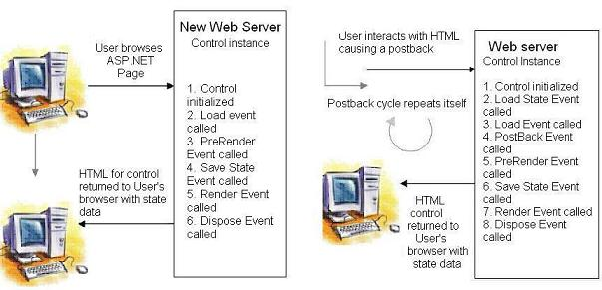

PreInit | Use this event for the following:  • Check the IsPostBack property to determine whether this is the first time the page is  being processed.  • Create or re-create dynamic controls.  • Set a master page dynamically.  • Set the Theme property dynamically.
Init | Use this event to read or initialize control properties
InitComplete | Use this event for processing tasks that require all initialization  be complete.
PreLoad | Use this event if we need to perform processing on user page or control before the Load event. After the Page raises this event, it loads view state for itself and all controls, and then processes any postback data included with the Request instance.
Load | The Page calls the OnLoad event method on the Page, then recursively does the same for each child control, which does the same for each of its child controls until the page and all controls are loaded.
LoadComplete | Use this event for tasks that require that all other controls on the page be loaded.
Page_PreRender | The application is about to render the page object.
Page_Unload | The page is unloaded from memory.
Page_Disposed | The page object is released from memory. This is the last event in the life of a page object.

Architecture of ASP.NET Framework:
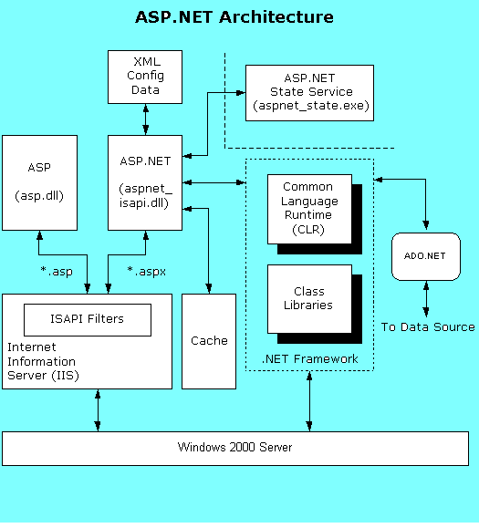
The configuration of ASP.NET is managed by information stored in XML-format in a configuration file named Web.Config. The cache allows for improved performance of ASP.NET as the most commonly requested pages would be served from the ASP.NET cache. State management services for ASP.NET are provided by the ASP.NET state service. The .NET Framework provides the Common Language Runtime (CLR) which compiles and manages the execution of ASP.NET code, and the class libraries which offer prebuilt programmatic functionality for Web Forms, XML support, and exception handling. ADO.NET provides ASP.NET with connections to databases.

Advantage of ASP.NET:
- ASP.NET drastically reduces the amount of code required to build large applications.
- With built-in Windows authentication and per-application configuration, applications are safe and secured.
- It provides better performance by taking advantage of early binding, just-in-time compilation, native optimization, and caching services.
- The ASP.NET framework has a rich toolbox and designer in the Visual Studio integrated development environment.
- ASP.NET provides WYSIWYG editing, drag-and-drop server controls, and automatic deployment features.
- ASP.NET makes it easy to perform common tasks from simple form submission and client authentication to deployment and site configuration.
- Increase in customerivity by removing 70% of the code.
- Use of same controls for all types of devices.
- Provide a faster and better web server platform.
- Simplified compilation and installation
- Simplified administration of web applications

Advanced Features of ASP.NET:
- Master Pages, Themes, and Web Parts
- Standard controls for navigation
- Standard controls for security
- Roles, personalization, and internationalization services
- Improved and simplified data access controls
- Full support for XML standards like, XHTML, XML, and WSDL
- Improved compilation and deployment (installation)
- Improved site management
- New and improved development tools

Master Pages
Master page is a way for applying a consistent look for a complete web site. A master page is a template for other pages, with shared look and functionality. The master page defines placeholders for content pages. The result page is a combination of the master page and the content page.

Themes
Theme is another feature of ASP.NET. Theme is also known as skin. It allows developers to create a customized look for web applications.
Advantages of themes are
- It is simple to customize the appearance of a site as per the requirement.
- Themes can to be applied to controls, pages and entire web sites.
- Themes allow all visual elements to be customized as per the requirement.

Web Parts
Web Parts provide a consistent look for a site while still allowing user customization of style and content. Web Parts has two controls as follows:
- Zone controls - areas on a page where the content is consistent.
- Web part controls - content areas for each zone.

Navigation
ASP.NET has built-in navigation controls to navigate various pages of a web site like
- Site Maps
- Dynamic HTML menus
- Tree Views

Security
Security is very important for protecting confidential and personal information. In ASP.NET following controls has been provided:
- Login control which provides login functionality.
- LoginStatus control to control the login status.
- LoginName control to display the current user name.
- LoginView control, to provide different views depending on login status.
- CreateUser wizard, to allow creation of user accounts.
- PasswordRecovery control to provide the "I forgot my password" functionality.

Roles and Personalization
ASP.NET has personalization feature for storing user details. This provides an easy way to customize user and user group properties..

Internationalization
It is important to reach different people with different languages. ASP.NET has an improved support for multiple languages.

Data Access
Most of the dynamic web sites are data driven using databases or XML files as data sources. With ASP.NET has inbuilt support for use of different data sources. ASP.NET has new data controls removing the need for programming and in-depth knowledge of data connections.

Mobility Support
The problem with Mobile devices is screen size and display capabilities. In ASP.NET the Microsoft Mobile Internet Toolkit(MMIT) support is provided. There are inbuilt controls for developing mobile phone based web applications.

Images
ASP.NET has new controls for handling images:
- The ImageMap control - image map support
- The DynamicImage control - image support for different browsers
These controls are important for better image display on mobile devices like hand-held computers and mobile phones.

Automatic Compilation
ASP.NET provides automatic compilation. All files within a directory will be compiled on the first run, including support for WSDL, and XSD files.

Compiled Deployment (Installation) and Source Protection
ASP.NET also provides pre-compilation. An entire web site can be pre-compiled. This provides an easy way to deploy (upload to a server) compiled applications, and because only compiled files are deployed, the source code is protected.

Site Management
ASP.NET has three new features for web site configuration and management:
- New local management console
- New programmable management functions (API)
- New web-based management tool

Development Tools
With ASP.NET Visual Studio.NET was released with project and design features for corporate developers. With ASP.NET, Visual Studio was released. Main features for Visual Studio include:
- Support for the all features described above
- Upload files from anywhere (FTP, File System, Front Page)
- No project files.
- Allowing code to be manipulated outside Visual Studio.
- Integrated Web Site Administration Tool
- No "build" step ability to compile on first run

ASP.NET Page Syntax
An ASP.NET page is defined as a file in a Web application with “.aspx” extension with an HTML form element that specifies runat="server". We can optionally specify an @Page directive or other directive , one or more Web server controls and server code.
The mapping of file name extensions to ASP.NET is done by Internet Information Services (IIS).
We must include our HTML form element within <html> and <body> tags. Some browsers will return an error if we exclude these tags.

The following example shows a basic ASP.NET page.
<%@ Page Language="VB" %>
<html>
<body>
<form runat="server">
</form>
</body>
</html>

Directives
The ASP.NET page framework supports the following directives.
@ Page | Defines page-specific attributes used by the ASP.NET page parser and compiler. Can be included only in .aspx files.
@ Control | Defines control-specific attributes used by the ASP.NET page parser and compiler. Can be included only in .ascx files (user controls).
@ Import | Explicitly imports a namespace into a page or user control.
@ Implements | Declaratively indicates that a page or user control implements a specified .NET Framework interface.
@ Register | Associates aliases with namespaces and class names, thereby allowing user controls and custom server controls to be rendered when included in a requested page or user control.
@ Assembly | Links an assembly to the current page during compilation, making all the assembly's classes and interfaces available for use on the page.
@ Master | Identifies an ASP.NET master page.
@ WebHandler | Identifies an ASP.NET IHttpHandler page.
@ PreviousPageType | Provides the means to get strong typing against the previous page as accessed through the PreviousPage property.
@ MasterType | Assigns a class name to the Master property of an ASP.NET page, so that the page can get strongly typed references to members of the master page.
@ OutputCache | Declaratively controls the output caching policies of a page or user control.
@ Reference | Declaratively links a page or user control to the current page or user control.
ASP.NET treats any directive block (<%@ %>) that does not contain an explicit directive name as an @ Page directive for a page, or an @ Control directive for a user control.

ASP.NET - Server Controls
ASP.NET has solved common problems of website designing with server controls. Server controls are tags that are understood by the server. There are three kinds of server controls:
- HTML Server Controls - Traditional HTML tags
- Web Server Controls - New ASP.NET tags
- Validation Server Controls - For input validation

ASP.NET - HTML Server Controls
HTML server controls are HTML tags understood by the server. HTML elements in ASP.NET files are by default treated as text. To make these elements programmable, add a runat="server" attribute to the HTML element. This attribute indicates that the element should be treated as a server control. The id atribute is added to identify the server control. The id reference can be used to manipulate the server control at run time.
All HTML server controls must be within a <form> tag with the runat="server" attribute. The runat="server" attribute indicates that the form should be processed on the server. It also indicates that the enclosed controls can be accessed by server scripts.
In the following example we declare an HtmlAnchor server control in an .aspx file. Then we manipulate the href attribute of the HtmlAnchor control in an event handler (an event handler is a method that executes code for a given event). The Page_Load event is one of many events that ASP.NET understands:
<script runat="server">
Sub Page_Load
link1.HRef="http://www.google.com"
End Sub
</script>
<html>
<body>
<form runat="server">
<a id="link1" runat="server">Visit Google.com!</a>
</form>
</body>
</html>

ASP.NET - Web Server Controls
Web server controls are special ASP.NET tags understood by the server. Like HTML server controls, Web server controls are also created on the server and they require a runat="server" attribute to work. However, Web server controls do not necessarily map to any existing HTML elements and they may represent more complex elements. The syntax for creating a Web server control is:
<asp:control_name id="some_id" runat="server" />

ASP.NET – Validation Server Controls
Validation server controls are used to validate user-input. If the user-input does not pass validation, it will display an error message to the user. Each validation control performs a specific type of validation (like validating against a specific value or a range of values).
By default, page validation is performed when a Button, ImageButton, or LinkButton control is clicked. We can prevent validation when a button control is clicked by setting the CausesValidation property to false. The syntax for creating a Validation server control is:
<asp:control_name id=”some_id” runat=”server” />

About Back-End Tool

What's a Database Management System?
A database can be defined as a collection of information organized in such a way that it can be retrieved and used. A database management system (DBMS) can further be defined as the tool that enables us to manage and interact with the database.
Most DBMS’s perform the following functions:
- Store data
- Create and maintain data structures
- Allow concurrent access to many users
- Enforce security and privacy
- Allow extraction and manipulation of stored data
- Enable data entry and data loading
- Provide an efficient indexing mechanism for fast extraction of selected data
- Provide consistency among different records
- Protect stored data from loss by backup and recovery process

Several different types of DBMS’s have been developed to support these requirements. These systems can broadly be classified in the following classes:
A hierarchical DBMS stores data in a tree-like structure:
It assumes a parent-child relationship between the data. The top of the tree, known as the root, can have any number of dependents. Dependents, in turn, can have any number of sub dependents, and so on. Hierarchical database systems are now obsolete.
A network DBMS stores data in the form of records and links:
This system allows more flexible many-to-many relationship than do hierarchical DBMS’s. Network DBMS’s are very fast and storage-efficient. Network database management systems allowed complex data structures but were very inflexible and required tedious design. An airline reservation system is one example of this type of DBMS system.
Relational DBMS’s (RDBMS’s) probably have the simplest structure a database can have:
In an RDBMS, data is organized in tables. Tables, in turn, consist of records, and records of fields. Each field corresponds to one data item. Two or more tables can be linked (joined) if they have one or more fields in common. RDBMS’s are easy to use and have flourished in the last decade.
They're commonly used on low-end computer systems. In the last few years, however, their use has expanded to more powerful computer systems.

Sql SERVER

SQL Server is a relational database management system used to store and manipulate large collection of information of any kind. Here RDBMS refers to the organization of data in a series of rows and columns in a manner that any specific piece of information is available with the click of a mouse and a few keystrokes. MS- SQL Server has tools which are easy to use and provide powerful development environment, making it an appropriate choice for novices as well as professionals.
For example, SQL Server can be used to enter and maintain customer awards, inventory records of a warehouse, Telephone numbers once the records are stored, any type of queries can be asked, report can created and data entry forms can be designed. At an advanced level, SQL Server can be used for developing custom database applications by employing SQL Server Basic and a distribution kit for compiling applications.

There are various Components in the MS-SQL SERVER are as.

Data base Window: -
Here all objects of a data base are stored in single files having extension MDF. The object are managed through the database Windows
Database and Tables
Database is collection of information retained in the form of table. Table consists of rows and columns. Each table stored information about entity such as customer, employee, customer and patient. Each row in the table represents a single record of an entity. Each column contains a discrete element of information, called a field. A field might be a customer name, house number, unit number or telephone number. To illustrate the concept of a table, record and field, a customer database is used which uses different tables to store.
      - Roll number, name, Father’s name and class of customers.
      - Free information (Fees table).
      - Gradation information (Grades table)
The first table (Customer table) stores Roll Number, Name and Father Name, Date of birth, Class and session of customers.
The first row in the table shows the name of different fields. The next four rows show four different records having different values for different fields.
The second tables stores information regarding fee details of the customers. It has rolled number, class, fees, due day, late fees, and paid (y/n) as different fields.
ROLL .NO | CLASS | FEES/SEM | DUE DATE | LATE FEE | PAID (Y or N)
101 | BIT | 8000 | 10/8/99 | 8500 | Y
102 | BCA | 7000 | 7/8/99 | 7500 | Y
103 | BSc | 6000 | 5/8/99 | 6500 | N
104 | BIT | 8000 | 10/8/99 | 8500 | N

The customer table and fees table have two common fields Roll number and class to create a relation between customer and his fee details.
The third table stores the information regarding the grades stored in different subjects. This table has Roll no, Class and Grades in three subjects as different fields.
Roll .No | Class | Computer | Math’s | Physics
101 | BIT | A | B | A
102 | BCA | B | B | A
103 | B Sc | B | C | B
104 | BIT | C | D | C

Here in the three tables, Roll number and class fields are common, but class field does not have a unique value for different customers. Class field has a same value for the customers with the Roll number 101 and 104 but the roll number field is having different value for all the customers. So it is referred as a unique field.
Stored Procedure
A Stored Procedure is a set of SQL statements to add, modify, delete and extract information according to user requirement.
View
A View extracts and displays information from a database table as per specific condition.

DESIGN
Website design is actually a multistep process that focuses on four distinct attributes of a program: data structure, Website architecture, interfaces representation and procedural details. The design process translates the requirements into a representation of the Website that can be accessed for quality before code generation begins.
It is the most creative and challenging phase of the SDLC. It refers to the technical specifications that will be applied to the system. The first step is to design the output format. Sample of the output are prepared. Second step is to design the set of the inputs that are to given for the processing. The important question that should answer in this phase is” What is the system and how to solve the problem?”
It mainly includes three things:

Tables
DFD’s

DATABASE DESIGN

Databases are used to store the information in the form of the records. To create a database we can use database systems like Sql Server and access. I have used Sql Server in my project because of its security.
Tables:

product
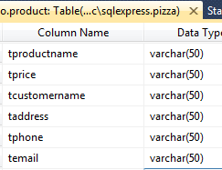

Data Flow Diagrams (DFD):

Data Flow Diagram is the way of expressing system requirements in a graphical form. A DFD also known as BUBBLE CHART has a purpose of clarifying system requirements and identifying major transformations that will become the program in this system design.

DFD Symbols
A square defines a source of destination or system data.

An arrow identifies the data flow or data in motion. It is a pipeline through which information flows.

A circle or bubble represents a process transform incoming data flow in to outgoing data flow.

A horizontal line represents data stored or data at rest or a temporary rest repository of data.
Project Is Loaded As Shown Below:
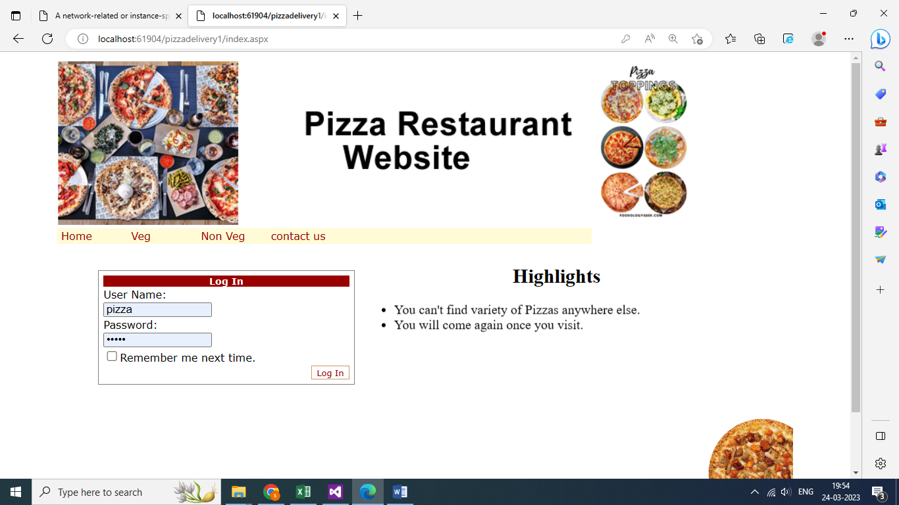
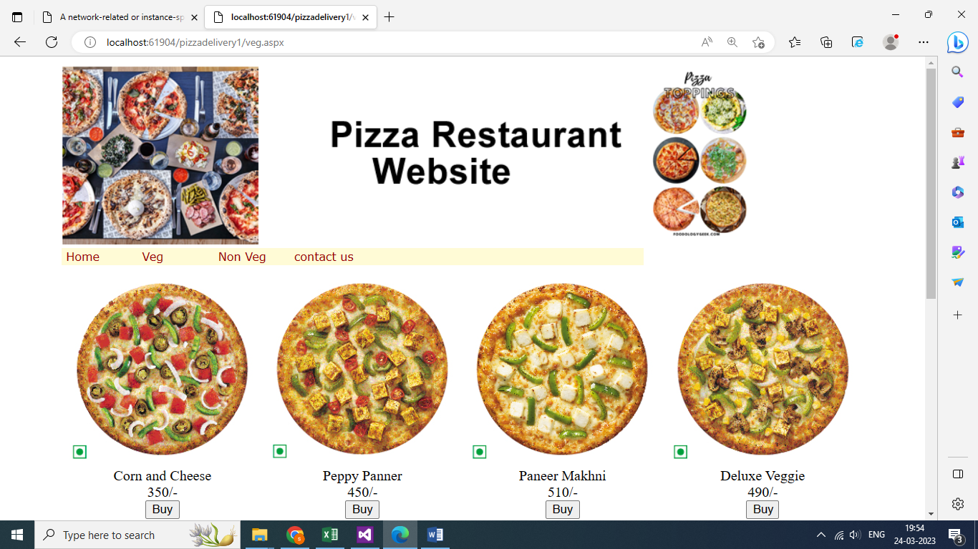
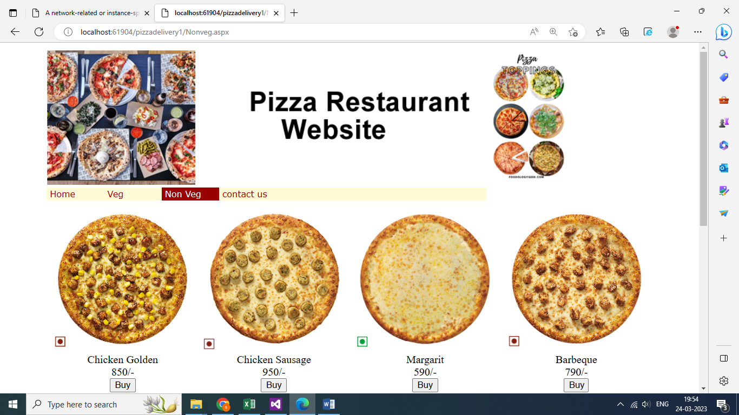

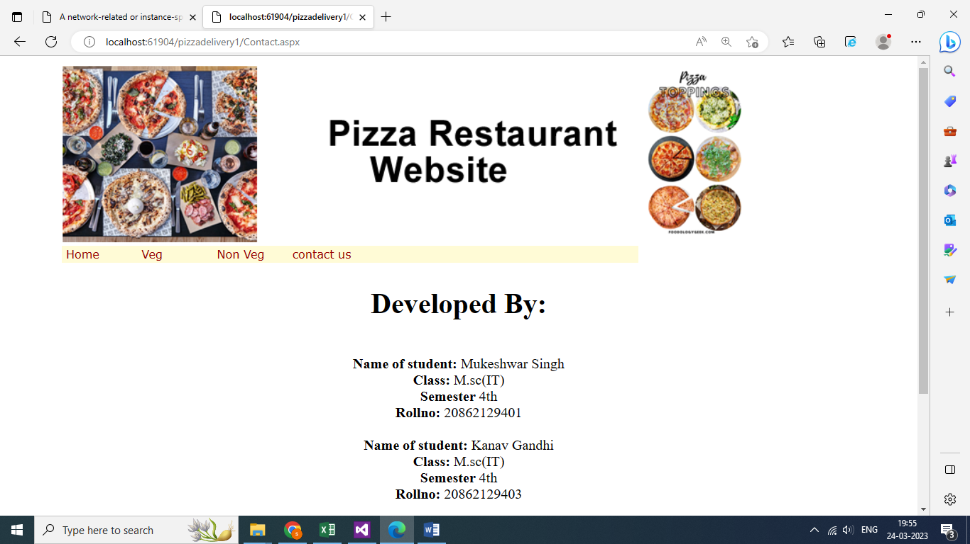

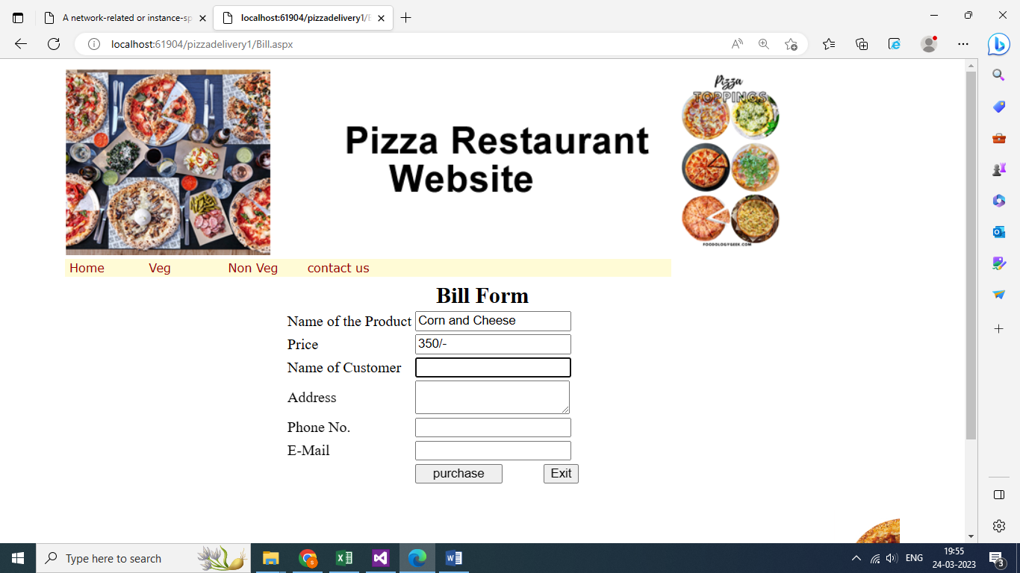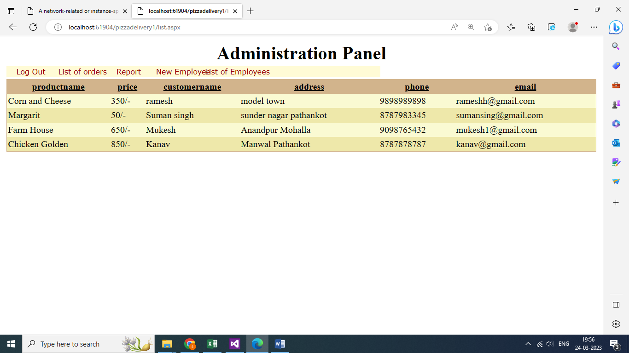

index.aspx
<%@ Page Title="" Language="C#" MasterPageFile="~/MasterPage.master" AutoEventWireup="true" CodeFile="index.aspx.cs" Inherits="pics_Default" %>

<asp:Content ID="Content1" ContentPlaceHolderID="head" Runat="Server">
<style type="text/css">
.style1
{
width: 800px;
}
.style2
{
width: 316px;
}
</style>
</asp:Content>
<asp:Content ID="Content2" ContentPlaceHolderID="ContentPlaceHolder1" Runat="Server">
<table align="center" class="style1">
<tr>
<td class="style2">
<asp:Login ID="Login1" runat="server" BorderPadding="4" BorderStyle="Solid"
BorderWidth="1px" Font-Names="Verdana" Font-Size="0.8em" Height="130px"
TextLayout="TextOnTop" Width="302px" onauthenticate="Login1_Authenticate">
<InstructionTextStyle Font-Italic="True" ForeColor="Black" />
<LoginButtonStyle BackColor="White" BorderColor="#CC9966" BorderStyle="Solid"
BorderWidth="1px" Font-Names="Verdana" Font-Size="0.8em" ForeColor="#990000" />
<TextBoxStyle Font-Size="0.8em" />
<TitleTextStyle BackColor="#990000" Font-Bold="True" Font-Size="0.9em"
ForeColor="White" />
</asp:Login>
</td>
<td>
<h2 align="center">Highlights</h2>
<marquee direction="down" scrollamount="1">
<ul>
<li>50% off first order </li>
<li>20% off on every order for club members. </li>
<li>We offer best pizzas in the entire city. </li>
<li>You can't find variety of Pizzas anywhere else.</li>
<li>You will come again once you visit.</li>
</ul></marquee>

</td>
</tr>
</table>
</asp:Content>

index.aspx.cs
using System;
using System.Collections.Generic;
using System.Linq;
using System.Web;
using System.Web.UI;
using System.Web.UI.WebControls;

public partial class pics_Default : System.Web.UI.Page
{
protected void Login1_Authenticate(object sender, AuthenticateEventArgs e)
{
string u, p;
u = Login1.UserName;
p = Login1.Password;
if (u == "pizza" && p == "pizza")
Response.Redirect("list.aspx");
}
}

MasterPage.master
<%@ Master Language="C#" AutoEventWireup="true" CodeFile="MasterPage.master.cs" Inherits="pics_MasterPage" %>

<!DOCTYPE html PUBLIC "-//W3C//DTD XHTML 1.0 Transitional//EN" "http://www.w3.org/TR/xhtml1/DTD/xhtml1-transitional.dtd">

<html xmlns="http://www.w3.org/1999/xhtml">
<head runat="server">
<title></title>
<asp:ContentPlaceHolder id="head" runat="server">
</asp:ContentPlaceHolder>
</head>
<body>
<form id="form1" runat="server">
<div>
<table Width="900" align="center">
<tr>
<td>
<asp:Image ID="Image1" runat="server" ImageUrl="~/pics/top.png" />
</td>
</tr>
<tr>
<td>
<asp:Menu ID="Menu1" runat="server" Orientation="Horizontal" BackColor="#FFFBD6" DynamicHorizontalOffset="2" Font-Names="Verdana" Font-Size="0.8em" ForeColor="#990000" StaticSubMenuIndent="10px" Width="650px">
<DynamicHoverStyle BackColor="#990000" ForeColor="White" Width="200px" />
<DynamicMenuItemStyle HorizontalPadding="5px" ItemSpacing="150px" VerticalPadding="2px" Width="200px" />
<DynamicMenuStyle BackColor="#FFFBD6" Width="600px" />
<DynamicSelectedStyle BackColor="#FFCC66" />
<Items>
<asp:MenuItem Text="Home" Value="Home" NavigateUrl="~/index.aspx"></asp:MenuItem>
<asp:MenuItem Text="Veg" Value="New Item" NavigateUrl="~/veg.aspx"></asp:MenuItem>
<asp:MenuItem Text="Non Veg" Value="New Item"
NavigateUrl="~/Nonveg.aspx">
</asp:MenuItem>
<asp:MenuItem Text="contact us" Value=" Contact Us"
NavigateUrl="~/Contact.aspx"></asp:MenuItem>
</Items>
<StaticHoverStyle BackColor="#990000" ForeColor="White" />
<StaticMenuItemStyle HorizontalPadding="5px" VerticalPadding="2px" Width="75px" />
<StaticMenuStyle Width="550px" />
<StaticSelectedStyle BackColor="#FFCC66" />
</asp:Menu>
</td>
</tr>
<tr>
<td>
<asp:ContentPlaceHolder ID="ContentPlaceHolder1" runat="server">
</asp:ContentPlaceHolder>
</td>
</tr>
<tr>
<td>
<marquee>
<asp:Image ID="Image2" runat="server" Height="150px"
ImageUrl="~/pics/Dominator.jpg" Width="150px" />
<asp:Image ID="Image3" runat="server" Height="150px"
ImageUrl="~/pics/Margherit.jpg" Width="150px" />

<asp:Image ID="Image5" runat="server" Height="150px"
ImageUrl="~/pics/Chicken_Sausage.jpg" Width="150px" />
<asp:Image ID="Image6" runat="server" Height="150px"
ImageUrl="~/pics/Veg_Extravaganz.jpg" Width="150px" />
<asp:Image ID="Image7" runat="server" Height="150px"
ImageUrl="~/pics/Peppy_Paneer.jpg" Width="150px" /></marquee>
</td>
</tr>
</table>
</div>
</form>
</body>
</html>

veg.aspx
<%@ Page Title="" Language="C#" MasterPageFile="~/MasterPage.master" AutoEventWireup="true" CodeFile="veg.aspx.cs" Inherits="Default2" %>

<asp:Content ID="Content1" ContentPlaceHolderID="head" Runat="Server">
<style type="text/css">
.style1
{
text-align: center;
}
</style>
</asp:Content>
<asp:Content ID="Content2" ContentPlaceHolderID="ContentPlaceHolder1" Runat="Server">
<table class="auto-style2">
<tr>
<td class="style1">
<asp:Image ID="Image12" runat="server" Height="220px"
ImageUrl="~/pics/Mexican_Green_Wave.jpg" Width="220px" />
<br />
Corn and Cheese<br />
350/-<br />
<asp:Button ID="Button1" runat="server" Text="Buy" OnClick="Button1_Click" />
</td>
<td class="style1">
<asp:Image ID="Image16" runat="server" Height="220px"
ImageUrl="~/pics/Peppy_Paneer.jpg" Width="220px" />
<br />
Peppy Panner<br />
450/-<br />
<asp:Button ID="Button2" runat="server" Text="Buy" OnClick="Button2_Click" />
</td>
<td class="style1">
<asp:Image ID="Image17" runat="server" Height="220px"
ImageUrl="~/pics/Paneer_Makhni.jpg" Width="220px" />
<br />
Paneer Makhni<br />
510/-<br />
<asp:Button ID="Button3" runat="server" Text="Buy" OnClick="Button3_Click" />
</td>
<td class="style1">
<asp:Image ID="Image18" runat="server" Height="220px"
ImageUrl="~/pics/Deluxe_Veggie.jpg" Width="220px" />
<br />
Deluxe Veggie<br />
490/-<br />
<asp:Button ID="Button4" runat="server" Text="Buy" OnClick="Button4_Click" style="width: 37px" />
</td>
</tr>
<tr>
<td class="style1">
<asp:Image ID="Image19" runat="server" Height="220px"
ImageUrl="~/pics/Digital_Veggie_Paradise_olo_266x265.jpg" Width="220px" />
<br />
Digital Veggie Paradise<br />
650/-<br />
<asp:Button ID="Button5" runat="server" Text="Buy" OnClick="Button5_Click" />
</td>
<td class="style1">
<asp:Image ID="Image20" runat="server" Height="220px"
ImageUrl="~/pics/Double_Cheese_Margherita.jpg" Width="220px" />
<br />
Double Cheese Margarita<br />
750/-<br />
<asp:Button ID="Button6" runat="server" Text="Buy" OnClick="Button6_Click" />
</td>
<td class="style1">
<asp:Image ID="Image21" runat="server" Height="220px"
ImageUrl="~/pics/Farmhouse.jpg" Width="220px" />
<br />
Farmhouse<br />
650/-<br />
<asp:Button ID="Button7" runat="server" Text="Buy" OnClick="Button7_Click" />
</td>
<td class="style1">
<asp:Image ID="Image22" runat="server" Height="220px"
ImageUrl="~/pics/Mexican_Green_Wave.jpg" Width="220px" />
<br />
Green Wave<br />
490/-<br />
<asp:Button ID="Button8" runat="server" Text="Buy" OnClick="Button8_Click"
style="width: 37px" />
</td>
</tr>
<tr>
<td class="style1">
&nbsp;</td>
<td class="style1">
&nbsp;</td>
<td class="style1">
&nbsp;</td>
<td class="style1">
&nbsp;</td>
</tr>
</table>
</asp:Content>

N onveg.aspx
<%@ Page Title="" Language="C#" MasterPageFile="~/MasterPage.master" AutoEventWireup="true" CodeFile="Nonveg.aspx.cs" Inherits="Default2" %>

<asp:Content ID="Content1" ContentPlaceHolderID="head" Runat="Server">
<style type="text/css">
.style1
{
text-align: center;
}
</style>
</asp:Content>
<asp:Content ID="Content2" ContentPlaceHolderID="ContentPlaceHolder1" Runat="Server">
<table class="auto-style2">
<tr>
<td class="style1">
<asp:Image ID="Image12" runat="server" Height="220px"
ImageUrl="~/pics/Chicken_Golden_Delight.jpg" Width="220px" />
<br />
Chicken Golden<br />
850/-<br />
<asp:Button ID="Button1" runat="server" Text="Buy" OnClick="Button1_Click" />
</td>
<td class="style1">
<asp:Image ID="Image16" runat="server" Height="220px"
ImageUrl="~/pics/Chicken_Sausage.jpg" Width="220px" />
<br />
Chicken Sausage<br />
950/-<br />
<asp:Button ID="Button2" runat="server" Text="Buy" OnClick="Button2_Click" />
</td>
<td class="style1">
<asp:Image ID="Image17" runat="server" Height="220px"
ImageUrl="~/pics/Margherit.jpg" Width="220px" />
<br />
Margarit<br />
590/-<br />
<asp:Button ID="Button3" runat="server" Text="Buy" OnClick="Button3_Click" />
</td>
<td class="style1">
<asp:Image ID="Image18" runat="server" Height="220px"
ImageUrl="~/pics/Pepper_Barbeque.jpg" Width="220px" />
<br />
Barbeque<br />
790/-<br />
<asp:Button ID="Button4" runat="server" Text="Buy" OnClick="Button4_Click" style="width: 37px" />
</td>
</tr>
<tr>
<td class="style1">
<asp:Image ID="Image19" runat="server" Height="220px"
ImageUrl="~/pics/Pepper_Barbeque_&amp;_Onion.jpg" Width="220px" />
<br />
Pepper Barbeque<br />
850/-<br />
<asp:Button ID="Button5" runat="server" Text="Buy" OnClick="Button5_Click" />
</td>
<td class="style1">
<asp:Image ID="Image20" runat="server" Height="220px"
ImageUrl="~/pics/Dominator.jpg" Width="220px" />
<br />
Dominator<br />
750/-<br />
<asp:Button ID="Button6" runat="server" Text="Buy" OnClick="Button6_Click" />
</td>
<td class="style1">
<asp:Image ID="Image21" runat="server" Height="220px"
ImageUrl="~/pics/Fresh_Veggie.jpg" Width="220px" />
<br />
Fresh Cheese<br />
650/-<br />
<asp:Button ID="Button7" runat="server" Text="Buy" OnClick="Button7_Click" />
</td>
<td class="style1">
<asp:Image ID="Image22" runat="server" Height="220px"
ImageUrl="~/pics/Veg_Extravaganz.jpg" Width="220px" />
<br />
Extravanga<br />
990/-<br />
<asp:Button ID="Button8" runat="server" Text="Buy" OnClick="Button8_Click"
style="width: 37px" />
</td>
</tr>
<tr>
<td class="style1">
&nbsp;</td>
<td class="style1">
&nbsp;</td>
<td class="style1">
&nbsp;</td>
<td class="style1">
&nbsp;</td>
</tr>
</table>
</asp:Content>

contact.aspx
<%@ Page Title="" Language="C#" MasterPageFile="~/MasterPage.master" AutoEventWireup="true" CodeFile="Contact.aspx.cs" Inherits="_Default" %>

<asp:Content ID="Content1" ContentPlaceHolderID="head" Runat="Server">
<style type="text/css">
.style1
{
width: 400px;
}
.style2
{
text-align: center;
}
</style>
</asp:Content>
<asp:Content ID="Content2" ContentPlaceHolderID="ContentPlaceHolder1" Runat="Server">
<table align="center" class="style1">
<tr>
<td class="style2">
<h1>
<strong>Developed By:</strong></h1>
<br />
<strong>Name of student: </strong>Shivani hareechand<br />
<strong>Class:</strong> Bsc(IT)<br />
<strong>Semester</strong> 6th<br />
<strong>Rollno:</strong> 3716<br />
<br />
</td>
</tr>
</table>
</asp:Content>

Bill.aspx
<%@ Page Title="" Language="C#" MasterPageFile="~/MasterPage.master" AutoEventWireup="true" CodeFile="Bill.aspx.cs" Inherits="Default2" %>

<asp:Content ID="Content1" ContentPlaceHolderID="head" Runat="Server">
</asp:Content>
<asp:Content ID="Content2" ContentPlaceHolderID="ContentPlaceHolder1" Runat="Server">
<table align="center" class="auto-style2">
<tr>
<td colspan="3" style="text-align: center">
<asp:Label ID="Label8" runat="server" Font-Bold="True" Font-Size="X-Large"
Text="Bill Form"></asp:Label>
</td>
</tr>
<tr>
<td>
<asp:Label ID="Label1" runat="server" Text="Name of the Product"></asp:Label>
</td>
<td class="auto-style3">
<asp:TextBox ID="tproductname" runat="server" Width="160px"></asp:TextBox>
</td>
<td>
&nbsp;</td>
</tr>
<tr>
<td>
<asp:Label ID="Label3" runat="server" Text="Price"></asp:Label>
</td>
<td class="auto-style3">
<asp:TextBox ID="tprice" runat="server" Width="160px"></asp:TextBox>
</td>
<td>
&nbsp;</td>
</tr>
<tr>
<td>
<asp:Label ID="Label4" runat="server" Text="Name of Customer"></asp:Label>
</td>
<td class="auto-style3">
<asp:TextBox ID="tcustomername" runat="server" Width="160px"></asp:TextBox>
</td>
<td>
<asp:RequiredFieldValidator ID="RequiredFieldValidator2" runat="server"
ControlToValidate="tcustomername" ErrorMessage="Please fill value"
Font-Bold="False" ForeColor="#CC6600"></asp:RequiredFieldValidator>
</td>
</tr>
<tr>
<td>
<asp:Label ID="Label5" runat="server" Text="Address"></asp:Label>
</td>
<td class="auto-style3">
<asp:TextBox ID="taddress" runat="server" TextMode="MultiLine" Width="160px"></asp:TextBox>
</td>
<td>
<asp:RequiredFieldValidator ID="RequiredFieldValidator3" runat="server"
ControlToValidate="taddress" ErrorMessage="Please fill value" Font-Bold="False"
ForeColor="#CC6600"></asp:RequiredFieldValidator>
</td>
</tr>
<tr>
<td>
<asp:Label ID="Label6" runat="server" Text="Phone No."></asp:Label>
</td>
<td class="auto-style3">
<asp:TextBox ID="tphone" runat="server" Width="160px"></asp:TextBox>
</td>
<td>
<asp:RequiredFieldValidator ID="RequiredFieldValidator4" runat="server"
ControlToValidate="tphone" ErrorMessage="Please fill value" Font-Bold="False"
ForeColor="#CC6600"></asp:RequiredFieldValidator>
</td>
</tr>
<tr>
<td>
<asp:Label ID="Label7" runat="server" Text="E-Mail"></asp:Label>
</td>
<td class="auto-style3">
<asp:TextBox ID="temail" runat="server" Width="160px"></asp:TextBox>
</td>
<td>
<asp:RequiredFieldValidator ID="RequiredFieldValidator5" runat="server"
ControlToValidate="temail" ErrorMessage="Please fill value" Font-Bold="False"
ForeColor="#CC6600"></asp:RequiredFieldValidator>
</td>
</tr>
<tr>
<td class="auto-style4"></td>
<td class="auto-style5">
<asp:Button ID="Button1" runat="server" style="text-align: center"
Text="purchase" Width="94px" onclick="Button1_Click" />
&nbsp;&nbsp;&nbsp;&nbsp;&nbsp;&nbsp;&nbsp;&nbsp;&nbsp;
<asp:Button ID="Button2" runat="server" Text="Exit" onclick="Button2_Click"
CausesValidation="False" />
</td>
<td class="auto-style4"></td>
</tr>
<tr>
<td>&nbsp;</td>
<td class="auto-style3">
<asp:Label ID="message" runat="server"></asp:Label>
</td>
<td>&nbsp;</td>
</tr>
</table>
</asp:Content>

list.aspx
<%@ Page Title="" Language="C#" MasterPageFile="~/MasterPage.master" AutoEventWireup="true" CodeFile="list.aspx.cs" Inherits="Default2" %>

<asp:Content ID="Content1" ContentPlaceHolderID="head" Runat="Server">
</asp:Content>
<asp:Content ID="Content2" ContentPlaceHolderID="ContentPlaceHolder1" Runat="Server">
<asp:GridView ID="GridView1" runat="server" AllowPaging="True"
AllowSorting="True" AutoGenerateColumns="False"
BackColor="LightGoldenrodYellow" BorderColor="Tan" BorderWidth="1px"
CellPadding="2" DataSourceID="SqlDataSource1" ForeColor="Black"
GridLines="None" Height="126px" Width="524px">
<AlternatingRowStyle BackColor="PaleGoldenrod" />
<Columns>
<asp:BoundField DataField="tproductname" HeaderText="tproductname"
SortExpression="tproductname" />
<asp:BoundField DataField="tprice" HeaderText="tprice"
SortExpression="tprice" />
<asp:BoundField DataField="tcustomername" HeaderText="tcustomername"
SortExpression="tcustomername" />
<asp:BoundField DataField="taddress" HeaderText="taddress"
SortExpression="taddress" />
<asp:BoundField DataField="tphone" HeaderText="tphone"
SortExpression="tphone" />
<asp:BoundField DataField="temail" HeaderText="temail"
SortExpression="temail" />
</Columns>
<FooterStyle BackColor="Tan" />
<HeaderStyle BackColor="Tan" Font-Bold="True" />
<PagerStyle BackColor="PaleGoldenrod" ForeColor="DarkSlateBlue"
HorizontalAlign="Center" />
<SelectedRowStyle BackColor="DarkSlateBlue" ForeColor="GhostWhite" />
<SortedAscendingCellStyle BackColor="#FAFAE7" />
<SortedAscendingHeaderStyle BackColor="#DAC09E" />
<SortedDescendingCellStyle BackColor="#E1DB9C" />
<SortedDescendingHeaderStyle BackColor="#C2A47B" />
</asp:GridView>
<asp:SqlDataSource ID="SqlDataSource1" runat="server"
ConnectionString="<%$ ConnectionStrings:conn %>"
SelectCommand="SELECT * FROM [product]"></asp:SqlDataSource>
</asp:Content>

bill.aspx.cs
using System;
using System.Collections;

using System.Linq;
using System.Web;
using System.Web.Security;
using System.Web.UI;
using System.Web.UI.HtmlControls;
using System.Web.UI.WebControls;
using System.Web.UI.WebControls.WebParts;
using System.Xml.Linq;
using System.Data.SqlClient;
using System.Configuration;
using System.Data;
using System.Text;

public partial class Default2 : System.Web.UI.Page
{

SqlConnection con = new SqlConnection();
static string product, price;
protected void Page_Load(object sender, EventArgs e)
{
product=Convert.ToString(Session["pname"]);
price=Convert.ToString(Session["price"]);
tproductname.Text=product;
tprice.Text=price;
tcustomername.Focus();
con.ConnectionString = ConfigurationManager.ConnectionStrings["conn"].ConnectionString;

if (con.State == ConnectionState.Closed)
{
con.Open();
}

}
protected void Button1_Click(object sender, EventArgs e)
{
try
{

String insertCmd = "insert into product values (@n,@p,@c,@a,@tp,@e)";
SqlCommand myCommand = new SqlCommand(insertCmd, con);
myCommand.Parameters.Add(new SqlParameter("@n", SqlDbType.VarChar,50));
myCommand.Parameters["@n"].Value = tproductname.Text;

myCommand.Parameters.Add(new SqlParameter("@p", SqlDbType.VarChar, 50));
myCommand.Parameters["@p"].Value = tprice.Text;

myCommand.Parameters.Add(new SqlParameter("@c", SqlDbType.VarChar, 50));
myCommand.Parameters["@c"].Value = tcustomername.Text;

myCommand.Parameters.Add(new SqlParameter("@a", SqlDbType.VarChar, 50));
myCommand.Parameters["@a"].Value = taddress.Text;

myCommand.Parameters.Add(new SqlParameter("@tp", SqlDbType.VarChar, 50));
myCommand.Parameters["@tp"].Value = tphone.Text;

myCommand.Parameters.Add(new SqlParameter("@e", SqlDbType.VarChar, 50));
myCommand.Parameters["@e"].Value = temail.Text;

myCommand.ExecuteNonQuery();

message.Text = "<b>Order successfully generated</b><br>";

tproductname.Text="";
tprice.Text="";
tcustomername.Text="";

taddress.Text="";
tphone.Text="";
temail.Text="";
tproductname.Focus();
}
catch (Exception ex)
{

message.Text = "ERROR" + ex.ToString();

}
}
protected void Button2_Click(object sender, EventArgs e)
{
Response.Redirect("index.aspx");
}
}

Employee.aspx
<%@ Page Language="C#" MasterPageFile="~/MasterPage2.master" AutoEventWireup="true" CodeFile="employee.aspx.cs" Inherits="registration" Title="Untitled Page" %>

<asp:Content ID="Content1" ContentPlaceHolderID="ContentPlaceHolder1" Runat="Server">
<table align="center" style="width: 600px">
<tr>
<td style="width: 162px">
<b>Name of Employee</b></td>
<td>
<asp:TextBox ID="employeename" runat="server" Width="200px"></asp:TextBox>
</td>
<td>
<asp:RequiredFieldValidator ID="RequiredFieldValidator1" runat="server"
ControlToValidate="employeename" ErrorMessage="Can't be Left Blank"></asp:RequiredFieldValidator>
</td>
</tr>
<tr>
<td style="width: 162px">
<b>Address</b></td>
<td>
<asp:TextBox ID="address" runat="server" TextMode="MultiLine" Width="200px"></asp:TextBox>
</td>
<td>
<asp:RequiredFieldValidator ID="RequiredFieldValidator2" runat="server"
ControlToValidate="address" ErrorMessage="Can't be Left Blank"></asp:RequiredFieldValidator>
</td>
</tr>
<tr>
<td style="width: 162px">
<b>Mobile Number
<br />
</b></td>
<td>
<asp:TextBox ID="mobileno" runat="server" Width="200px"></asp:TextBox>
</td>
<td>
<asp:RequiredFieldValidator ID="RequiredFieldValidator3" runat="server"
ControlToValidate="mobileno" ErrorMessage="Can't be Left Blank"></asp:RequiredFieldValidator>
</td>
</tr>
<tr>
<td style="width: 162px">
<b>E-Mail Id</b></td>
<td>
<asp:TextBox ID="email" runat="server" Width="200px"></asp:TextBox>
</td>
<td>
<asp:RequiredFieldValidator ID="RequiredFieldValidator4" runat="server"
ControlToValidate="email" Display="Dynamic"
ErrorMessage="Can't be Left Blank"></asp:RequiredFieldValidator>
<asp:RegularExpressionValidator ID="RegularExpressionValidator1" runat="server"
ControlToValidate="email" Display="Dynamic"
ErrorMessage="Wrong E-Mail Filled"
ValidationExpression="\w+([-+.']\w+)*@\w+([-.]\w+)*\.\w+([-.]\w+)*"></asp:RegularExpressionValidator>
</td>
</tr>
<tr>
<td style="width: 162px; height: 35px;">
<b>Designation </b></td>
<td style="height: 35px">
<asp:DropDownList ID="designation" runat="server" Height="16px" Width="196px">
<asp:ListItem>N/A</asp:ListItem>
<asp:ListItem>Principal</asp:ListItem>
<asp:ListItem>Professor</asp:ListItem>
<asp:ListItem>Asst. Professor</asp:ListItem>
<asp:ListItem>Lecturer</asp:ListItem>
<asp:ListItem>Clerk</asp:ListItem>
<asp:ListItem>Peon</asp:ListItem>
<asp:ListItem>Sweeper</asp:ListItem>
<asp:ListItem>Librarian</asp:ListItem>
<asp:ListItem>Other</asp:ListItem>
</asp:DropDownList>
</td>
<td style="height: 35px">
</td>
</tr>
<tr>
<td style="width: 162px; height: 33px;">
<b>Salary</b></td>
<td style="height: 33px">
<asp:TextBox ID="salary" runat="server" Width="200px">0</asp:TextBox>
</td>
<td style="height: 33px">
</td>
</tr>
<tr>
<td style="width: 162px">
&nbsp;</td>
<td>
<asp:Button ID="Button1" runat="server" Height="45px" Text="Save Record"
Width="198px" onclick="Button1_Click" />
</td>
<td>
&nbsp;</td>
</tr>
<tr>
<td style="width: 162px">
&nbsp;</td>
<td style="text-align: center">
<asp:Label ID="message" runat="server" Font-Bold="True"></asp:Label>
</td>
<td>
&nbsp;</td>
</tr>
</table>
</asp:Content>

Employee.aspx.cs
using System;
using System.Collections;
using System.Configuration;
using System.Data;
using System.Linq;
using System.Web;
using System.Web.Security;
using System.Web.UI;
using System.Web.UI.HtmlControls;
using System.Web.UI.WebControls;
using System.Web.UI.WebControls.WebParts;
using System.Xml.Linq;
using System.Data.SqlClient;

public partial class registration : System.Web.UI.Page
{
SqlConnection con = new SqlConnection();

protected void Page_Load(Object Src, EventArgs E)
{
con.ConnectionString = ConfigurationManager.ConnectionStrings["conn"].ConnectionString;
if (con.State == ConnectionState.Closed)
{
con.Open();
}
}

protected void Button1_Click(object sender, EventArgs e)
{
String insertCmd = "insert into employee values (@n,@a,@m,@e,@d,@s)";
SqlCommand myCommand = new SqlCommand(insertCmd, con);
myCommand.Parameters.Add(new SqlParameter("@n", SqlDbType.VarChar, 50));
myCommand.Parameters["@n"].Value = employeename.Text;

myCommand.Parameters.Add(new SqlParameter("@a", SqlDbType.VarChar, 50));
myCommand.Parameters["@a"].Value = address.Text;

myCommand.Parameters.Add(new SqlParameter("@m", SqlDbType.VarChar, 50));
myCommand.Parameters["@m"].Value = mobileno.Text;

myCommand.Parameters.Add(new SqlParameter("@e", SqlDbType.VarChar, 50));
myCommand.Parameters["@e"].Value = email.Text;

myCommand.Parameters.Add(new SqlParameter("@d", SqlDbType.VarChar, 50));
myCommand.Parameters["@d"].Value = Convert.ToString(designation.SelectedItem);

myCommand.Parameters.Add(new SqlParameter("@s", SqlDbType.VarChar, 50));
myCommand.Parameters["@s"].Value = salary.Text;
try
{
myCommand.ExecuteNonQuery();
message.Text = "Data Saved";
}
catch (SqlException ex)
{
message.Text = "ERROR" + ex.ToString();
}
myCommand.Connection.Close();

}

}

TESTING

“Testing refers to the process of exercising or evaluating a system or system components by automated means to verify that it satisfies specified requirements or to identify differences between expected and actual results.”
Testing is a critical element of Website quality assurance and represents the ultimate review of specification, design, and coding. The importance of Website testing and its implications with respect to Website quality cannot be overemphasized.
There are number of rules that can be serve as testing objectives:
- Testing is a process of executing a program with the intent of finding an error.
- A good test case is one that has a high probability of finding an undiscovered error.
- A successful test is one that uncovers as undiscovered error.
During the development of the project the following testing steps are performed:
Unit Testing:
In this testing each module was tested individually for all tactical units to rectify errors and finally all modules are integrated and tested. Sample data are used for testing.
Integrated Testing:
The relationship between different modules are check under this testing and all the modules are integrated into a single system and that system is tested with sample data.
Functional Testing:
During this testing, test cases are generated solely on the basis of the requirements or specifications of the program or module. The internals of the module or the program are not considered for selection of test cases. Due to its nature, functional testing is called “BLACK BOX” testing. Here the nominal inputs are given and the results are matched with the expected results. Input values are given in a way to check the boundary conditions.
Performance Test:
Input values are chosen in such a way to check the response time or execution time or throughput of the system.
At present, the system is being run in parallel with the manual system for further testing.
System must be able to pass the various tests performed in the testing stage, like about the system functions, various options provided by the system, giving the desired results at different inputs, its execution time, its response time, its throughput etc. System must fulfill the criteria specified in functional and performance requirements. The output of the system should meet the required correctness, reliability and satisfaction of the user.
Testing the application at different levels of completion has been done so as to check whether the application will work on implementation with maximum efficiency and correctness. Our project guide Mr. Hardeep Singh tested different modules of the project time to time. Many times I had known our shortcomings in the project through these testing sessions.
A tested application has greater chances of being successful in the live environment. So, testing provides an efficient working project.

IMPLEMENTATION

In system development a phase that focuses on user training, site preparation, and file conversion for installing a candidate system. Implementation means a process of converting a revised system design into an operational one.
Implementation is a process that includes all those activities that take place to concert from old system to the new system. The new system may be totally new, replacing an existing manual or automated system or major modification to an existing system. Proper implementation is essential to provide a reliable system to meet organizational requirements.
During the implementation stage, a live demo undertaken and made in front of end users. The various features provided in the system were discussed during implementation. Doubts and clarifications were cleared immediately.
Implementation simply means converting a new system design into operation. This involves creating computer-compatible files, training the operation staff, and installing hardware, terminals, and telecommunication hardware (where necessary) before the system is up and running.
System implementation phase of the project is after the testing phase. In this phase the system is sent to the client’s site and implemented there. This phase encompasses all the organizational and technical aspects of successful implementation from the end user acceptance to data access. System implementation is primarily concerned with user training and site preparation. Having tested the system for user acceptance, before implementation of the system, it is very necessary to train the user about its working. This method focuses on critical need as:
- Gaining organizational and personal acceptance.
- Providing decision makers with the ability to closely monitor their operations on a regular basis.

HARDWARE REQUIREMENTS:
For installing and executing the Pizza Restaurant Website.
- Pentium based Computer.
- Windows 10/11
- Minimum 120 GB Hard Disk.
- 1 GB RAM
- Keyboard
- Mouse
- Monitor
- DVD Writer
- Printer
- Scanner

SOFTWARE REQUIREMENTS

Visual Studio 2012
SQL Server

Advantages
The proposed system aims at satisfying the need of the organization in an effective manner as well as attempting to overcome the shortcoming of the existing system. The proposed system ha the following objectives.
- Providing adequate security of data:
In the existing system records are maintained manually in the different registers, no provision of security is available in the existing system. So a provision of adequate security is the current requirement, which is fulfilled by the proposed system.
- Making a user friendly system:
The proposed system aims at providing a user friendly system by providing the various facilities for updating data related to various customers with the user doing the last work and the system providing all the related information for updating.
- Making data retrieval fast:
Since the proposed system does not involve record maintenance in different registers, so the procedure for data retrieval become very fast as compared to the manual procedure of retrieving the information.
- Keeping necessary storage of data for reference:
The proposed system aims at providing the necessary storage of data which might be required for further reference at some later stage.
- More reliability and reduced paper work:
Since the most of the work is done on the computer in the proposed system, it aims at providing more reliability of data and also paper work is reduced to a great extent.
- Reducing the cost of maintaining the system:
The proposed system aims at reducing the cost of the maintenance of the system, as now the information related to the various customers is not stored in different registers but on just one system.
- Providing validation for data integrity:
The proposed system aims at providing validations.

Conclusion

In the system designed here, which is entitled “Pizza Restaurant Website”, we try our best to cover successfully and accurately all the requirements of the Pizza Shop. The project has been the rewarding experience in many ways. We have gained an insight into the working of the project. This represents the real world situation.
In order to generate the final report, all steps involved in database designing had to be carefully followed. This has strengthened our understanding of the database design.
Initially there were problems with the validations, but with the guidance of our project guides we were able to solve them and to implement the validations.
Finally, we would like to mention that this project has given us ideas of handling real life situations concerning data management in an efficient way.

REFERENCES

- Mastering ASP.NET with C#, BPB Publications
- Microsoft ASP.NET Guide.
- ASP.NET with C# Programming, Black Book
- www.w3schools.com
- www.microsoft.com

