Eureka Server is a service registry used in microservices architecture, mainly with Spring Cloud Netflix Eureka. It helps different services discover and communicate with each other dynamically without hardcoding URLs.

🔹 Why Do We Need Eureka Server?
In a microservices system:
- You may have multiple services (User Service, Order Service, Payment Service, etc.)
- Each service can run on different ports or even different machines
- Services can scale up/down dynamically
👉 Problem:
How does one service know where another service is running?
👉 Solution:
Use Eureka Server as a central registry.

🔹 What Does Eureka Server Do?
Eureka Server acts like a phone directory for services.
It:
- Registers services (when they start)
- Stores their locations (IP + Port)
- Helps other services discover them
- Removes unavailable services automatically

🔹 How It Works (Step-by-Step)
- Service Starts
  - Example: User-Service starts
  - It registers itself with Eureka Server
- Registration
  - Eureka stores:
User-Service → localhost:8081
- Another Service Needs It
  - Example: Order-Service wants to call User-Service
- Discovery
  - Instead of hardcoding URL, it asks Eureka:
Where is User-Service?
- Eureka Responds
  - Returns: localhost:8081
- Communication
  - Order-Service calls User-Service using that info

🔹 Key Concepts
1. Service Registration
Each microservice registers itself with Eureka.
2. Service Discovery
Services query Eureka to find other services.
3. Heartbeat Mechanism
- Services send heartbeat every ~30 seconds
- If missed → Eureka removes the service

🔹 Types of Eureka Components
1. Eureka Server
- Central registry
- Keeps track of all services
2. Eureka Client
- Any microservice that:
  - Registers itself
  - Fetches other services

🔹 Advantages
✔ No hardcoded URLs
✔ Dynamic scaling support
✔ Fault tolerance
✔ Load balancing (with Ribbon / Spring Cloud LoadBalancer)
✔ Easy microservice communication

🔹 Simple Analogy
Think of Eureka Server as a Zomato/Swiggy app:
- Restaurants = Microservices
- App = Eureka Server
- You = Service requesting another service
Instead of remembering restaurant addresses, you just search on the app.

🔹 Example Configuration (Spring Boot)
Enable Eureka Server
@EnableEurekaServer
@SpringBootApplication
public class EurekaServerApplication {
public static void main(String[] args) {
SpringApplication.run(EurekaServerApplication.class, args);
}
}
Client Configuration
eureka.client.service-url.defaultZone=http://localhost:8761/eureka/

🔹 Default URL
Eureka Dashboard:
http://localhost:8761

🔹 Interview Tip 💡
👉 If asked:
"Why use Eureka instead of hardcoding URLs?"
Answer:
Because in microservices, instances change dynamically. Eureka provides service discovery, making the system scalable and loosely coupled.

🔷 Part 1: Step-by-Step — Integrate Eureka with Spring Boot
We’ll build:
- 1 Eureka Server
- 2 Microservices (User-Service, Order-Service)

✅ Step 1: Create Eureka Server
1. Add Dependency (Spring Initializr)
Add:
- Spring Web
- Eureka Server
2. Enable Eureka Server
@SpringBootApplication
@EnableEurekaServer
public class EurekaServerApplication {
public static void main(String[] args) {
SpringApplication.run(EurekaServerApplication.class, args);
}
}
3. application.properties
server.port=8761
eureka.client.register-with-eureka=false
eureka.client.fetch-registry=false
👉 Start the app and open:
http://localhost:8761

✅ Step 2: Create a Microservice (User-Service)
1. Add Dependency
- Spring Web
- Eureka Discovery Client
2. Enable Eureka Client
@SpringBootApplication
@EnableEurekaClient
public class UserServiceApplication {
public static void main(String[] args) {
SpringApplication.run(UserServiceApplication.class, args);
}
}
3. application.properties
spring.application.name=USER-SERVICE
server.port=8081
eureka.client.service-url.defaultZone=http://localhost:8761/eureka/

✅ Step 3: Create Another Microservice (Order-Service)
Same steps, just change name & port:
spring.application.name=ORDER-SERVICE
server.port=8082
eureka.client.service-url.defaultZone=http://localhost:8761/eureka/

✅ Step 4: Run Everything
Start in order:
- Eureka Server
- User-Service
- Order-Service
👉 Go to dashboard:
http://localhost:8761
You’ll see:
USER-SERVICE
ORDER-SERVICE

✅ Step 5: Inter-Service Communication (IMPORTANT)
Instead of:
http://localhost:8081/users
Use:
http://USER-SERVICE/users

🔹 Using RestTemplate (with Load Balancing)
@Bean
@LoadBalanced
public RestTemplate restTemplate() {
return new RestTemplate();
}
Call service:
String response = restTemplate.getForObject(
"http://USER-SERVICE/users", String.class);

🔹 Using Feign Client (Recommended in Interviews)
@FeignClient(name = "USER-SERVICE")
public interface UserClient {
@GetMapping("/users")
List<String> getUsers();
}

🔷 Part 2: Real-World Architecture Diagram

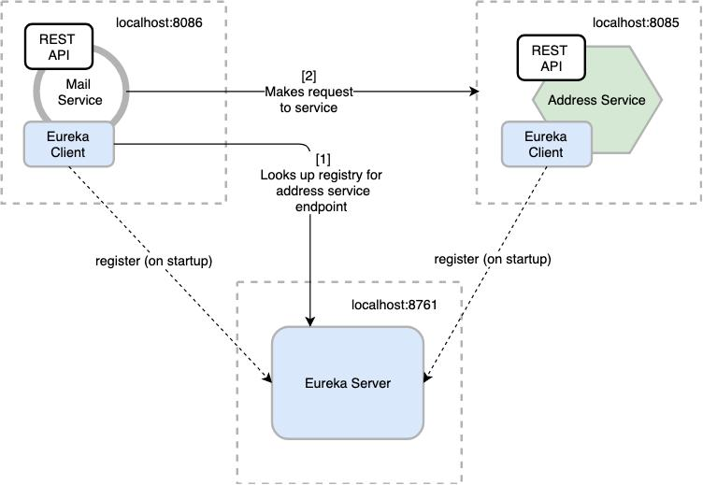

🔥 Interview Tips (Very Important)
💡 Common Questions:
👉 Q: What happens if Eureka Server goes down?
- Clients still work using cached registry (self-preservation mode)
👉 Q: Difference between Eureka Client & Discovery Client?
- DiscoveryClient is generic
- EurekaClient is Netflix-specific
👉 Q: Why not hardcode URLs?
- Services scale dynamically
- Instances change frequently
👉 Q: What replaces Eureka in modern systems?
- Kubernetes Service Discovery
- Consul

🚀 Pro

🔷 Forward Proxy vs Reverse Proxy (Simple + Interview Ready)

🔹 What is a Forward Proxy?
A forward proxy sits between client and internet.
👉 It represents the client.
📌 Flow:
Client → Forward Proxy → Internet (Server)
🌐 Visual
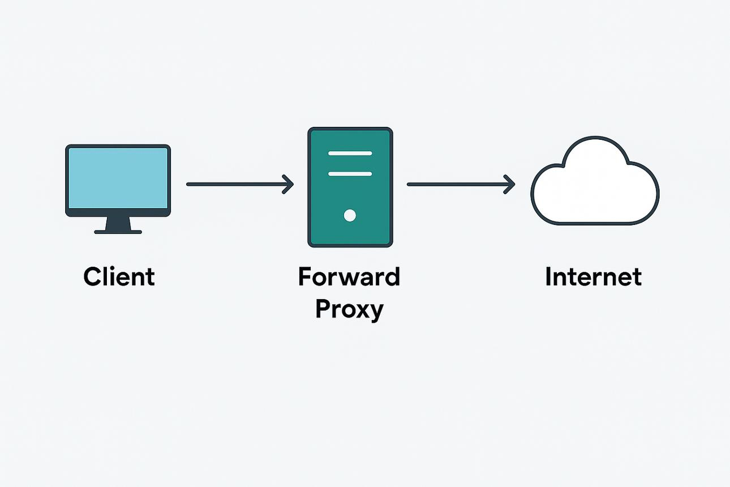
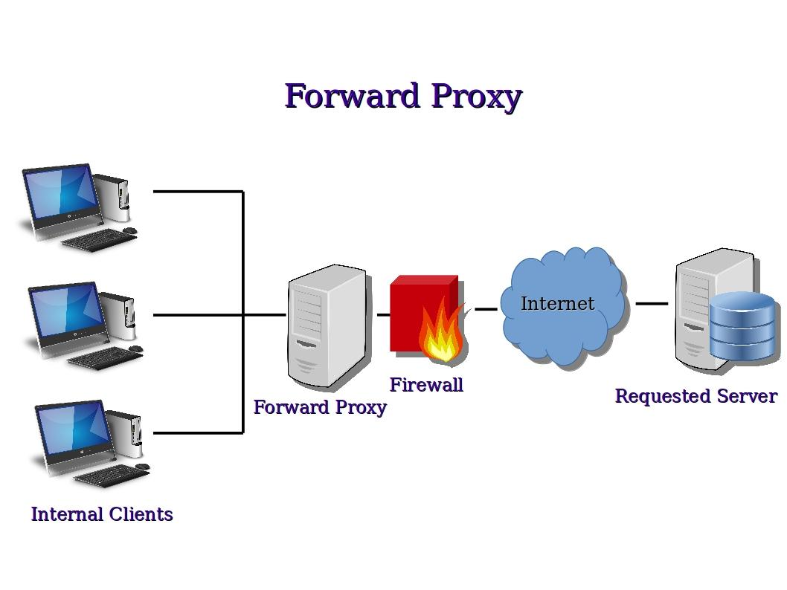
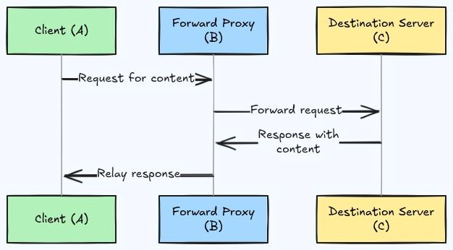
5
🔑 Key Points:
- Hides client identity (IP)
- Used for:
  - Security (company networks)
  - Access control (block websites)
  - Caching
💡 Example:
- In a company, employees cannot directly access the internet
- All requests go through a proxy server

🔹 What is a Reverse Proxy?
A reverse proxy sits between internet and servers.
👉 It represents the server.
📌 Flow:
Client → Reverse Proxy → Backend Servers
🌐 Visual
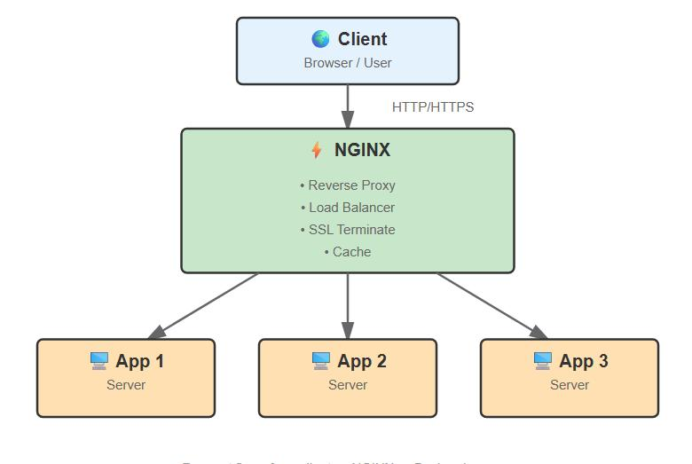
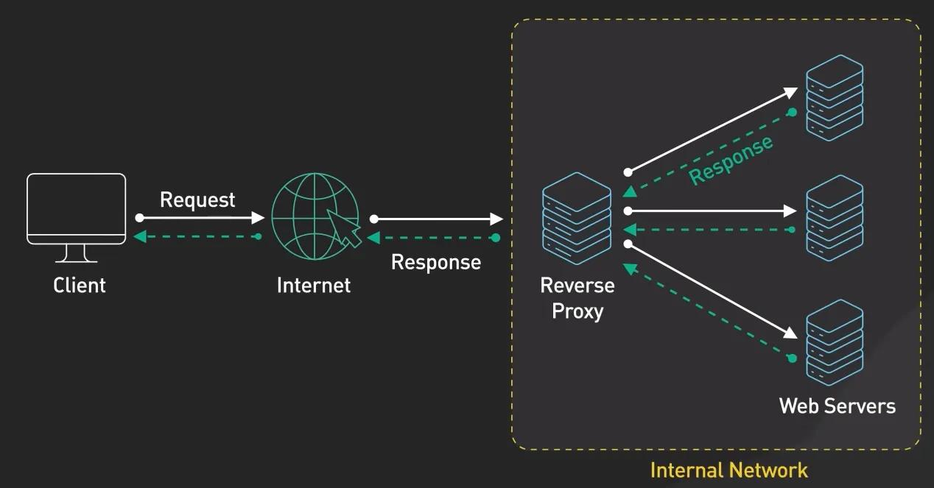
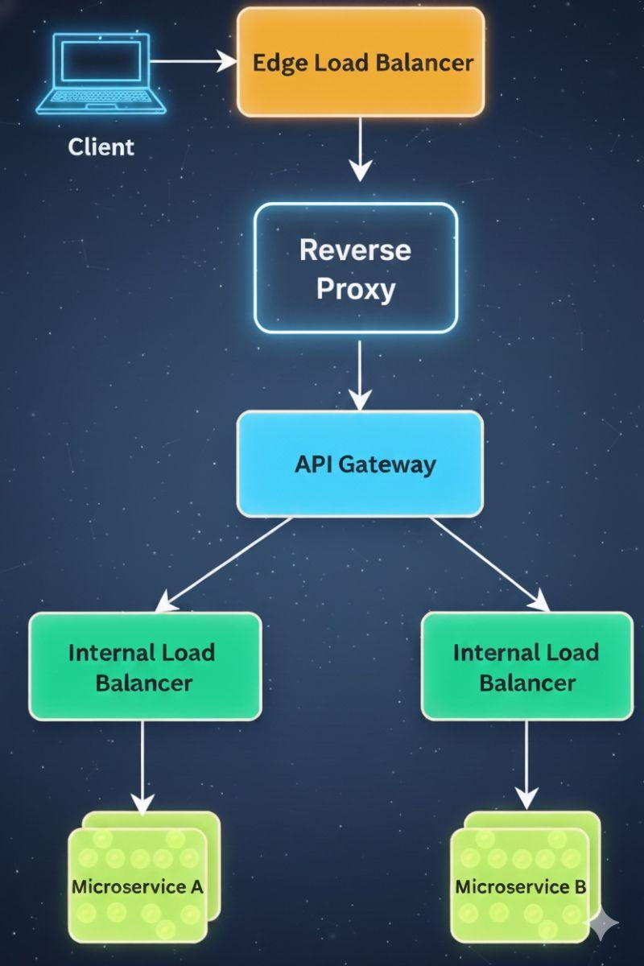
6
🔑 Key Points:
- Hides server details
- Used for:
  - Load balancing
  - Security (SSL termination, firewall)
  - Caching
  - Routing requests
💡 Example:
- You hit amazon.com
- Request goes to reverse proxy (like Nginx)
- It routes to appropriate backend service

🔥 Key Differences (Very Important)
Feature | Forward Proxy | Reverse Proxy
Represents | Client | Server
Position | Before internet | Before backend servers
Hides | Client identity | Server identity
Used by | Clients | Servers
Common Use | Filtering, anonymity | Load balancing, routing

🔹 Real-World Examples
🔸 Forward Proxy
- Corporate proxy servers
- VPNs
🔸 Reverse Proxy
- Nginx
- API Gateway (Spring Cloud Gateway)
- Cloudflare

🔥 Interview Answer (Best Short Version)
A forward proxy sits in front of clients and hides client identity, while a reverse proxy sits in front of servers and hides server details. Forward proxy is used for client-side control like filtering, while reverse proxy is used for server-side features like load balancing and routing.

