

Computer Games Development CW208
Technical Design Document
Year IV

Monika Nusi
C00285423
12/04/2026

Table of Contents

Procedural Generation 2
Player 6
A* Pathfinding 6
Zombie FSM 8
Seperation Steering 10
Boss Zombie 11
Boss Sates 11
Difficulty system 12
CRC Cards 13
References 16

Procedural Generation
The dungeon in zombie always different. Every time the player starts the game the dungeon is built from scratch. Every toom layout, every shape, door position and every room type assignment is different. This is all is the MapGenerator class and id triggered by a single call to m_mapGenerator.generate form the game constructor. It is an 8x6 grid which means there are 48 possible rooms. There are the steps to how this system works

1. Reset
The whole grid is always built from scratch and is reset to default empty room object.
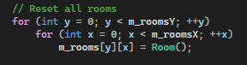
2.The guaranteed downward path
This is the most important step. A random columns on row 0 is chosen as the start room The downward walk begins there. It rolls a random number between 0 and 2, then moves left, right or down the walk then continues until the cursor reaches the bottom row and activates every spot it lands on.
This makes sure there is always a guaranteed path in the dungeon. The path is never just a straight line as the cursor goes left and right.
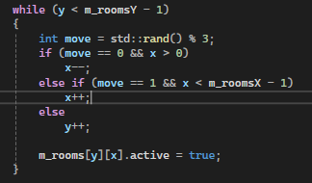
3.Random side rooms
When the main path is built every slot that the walk didn’t activate is given a 1 in 4 chance of being a side room. These side rooms will attach to an active room and will make dead ends or more exploration areas, so the game is not just one straight path. The position and number of side rooms in random so some playthroughs may be simpler and more straightforward than others depending on the number of side rooms.
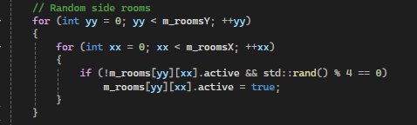
4.Exits
The right and down neighbours are checked in every active room. If the rooms are active a connection is made by setting exit flags on both rooms. It checks for only right and down connections and left and up are created as the mirror of another room’s connection.
The active room then knows which of the four edges can lead somewhere. These flags are used throughout the gameplay. In game.cpp the room transition system decides whether the player can walk through an edge and generateRoomLayout decides where to carve doorways.
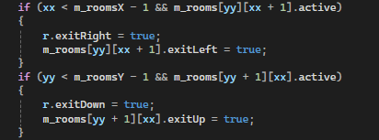
5.BFS distance and boss placement
The breath fist search start at the start room and visits every connected room and it counts how many hops there is from the start. Rooms that are disconnected to the main path are at distance -1 and stay unreachable.
When the BFS is done the generator scans the grid and finds which reachable room has the highest hop count. That room will be the boss room. This means that the boss room will always be the furthest room. Because it was discovered by BFS means that its always reachable.
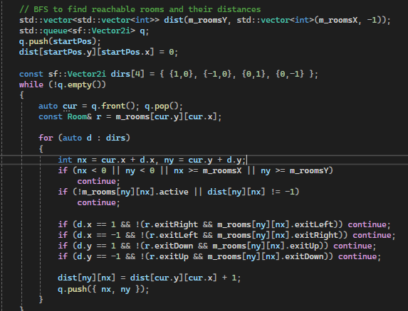

6.Room Type Assignment
The active rooms remaining are randomly assigned any of the three-room types. Normal rooms occupy 60% of the map, treasure rooms occupy 20 % of the map, and trap rooms occupy the final 20% of the map
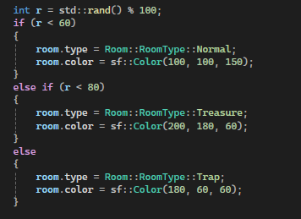

7.Room interior Generation
generateRoomLayout is called on every active room. All border tiles are set to be walls interior tiles have a 20 % chance to be a wall giving the dungeon more obstacles.
Doorways are then carved in the border walls in the middle of every connected edge. The doors are three tiles wide so it’s always possible for the player to get through. The doorways are written as value 2 instead of the open floor. Every room connection in the dungeon is locked until the player opens it.
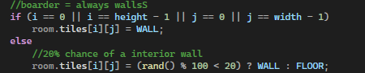
When the player finds a key and holds the E button near a locked door, the setTile is called by Game.cpp and the locked door tiles are set to 0.

Room Transition System
When the player walks into a doorway the camera slides into the next room and both rooms are rendered at the same time. All of this is managed through a Transition state and a set camera offset.

Detecting The Room Exit
The function checks whether the player crossed any of the four screen edges within a 40px margin. A border tile is also checks if the tile is an unlocked door tile (value 0). If the tile is locked (2) and blocking the doorway, the player won’t be able to pass.
If the checks are valid the saveCurrentRoomState is called right before the transition begins, m_nextRoom is set and m_transition will go to sliding.
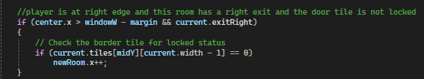
Camera sliding
The sliding target is calculated as a pixel offset equal to one full screen width or height in the direction of travel.
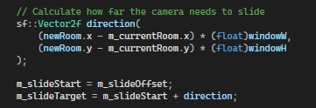
The camera moves toward m_slideTarget at 800 pixels per second every frame. Both rooms are drawn the same time during the slide. When the camera offset reaches the target within 1 pixel it snaps to the final position and the transition ends.

When the slide finishes getDoorSpawn is called to calculate where the player should appear in the new room.

Saving Room State
saveCurrentRoomState stores the current vectors for zombies, minions, traps, pickups, keys, decorations and torches into separate std::map containers. This means that when the player kills a zombie in the room and leaves the room and comes back later that zombie will still be dead.
Loading Room State
LoadRoomState runs after the slide transition finishes it then checks each map if the new room has been visited before.
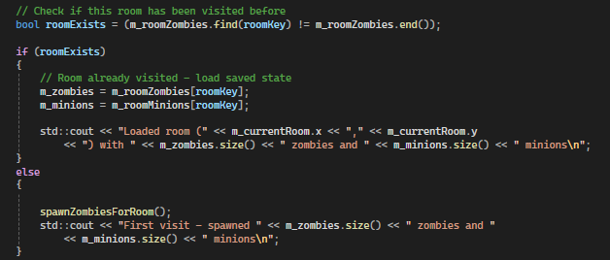

Player
The player has movement, shooting, health, ammo and a 5 slot inventory.
Movement
The player can move with WASD at 200 pixels per second. The movement direction also chooses which animation to play. The sprite sheet has 8 rows and its one row per direction. There is a sound effect for the footsteps which plays on a 0.4 second timer while the player is moving.
Shooting
The player shoots with the left mouse button. The direction vector is calculated from the player centre to the mouse. The exact mouse direction is passed to the bullet constructor so the bullet will move towards the player’s mouse. Each shot takes away one ammo from the player.

Inventory system
The player has a vector of InventoryItem struct and they hold either Health or Ammo and how many there is of each. Items are added to the inventory when the player walks over them. There are 5 slots and are displayed on the top of the screen. The player can press the keys 1-5 depending on which item they want to use.

A* Pathfinding
Every enemy in zombie must be able to find the player. I use A* for this. This system is made in Pathfinding.h and it takes the current rooms tile grid, tile coordinate and the goal tile coordinate it then returns a list of positions forming the shortest walkable path between the enemy and the player.
The findPath function is called in Zombie class whenever they need to find a new route to the player. The enemy then gets a sequence of tile grid positions that they need to follow to get to the player. It also recalculates whenever the player moves far enough away from the enemy’s last knows positions

The algorithm uses three data structures to do this. It uses open list which is a min priority queue that always gives back the best tile to explore next.
PQ Node is a simple struct holding a tile coordinate and a priority score. It’s basically so that it gives the tile with the lowest cost first. Lower score means more promising A*
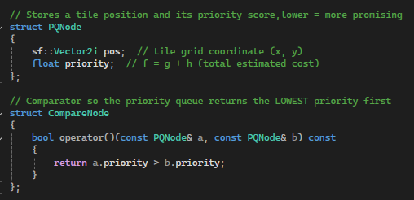

The Heuristic
The heuristic function estimates how far a given tile is from the goal. I use Manhattan distance, which is the sum of absolute horizontal and vertical difference between two coordinates.
This is an example of Manhattan distance
h = |x₂ - x₁| + |y₂ - y₁|

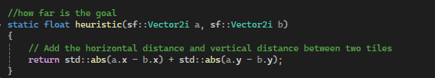
The full priority score for any tile is calculated as
F= g+ h
G - the cost to reach that tile
H - estimated distance to the goal
The algorithm then processes which tile has the lowest f score next then steers the search towards the goal.

The Main Loop
The algorithm pushes the start tile to the list of priority 0 and making the cost 0. It removes the lowest priority tile off the queue. If that tile is the goal the search will stop otherwise it checks all the four directions.

Zombie FSM
The standard zombie is controlled by a finite state machine with six states: Idle, Patrol, chase, Attack, cooldown and dying.
Idle - The zombie will start in this state and immediately transition to Patrol. This is a default starting state
Patrol -The zombie will walk around randomly and every 1.2 seconds a new direction. The zombie moves 60 pixels per second until the next direction change, if the player gets within 320 pixels during patrol the zombie will change states to chase.
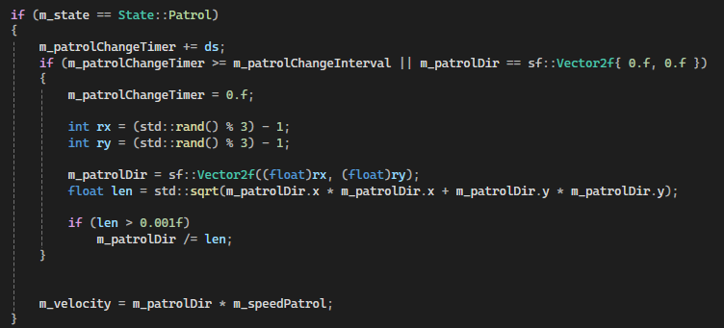
Chase - The zombie will move towards the player using A* pathfinding. Instead of recalculating the path every single frame findPath is called every 0.4 seconds. The result of findPath is a list of tile positions. the zombie takes only the second tile in that list as its immediate movement target and walks toward it at 120 pixels per second. It then recalculates and takes the next step, and so on, following the path one tile at a time.
If the player is in the 320 radius of the zombie, the zombie keeps updating the last known player position. If the player leaves this radius the zombie doesn’t just stop in keeps moving toward the players last knowns position but also slows down to its normal speed. There is a search timer of 2.5 seconds and if the player is still not found the zombie returns back to patrol state.
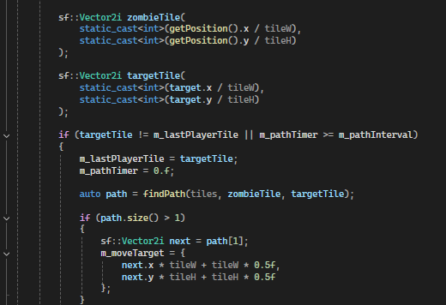
Attack- This is when the player enters the attack range of 55 pixels. To make sure that the damage isn’t dealt every single frame the enemy and player hitbox overlaps and drain the health too fast I use the m_hasDealtDamageThisAttack flag. When the attack timer of 0.25 seconds ends the cooldown timer is set back to 0.
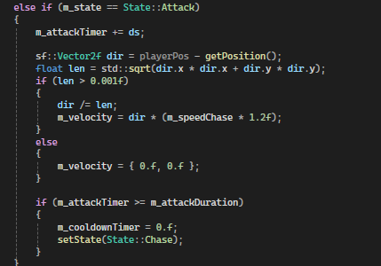

Cooldown - After an attack the zombie had to wait 0.5 seconds before attacking again.
Dying- This is triggered when the zombie health reaches zero. The zombie stops moving and the death animation plays. The zombie is then erased from the vector.

Alert system
When the player is spotted by the zombie it transitions to chase and it sends m_alerted = true and m_hasSpreadAlert scans every other zombie in the room this means that any zombie within the 200 pixel radius that is currently in patrol state is going to transition into chase mode as well. They are also given the same last known position of the player. This means when the player alerts one zombie is going to alert all zombies close to it to attack.
The debug rendering in Game.cpp is visible by pressing Q. The alert radius id a yellow 200px circle and a blue circle chase range is 320 pixels. Red cross is drawn at the players last known position if they leave the chase range.

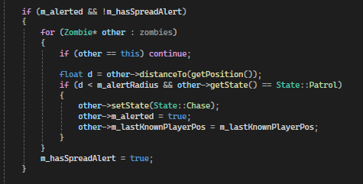

Separation Steering
When there are multiple zombies in the same area they will naturally stack on top of each other when running towards the player. I use separation steering to prevent this. Each zombie checks every other zombie in the room. for any zombie with a separation of 50px it calculates a vector pointing directly away from that neighbour and adds it to a separation total. The total is added to the zombie’s velocity is scaled m_separationStrength (40).
This pushes overlapping zombies apart. Combined with the alert system, it makes the zombie groups feel like they are surrounding the player from multiple angels then to all be in a single pile.
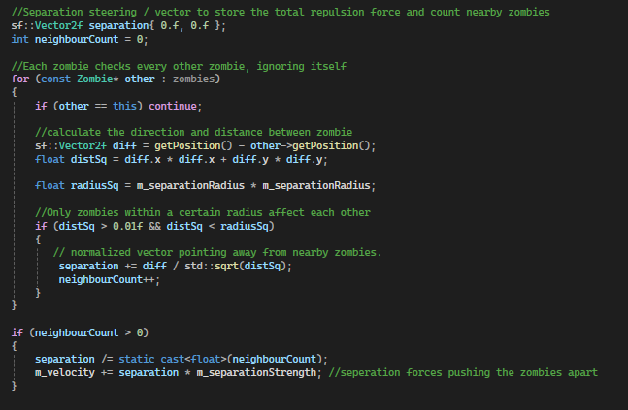

Boss Zombie
The boss zombie has 6 states- idle, walking, charging, BigAttack, SummonMinions and dying. There are three cooldown timers that the boss uses for charges, heavy attacks and summoning minions.

Boss Sates
Walking - The boss checks the three conditions every frame based on the priority. The minions will be summed if the boss is at 50% health for the first time or 5% random time if the cooldown expired. The boss will also charge at the player if they are between 120 -300 px away. The boss will attack the player if they are 120 px in range. If none of these are true, the zombie will continue moving towards the player.
Charging - It moves in the direction that it was locked on when the charge attack began at 250 px per second. Which is way faster than before. After 1.5 seconds it returns to walking.
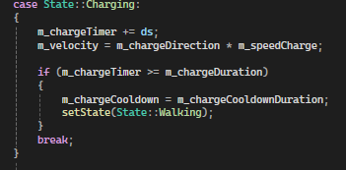
Big attack – It attacks the player if they are withing 120px and deals 30 damage at medium difficulty.
Summon Minions – Boss stops moving and if m_shouldSpawnMinions is set to true and a 15 second cooldown starts and 3 minions are spawned in a circle around the boss.
Dying - Death animation and death sound plays. Ending screen comes up.

Difficulty system
All the difficulty in the game is controlled by a DifficultySettings struct in difficultySettings.h. there is three different modes – Easy, medium and hard. The chosen instance is created in Main.cpp and passed into the game constructor and is stored as m_difficulty.
The difficulty settings control:
Player - Health, ammo and fire rate.
Lightning - how dark the dungeon is and how much light the player gets arouund them.
Enemy count - How many zombies and minions soawn in the room.
Enemy stats – Health and damage for zombies, minions and the boss.
Traps – How many traps there are in the room
Pickups – Health and ammo are randomised within a min/max range.

Setting | Easy | Medium | Hard
Player Health | 150 | 100 | 75
Player Ammo | 200 | 100 | 50
Fire Rate | 0.10 | 0.15 | 0.25
Ambient Light | 120 | 80 | 50
Player Light Radius | 350px | 280px | 200px
Zombie Health | 80 | 100 | 150
Zombie Damage | 8 | 10 | 20
Boss Health | 300 | 500 | 800
Normal Room Zombies | 1 | 5 | 10
Trap Room Traps | 4 | 8 | 12
Health Pickup Range | 40-70 | 25-50 | 10-25

CRC Cards
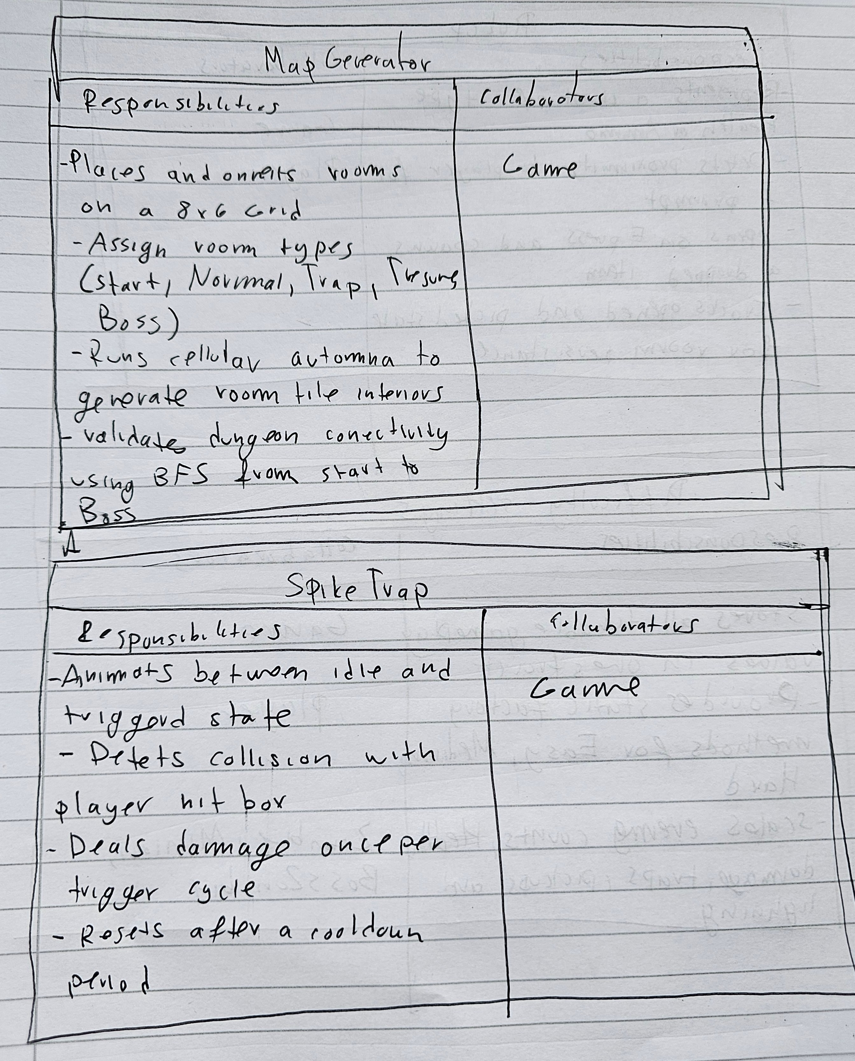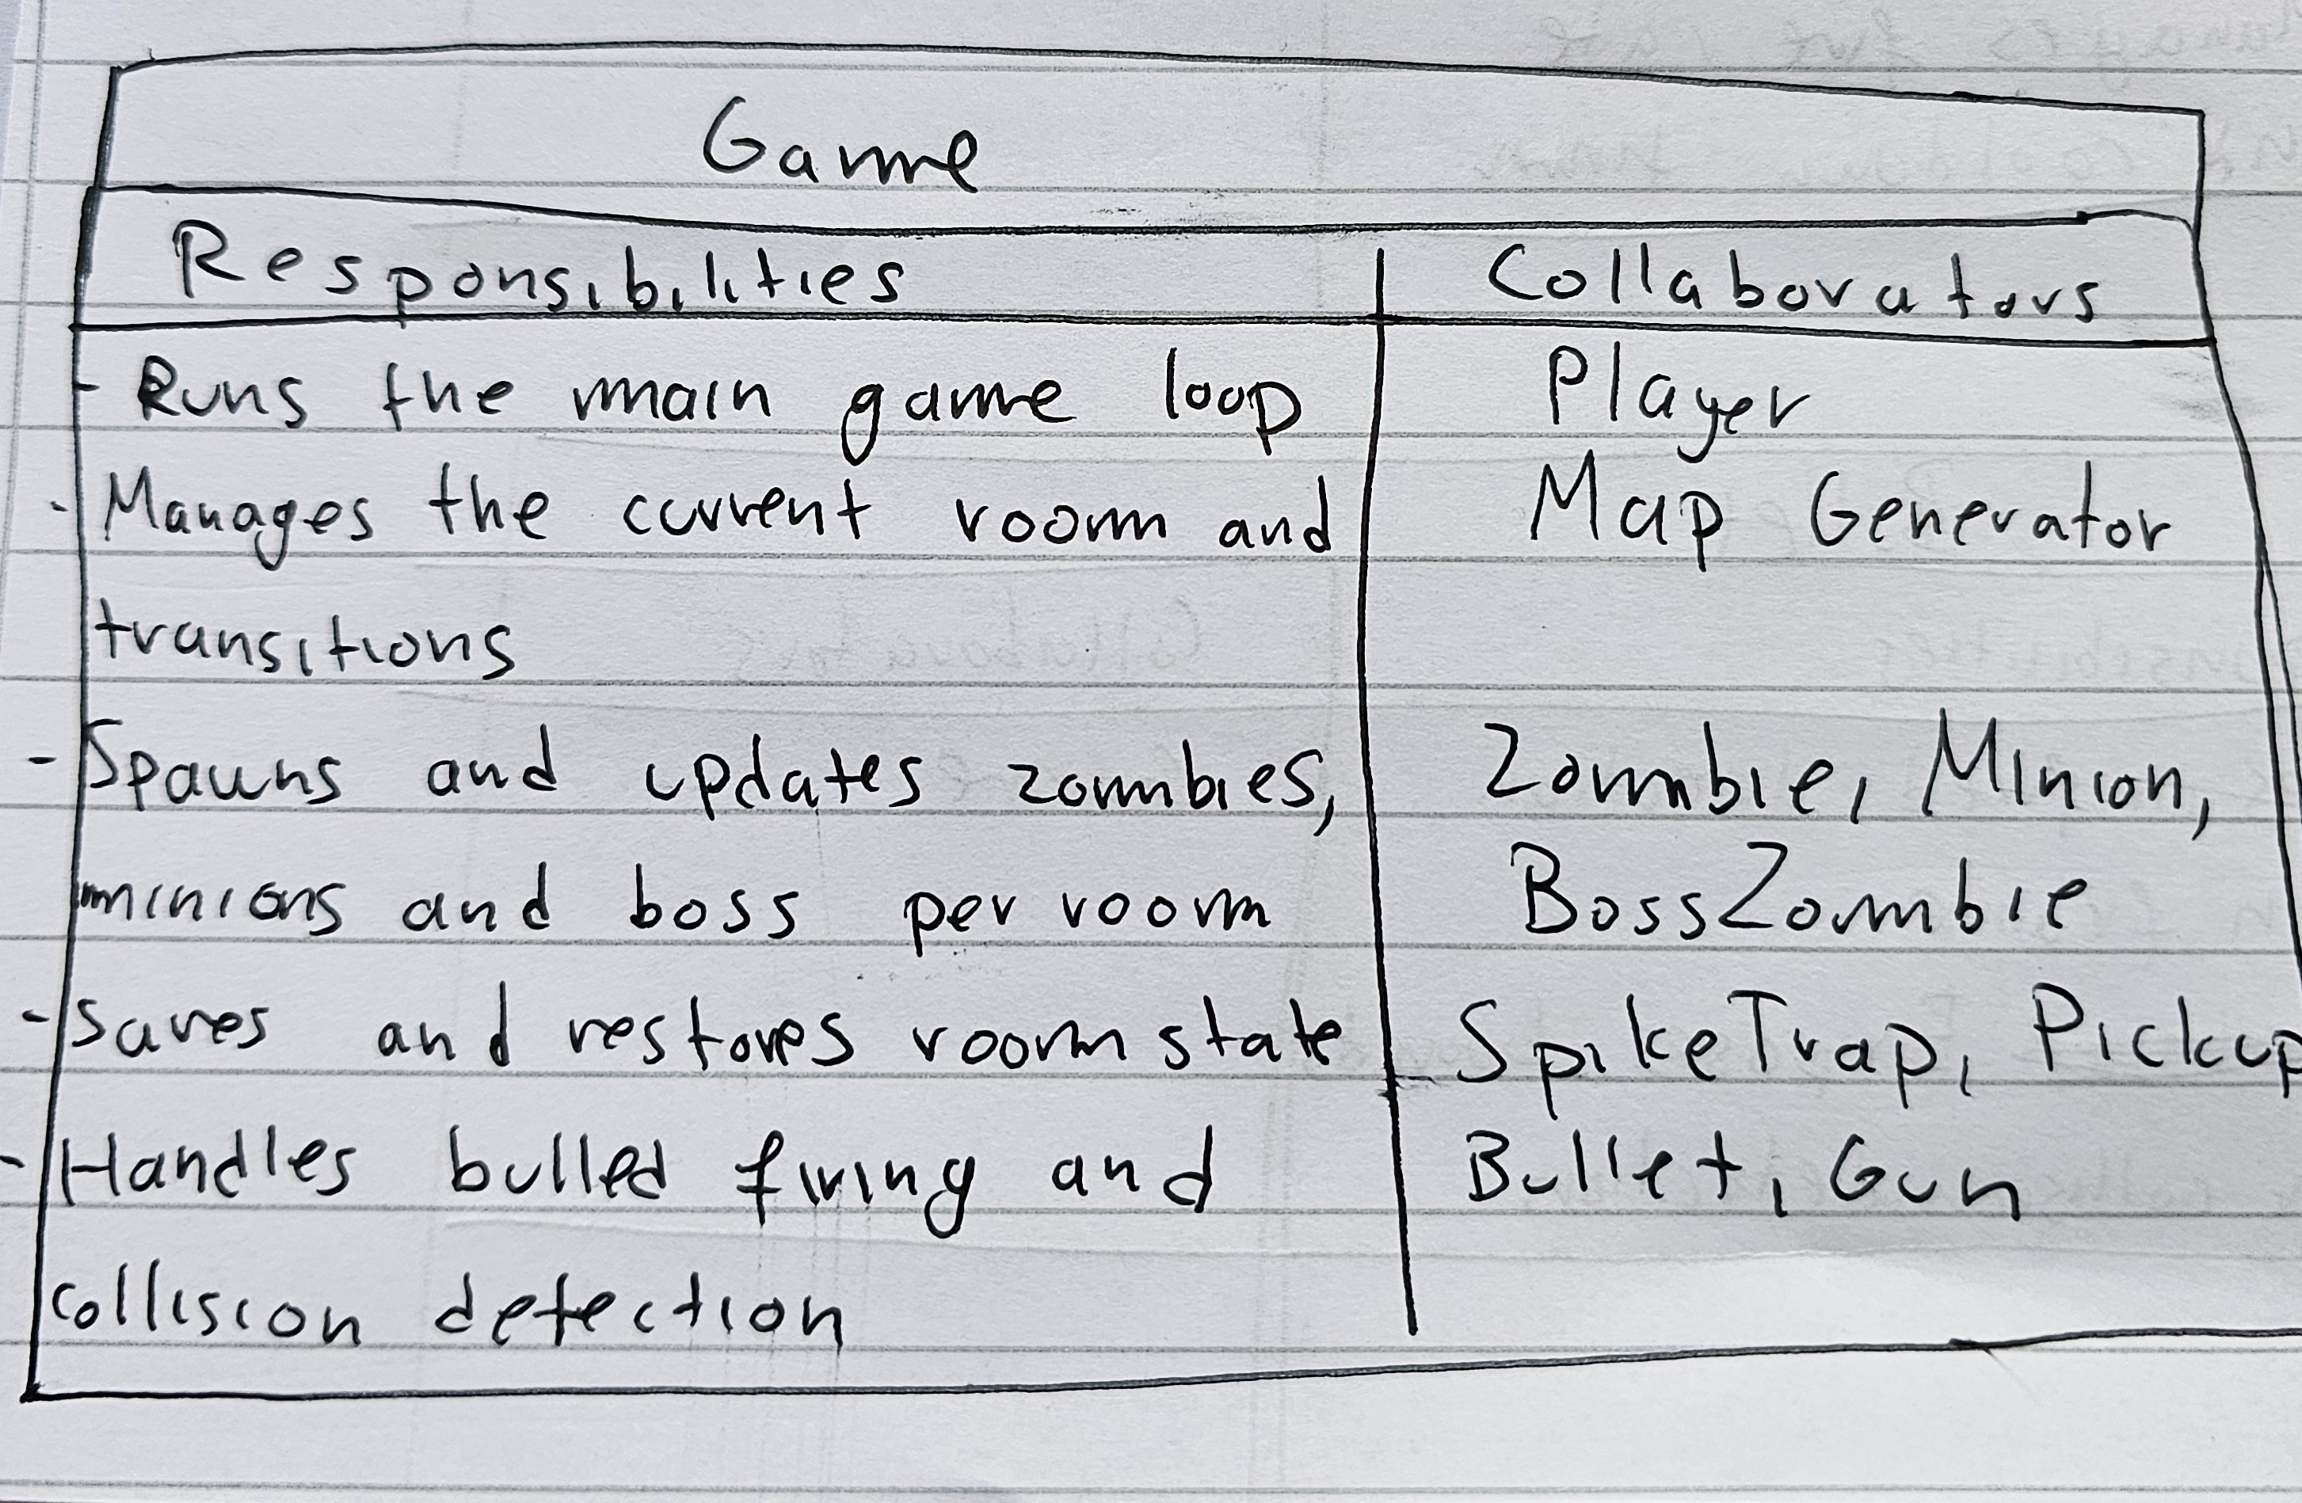
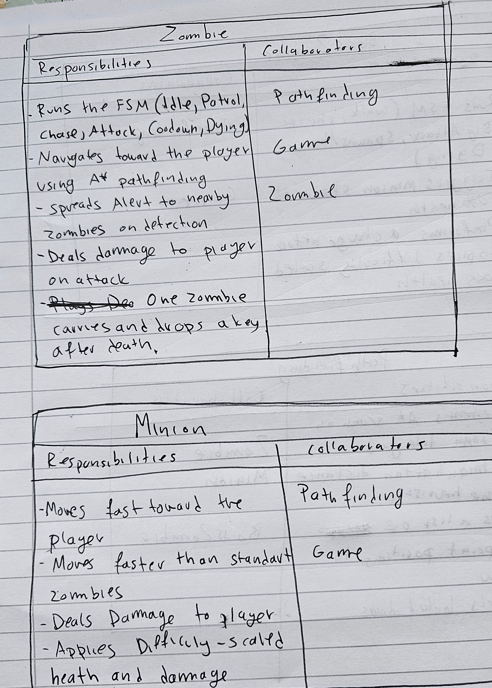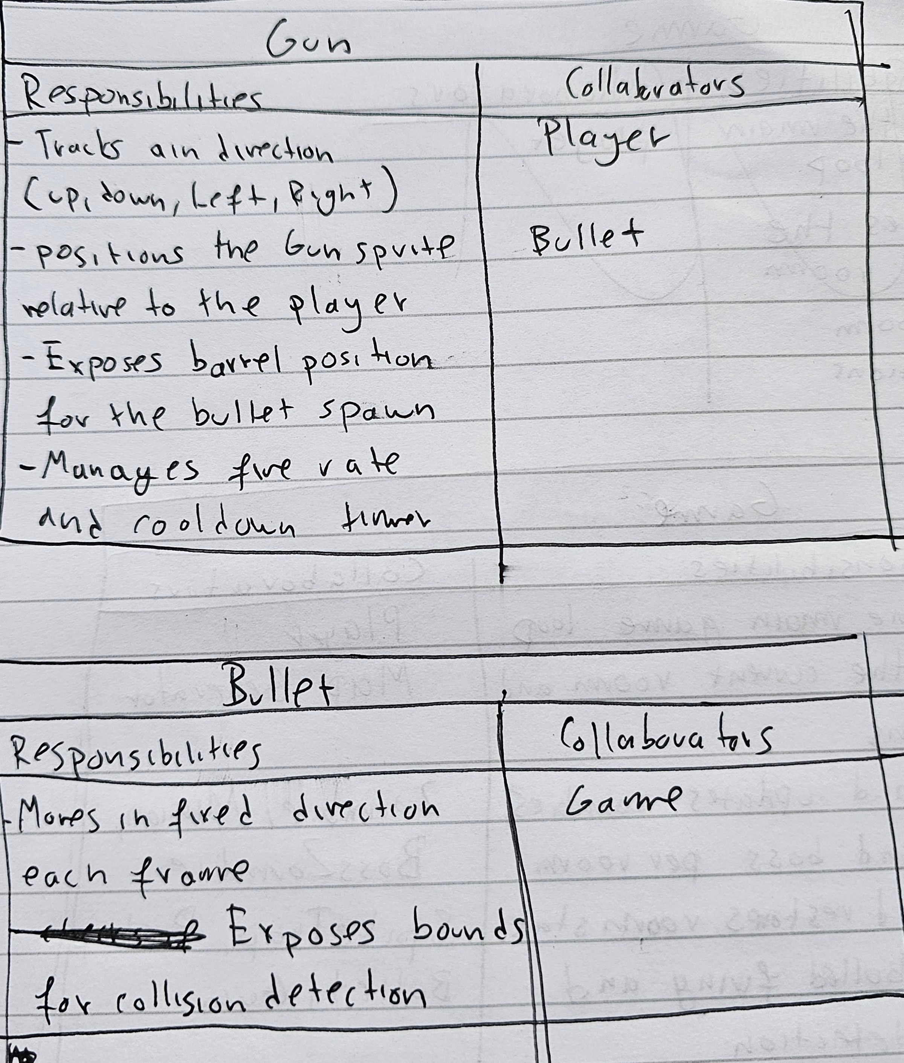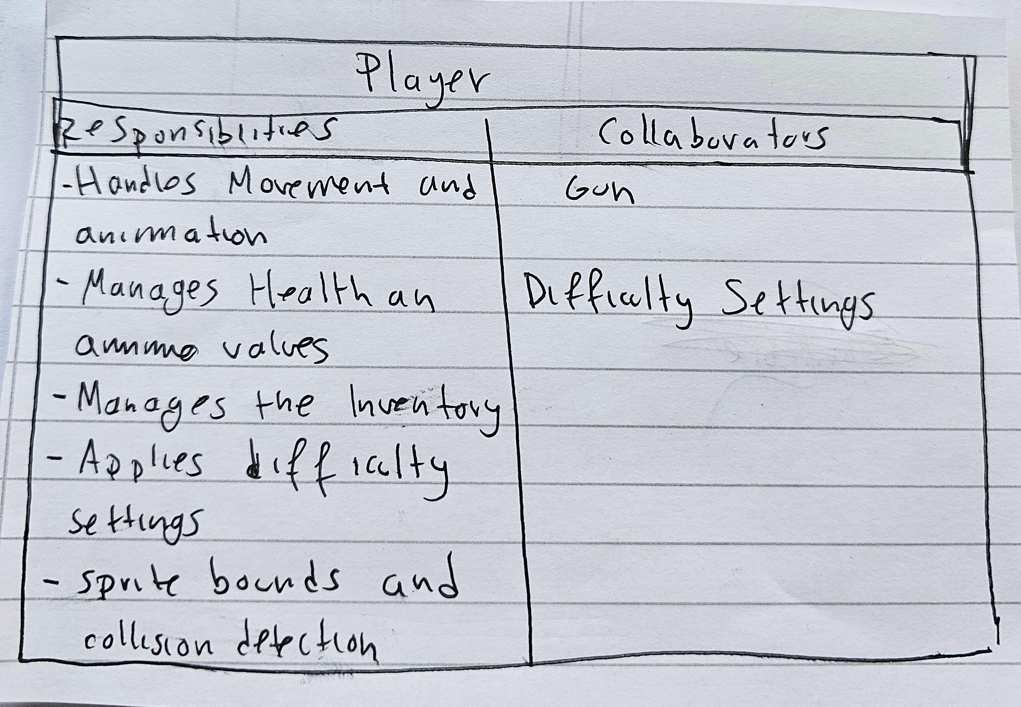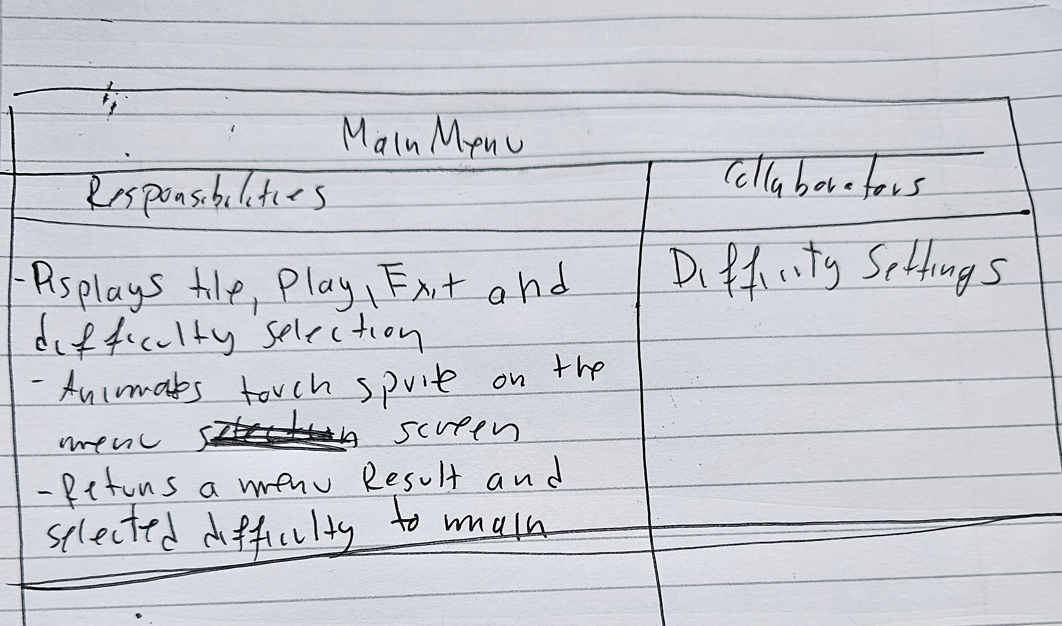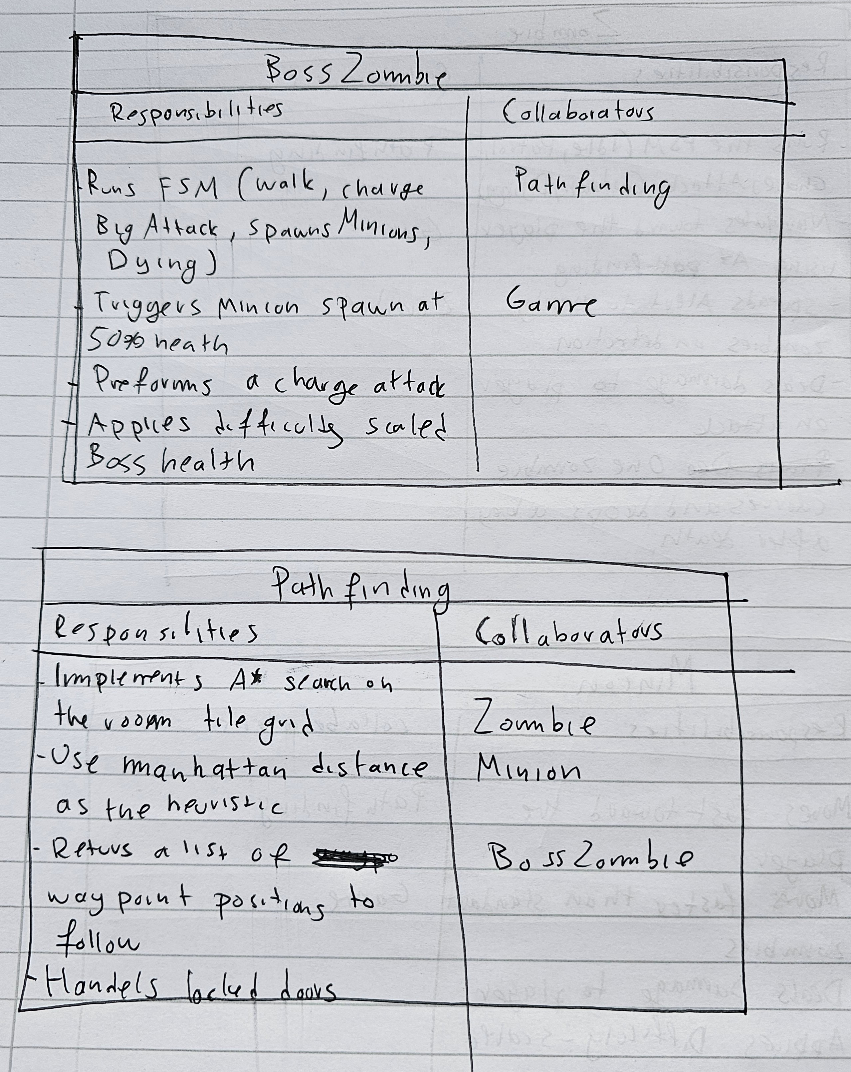
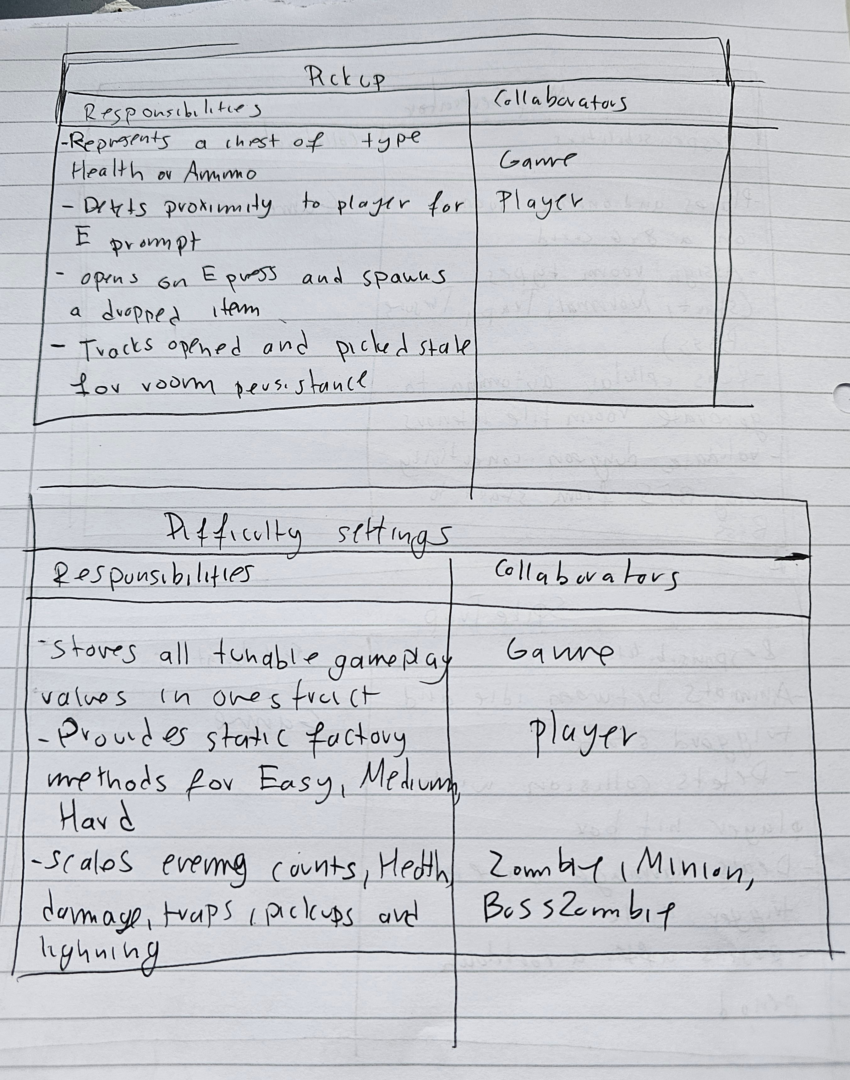

References

