

Computer Games Development CW208
GDD
Year IV

Monika Nusi
C00285423

Submisson date
12/04/2026

Contents

Game Overview 4
Feature Set 4
General Features 4
Gameplay 5
Map and Navigation 5
Player Inventory 5
Combat System 5
Enemy Types 5
Basic Zombie AI Behaviour 5
Minions 6
Boss Zombie 6
Managing Resources 6
Key collection 6
The Game World 8
Overview 8
A living dungeon 8
Variety Through Procedural Generation 8
Locked Doors 8
The Physical World 8
Overview 8
Key Locations 9
Travel 9
Scale 9
Objects 9
Time 10
Three Minutes of Gameplay 10
Rendering System 11
2D/3D Rendering 11
Lightning 11
Camera 11
Overview 11
Room transition 11
HUD and Menus 11
Game Engine 12
Overview 12
Room and World State 12
Collision Detection 12
User Interface 12
Overview 12
Health bar 12
Ammo Counter 12
Key indicator 13
Door unlock progress 13
Inventory 13
Chest Prompts 13
Mini-map 13
Letter Viewer 13
Game over screen 14
Ending screen 14
Main Menu 14
Musical Scores and Sound Effects 14
Overview 14
Music 15
Sound Effects 15
Single-Player Game 16
Overview 16
Exploration and Resource Management 16
Combat and Enemies 16
Story 16
Hours of Gameplay 17
Appendix 17
References 18

Game Overview

Game Title - ZOMBIE
Genre – Top-down Action shooter survival
Platform – PC
Engine – SFML
This is a top-down survival shooter game where the player can walk around the procedurally generated dungeon while fighting zombies, collecting ammo and health potions avoiding traps and managing resources and ultimately hunting down the boss to rescue lily – a missing girl the player must find. This game has pathfinding AI, multiple enemy types such as regular zombies, small fast zombies and a boss zombie. The game also features three difficulty modes and a lightning system.

Feature Set

General Features
Procedurally Generated map – in each playthrough the 8x6 dungeon layout will be different, the path to the boss room will also always be different making the game repayable.
State machine AI - Intelligent enemy behaviour has Patrol, chase, attack and search states
Pathfinding - the enemies can navigate around obstacles using A*
Room states - rooms remember pickups, keys picked up, enemy positions when revisited
Audio system – Sound effects that adapt to game situations
Boss encounter- Challenging boss battle with different complex mechanics such as minion summoning and dashing.
Mini map – a small map on top left of the players screen revealing explored areas.
Chests- Interactive chests with resources the payer needs to survive such as ammo and heath potions
Locked door – the player can unlock the door by holding “E”
Difficulty system - three game modes the player can choose from (easy, medium, hard) that scale player stats, enemy counts, enemy stats, trap counts, pickup values, fire rates and lightning.

Gameplay

Map and Navigation
The dungeon in this game is an 8x 6 grid. The active rooms are connected by doorways in any four directions. The room interior is a 10 x 10 tile grid.
The player must stand within 120 px od a locked door and hold “E” to open it. Releasing E and moving away from the locked door cancels the unlock. When the player unlocks it the door tile clears in both the current room and the adjacent room simultaneously so neither side blocks passage after the unlock is complete.

Player Inventory
The player has 5 inventory slots displayed on the screen. When the player picks up ammo or health potions they are added to the inventory, and the player can use them by pressing the number keys depending which item they want to use.

Combat System
The combat system is mouse aimed shooting where the player can fire bullets where they aim and shooting by pressing left click. Each shot will waste the player ammo which forces the player to carefully manage their resources throughput their adventure in the dungeon.
The shooting mechanism operates on a 0.3 second cooldown preventing the player to spam while shooting. Bullets travel 400 pixels per second and deal`s 25 damage to the zombie. The hitbox-based collision ensures precise combat interactions with enemies. Enemy health bars float above their heads, providing visual feedback, different enemy types deal different amounts of damage, regular zombies deal 10 damage, minions deal 25 damage and the boss zombie deals 20-30 damage depending on attack type.

Enemy Types

Basic Zombie AI Behaviour
The enemy AI uses state machines that gives the zombies good behaviour patterns. Zombies begin in patrol state wandering randomly through the rooms until the players enters their detection radius. When the zombie is alerted the zombies will alert other zombies and let them know the players location withing the 250- pixel alert radius, triggering a coordinated swarm behaviour, when the players leave the zombies line of sight the zombies will loose the sight of the player but they won’t immediately give up they will go to the players last known location and search there for 10 seconds before returning to patrol state.
The pathfinding system uses A* algorithm to navigate the tile-based environment, it recalculates paths every 0.3 seconds to adapt to player movement. Zombies intelligently navigate around walls and obstacles instead of running into them and being stuck.
The zombies have attack cooldowns so they can spam and kill the player immediately. They have 2.5 seconds between attacks and the boss needs 3 seconds between each attack. Creating predictable window for counterattacks.
Separation steering system - This prevents the enemy clustering on top of one another when chasing the player. They calculate repulsion forces from nearby zombies within 50-pixel radius, spreading out, this makes the game look more natural since the player can manoeuvre in besewn the enemies and they are being attacked from every side. The separation strength is 20 pixels, and the zombies will maintain personal space.
Memory system gives the game a more natural feel. Zombies remember the players last known position and continue pathfinding to the last known positions even after loosing dight of the player.

Minions
They are small and fast enemies that are far more aggressive than regular zombies. They have less health and deal less damage, but they are faster then regular zombies and will chase the player from across the room. Unlike regular zombies they don’t have patrol phase.
Their AI is simpler, but they become harder to kill when they are in large groups. They can spawn anywhere in the dungeon, and they can be summoned by the boss zombie. Their health and damage are different based on difficulty level.

Boss Zombie
The boss zombie is the biggest threat in the dungeon and is what the player must defeat to win the game. The boss zombie is way larger and has more attacks than regular zombies
The boss has the ability to charge at the player, when the boss is close to the player it preforms a heavy attack, the hardest moment in the fight happens when the boss drops to half health. The boss stops and summons minions around itself forcing the player to focus on killing both the boss and the minions and continues to spawn them throughout the fight.

Managing Resources
The player will start with 100 maximum health and 50 ammo in their inventory, since the player will constantly use up ammo and health fighting zombies, they will be able to find chests around the map with these resources. The chest can be opened by pressing “E” when standing close to it. Health potions will restore 25 -50 health and ammo chests will give player 20-30 bullets.

Key collection
One randomly selected zombie per room will have a key and when that zombie dies a key will drop. The player can pick up the key by walking over it and it will show up in their inventory, this adds difficulty to the game since the player must kill zombies to find a key an get to the next room
Normal rooms will have 2-3 chests while traps will have less, treasure rooms will have 4-5 chests. The boss room will also have 2 of each providing last chance preparation opportunity before the final fight.

The Game World

Overview
The game world of my game zombie is a dark dungeon crawling with zombies. Every time the layout, paths, rooms and hazards change so no playthrough will be the same. The player has no map to guide them at the start only a gun and light around them to navigate. The player will find everything they need to survive.

A living dungeon
Every room in the dungeon is a different space but the rooms wont reset when the player leaves. Enemies that were wounded will stay wounded, chests that have been looted will stay open and so on. The dungeon will remember everything the player has done to it. this makes the player question their decisions about wasting ammo in a early room or missing a chest.
Torches flicker on the walls giving the player light. Each torch flickers randomly so the animation never feels static. Bone piles are scattered around the dungeon in different sizes. The deeper the player gets in the dungeon the scarier the atmosphere is. Trap room have a lot of bones, traps and the boss room has a music shift to scare the player.

Variety Through Procedural Generation
The dungeon is different each playthrough. The placement of every room, the path connecting them and the route to the boss room. No single path is guaranteed, and the mini map start completely dark and only reveals the rooms to the player only when they discover it. This means that player can’t memorise the dungeon layout and find the boss is. Every run is a process of exploration and of player discovering the world in real time while managing health, ammo and the enemy’s around them, a path to the boss room always exists but the player never knows the dangerous rooms stand in between the player and the boss.

Locked Doors
The dungeon does not just let the player walk wherever they want. Doors in each room are locked. To open them the player has to fid a key that dops if the player kills the key carrying zombie in the room. Carrying the key and standing near the door and holding “E” will let the player pass through. This means that it can’t be rushed and the player can be attacked mid unlock if they didn’t kill all the zombies in the room.

The Physical World

Overview
The physical world of ZOMBIE is dungeon rendered from a top-down perspective. The entire dungeon fits within the 8 x 6 grid of rooms. The world is tile based with each room built from 10x 10 grid of floor, wall and door tiles, the player experiences rooms one at the time with he camera sliding smoothly between rooms as the player goes through doorways
There are the key components of the physical world

Key Locations
The dungeon has 5 types of rooms that have different purposes. The start room is where the player spawns and the adventure begin. It has a small number of enemies and a few chests it is the only room where the story letter drops telling the player their purpose in the dungeon. This room feels safe and gives a player the chance to see how it works. Normal rooms are the most common room in the dungeon and where combat takes place. It’s filled with zombies, minions and traps. Trap rooms are very dangerous. The floor is filled with traps and way more enemies are spawned in this room. Tresure rooms are rooms with more chests than any other rooms, there is less enemies and more rewards preparing the player for the boss fight. The boss room is the destination and is marked red on the mini map. It’s filled with traps and bones and a home of the boss zombie. Defeating the boss means the player has beat the game

Travel
The player moves through the dungeon on foot by using WASD movement. Rooms are connected with doorways in any 4 directions and when the player has unlocked the door and walks to the edge of the room it triggers a smooth camera slide into adjacent room with the player repositions at the entrance on the other side.

Scale
The room interior is divided into 10 x 10 grid with each tile scaled to fill the screen. The player is roughly 2 tiles tall. Regular zombies are like the size of the player. The boss zombie is 5 times the size of the regular zombie making it look way more dangerous than a regular zombie. Bullets are small and fast. The rooms are not large, and encounters happened at close range and there is rarely anywhere safe to stand still. The rooms are full of enemies, and the player rarely has anywhere to hide but that also means that the enemies have nowhere to hide from the player’s gun.

Objects
Health Chest - Sits closed on the floor until the player stands close to it and hold e to open it. The health potion then drops on the floor.
Health potion - drops from the chest when player open is and it has a bobbing animation. When the player walks over it goes straight to the player’s inventory.
Ammo chest - identical behaviour to the health chest but drop ammo instead
Ammo - drops from the chest when player open is and it has a bobbing animation. When the player walks over it goes straight to the player’s inventory.
Key –-Dropped by one zombie per room and the player collects it by walking over it.
Spike trap - The spike trap is trigger if the player walks over it. It deals damage to the player then has a cooldown before it can trigger again.
Torch - they are positioned randomly on wall tiles. Each torch has a light source to help player see in the dungeon
Bone pile - Decoration spawned in the dungeon. The size and angle of the bones are randomized. it has no gameplay effect and are only for decoration.
Story letter - A letter that drops from the first zombie in the dungeon. The player picks it up by walking over it. The gameplay freezes and the full letter view opens informing the player their mission in the dungeon.
Bullet- a projectile spawned from the gun when the player fires. It travels in a straight line, disappears if the player shoots the wall and hits the enemy

Time

Three Minutes of Gameplay
Time in ZOMBIE is not measured by a clock. The player sets their own pace. However, a focused playthrough builds naturally into a crescendo across three distinct phases of tension.
Minute 1 is about orientation and discovery. That plyers spawns in a quiet start room and kills the first zombie (The player friend mia) and finds the letter. The player read the letter and imminently knows what they must do. Lily is somewhere deep in the dungeon and player must find her.
Minute 2 is where there is more pressure for the player. The payer enters a normal room and finds zombies and minions. The moment one zombie detects the player the alert spreads, pulling every enemy in the room to follow the player. The player must fight them off while opening chests around the room gathering ammo and health potions to stay alive. One of the zombies that the player kills will drop a key to the next room, and it feels like a small victory for the player
Minute 3 - The boss room opens and the music starts. The player imminently notices something wrong with the boss. The boss zombie has the same hair as lily the missing girl you’re supposed to find making the player in the edge of their seat. The boss zombie charges at the player, uses heavy attacks and summons minions. Every bullet and health potions becomes important. When the player kills the boss, The dungeon gets quiet and the ending screen appears with lily’s photo and a few sentences closing the story that the player has been carrying form minute 1.

Rendering System

2D/3D Rendering
ZOMBIE is a top-down 2D dungeon game and has a flat overhead view with the same perspective as classic dungeon crawlers. The game runs at 60 frames per second, and the screen is always showing one room at a time except for when the player moves between rooms and the screen slides to show the transition. The visual style of the game is pixel art.
The game is 2D and every sprite is drawn from above. The player always sees a clean flat image.

Lightning
It works both as a gameplay mechanic and a cosmetic choice to improve the atmosphere of the game. The dungeon is not fully visible and can only see a circle of warm orange light around themselves, the room is dark and its harder to see enemies approaching.
Torches add small flickering light to the room. giving the player more light sources.
On Hard difficulty the light takes on a deep blood-red tint and the player's own light pool shrinks further making each room feel more dangerous than on lower settings.

Camera

Overview
The camera stays still when the player is in a room and only moves if the player goes to enter the next room.

Room transition
When the player steps into a doorway the screen slides in the direction of the new room. Both room are visible side by side for a moment the slide is in progress giving the transition a clean cinematic feel instead of just switching right away.

HUD and Menus
The health bar, ammo counter, inventory slots, key indicator, mini map and all other UI elements are always fixed on the screen during transitions.

Game Engine

Overview
ZOMBIE is built on SFML a lightweight multimedia library that handles window creation, input, graphics, and audio.

Room and World State
The engine keeps track of every room in the dungeon as well as the undiscovered rooms. Each room stores its own list of enemies, pickups, traps, decorations, dropped items, keys, and torches separately If the player leaves the room and comes back to it later everything will stay exactly like it was. wounded enemies, opened chests will stay the same.

Collision Detection
ZOMBIE uses tile-based collisions every room is made up of a grid of tiles, and each tile is either a floor, a wall, or a locked door. When the player moves the game checks which tiles they overlap with and if any of those tiles are walls the player can’t go through. The player, zombies and boss all use this same collision system. Bullets use the same tile check but are destroyed when hitting the wall instead of being pushed back.

User Interface

Overview
The UI in ZOMBIE is always fixed at the top of the screen. The player can pause the game at any time. health, ammo, if the player got the key, inventory, and the map is visible on the screen without the player ever having to stop moving. When the player joins the game there is a main menu where the player can press play, exit and change the difficulty level of the game.

Health bar
The health bar is on the upper centre of the screen, and it made up of two layered rectangles, a dark one on the bottom and a bright red on top that shrinks in real time when the player is damaged. The player always has visual feedback on their health.

Ammo Counter
The ammo counter is in the right of the health bar, and it shows the current amount of players ammo. It updated every frame, so it shows the exact number of ammo after every shot fired. On hard mode the player has a very little amount of ammo making this counter important for the player to see and use their ammo wisely.

Key indicator
Below the health bar there is a text on the screen letting the player know if they have a a key or not it says either Key: YES, or Key: NO. It updates right away if the player picks up the key and when the player uses the key.

Door unlock progress
When the player is standing next to a locked door while carrying a key, two Prompts appear on the screen. The first is “Hold E to unlock” and a live counter showing the amount the player has been holding “E”. Both prompts disappear when the player moves away, releases the key or opens the door.

Inventory
On the middle of the screen there is a 5-item slot to keep the players health potions and ammo. Each slot has a dark background and a white border. When an item is stored in a slot its icon fills the slot and a small number in the corner shows the amount of health the player gets if they use it and ammo the player gets. Slot numbers 1 through 5 are marked in yellow in the top-right corner so the player knows which key to press to use the specific item they need. The slot clears immediately when the item is used.

Chest Prompts
If the player walks over to a unopened chest a small text prompt appears telling the player to press e to open it and the prompt disappears if the player walks away.

Mini-map
The mini-map is in the top-left corner of the screen. It shows the full 8×6 dungeon grid with each room represented as a square. Black squares represent the rooms player hasn’t discovered yet and the rooms visited are grey. The start room is always highlighted green once visited and the boss room is red once the player finds it. The player’s position is yellow on the map.

Letter Viewer
When the player picks up Mias letter the game pauses and the letter is zoomed in on the screen. There is a prompt that also shows up telling the player to click the letter to open it. Mia's message appears to the right alongside a small portrait of Mia and a photograph of Lily to show the player how she looks. A prompt then shows up telling the player to press e to close it.

Game over screen
If the player dies the game stops and the GAME OVER screen appears and is displayed in a large red text and a back to main menu button.

Ending screen
When the boss is defeated the game transitions into a game ending screen. Three lines of text are centered on the screen saying, "You found her.", "She had been waiting in the dark.", and "Rest now, little one." and Lily's photograph. There is also a button to go back to main menu.

Main Menu
The main menu is the first thing the player sees when starting the game. It shows a background image with three animated flickering torches behind the title for the creepy atmosphere The title is positioned on the center of the screen.
Under the title there are buttons. Both play and exit buttons dim slightly when hovered over to give clear visual feedback before clicking.
Under those buttons the player can choose their difficulty Easy, Medium, and Hard. Clicking one selects it and highlights it in a color matching the difficulty level. Green for Easy, yellow for Medium, and red for Hard. Medium is selected by default.
If the player chooses the hard difficulty the entire menu background turns deep red showing the player a visual signal that the player has chosen the most punishing experience before the game has even started.

Musical Scores and Sound Effects

Overview
My game uses SFML's built-in audio system for all sound in the game. There is subtle creepy background music during the gameplay, but when the player enters the boss room it changes to different fight music that alarms the player. Sound effects are also used in this game.

Music
The game has two pieces of music during gameplay.
The ambient dungeon music which is played the whole time the player is exploring the dungeon and gives the player the feeling of uneasy wondering what could happen.
The boss music is a separate and more intense track that begins the moment the player steps into the Boss Room, the moment the boss is defeated the music stops.

Sound Effects
The game has a full set of sound effects of player and enemy actions.
Gunshot - Plays every time the player fires a bullet
Player footsteps - Plays on a repeating timer while the player is moving,
Pickup sound - Plays when the player picks up an item such as health potions or ammo
Zombie groan - Each zombie plays a groan sound. The interval and volume changes depending on the zombie's state quieter and less frequent while patrolling and louder and more frequent while chasing or attacking.
Zombie death sound – Plays when a zombie dies

Single-Player Game

Overview
ZOMBIE is a singleplayer top-down dungeon crawler. To finish the game, the player must fight zombies, manage their limited health and ammunition, and find the boss room while exploring the procedurally generated dungeon room by room. The story and victory condition are the same, but each run creates a different dungeon layout, giving each replay a different gameplay.

Exploration and Resource Management
The camera slides to show each new location as the player moves through rooms in the dungeon. The minimap in the upper-left corner of the screen keeps track of every room the player visits. Unvisited rooms blurred. The player must press E to open chests, pick up lost items, and store them in their five-slot inventory for later use. Every choice you make regarding when to use a health potion or ammo matters because resources are limited during the entire run.

Combat and Enemies
When fighting enemies you aim with your mouse and fire with a left click. Depending on where the mouse cursor is pointing in relation to the player, the player can shoot in any direction. There are three different kinds of enemies, the Boss Zombie, who has a charge attack and spawn minions. Minions deal less damage but are more dangerous in groups. Ordinary Zombies that patrol and chase. Finite state machines are used by all enemies to control their behaviour and use A* pathfinding to go around obstacles. The number of enemies that appear in a room, their damage output, their health, and the amount of light the player can see are all impacted by difficulty.

Story
In the first room in the dungeon, Alex is given a letter by her friend Mia . It contains the story. The game pauses and the letter cover the screen. When you click on it, a handwritten note from a girl named Mia appears, explaining that two days ago, her younger sister Lily walked into the dungeon. Mia went to go look for her and discovered Lily's ribbon close to the door, Mia was bitten and was never able to escape and recue Lily. Lily is somewhere in the deepest part of the dungeon, and she wants the player to rescue her. To let the player know who they are searching for, the letter includes a picture of Lily.
The plyer fights zombies in the dungeon trying to get to the deepest part to find lily and when they get there the player notices a big zombie and a music change to indicate something is happening. As the player fights the big zombie they notice a bow on its head. The same one that lily had at the start of the game. The player kills the boss zombie, and an end screen appears that the zombie was Lily.
The full letter is readable in-game and is included in the appendix of this document.

Hours of Gameplay
Depending on how thoroughly the player explores and how fast they find the boss chamber in the dungeon a single run from the starting room to fighting the boss takes five to ten minutes. Since each run creates a different dungeon, the game is meant to be played repeatedly, play This is greatly extended by hard mode, which makes each room a bigger challenge by decreasing health, ammunition, and lighting while increasing the number of enemies.

Appendix
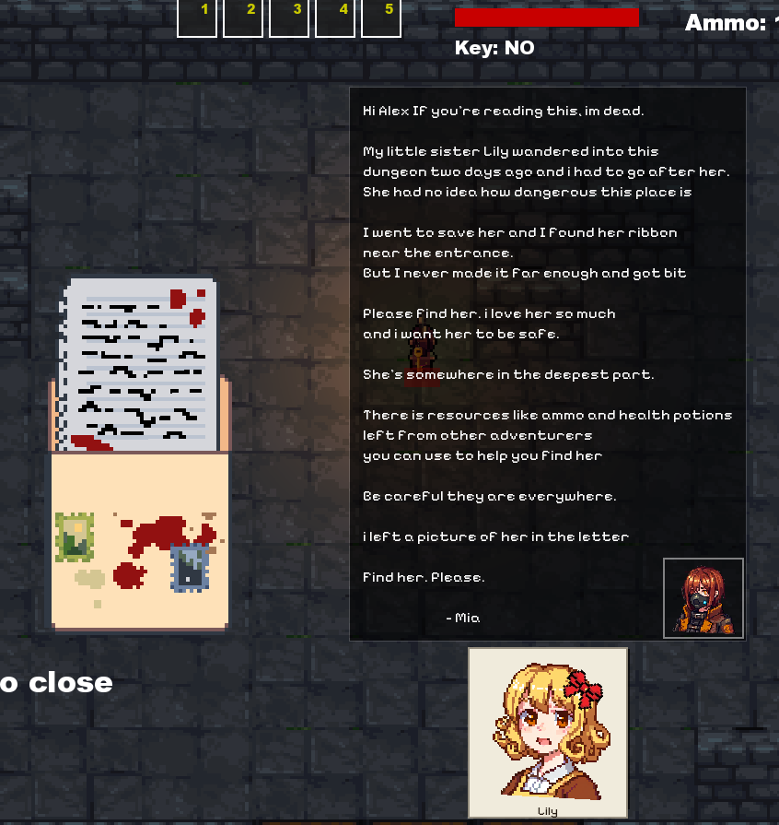

References

