

**Software Requirements Specification**

**for**

**EKG Using Cloud Services**

**Version 1.0**

**Prepared by**

Abdullah Alshamdayn

Justin Biggs

Joe Childress

Sai Monika Dasari

Stetson Bosecker

**Team 4**

**October 11, 2020**

***Copyright © 1999 by Karl E. Wiegers. Permission is granted to use, modify, and distribute this document.***

Table of Contents

Table of Contents 2

1. Introduction 5

1.1 Purpose 5

1.2 Document Conventions 5

1.3 Intended Audience and Reading Suggestions 5

1.4 Product Scope 5

1.5 References 5

2. Overall Description 7

2.1 Product Perspective 7

2.2 Product Functions 7

2.3 User Classes and Characteristics 7

2.4 Operating Environment 7

2.5 Design and Implementation Constraints 7

2.6 User Documentation 7

2.7 Assumptions and Dependencies 8

3. External Interface Requirements 8

3.1 User Interfaces 8

3.2 Hardware Interfaces 11

3.3 Software Interfaces 12

3.4 Communications Interfaces 12

4. Domain Model 13

5. System Features (Use Cases) 13

5.1 Login 13

5.2 Logout 14

5.3 Add User 15

5.4 Update User 16

5.5 Deactivate User 17

5.6 Password Reset 17

5.7 Get User 18

5.8 Get Users 19

5.9 Register EKG DAQ 20

5.10 Unregister EKG DAQ 21

5.11 Register EKG Tablet 22

5.12 Unregister EKG Tablet 22

5.13 Pair Tablet and DAQ 23

5.14 UnPair Tablet and DAQ 24

5.15 Register Patient 25

5.16 Update Patient 26

5.17 Discharge Patient 27

5.18 Delete Patient 28

5.19 Get Patients 29

5.20 Get Patient 30

5.21 Add EKG Order 31

5.22 View EKG Order 32

5.23 Update EKG Order 33

5.24 Cancel EKG Order 35

5.25 Get EKG Orders 36

5.26 Assign TabletDAQ Pair 37

5.27 Unassign TabletDAQ Pair 39

5.28 Begin EKG 40

5.29 Record EKG 41

5.30 Cancel EKG 42

5.31 Upload EKG 42

5.32 Add EKG To Order 43

5.33 View EKG 44

5.34 Get EKG Exams 45

5.35 Analyze EKG 46

6. Other Nonfunctional Requirements 48

6.1 Performance Requirements 48

6.2 Safety Requirements 48

6.3 Security Requirements 49

6.4 Software Quality Attributes 49

7. Other Requirements 49

Appendix A: Glossary 50

Appendix B: Analysis Models 50

Appendix C: To Be Determined List 50

**Revision History**

|  |  |  |  |
| --- | --- | --- | --- |
| **Name** | **Date** | **Reason For Changes** | **Version** |
|  |  |  |  |
|  |  |  |  |
| Team 4 | 10/11/2020 | First Draft | 1.0 |
|  |  |  |  |

# Introduction

## Purpose

The purpose of this document is to provide an informative description of the Electrocardiography Cloud Services. More precisely, an enhancement on the overall system. Further, this document shows both functional and non-functional requirements, as well as other requirements such as features, and the system interface.

## Document Conventions

This Document was created based on the IEEE template for System Requirement Specification Documents

## Intended Audience and Reading Suggestions

This SRS document is applicable to Developer, System Architect, System Tester, System Manager, and stakeholder.

The remaining sections of this document are organized in the following order, in Selection 2 an overall general description of the project is discussed. Section 3 provides external interface requirements that include user GUI, software, hardware, and communication interface. Section 4 gives the domain model. Whereat section 5 discusses system features, which include use cases and functional requirements. Finally, non-functional requirements are covered in section 6.

## Product Scope

This EKG Cloud Service system delivers an improvement over existing EKG systems. This system will facilitate the process of viewing and monitoring patient records by healthcare professionals. Furthermore, the system allows healthcare providers to deliver personal and reliable services towards patients’ overall experience. That encompasses advance alerts for critical changes in their EKG study, in conjunction with maintaining scalability, security, and accuracy. Also, to grant patients real-time access to their records. Thus, system administrator can implement any necessary modification.

## References

Hsieh, Jui-chen; Hsu, Meng-Wei; ‘BMC Medical Informatics and Decision Making’ <https://bmcmedinformdecismak.biomedcentral.com/articles/10.1186/1472-6947-12-77>

Nasiff Associates, Inc. ‘CardioCard EKG Module’

<https://nasiff.com/ecg_restingbt.html>

Amazon Web Services – Internet of Things Framework,

<https://aws.amazon.com/iot/>

Health and Human Services, ‘Summary of the HIPAA Privacy Rule’,

<https://www.hhs.gov/hipaa/for-professionals/privacy/laws-regulations/index.html>

# Overall Description

## Product Perspective

*<Describe the context and origin of the product being specified in this SRS. For example, state whether this product is a follow-on member of a product family, a replacement for certain existing systems, or a new, self-contained product. If the SRS defines a component of a larger system, relate the requirements of the larger system to the functionality of this software and identify interfaces between the two. A simple diagram that shows the major components of the overall system, subsystem interconnections, and external interfaces can be helpful.>*

## Product Functions

*<Summarize the major functions the product must perform or must let the user perform. Details will be provided in Section 4, so only a high level summary (such as a bullet list) is needed here. Organize the functions to make them understandable to any reader of the SRS. A picture of the major groups of related requirements and how they relate, such as a top level data flow diagram or object class diagram, is often effective.>*

## User Classes and Characteristics

*<Identify the various user classes that you anticipate will use this product. User classes may be differentiated based on frequency of use, subset of product functions used, technical expertise, security or privilege levels, educational level, or experience. Describe the pertinent characteristics of each user class. Certain requirements may pertain only to certain user classes. Distinguish the most important user classes for this product from those who are less important to satisfy.>*

## Operating Environment

*<Describe the environment in which the software will operate, including the hardware platform, operating system and versions, and any other software components or applications with which it must peacefully coexist.>*

## Design and Implementation Constraints

*<Describe any items or issues that will limit the options available to the developers. These might include: corporate or regulatory policies; hardware limitations (timing requirements, memory requirements); interfaces to other applications; specific technologies, tools, and databases to be used; parallel operations; language requirements; communications protocols; security considerations; design conventions or programming standards (for example, if the customer’s organization will be responsible for maintaining the delivered software).>*

## User Documentation

*<List the user documentation components (such as user manuals, on-line help, and tutorials) that will be delivered along with the software. Identify any known user documentation delivery formats or standards.>*

## Assumptions and Dependencies

*<List any assumed factors (as opposed to known facts) that could affect the requirements stated in the SRS. These could include third-party or commercial components that you plan to use, issues around the development or operating environment, or constraints. The project could be affected if these assumptions are incorrect, are not shared, or change. Also identify any dependencies the project has on external factors, such as software components that you intend to reuse from another project, unless they are already documented elsewhere (for example, in the vision and scope document or the project plan).>*

# External Interface Requirements

## User Interfaces

The following illustrations are mockups of the type of user interface that can be expected on the final product. There are three types of users for the system: patients, doctors/nurses and EKG specialists, and system administrators.

**Patient Interface**

The patient has the most limited amount of accessibility to the software. The patient is only responsible for attaching the EKG leads in the home setting and starting the data logging software on the tablet as shown in Fig. 3.1:

**Fig 3.1: Patient side tablet view. Note that inaccessible features are grey.**

**Doctors, Nurses and EKG Technicians**

Doctors, nurses, and EKG technicians can access the EKG system by mobile device or web browser. The user interface for these users are shown in figures 3.2, 3.3, 3.4, and 3.5.

**Figure 3.2: Login page for web users.**

**Figure 3.3: Patient directory page for web users.**

**Figure 3.4: Patient record view (web browser)**

**Figure 3.5: Patient record view (mobile)**

**System Managers**

System managers use the same log in screen to sign into the system management web portal. They are taken to the interface in figure 3.6:

**Figure 3.6: System Management Dashboard**

## Hardware Interfaces

Since this system is meant to complement medical equipment, an attempt has been made to incorporate as much existing hardware as possible to avoid lengthy approval processes by the FDA. As such, the EKG leads, and EKG Data Acquisition System (DAQ) use existing hardware. The DAQ chosen is the Nasiff CardioCard Mobile. It connects directly to the EKG leads and communicates wirelessly via Bluetooth to a tablet in the patient’s home. Figure 3.7 shows the EKG DAQ. It may also be connected via USB.

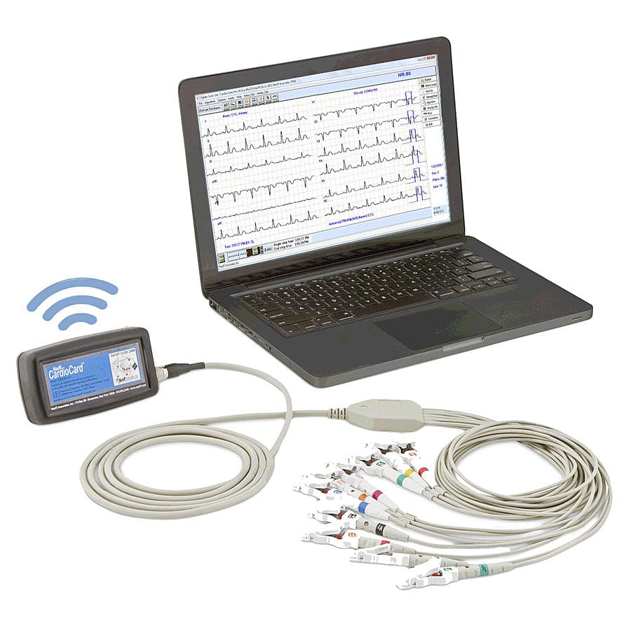

Figure 3.7

## Software Interfaces

The following is used as software interfaces:

* Amazon Web Services - Cloud Environment

Amazon Web Services has all of the tools necessary to implement this system across web browsers and mobile devices. Amazon RDS will be used as an SQL database. Amazon S3 File Storage is used to house EKG files for use by the core web service. The doctor’s mobile device interfaces directly with the core web service through an application. Otherwise, the core web service interfaces with the web portal for use with web browsers.

## Communications Interfaces

Communication interfaces to be used:

* Bluetooth
* USB
* HTTPS
* Wi-Fi
* Ethernet

Bluetooth or USB may be used to transfer the raw EKG data to the collection device. The collection device requires an internet connection. The data is then transferred via HTTPS to the Amazon Cloud service. Once in the cloud, the data can be accessed from a client device through HTTPS. The client device may be networked via ethernet or Wi-Fi.

# Domain Model

<Sometimes, this section is optional. However, it may be important to have it since domain model may give more useful as well>

# System Features (Use Cases)

## Login

### Name: Login

### Actor: Doctor, Nurse, EKG Technician, System Manager

### Goal: Authenticate user

### Input: Username, Password

### Output: Successful Login

### Main Scenario: Actor enters username and password and is provided access into the system if correct credentials are provided

### Pre-condition: Actor is not logged in

### Steps:

#### Step 1: Actor clicks Login command button

#### Step 2: Actor enters username and password

#### Step 3: Actor's credentials are verified and authorization into the system is granted. Actor is presented with the Main Page

### Post-condition: Actor is authenticated and granted access into the system

### Exception Scenario 1: Provided username and password combination are incorrect. A failed login message is displayed to the user.

### Diagram

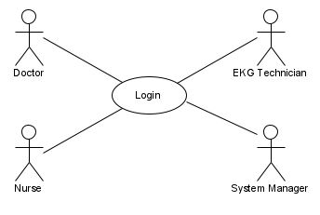

Figure 5.1: Login Use Case

## Logout

### Name: Logout

### Actor: Doctor, Nurse, EKG Technician, System Manager

### Goal: End authorized session

### Input: None

### Output: Successful Logout

### Main Scenario: Actor desires to end their session

### Pre-condition: Actor is actively logged in

### Steps:

#### Step 1: Actor clicks Logout command button

#### Step 2: Actor's session is terminated

#### Step 3: Login Page is presented

### Post-condition: None

### Exception Scenario 1: None

### Diagram

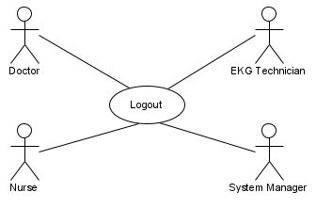

Figure 5.2: Logout Use Case

## Add User

### Name: Add User

### Actor: System Manager

### Goal: Add a new user to the system

### Input: Username, Firstname, Middlename, Lastname, Role, Email

### Output: New user added to system

### Main Scenario: Actor desires to create a new user account in the system and assign the new user to a role

### Pre-condition: New username does not already exist in the system

### Steps:

#### Step 1: Actor clicks on New User command button on User Management Page

#### Step 2: New user form is displayed

#### Step 3: Actor enters new user information into the form

#### Step 4: Actor clicks OK command button

### Post-condition: New user created

### Exception Scenario 1: New User already exists in the system. User already exists error message displayed to Actor.

### Diagram

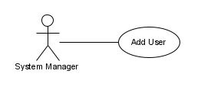

Figure 5.3: Add User Use Case

## Update User

### Name: Add User

### Actor: System Manager

### Goal: Update user's information

### Input: Selected User

### Output: User Information Updated

### Main Scenario: Actor desires to update information for a given user

### Pre-condition: User exists in the system

### Steps:

#### Step 1: Actor opens User Management Page

#### Step 2: Actor clicks checkbox next to desired User account

#### Step 3: User Details page is displayed

#### Step 4: Actor modifies user information as needed

#### Step 5: Actor click OK button to save changes

### Post-condition: User information updated

### Exception Scenario 1: Actor enters invalid information which results in validation errors being displayed

### Diagram

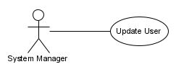

Figure 5.4: Update User Use Case

## Deactivate User

### Name: Deactivate User

### Actor: System Manager

### Goal: Deactivate a User account

### Input: Selected User

### Output: User Deactivated Confirmation

### Main Scenario: Actor desires to deactivate a user account

### Pre-condition: User account is active

### Steps:

#### Step 1: Actor opens User Management Page

#### Step 2: Actor clicks checkbox next to User account in User Account List

#### Step 3: Actor clicks Deactivate command button

### Post-condition: User account deactivated

### Exception Scenario 1: None

### Diagram

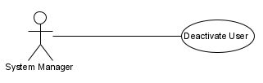

Figure 5.5: Deactivate User Use Case

## Password Reset

### Name: Password Reset

### Actor: Doctor, Nurse, EKG Technician, System Manager

### Goal: Allow actor to change their password

### Input: Username, Current Password

### Output: Password Changed

### Main Scenario: Actor desires to change their current password

### Pre-condition: Actor is currently authenticated

### Steps:

#### Step 1: Actor clicks Password Reset command button on Main Page

#### Step 2: Actor presented with prompt for current password as well as double-prompt to enter new password twice

#### Step 3: Actor clicks OK command button to apply new password

### Post-condition: None

### Exception Scenario 1: New password entered twice does not match. Actor is re-prompted to enter new password twice.

### Diagram

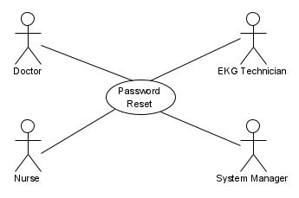

Figure 5.6: Password Reset Use Case

## Get User

### Name: Get User

### Actor: System Manager

### Goal: Retrieve details on specific user

### Input: Username, Userid

### Output: User Details Retrieved

### Main Scenario: Actor desires to view details for a specific user account

### Pre-condition: Actor is authorized to access User Management

### Steps:

#### Step 1: Actor clicks Details command button for desired user

#### Step 2: User Details page is displayed

### Post-condition: None

### Exception Scenario 1: None

### Diagram

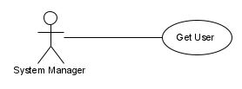

Figure 5.7: Get User Use Case

## Get Users

### Name: Get User

### Actor: System Manager

### Goal: Retrieve list of user accounts

### Input: None

### Output: User List Retrieved

### Main Scenario: Actor desires to view a listing of all user accounts

### Pre-condition: Actor is authorized to access User Management

### Steps:

#### Step 1: Actor is authorized to access User Management.

#### Step 2: User Listing Grid is displayed

### Post-condition: None

### Exception Scenario 1: None

### Diagram

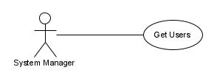

Figure 5.8: Get Users Use Case

## Register EKG DAQ

### Name: Register EKG DAQ

### Actor: System Manager

### Goal: Register a new EKG DAQ (by device id)

### Input: EKG DAQ QR Code

### Output: EKG DAQ Added Confirmation

### Main Scenario: Actor desires to add a new EKG DAQ into the DAQ inventory

### Pre-condition: EKG DAQ device id does not already exist in the inventory

### Steps:

#### Step 1: Actor clicks Register New DAQ command button on DAQ Management Page.

#### Step 2: Actor presented with New DAQ form

#### Step 3: Actor scans DAQ QR Code which inserts DAQ device id and other information in to form

#### Step 4: Actor clicks Add DAQ command button to register new DAQ

### Post-condition: EKG DAQ is registered

### Exception Scenario 1: EKG DAQ QR Code device id already exists in the system. AQ already exists message displayed to Actor.

### Diagram

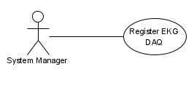

Figure .: Register EKG DAQ Use Case

## Unregister EKG DAQ

### Name: Unregister EKG DAQ

### Actor: System Manager

### Goal: Unregister an EKG DAQ (by device id)

### Input: EKG DAQ QR Code, EKG DAQ device id

### Output: EKG DAQ Unregistered Confirmation

### Main Scenario: Actor desires to unregister a EKG DAQ to retire it from the system

### Pre-condition: EKG DAQ device id exists in the system

### Steps:

#### Step 1: Actor click Unregister DAQ command button on DAQ Management Page.

#### Step 2: Unregister DAQ device id prompt displayed

#### Step 3: Actor scans DAQ QR Code or enters device id

#### Step 4: Actor clicks OK command button

### Post-condition: EKG DAQ is unregistered

### Exception Scenario 1: EKG DAQ QR Code device id does not exist in the system. DAQ not found message displayed to Actor.

### Diagram

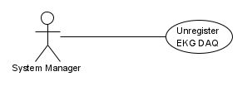

Figure 5.10: Unregister EKG DAQ Use Case

## Register EKG Tablet

### Name: Register EKG Tablet

### Actor: System Manager

### Goal: Register a new EKG Tablet (by device id)

### Input: EKG Tablet QR Code

### Output: EKG Tablet Registered Confirmation

### Main Scenario: Actor desires to add a new EKG Tablet into the Tablet inventory

### Pre-condition: EKG Tablet device id does not already exist in the inventory

### Steps:

#### Step 1: Actor clicks Register New Tablet command button on Tablet Management Page.

#### Step 2: Actor presented with New Tablet form

#### Step 3: Actor scans Tablet QR Code which inserts Tablet device id and other information into form

#### Step 4: Actor clicks Add Tablet command button to register new Tablet

### Post-condition: EKG Tablet is registered

### Exception Scenario 1: EKG Tablet QR Code device id already exists in the system. Tablet already exists message displayed to Actor.

### Diagram

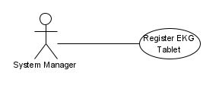

Figure 5.11: Register EKG Tablet Use Case

## Unregister EKG Tablet

### Name: Unregister EKG Tablet

### Actor: System Manager

### Goal: Unregister a new EKG Tablet (by device id)

### Input: EKG Tablet QR Code, EKG Tablet device id

### Output: EKG Tablet Unregistered Confirmation

### Main Scenario: Actor desires to unregister a EKG Tablet to retire it from the system

### Pre-condition: EKG Tablet device id exists in the system

### Steps:

#### Step 1: Actor click Unregister Tablet command button on Tablet Management Page

#### Step 2: Unregister Tablet device id prompt displayed

#### Step 3: Actor scans Tablet QR Code or enters device id

#### Step 4: Actor clicks OK command button

### Post-condition: EKG Tablet is unregistered

### Exception Scenario 1: EKG Tablet QR Code device id does not exist in the system. Tablet not found message displayed to Actor.

### Diagram

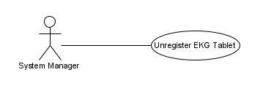

Figure 5.12: Unregister EKG Tablet Use Case

## Pair Tablet and DAQ

### Name: Pair Tablet and DAQ

### Actor: System Manager

### Goal: Pair a EKG Tablet with an EKG DAQ

### Input: EKG Tablet QR Code or EKG Tablet device id, and EKG DAQ QR Code or EKG DAQ device id

### Output: New EKG Tablet/EKG DAQ Pair Created

### Main Scenario: Actor desires to pair a specific EKG Tablet with a specific EKG DAQ

### Pre-condition: EKG Tablet device id and the EKG DAQ device id exists in the system and both are not currently a member of a pair

### Steps:

#### Step 1: Actor clicks Device Management command button to open the Device Management module

#### Step 2: Actor clicks Add Pair command button and New Pair form is displayed

#### Step 3: Actor scans the EKG Tablet QR Code and the EKG DAQ QR Code

#### Step 4: Actor clicks OK command button to save the new Pair

### Post-condition: New EKG Tablet/DAQ Pair Created

### Exception Scenario 1: If the EKG Tablet and or the EKG DAQ are currently members of another pair, an error message is displayed to the Actor. The error message will inform the Actor of the conflicting Pair details.

### Diagram

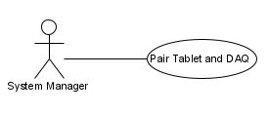

Figure 5.13: Pair Tablet and DAQ Use Case

## UnPair Tablet and DAQ

### Name: UnPair Tablet and DAQ

### Actor: System Manager

### Goal: UnPair a EKG Tablet with an EKG DAQ

### Input: EKG Tablet QR Code or EKG Tablet device id, or EKG DAQ QR Code or EKG DAQ device id

### Output: Existing EKG Tablet/EKG DAQ Pair Dissolved

### Main Scenario: Actor desires to unpair a specific EKG Tablet or a specific EKG DAQ

### Pre-condition: EKG Tablet device id or the EKG DAQ device id is currently a member of a pair

### Steps:

#### Step 1: Actor clicks Device Management command button to open the Device Management module

#### Step 2: Actor clicks UnPair command button and a Pair Details form is displayed

#### Step 3: Actor scans the EKG Tablet QR Code or the EKG DAQ QR Code, and then displays the Pair member EKG Tablet and EKG DAQ details.

#### Step 4: Actor checks the Dissolve checkbox on the Pair Details page.

#### Step 5: Actor clicks OK command button to OK command button to dissolve the Pair, and is presented with a Dissolve confirmation dialog

#### Step 6: Actor clicks OK command button on the confirmation dialog to dissolve the pair

### Post-condition: Selected EKG Tablet/DAQ Pair Dissolved

### Exception Scenario 1: If the EKG Tablet/DAQ Pair is currently assigned to a patient, an error message is displayed to the Actor. The error message will display the current Pair details including the patient and EKG order to which the Pair is currently assigned.

### Diagram

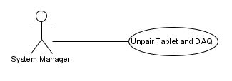

Figure 5.14: Unpair Tablet and DAQ Use Case

## Register Patient

### Name: Register Patient

### Actor: Doctor, Nurse, EKG Technician, System Manager

### Goal: Register a Patient

### Input: medical record number, firstname, middlename, last name, dob, gender, ssn, phone, email, primary care physician

### Output: Patient Registration Created

### Main Scenario: Actor desires to register a patient in preparation for potential future EKG orders

### Pre-condition: Patient is not already registered

### Steps:

#### Step 1: Actor click Register command button on Patient Management page.

#### Step 2: New Registration form is displayed

#### Step 3: Actor completes patient demographics form

#### Step 4: Actor clicks OK command button to save the new registration

### Post-condition: Patient Registered

### Exception Scenario 1: If patient is already registered, error message is displayed stating the patient is already registered.

### Diagram

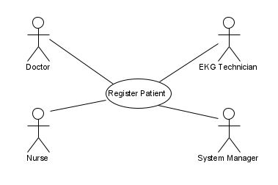

Figure 5.15: Register Patient Use Case

## Update Patient

### Name: Update Patient

### Actor: Doctor, Nurse, EKG Technician, System Manager

### Goal: Update patient information

### Input: Selected Patient

### Output: Patient Information Updated

### Main Scenario: Actor desires to update information for a given patient

### Pre-condition: Patient exists in the system

### Steps:

#### Step 1: Actor opens Patient Management Page

#### Step 2: Actor clicks checkbox next to desired Patient

#### Step 3: Patient Details page is displayed

#### Step 4: Actor modifies patient information as needed

#### Step 5: Actor click OK button to save changes

### Post-condition: Patient information updated

### Exception Scenario 1: Actor enters invalid information which results in validation errors being displayed

### Diagram

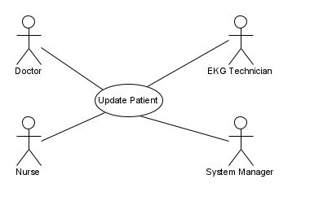

Figure 5.16: Update Patient Use Case

## Discharge Patient

### Name: Discharge Patient

### Actor: Doctor, Nurse, EKG Technician, System Manager

### Goal: Update patient information

### Input: Selected Patient

### Output: Patient is Discharged

### Main Scenario: Actor desires to discharge a given patient

### Pre-condition: Patient exists in the system and is currently registered as well as having no open EKG Orders

### Steps:

#### Step 1: Actor opens Patient Management Page

#### Step 2: Actor clicks Details next to desired Patient

#### Step 3: Patient Details page is displayed

#### Step 4: Actor selects Discharge option in Status DropDownList

#### Step 5: Actor click OK button to save changes

### Post-condition: Patient is Discharged

### Exception Scenario 1: None

### Diagram

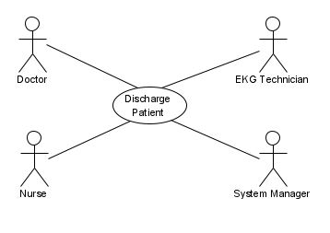

Figure 5.17: Discharge Patient Use Case

## Delete Patient

### Name: Delete Patient

### Actor: Doctor, Nurse, EKG Technician, System Manager

### Goal: Delete a Patient

### Input: Selected Patient

### Output: Patient is Deleted

### Main Scenario: Actor desires to delete a patient record from the system

### Pre-condition: Patient exists in the system and has no existing EKG Order History in the system

### Steps:

#### Step 1: Actor opens Patient Management Page

#### Step 2: Actor clicks Delete link next to the desired patient to be deleted

#### Step 3: Actor is presented with a Confirmation dialog

#### Step 4: Actor clicks YES checkbox and then clicks OK command button

### Post-condition: Patient is Deleted

### Exception Scenario 1: None

### Diagram

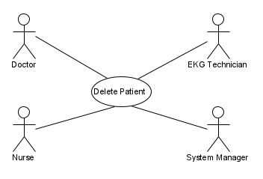

Figure 5.18: Delete Patient Use Case

## Get Patients

### Name: Get Patients

### Actor: Doctor, Nurse, EKG Technician, System Manager

### Goal: Get Collection of Patients

### Input: medical record number, firstname, middlename, last name

### Output: Matching Patient Results Displayed

### Main Scenario: Actor desires to search for patients

### Pre-condition: Actor is authorized to access Patient Management

### Steps:

#### Step 1: Actor click Patient Search command button on Main Menu

#### Step 2: Search text boxes are displayed for MRN and Patient Last, Middle, and First

#### Step 3: Actor enters search criteria and clicks Search command button

#### Step 4: Matching results are displayed in a grid

### Post-condition: None

### Exception Scenario 1: No Match Found for specified search criteria. Actor is presented with No Results Found error message. If Number of Results is beyond result limit, eror message is displayed with the result count and the Actor is advised to specify additional search criteria to narrow the search

### Diagram

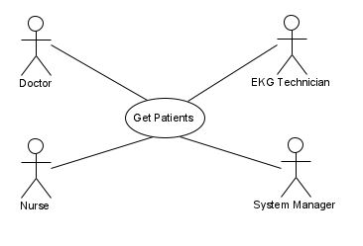

Figure 5.19: Get Patients Use Case

## Get Patient

### Name: Get Patient

### Actor: Doctor, Nurse, EKG Technician, System Manager

### Goal: Get a Specific Patient

### Input: Selected Patient

### Output: Patient is Displayed

### Main Scenario: Actor desires to retrieve a certain patient record

### Pre-condition: Actor is authorized to access Patient Management

### Steps:

#### Step 1: Actor selects a specific patient record

#### Step 2: Actor is presented with the patient record details

### Post-condition: None

### Exception Scenario 1: None

### Diagram

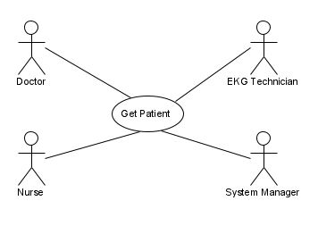

Figure 5.20: Get Patient Use Case

## Add EKG Order

### Name: Add EKG Order

### Actor: Doctor, Nurse, EKG Technician, System Manager

### Goal: Add an EKG Order

### Input: patient MRN, Ordering MD

### Output: New EKG Order Added

### Main Scenario: Actor desires to enter a new EKG order on a patient

### Pre-condition: Actor is authorized to add an EKG order, and patient is registered in the system

### Steps:

#### Step 1: Actor click Patient Search command button on Order Management page

#### Step 2: Search text boxes are displayed for MRN and Patient Last, Middle, and First

#### Step 3: Actor enters search criteria and clicks Search command button

#### Step 4: Matching results are displayed in a grid

#### Step 5: Actor selects the desired patient and clicks Details link on the row of the desired patient

#### Step 6: Patient Details page is displayed showing patient demographics as well as a list of existing EKG orders for the patient.

#### Step 7: Actor clicks New Order command button

#### Step 8: New EKG Order page is displayed

#### Step 9: Actor completed new EKG order form

#### Step 10: Actor clicks Save command button to save the new EKG Order

### Post-condition: New EKG Order is Created

### Exception Scenario 1: If patient does not exist in system, Actor must Add New Patient record first.

### Diagram

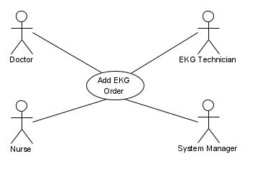

Figure 5.21: Add EKG Order Use Case

## View EKG Order

### Name: View EKG Order

### Actor: Doctor, Nurse, EKG Technician, System Manager

### Goal: View an EKG Order

### Input: orderId

### Output: EKG Order Details Displayed

### Main Scenario: Actor desires to view details of an EKG order

### Pre-condition: Actor is authorized to view an EKG order

### Steps:

#### Step 1: Actor opens either Patient Management or Order Management

#### Step 2: Search text boxes are displayed for MRN, Patient Last, Middle, and First

#### Step 3: Actor enters search criteria and clicks Search command button

#### Step 4: Matching results are displayed in a grid

#### Step 5: Actor selects the desired EKG order and clicks Details link on the row of the desired patient

#### Step 6: Patient Details page is displayed showing patient and EKG order details

### Post-condition: None

### Exception Scenario 1: None

### Diagram

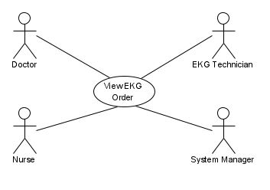

Figure 5.22: View EKG Order Use Case

## Update EKG Order

### Name: Update EKG Order

### Actor: Doctor, Nurse, EKG Technician, System Manager

### Goal: Update an EKG Order

### Input: orderId

### Output: EKG Order information updated

### Main Scenario: Actor desires to modify information for an EKG order

### Pre-condition: Actor is authorized to update an EKG order

### Steps:

#### Step 1: Actor opens either Patient Management or Order Management

#### Step 2: Search text boxes are displayed for MRN, Patient Last, Middle, and First

#### Step 3: Actor enters search criteria and clicks Search command button

#### Step 4: Matching results are displayed in a grid

#### Step 5: Actor selects the desired EKG order and clicks Details link on the row of the desired patient

#### Step 6: Patient Details page is displayed showing patient and EKG order details

#### Step 7: Actor clicks Edit command button to display Order Edit page

#### Step 8: Actor modifies the desired information

#### Step 9: Actor clicks Save command button

### Post-condition: EKG Order is updated

### Exception Scenario 1: If Actor enters invalid information into the various fields in the EKG Order edit form, error messages are displayed outlining the invalid information

### Diagram

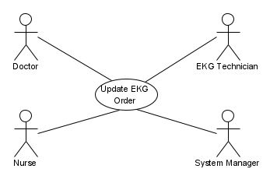

Figure 5.23: Update EKG Order Use Case

## Cancel EKG Order

### Name: Cancel EKG Order

### Actor: Doctor, Nurse, EKG Technician, System Manager

### Goal: Cancel an EKG Order

### Input: orderId

### Output: EKG Order cancelled

### Main Scenario: Actor desires to cancel an EKG order

### Pre-condition: Actor is authorized to cancel an EKG order

### Steps:

#### Step 1: Actor opens either Patient Management or Order Management

#### Step 2: Search text boxes are displayed for MRN, Patient Last, Middle, and First

#### Step 3: Actor enters search criteria and clicks Search command button

#### Step 4: Matching results are displayed in a grid

#### Step 5: Actor selects the desired EKG order and clicks Details link on the row of the desired patient

#### Step 6: EKG Order Details page is displayed showing patient and EKG order details

#### Step 7: Actor clicks Cancel command button

#### Step 8: Actor is asked to confirm Order cancellation in a pop-up dialog

#### Step 9: Actor checks YES checkbox and CANCEL command button on Confirmation dialog

### Post-condition: EKG Order is cancelled

### Exception Scenario 1: None

### Diagram

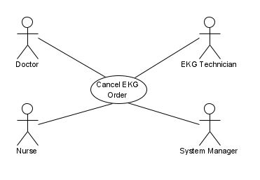

Figure 5.24: Cancel EKG Order Use Case

## Get EKG Orders

### Name: Get EKG Orders

### Actor: Doctor, Nurse, EKG Technician, System Manager

### Goal: Get Collection of EKG Orders

### Input: medical record number, firstname, middlename, last name, order daterange, orderingmd, orderid

### Output: Matching EKG Orders Results Displayed

### Main Scenario: Actor desires to search for EKG orders

### Pre-condition: Actor is authorized to access Orders

### Steps:

#### Step 1: Actor click Order Search command button on Main Menu

#### Step 2: Search text boxes are displayed for MRN and Patient Last, Middle, and First, order daterange, orderingmd, orderid

#### Step 3: Actor enters search criteria and clicks Search command button

#### Step 4: Matching results are displayed in a grid

### Post-condition: None

### Exception Scenario 1: No Match Found for specified search criteria. Actor is presented with No Results Found error message. If Number of Results is beyond result limit, error message is displayed with the result count and the Actor is advised to specify additional search criteria to narrow the search

### Diagram

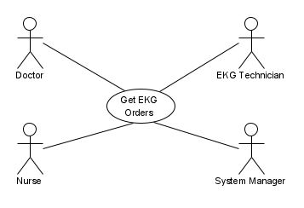

Figure 5.25: Get EKG Orders Use Case

## Assign TabletDAQ Pair

### Name: Assign TabletDAQ Pair

### Actor: Nurse, EKG Technician, System Manager

### Goal: Assign a TabletDAQ Pair to an EKG Order

### Input: pairId, orderId

### Output: TabletDAQ Pair Assigned to specific EKG Order

### Main Scenario: Actor desires to assign a TabletDAQ Pair to a patient's EKG order

### Pre-condition: Actor is authorized to assign TabletDAQ Pair to an existing EKG Order.

### Steps:

#### Step 1: Actor clicks Order Management

#### Step 2: Actor clicks Order Search

#### Step 3: Search text boxes are displayed for MRN and Patient Last, Middle, First, Order Daterange, Order Status

#### Step 4: Actor clicks Details link next to desired Order

#### Step 5: On EKG Order Details page, Actor clicks Assign HW command button

#### Step 6: Actor is presented with list of unassigned, available TabletDAQ Pairs

#### Step 7: Actor scans EKG Tablet and EKG DAQ QR Codes to Assign Pair to Order

### Post-condition: TabletDAQ Pair assigned to specific EKG Order

### Exception Scenario 1: If Tablet and/or DAQ scanned are already assigned to an open EKG Order or are on maintenance list, display error dialog to Actor stating Scanned Pair Cannot be Assigned and Why

### Diagram

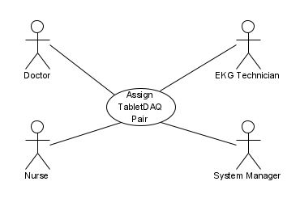

Figure 5.26: Assign TabletDAQ Pair Use Case

## Unassign TabletDAQ Pair

### Name: Unassign TabletDAQ Pair

### Actor: Nurse, EKG Technician, System Manager

### Goal: UnAssign a TabletDAQ Pair from an EKG Order

### Input: pairId, orderId

### Output: TabletDAQ Pair UnAssigned from specific EKG Order

### Main Scenario: Actor desires to unassign a TabletDAQ Pair from currently assigned EKG order

### Pre-condition: Actor is authorized to unassign TabletDAQ Pair from an existing EKG Order

### Steps:

#### Step 1: Actor clicks Device Management

#### Step 2: Actor clicks Unassign HW command button

#### Step 3: Actor is prompted to Scan device QR Code

#### Step 4: Actor is presented with Device Details of the scanned Tablet and/or DAQ including active pairings and EKG Order assignment history

#### Step 5: Actor clicks Unassign Pair command button

#### Step 6: Actor is presented with Confirmation dialog and clicks OK to confirm removal from assignment to EKG Order

### Post-condition: TabletDAQ Pair unassigned from EKG Order

### Exception Scenario 1: If Tablet and/or DAQ scanned is currently assigned to open EKG Order, display error dialog to Actor stating Scanned Pair is assigned to an open EKG order

### Diagram

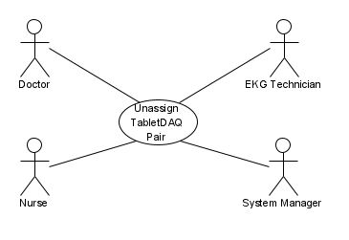

Figure 5.27: Unassign TabletDAQ Pair Use Case

## Begin EKG

### Name: Begin EKG

### Actor: Patient

### Goal: Prepare Patient for EKG Exam

### Input: None

### Output: Tutorial Video to demonstrate to Patient/Caregiver how to properly connect EKG leads to patient and how to perform the EKG exam

### Main Scenario: Actor desires to begin the EKG Exam procedure

### Pre-condition: None

### Steps:

#### Step 1: Actor unboxes EKG Home Kit containing EKG Tablet, EKG DAQ, EKG leads, EKG electrodes, and Quick Setup Guide guide

#### Step 2: Actor turns on Tablet and DAQ

#### Step 3: Actor presses Start button on Tablet home screen

#### Step 4: Actor watches Video Tutorial to properly connect EKG leads

### Post-condition: None

### Exception Scenario 1: None

### Diagram

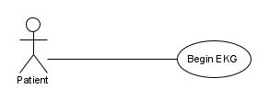

Figure 5.28: Begin EKG Use Case

## Record EKG

### Name: Record EKG

### Actor: Patient

### Goal: Record EKG Data

### Input: None

### Output: Captured EKG Signals displayed on Tablet screen and saved into EKG data file in Tablet RAM

### Main Scenario: Actor desires to being recording their EKG exam

### Pre-condition: Tablet has Bluetooth/USB confirmed connectivity to EKG DAQ, internet connectivity to EKG Cloud Service, and EKG signal integrity status from DAQ

### Steps:

#### Step 1: Actor presses Record EKG button on Tablet

#### Step 2: Tablet sends StartCapture command to DAQ

#### Step 3: Tablet receives digital EKG data from DAQ

### Post-condition: EKG Data Recorded

### Exception Scenario 1: If any Pre-condition tests fail, Actor is presented with suggest of next steps to resolve failed pre-condition test

### Diagram

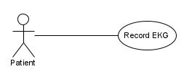

Figure 5.29: Record EKG Use Case

## Cancel EKG

### Name: Cancel EKG

### Actor: Patient

### Goal: Cancel EKG Recording

### Input: None

### Output: Active EKG Recording is Stopped. Tablet Home Screen displayed.

### Main Scenario: Actor desires to abort the current EKG Recording

### Pre-condition: EKG Recording is running

### Steps:

#### Step 1: Actor presses Cancel EKG button on Tablet

#### Step 2: Actor redirected to Tablet Home Screen

### Post-condition: EKG Recording Cancelled

### Exception Scenario 1: None

### Diagram

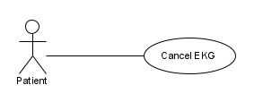

Figure 5.30: Cancel EKG Use Case

## Upload EKG

### Name: Upload EKG

### Actor: Patient

### Goal: Upload Recorded EKG data to EKG Cloud Service

### Input: None

### Output: EKG Recorded data uploaded to EKG Cloud Service

### Main Scenario: Actor desires to uploaded EKG Recording to EKG Cloud Service for analysis

### Pre-condition: Valid EKG Data File recorded by Tablet

### Steps:

#### Step 1: Actor is presented with a dialog on Tablet that states when sufficient EKG data has been recorded

#### Step 2: Actor is prompted to upload the EKG data file to the cloud

#### Step 3: Actor presses Upload button to approve the Data Upload

### Post-condition: EKG Data Uploaded

### Exception Scenario 1: If Upload fails, Actor is presented with an error message and prompted to retry the Upload or Cancel Upload.

### Diagram

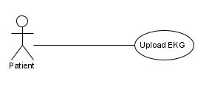

Figure 5.31: Upload EKG Use Case

## Add EKG To Order

### Name: Add EKG To Order

### Actor: EKG Web Service

### Goal: Save Uploaded EKG Data to Database and File System

### Input: EKG Data File, orderId

### Output: EKG Data Added to correct EKG Order

### Main Scenario: Actor desires to save the newly EKG data to the proper EKG Order, and in turn, proper Patient in system

### Pre-condition: EKG Data File validated and matched to valid existing EKG order

### Steps:

#### Step 1: Actor parses EKG data file to obtain associated orderId

#### Step 2: Actor adds relevant EKG metadata to SQL database relating EKG exam to correct EKG Order.

#### Step 3: EKG Data File stored on File Storage and checksum performed

### Post-condition: EKG Exam Created, related EKG Order Updated, and uploaded EKG Data Saved

### Exception Scenario 1: If no matching EKG Order found by Actor, the received EKG Exam Data is placed into a Mismatched List for Human Reconciliation

### Diagram

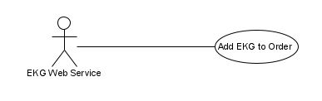

Figure 5.32: Add EKG to Order Use Case

## View EKG

### Name: View EKG

### Actor: Doctor, Nurse, EKG Technician, System Manager

### Goal: Provide Actor with ability to View Recorded EKG Data

### Input: examId, orderId

### Output: EKG Exam Data Displayed

### Main Scenario: Actor desires to View Recorded EKG Exam data

### Pre-condition: Actor is authorized to View EKG Exams and desired EKG Exam exists in system

### Steps:

#### Step 1: Actor opens either Patient Management or Order Management

#### Step 2: Search text boxes are displayed for MRN, Patient Last, Middle, and First

#### Step 3: Actor enters search criteria and clicks Search command button

#### Step 4: Matching results are displayed in a grid

#### Step 5: Actor selects the desired EKG order and clicks Details link on the row of the desired patient

#### Step 6: Patient Details page is displayed showing patient and EKG order details

#### Step 7: Recorded EKG Exams associated with the current Order are displayed in a results listing

#### Step 8: Actor selects the EKG Exam desired for viewing

#### Step 9: EKG 12-lead signal data is "played"

### Post-condition: None

### Exception Scenario 1: If there are no upload EKG Recordings for the selected EKG Order, a message show there are no EKG Recordings for this Order is displayed to the Actor.

### Diagram

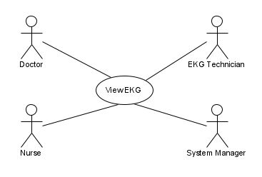

Figure 5.33: View EKG Use Case

## Get EKG Exams

### Name: Get EKG Exams

### Actor: Doctor, Nurse, EKG Technician, System Manager

### Goal: Get Collections to Available EKG Exams

### Input: medical record number, firstname, middlename, last name, order daterange, orderingmd, orderid

### Output: Matching EKG Orders Retrieved

### Main Scenario: Actor desires to search for EKG orders with EKG exams

### Pre-condition: Actor is authorized to access Orders

### Steps:

#### Step 1: Actor click Order Search command button on Main Menu

#### Step 2: Search text boxes are displayed for MRN and Patient Last, Middle, and First, order daterange, orderingmd, orderid

#### Step 3: Actor enters search criteria and clicks Search command button

#### Step 4: Matching Orders that contain EKG Exams are displayed in a grid

### Post-condition: None

### Exception Scenario 1: No Match Found for specified search criteria. Actor is presented with No Results Found error message.

### Diagram

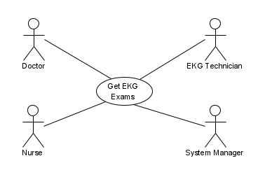

Figure 5.34: Get EKG Exams Use Case

## Analyze EKG

### Name: Analyze EKG

### Actor: Doctor, Nurse, EKG Technician, System Manager

### Goal: Analyze Performed EKG Exam Data

### Input: examId

### Output: Analysis Report of EKG Recorded data

### Main Scenario: Actor desires to generate a report from an automated analysis of the EKG data

### Pre-condition: Actor is authorized to access Orders, and a valid EKG data file exists for the specified EKG exam

### Steps:

#### Step 1: Actor opens either Patient Management or Order Management

#### Step 2: Search text boxes are displayed for MRN, Patient Last, Middle, and First

#### Step 3: Actor enters search criteria and clicks Search command button

#### Step 4: Matching results are displayed in a grid

#### Step 5: Actor selects the desired EKG order and clicks Details link on the row of the desired patient

#### Step 6: Patient Details page is displayed showing patient and EKG order details

#### Step 7: Recorded EKG Exams associated with the current Order are displayed in a results listing

#### Step 8: Actor selects the EKG Exam desired for viewing

#### Step 9: EKG 12-lead signal data is made available to "play"

#### Step 10: Actor clicks Analyze command button

#### Step 11: An EKG Analysis Report is displayed

### Post-condition: EKG Report Generated

### Exception Scenario 1: If there are no upload EKG Recordings for the selected EKG Order, a message show there are no EKG Recordings for this Order is displayed to the Actor.

### Diagram

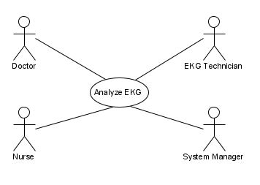

Figure 5.35: Analyze EKG Use Case

# Other Nonfunctional Requirements

## Performance Requirements

* Due to the significant and pressing nature of many electrocardiogram results, the EKG cloud service should be available to all users at all times. That is, the cloud service should be accessible at all hours of the day, every day of the week, and every week of the year.
* EKG data input stream will be limited by the user’s internet connection/speed. Once the data is in the file storage, however, the maximum response time for accessing the data files should be 5 seconds in order to better facilitate rapid responses from the medical team(s).
* The file storage will be replicated over multiple independent cloud servers to decrease the risk of failure. If a failure occurs on the initial file storage server, the database will point to a different server in order to keep the data transaction seamless.
* Uptime and downtime for the system will be continuously evaluated so that necessary maintenance operations will occurs during times that have the least probability for negatively impacting users.

## Safety Requirements

* The SQL database will simply store pointers to files in the Amazon S3 file storage. This will increase speed of database requests and insure that the database is not capable of modifying or interfering with the EKG data.
* EKG data will not be allowed to be deleted, and will instead be archived on the user side.
* The system will maintain log files which will allow data recovery and allow system admins to recognize points of failure in order to communicate inefficiencies with the development team.
* Database restore points will be created frequently in order to allow the database to rollback to a previous state.

## Security Requirements

* Users (patients and/or medical staff) will not have direct access to the Amazon RDS database or the Amazon S3 file storage. Only authorized members of the software development team will have access to these.
* Users will have unique IDs, and their passwords will be required to be at least 8 characters long, case sensitive, and include letters, numbers, and symbols.
* Accounts for medical staff will be generated and confirmed by the clinics/hospitals/etc. using the software in order to ensure that only authorized medical staff are able to access the software. Additionally, the respective medical facilities will be responsible for determining which nurses or attendants belong to a specific doctor’s team.
* Doctors will be required to verify patients as users before patients are allowed to submit data. Likewise, patients will be required to confirm that they are sending data to the correct doctor. This is an extra precaution to insure that patient data is not erroneously sent to unintended users.
* Doctors will confirm the privileges allowed for each member of their team.
* Database encryption will be employed as an additional precaution against data interception.

## Software Quality Attributes

* Adaptability: This is a measure of the software’s ability to adapt to changes in its environment. By using our database to point to files, we allow more efficient options to be easily interchanged in the future.
* Availability: This is a measure of the system’s ability to be accessed when needed. Scheduling maintenance during calculated downtimes allows the software’s unavailability to be limited and impact the fewest users.
* Portability: This is a measure of the software’s ability to be used within multiple environments. By providing a web portal, we allow the software to largely be impartial in regards to operation on user devices.
* Reliability: This is a measure of the system’s ability to be error-free over a given period of time. The replication of our file storage allows for quick recovery options if a file storage server fails.
* Usability: This is a measure of the software’s ability to be efficiently and effectively used by users. The high availability, portability, and reliability of our system combined with a simple user interface helps to insure a positive user experience that is characterized by ease of use.

# Other Requirements

*<Define any other requirements not covered elsewhere in the SRS. This might include database requirements, internationalization requirements, legal requirements, reuse objectives for the project, and so on. Add any new sections that are pertinent to the project.>*

Appendix A: Glossary

*<Define all the terms necessary to properly interpret the SRS, including acronyms and abbreviations. You may wish to build a separate glossary that spans multiple projects or the entire organization, and just include terms specific to a single project in each SRS.>*

Appendix B: Analysis Models

*<Optionally, include any pertinent analysis models, such as data flow diagrams, class diagrams, state-transition diagrams, or entity-relationship diagrams*.>

Appendix C: To Be Determined List

*<Collect a numbered list of the TBD (to be determined) references that remain in the SRS so they can be tracked to closure.>*