RELATING TO PUBLIC PARKS.

BE IT ORDAINED by the People of the City and County of Honolulu:

SECTION 1. Purpose. The purpose of this ordinance is to define camping.

SECTION 2. Section 10-1.1, Revised Ordinances of Honolulu 1990, as amended, is further amended to read as follows:

“**Sec. 10-1.1Definitions.**

“Camp” or “camping” means the use and occupation of a public park as a temporary or permanent dwelling place or sleeping place between the hours of 10:00 p.m. and 5:00 a.m.

“Dwelling place” means a place used for human habitation as an overnight accommodation, lodging, or shelter on either a temporary or permanent basis.

“Human habitation” means the act of utilizing, occupying, or inhabiting a place of lodging or shelter on a permanent or temporary basis as a place of residence or sojourn.

“Off-leash park” means a public park designated by the director of parks and recreation where dogs, and no other animal, shall be allowed to be off-leash.

“Public park” means any park, park roadway, playground, athletic field, beach, beach right-of-way, tennis court, golf course, swimming pool, or other recreation area or facility under the control, maintenance and management of the department of parks and recreation. “Public park” does not include a public thoroughfare defined as a “mall” under Section 29-1.1 unless the public thoroughfare has been (1) accepted, dedicated, or named by the council expressly as a “public park” or “park”; (2) placed under the control, maintenance, and management of and classified expressly as a “public park” or “park” by the department of parks and recreation; or (3) constructed or situated within a larger specific recreation area or facility listed in the preceding sentence.

“Sleeping place” means a place used by a person for the purpose of sleeping, where the person is asleep inside a tent, sleeping bag, or some form of temporary shelter or is asleep atop of or covered by materials such as a cot, mat, bedroll, bedding, sheet, blanket, pillow, bag, cardboard, or newspapers.”

SECTION 3. New ordinance material is underscored. When revising, compiling or printing this ordinance for inclusion in the Revised Ordinances of Honolulu, the revisor of ordinances need not include the underscoring.

SECTION 4. This ordinance shall take effect upon approval.

INTRODUCED BY:

Barbara Marshall (BR)

DATE OF INTRODUCTION:

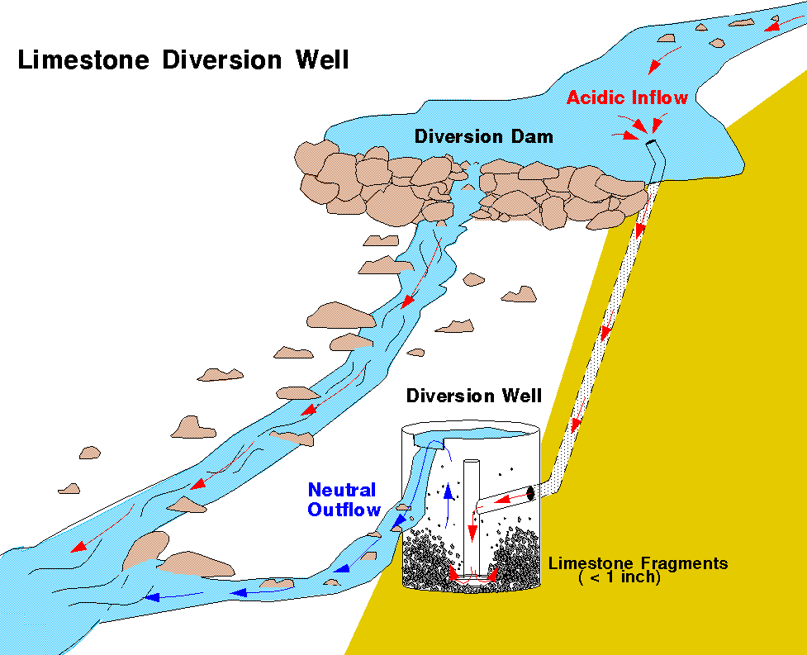

May 23, 2008

Honolulu, Hawaii Councilmembers

APPROVED AS TO FORM AND LEGALITY:

Deputy Corporation Counsel

APPROVED this day of , 20___.

MUFI HANNEMANN, Mayor

City and County of Honolulu