**Disorder-Induced Resistive Anomaly Near Ferromagnetic Phase Transitions\***

*Felix von Oppen*

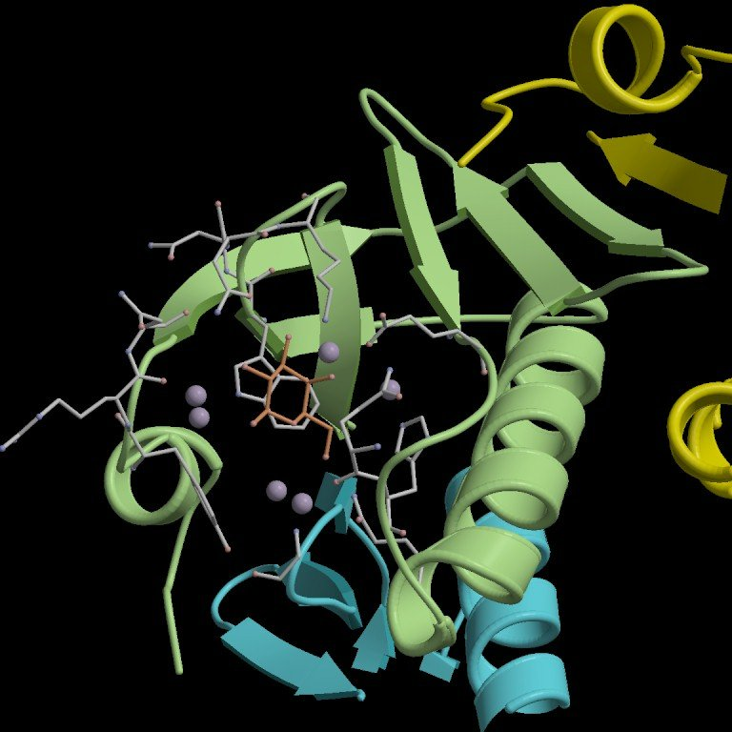

*Freie Universitat Berlin*

We show that the resistivity *ρ(T)* of disordered ferromagnets near, and above, the Curie temperature Tc generically exhibits a stronger anomaly than the scaling-based Fisher-Langer prediction. Treating transport beyond the Boltzmann description, we find that within mean-field theory, *dρ/dT* exhibits a |*T-Tc*|-1/2 singularity near *Tc*. Our results, being solely due to impurities, are relevant to ferromagnets with low *Tc*, such as SrRuO3 or diluted magnetic semiconductors, whose mobility near *Tc* is limited by disorder.

*Carsten Timm, M. E. Raikh, Felix von Oppen, Phys. Rev. Lett. **94**, 036602 (2005).