-----Original Message-----

From: Linda Mennitt [mailto:felix.com@verizon.net]

Sent: Monday, March 14, 2005 11:08 PM

To: comments

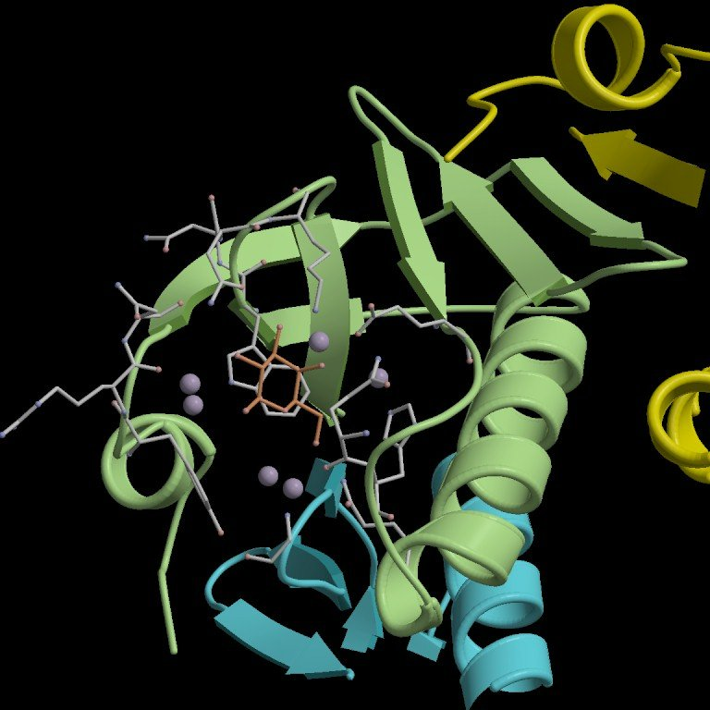

Subject: fair tax for all

Adverse Tax Consequences for Same-Sex Couples

1.Health Insurance for Partners - A Taxing Proposition: Employees pay

income and payroll tax on the health insurance premiums their employers provide for domestic partners who do not otherwise qualify as dependents. Benefits for different-sex spouses are not subject to this tax.

2.Flexible Spending Accounts Not So Flexible: Employees can use

flexible spending accounts to pay for a different-sex spouse's medical expenses, including eyeglasses, prescriptions, and co-pays, on a pre-tax basis. These accounts cannot be used for a same-sex partner, or even a same-sex spouse.

3.Retirement Savings - Death and Taxes: Tax treatment of retirement

savings, such as those found in 401(k) plans, privileges spouses and penalizes same-sex couples. This means that on the death of a partner, the surviving partner is left not only with the same emotional loss that a different-sex spouse experiences, but also with an unfair tax bill. This is problem is made even more acute by the fact that same-sex couples are denied survivors' benefits under Social Security, even though they pay the same payroll taxes as heterosexual workers.

4.Estate and Gift Taxes - Strangers Under the Law: Different-sex

spouses get a complete exemption from estate and gift taxes. But same-sex partners, even ones who are married in Massachusetts or parties to civil unions in Vermont, are treated as strangers under the tax code. So when a partner dies, their estate is subject to taxation.

Social Security - Adverse Consequences for Same-Sex Couples

1.Equal Contribution, Unequal Benefits: All GLBT people pay into

Social Security on an equal basis with their heterosexual counterparts, but are not eligible for equal benefits.

2.No Survivors' Benefits: Same-sex partners do not receive survivors'

benefits when a partner dies, even though they pay for them equally.

3.No Disability Benefits: Same-sex partners are not eligible for

spouse's benefits when a partner becomes disabled, even though they pay equally into the program.

4.Children Are Left Unprotected: Sixty percent of children being

raised by same-sex couples live in a jurisdiction where second-parent adoption is unavailable, meaning that these children cannot secure a recognized legal relationship with one of their parents. When a parent dies without such a legal relationship, the surviving child is not eligible for surviving child benefits under Social Security, even though the deceased parent paid into the program, and even if the parent supported the child for her whole life.

5.Even When a Child is Legally Adopted by Same-Sex Partner, Benefits

are STILL Unavailable: Social Security provides "surviving parent" benefits to the parent caring for a minor child when the other parent dies. But all children raised by same-sex couples are excluded from this benefit, even though their parents pay equally into Social Security, because it is only given to couples who are recognized as "spouses" under federal law, which same-sex couples are not. Even though the benefit is for children and not spouses, children being raised by GLBT people are denied it because their parents cannot marry.