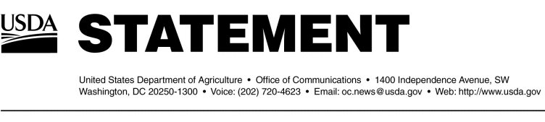

Release No. 0048.04Office of Communications (202) 720-4623

**BSE Update – Wednesday, January 28, 2004**

Depopulation Activities

Generated

On Tuesday, Jan. 27, 2004, 15 animals of interest were euthanized and sampled from the Moxee, WA, facility. In addition to this facility, USDA has previously conducted selective depopulation activities at these facilities:

Sunnyside, WA (bull calf premises) - a total of 449 animals depopulated

Mabton, WA (index premises) - a total of 131 animals depopulated

Mattawa, WA - a total of 39 animals depopulated

Connell, WA - a total of 15 animals depopulated

Boardman, OR - a total of 20 animals depopulated

Quincy, WA – a total of 18 animals depopulated

Tenino, WA – a total of 4 animals depopulated

Samples taken from the 15 animals depopulated in Connell, WA have tested negative. All 170 samples from the index herd and the Mattawa herd have completed testing; results were negative for BSE. The final test results for the samples taken at Boardman, OR; Quincy, WA; Tenino, WA; and Moxee, WA are not yet available.

Investigation Activities

At this time, 28 of the 81 animals that came from Canada have been located:

1 of the 81 is the BSE-positive cow and was located in the Index herd in Mabton, Washington.

9 of the 81 were located in the Index herd in Mabton, Washington.

3 were located at a facility in Tenino, Washington.

6 were located at a facility in Connell, Washington.

1 was located at a facility in Quincy, Washington.

3 were located at a facility in Mattawa, Washington.

1 was located at a facility in Moxee, Washington.

3 are located at a facility in Burley, Idaho.

1 is located at a facility in Othello, Washington.

Guidelines on bovine spongiform encephalopathy (BSE) issued by the World Organization for Animal Health (OIE), the international animal heath standard setting organization, state that animals born on a premises within one year (before or after) of a BSE-affected animal can be considered of significant interest to the country reporting the BSE detection. As such, USDA is focusing on 25 of the 81 animals also born into the birth herd of the index animal. Based on normal culling practices of local dairies, USDA’s Animal and Plant Health Inspection Service estimated that the Agency would be able to locate approximately 11 of these animals. APHIS has definitively located 14 of these animals.

Trade Issues

Specific trade information can be found at http://www.aphis.usda.gov/lpa/issues/bse/bse_trade_ban_status.html.

Other Issues

Additional information on BSE can be obtained by visiting the USDA website at http://www.usda.gov. Past BSE updates can also be found at http://www.aphis.usda.gov.

#