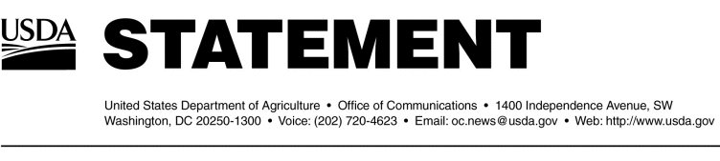

Release No. 0048.04Office of Communications (202) 720-4623

**BSE Update – Wednesday, January 28, 2004**

Depopulation Activities

On Tuesday, Jan. 27, 2004, 15 animals of interest were euthanized and sampled from the Moxee, WA, facility. In addition to this facility, USDA has previously conducted selective depopulation activities at these facilities:

on Service estimated that the Agency would be able to locate approximately 11 of these animals. APHIS has definitively located 14 of these animals.

Trade Issues

Specific trade information can be found at http://www.aphis.usda.gov/lpa/issues/bse/bse_trade_ban_status.html.

Other Issues

Additional information on BSE can be obtained by visiting the USDA website at http://www.usda.gov. Past BSE updates can also be found at http://www.aphis.usda.gov.

#