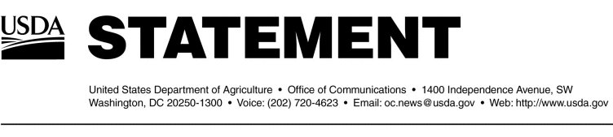

e been located:

1 of the 81 is the BSE-positive cow and was located in the Index herd in Mabton, Washington.

9 of the 81 were located in the Index herd in Mabton, Washington.

3 were located at a facility in Tenino, Washington.

6 were located at a facility in Connell, Washington.

1 was located at a facility in Quincy, Washington.

3 were located at a facility in Mattawa, Washington.

1 was located at a facility in Moxee, Washington.

3 are located at a facility in Burley, Idaho.

1 is located at a facility in Othello, Washington.

Guidelines on bovine spongiform encephalopathy (BSE) issued by the World Organ