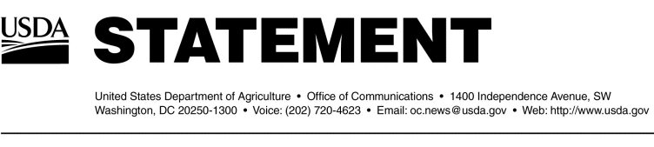

ell, WA - a total of 15 animals depopulated

Boardman, OR - a total of 20 animals depopulated

Quincy, WA – a total of 18 animals depopulated

Tenino, WA – a total of 4 animals depopulated