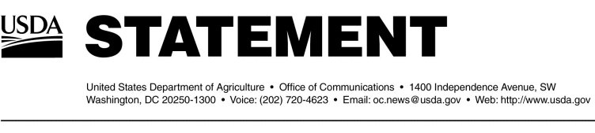

hington.

1 was located at a facility in Moxee, Washington.