Generated

Generated

|  |  |
| --- | --- |
| Concentrations of CCA Wood TreatmentsRecommended for Various Uses | |
| Retentions *(lbs./cu.ft.)* | Uses/Exposures |
| 0.10 – 0.25  0.21 – 0.41  0.31– 0.61  2.50 | Above ground  Soil & Freshwater use  Permanent Wood Foundation  Saltwater use |

recolonize a prop scar (Kruer, 1998). Damage to the plants and their rhizome system

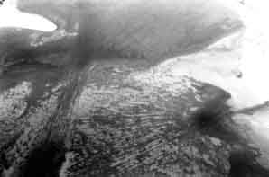

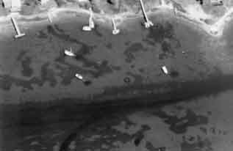

**Figure 3.**  Prop scarring in Waquoit Bay Massachusetts. From Crawford (2002)

often leads to both reduced wildlife habitat and destabilized sediments. Zieman (1976) reported that most propeller scarring takes place in water less that 1 meter (3.3 feet) in depth. Research in and around Corpus Christi Bay found that 39 percent of the seagrass meadows were either moderately (5–20 percent) or heavily (<20 percent) scarred based on the percentage of the area of the beds compared with the area of the propeller scars (Dunton and Schonberg, 2002).

*Contamination from fuel discharges—*

Outboard motors have long been associated with polluting of waterways. Milliken and Lee (1990) provide a good summary of the early literature. Two-cycle engines release up to 20 percent unburned fuel along with exhaust gases (Moore, 1998). Moore (1998) compared the polycyclic aromatic hydrocarbon (PAH), a carcinogenic organic molecule found in petroleum products, output from a two-cycle outboard engine with that from a four-cycle engine. The tests were run in tanks containing fresh water. The two-cycle motor discharged five times as much PAH as the four-cycle engine based on levels in the tanks. Most of this difference was due to a reduction in discharge of 2- and 3-ring compounds in the four-cycle. However, he found little difference between the levels of discharge of 4- and 5-ring compounds—those generally related to chronic toxicity. Albers (2002) notes that PAH concentrations in the water column are “usually several orders of magnitude below levels that are acutely toxic,” but those in sediments may be much higher.

Even when PAHs are found in coastal waters it is difficult to relate them directly to small dock use. Sanger and Holland (2002) looked at PAH levels in tidal creeks in South Carolina but were not able to distinguish PAHs from dock-related activities from other anthropogenic sources. Additionally, it is difficult to differentiate between general recreational boat use and that associated with small docks (Sanger, in Kelty and Bliven, 2003)

*Shoreline erosion—*

Boat wakes, which lap at the shoreline, can contribute to increased shore erosion (Zabawa *et al.* 1980; Camfield *et al.* 1980; Hagerty *et al.*