Generated

Generated

|  |  |
| --- | --- |
| Concentrations of CCA Wood TreatmentsRecommended for Various Uses | |
| Retentions *(lbs./cu.ft.)* | Uses/Exposures |
| 0.10 – 0.25  0.21 – 0.41  0.31– 0.61  2.50 | Above ground  Soil & Freshwater use  Permanent Wood Foundation  Saltwater use |

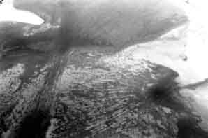

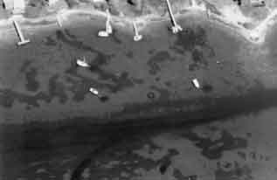

–W–1–80 114 pp. NTIS No. ADA083896.

Colligan, Mary and Cori Collins. 1995. *The Effect of Open-Pile Structures on Salt Marsh Vegetation.* NOAA/NMFS Habitat and Protected Resources Division. Pre-publication copy–not for distribution. 44p.

Cooper, P.A. 1990. Leaching of CCA from Treated Wood. *Proc. Canadian Wood Preservation Association* II: 144–169.

Crawford, R. N.Stolpe and M. Moore, Eds. 1998. *The Environmental Impacts of Boating: Proceedings of a workshop held at Woods Hole Oceanographic Institution, Woods Hole, MA. December 7–9 1994.* Technical Report WHOI-98-03

Crawford, R. 1998. Measuring Boating Effects of Turbidity in a Shallow Coastal Lagoon. In *The Environmental Impacts of Boating: Proceedings of a workshop held at Woods Hole Oceanographic Institution, Woods Hole, MA December 7–9 1994*. Technical Report: WHOI-98-03. R. Crawford, N. Stolpe and M.Moore. Eds.

Crawford, R. 2002. Secondary Wake Turbidity From Small Boat Operation in a Shallow, Sandy Bay. *Journal of Coastal Research* Special Issue 37.