Generated

Generated

|  |  |
| --- | --- |
| Concentrations of CCA Wood TreatmentsRecommended for Various Uses | |
| Retentions *(lbs./cu.ft.)* | Uses/Exposures |
| 0.10 – 0.25  0.21 – 0.41  0.31– 0.61  2.50 | Above ground  Soil & Freshwater use  Permanent Wood Foundation  Saltwater use |

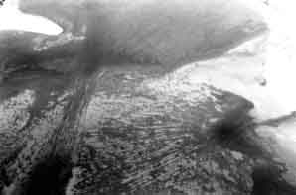

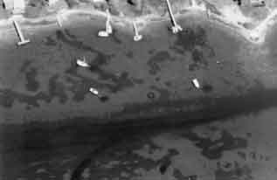

Evert, C.H., and A.E. DeWall. 1975. *Coastal Sand Level Changes in North Carolina*. Draft Report, Coastal Engineering Research Center, US Army Corps of Engineers.

Garriison, Paul J., David W. Marshall, Laura Stremick-Thompson, Patricia L. Cicero, and Paul D. Dearlove. 2005. *Effects of pier shading on littoral zone habitat and communities in Lakes Ripley and Rock, Jefferson County, Wisconsin.*