|  |  |
| --- | --- |
| ***Science Members*** |  |
| Andrew Steele | Carnegie Institution of Washington |
| Bob Anderson | University of Colorado |
| David Blake | Ames Research Center |
| Hunter Waite | University of Michigan |
| Jack Mustard | Brown University |
| Jan Amend | Washington University |
| Jan Toporski | Carnegie Institution of Washington |
| Janok Bhattacharya | Univ. of Texas, Dallas |
| Jennifer Biddle | Penn State |
| John Lindsay | JSC/LPI |
| Liane Benning | Leeds University |
| Luther Beegle | JPL |
| Pan Conrad | JPL |
| Rocco Mancinelli | SETI/ARC |
| Sherry Cady | Portland State |
| Will Brinckerhoff | APL |
| ***Engineering Members*** | |
| Greg Mungas | JPL |
| Knut Oxnevad | JPL |
| Roger Diehl | JPL |
| ***Program*** |  |
| David Beaty | Program Office--JPL |
| Jim Garvin | Program Office--HQ |
| Marguerite Syvertson | Program Office--JPL |

Generated

|  |  |
| --- | --- |
| **Source of Carbon** | **Carbon compounds. examples/comments** |
| Abiotic molecules from meteoritic / cometary influx | Amino acids, purines and pyrimidines, polycyclic aromatic hydrocarbons, chain hydrocarbons, fatty acids, sugars and sugar derivatives. |
| Prebiotic/abiotic molecules from synthesis reaction process on Mars | Amino acids, purines and pyrimidines, polycyclic aromatic hydrocarbons, chain hydrocarbons, fatty acids, sugars and sugar derivatives. |
| Terrestrial contaminating organics | Condensation products derived from rocket exhaust, lubricants, plasticizers, atmospheric contaminants |
| Terrestrial contaminating organisms | Whole cells, cell components (LPS, DNA, proteins, cytochromes) found on AFL itself. |
| Terrestrial like organisms – from Earth | Organisms not present on the craft measuring them, but had been previously transferred from Earth by either meteorite impact or contamination of previous spacecraft. Target molecules could include individual genes, membrane constituents, specific enzymes, and co-enzymes that would be expected to be over expressed or adapted in Martian conditions |
| Terrestrial-like organisms – evolved on Mars | Organisms that utilize terrestrial like biochemistries and have evolved on Mars Target molecules could include individual genes, membrane constituents, specific enzymes, and co-enzymes that would be expected to be over expressed or adapted in Martian conditions or organisms using metabolisms that would not be present on a space craft contaminant such as methanogens, psychrophiles endolithic survival mechanisms. |
| Non-terrestrial-like organisms | Utilizes an array of molecules for information storage, information transfer, compartmentalization and enzymatic activity that differ from those used by extant terrestrial life. Examples would be the use of novel amino acids and nucleotides or the use of novel nitrogen utilization strategies. |
| Fossil biomarkers | Detection of established terrestrial fossil biomarkers such as hopanes, archaeal lipids and steranes, for the detection of the diagenetic remains of terrestrial based life. Characterization of potential breakdown products that can be reasonably extrapolated from the detection of molecules comprising an extant Martian life form. Detection of the diagenesis products of extinct Martian organism based on carbon compositions consistent with biological fractionation of a narrow range of abiotic precursors. |

|  |  |  |  |
| --- | --- | --- | --- |
| **Component** | **% Total Weight (or mass C x10-13 g)** | **Number of Types** | **Preservation** |
| **Water** | 70 (NA) | 1 | Unknown in Organic and mineral phases |
| **Proteins** | 15 | ~2000 | 1000’s without protection by a mineral matrix. ~45Ma with protection?. |
| **Nucleic Acids** |  |  |  |
| DNA | 1 | 2+ | Oldest ? ~350,000 |
| RNA | 6 | (see below) | Days – Months (studies on longevity of RNA other than in clinical settings have not been performed. |
| *rRNA* | 5.5 | 3 | Days – Months |
| *tRNA* | 0.1 | ~32 | Days – Months |
| *mRNA* | 0.3 | 1000’s | Days – Months |
| *Non coding RNA* | 0.1 | 1000’s | Days – Months |
| **Polysaccharides** | ~1 | Uncounted | Chitin - 25Ma. Exopolymer sheaths ~2Ga |
| **Lipids** | 2 | ~50 | Cell wall components - Hopanes 2.7Ga |
| **Amino acids** | 0.4 | ~100 (20 main ones) | As protein diagenesis – Ma.  Chiral signal in fossils lost after ~ 1 Ma. |
| **Sugars** | ~3 | ~200 | Days to weeks (see polysaccharides) |
| **Other small organics** | 0.2 | ~200 | Porphyrins ~ 2 Ga |
| **Inorganic species (C, H, N, O, Fe, P, S etc).** | 1 (~100% dry weight) | ~20 – 30 (including inorganic complexes) | Isotopes may preserved for ? 3.5 Ga for C.  Research is continuing to define other isotope systematics for preservation of a biogenic signature. |
| **Diagenetic Macromolecular material** | Total cell breakdown products (100% dry weight of cells) | Kerrogens (4 types)  Melanoidins (100’s) | Kerrogens – ? 3.5Ga for biogenic (Type 1-3). Type 4 indicative of meteoritic input.  Melanoidins conbination of sugar and proteins, ~50 Ma. |

Generated

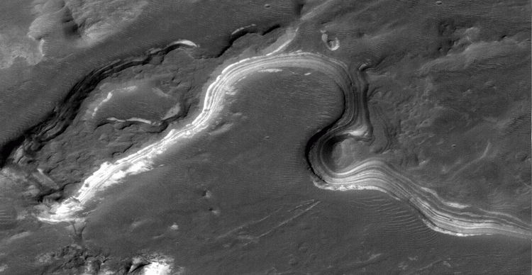

Generated

other less-interesting layers, and thus make the analysis of the core material give results that are not necessarily indicative of a specific region. Furthermore, the rock crushing mechanisms could produce material that is not necessarily representative of the entire core, due to the crushing mechanism. Simply put, a precision sample handling system needs to be developed that is much more advanced then the rock crushers on MSL. This precision sample handling system would most likely replace the rock crushers on MSL as they are currently designed, because there most likely is not enough mass to have both type of instruments aboard.

The precision sample handling system would need to produce fines from a core that are on the order of 100 m, although finer material is always preferable. These fines would need to be produced from regions of the core that are less then 1 cm in length. Although an exact amount of samples that would be useful for each analytical instrument cannot be accurately defined without knowing what instruments have been chosen, a good working number is 100 mg.

A further developed system for AFL would allow for fines to be obtained from various parts of the core, where astrobiologically interesting signatures were observed. These fines then could be identified by the contact suite or by analysis of the fines that were collected during the coring. A possible method this material can be obtained is via a pneumatic drill, analogous to a dentist drill. This type of sample processing of a core needs to be further addressed, as it may require holding the core so that further processing can occur. If the core would be held in a fixed position, a grinder could grind parts of the core while those fines are collected. Any other material that is produced from this step could be looked at with a microscopic imager, if one is chosen as apart of the science payload, but no further analytical analysis of it would need to be made.

### 8.3.4 Ice Samples

Terrestrial organisms can maintain a layer of liquid water around them in an environment where the temperature is below the freezing value for that corresponding pressure. Therefore, one of the main science investigations with ice is to determine if there is any liquid water in a sample. In addition, volatile material present in the sample might undergo reaction and hence change its form, which might lead to incomplete analysis of the obtained sample. Because of these reasons, it seems desirable to obtain a sample without allowing the temperature to pass above conditions in which phase transition that any water (and potential brine solution) present would undergo for the ambient pressure and temperatures present. From permafrost, it is expected that a core approximately 5 cm long and 1 cm diameter would be sufficient for further studies, however, a larger core would likely allow more comprehensive analysis to be performed. With permafrost samples, the possibility should be considered to include a sample concentration device in the sample possessing suite. This concentration process would only take place after any measurement on liquid H2O on the pristine sample has been performed.

The overall strategy for a “polar” mission largely depends on the choice of landing site, i.e. whether it is permafrost or on the polar cap. If a polar region is decided upon, it is suggested that the obtained ice core is analyzed as a whole, especially if only 5 x 1 cm core are obtained. This based on the assumption that the recent ice deposits will not show much evidence of layering or zoning. However, should new data become available through *Phoenix* investigations, this approach may have to be restructured and a more capable precision sub-sampling system be integrated into this mission concept.

### 8.3.5 Liquid and Heat extraction of organics

Organic analysis has been one of the important measurements the Astrobiology Science Steering Group has identified that AFL should be able to perform. In order to identify organic material, they need to be released from the matrix material they are a part of, especially since surface organics on Mars might be very rare. Several ways to extract organics form rock samples were discussed, including using heat and solvent extractions. Each extraction technique has its advantages and disadvantages. However, it is currently

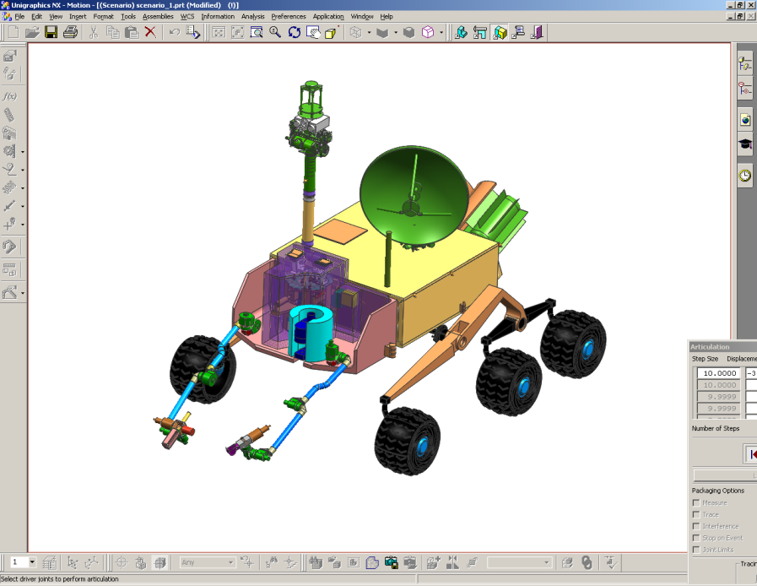

Generated

|  |  |  |  |  |  |  |  |  |  |  |  |  |  |  |  |  |  |  |  |  |  |  |  |  |  |
| --- | --- | --- | --- | --- | --- | --- | --- | --- | --- | --- | --- | --- | --- | --- | --- | --- | --- | --- | --- | --- | --- | --- | --- | --- | --- |
| **Table 8- Techniques Suggested for AFL by SSG Members** | | | | | | | | | | | |  |  |  |  |  |  |  |  |  |  |  |  |  |  |
|  |  |  | Measurement Tier | | | Example Target/Sample Information | | |  | Example Technique Characteristics (instrument implementation) where appropriate | | | | | | | |  | Discovery/Follow-up per Table 7 | | | |  |  |  |
| Technique | Data/ Signatures Sought | Mmnt Reqts Addessed (Section 7) | Remote Sensing/Standoff | Contact or Close Range | Analytical Lab | Physical Form (Solid, Gas, Liquid) | Example Origin/Host Material | Processing Required/ (Desired) | Sample Mass/ Volume | Distance to Target | Size of Area Probed/ FOV | Target Feature Scale | Selectivity | Detection Limits | Resolution | Precision | Mass Range | Other | Recent Surface Water | Hydrous Mineral Phases | Organic Molecules | Sedimen. Structures | Sedimen. Rocks | Evidence for Fossil Life | Microbes |
|  |  |  |  |  |  |  |  |  |  |  |  |  |  |  |  |  |  |  |  |  |  |  |  |  |  |
| stereo optical imaging | identify targets, evidence of weathering, sedimentation, alteration, etc. | A | x |  |  |  | sedimentary rocks/ structures | n |  | 1m - 10+km | 10cm - 1+km |  |  |  |  |  |  |  | 1 | 6 |  | 1,2,3,4 | 4 | 1,2,3,6,8 | 3 |
|  | identify surface samples | A |  |  |  |  |  |  |  | 10-100 m | 1-10 m | 10cm-1m |  |  |  |  |  |  |  |  |  |  |  |  |  |
|  | identify distant sedimentary outcrops | A |  |  |  |  |  |  |  | 1 km | 10-100 m | 1-10 cm |  |  | 10 cm @ 1 km | |  |  |  |  |  |  |  |  |  |
| VIS/NIR Spectroscopy | surface mineralogy, texture | B | x | x |  | s | rocks, fines | n (abr) |  | cm - m |  |  |  |  |  |  |  |  |  |  |  |  |  |  |  |
| mini TES | mineralogy | B | x |  |  | s |  | n (abr) |  | m - km |  |  |  |  |  |  |  |  |  |  |  |  | 1 |  |  |
| long focal length imaging | identify distant sedimentary outcrops | A | x |  |  |  |  | n |  | 10m - km | cm-10m | cm |  |  |  |  |  |  |  |  |  |  |  |  |  |
| laser ranging | distance to target | A | x |  |  |  | boulders, vertical faces | n |  | 100m - km | cm spot |  |  |  | cm @ 100 m | |  |  |  |  |  |  |  |  |  |
| LIBS | elemental composition | B | x |  |  | s | boulders, slopes | n |  | 1 - 25m | mm - cm spot |  | low (l absorb.) | ppmw |  | ~ 10% | elements | laser ablation | | 2,4 |  |  | 2,5 | 3 |  |
| ground penetrating radar | ice, H2O, other | B, C | x |  |  | s | subsurface | n |  | m - 10s m |  |  |  |  |  |  |  |  | 3 |  |  |  |  |  |  |
| seismic sounding | ice, H2O, other | B, C | x | x |  | s | subsurface | n |  | 100's m - km |  |  |  |  |  |  |  |  | 3 |  |  |  |  |  |  |
| neutron spectroscopy | ice, hydrated minerals | B | x | x |  |  | drill cores, fines | n (acq) |  | 10's cm - m's |  |  | high | variable <%-% | |  |  |  |  |  |  |  |  |  |  |
| gamma ray spectroscopy | elemental composition | B | x | x |  |  | any | n |  | 10's cm - m's |  |  | med | variable <%-% | |  |  |  | 5 |  |  |  |  |  |  |
| x-ray spectroscopy | elemental composition | B, E2 |  | x |  |  | any | n (acq) |  | cm | cm+ |  | med | variable <%-% | |  |  |  |  |  |  |  |  |  |  |
| Raman spectroscopy | mineralogy, some geochemical/organic | B, E | x | x |  |  | rocks | n (abr) |  | cm - m | cm+ |  | med |  |  |  |  |  |  | 1,5 | 1,4 |  | 2 | 1 |  |
| micro-Raman spectroscopy | mineralogy, some geochemical/organic | B,D,E |  | x | x |  | rock chips | n (acq, abr) | | mm - cm | < mm |  | med |  |  |  |  |  |  | 1,5 | 1,4 |  | 2 | 1 |  |
| micro-LIBS | elemental composition | B,D |  | x | x | s | rocks, chips | acq,pos |  | mm - cm | < mm |  | low (l absorb.) | |  |  |  |  |  | 2,4 |  |  | 2,5 | 3 |  |
| hand-lens-scale imaging | phase texture/identity | D |  | x |  | s |  | n (abr) |  | cm - m's | 0.1-10 mm | grains |  |  |  |  |  |  |  |  |  |  |  |  |  |
| optical microscopy | fine morphology | D,E |  | x | x | s |  | n (abr) |  | mm - cm | 0.001-1 mm | subgrain |  |  |  |  |  |  |  |  | 2 |  |  | 1,2,3,6,8 |  |
| confocal microscopy |  | D,E |  |  | x | s |  |  |  | mm | 0.001-1 mm | subgrain |  |  |  |  |  |  |  |  | 2 |  |  | 1,2,3,6,8 |  |
| near-field microscopy | very high res imaging | D,E |  |  | x | s | flat chip | acq, pos |  |  |  | subgrain |  |  |  |  |  |  |  |  |  |  |  |  |  |
| Mossbauer | Fe-bearing mineralogy | B |  | x | x | s |  |  |  | mm - cm |  | avg |  |  |  |  |  |  |  |  |  |  |  |  |  |
| Fe-NMR |  | B |  | x |  | s |  |  |  | mm - cm |  |  | high |  |  |  |  |  |  |  |  |  |  |  |  |
| XRD/XRF | mineralogy | B,D |  |  | x | s | drill cores, fines | acq, pow | mg's | 0 | whole sample | avg or grains | |  |  |  |  |  |  | 1 |  |  | 1,5 |  |  |
| FTIR | mineralogy, some geochemical/organic | B |  |  | x | s |  |  |  |  |  |  |  |  |  |  |  |  |  | 1,5 | 1,4,6 |  | 2,5 | 3 | 4 |
| VCD |  |  |  |  | x | s |  |  |  |  |  |  |  |  |  |  |  |  |  |  |  |  |  |  |  |
| deep UV fluorescence | organics: identity, oxidation state, … | B,D,E |  | x | x | s |  | n (abr) | surface? | mm - m |  | grain scale+ | |  |  |  |  |  |  |  | 1 |  |  | 3 |  |
| pyrolysis/GCMS | organic and some mineralogical/inorganic composition; isotopes | B,E |  |  | x | s,g,l |  | acq, pos, vac | mg-10's mg | 0 | whole sample | avg | low |  |  |  |  |  | 4 |  | 1,5 |  | 5 |  |  |
| chemical derivatization | less-tractable organics | E |  |  | x | s,l |  | liq |  | 0 | whole sample | avg |  |  |  |  |  |  | 4 |  | 1,4,7 |  | 5 |  |  |
| isotope ratio MS (IRMS) | C and other isotopes for bio-fractionation, age dating | E2 |  |  | x | s,l |  | acq, pos, vac | | 0 | whole sample | avg |  |  |  |  |  |  | 2 |  |  |  |  |  |  |
|  | compound-specific IRMS using sampling selectivity | E2 |  |  |  |  |  |  |  |  | whole sample | avg | cmpd isolated w/pyr, GC,or other proc. | | | |  |  |  |  |  |  |  |  |  |
| chiral GC | enantiomeric excess (ee) | E3 |  |  | x | s,g,l |  | acq, pos, gas | | 0 | whole sample | avg |  |  |  |  |  |  |  |  | 3 |  |  |  |  |
| circular dichroism | enantiomeric excess (ee) | E3 |  |  | x |  |  |  |  | 0 |  | avg |  |  |  |  |  |  |  |  | 3 |  |  |  |  |
| liquid chromatography (LC) | organics, ee | E |  |  | x | s,l |  | liq |  | 0 | whole sample | avg |  |  |  |  |  |  | 4 |  | 1,3,5 |  | 5 |  |  |
| 2D GCMS/TOF-MS | organic and some mineralogical/inorganic composition; isotopes | B,E |  |  | x | s,g,l | rocks/cores, fines | acq, pos, vac | 10's mg | 0 | whole sample | avg | low |  |  |  | ~1E3-1E5+ | | 4 |  | 1,5 |  | 5 |  |  |
| electrospray ionization MS (ESI/IMS/CIT-MS) | | E |  |  | x | s,g,l |  | acq, pos, vac | g's | 0 | whole sample | avg | low |  | Dm/m 1E2-1E3+ | |  | contact w/ fluidized sample | | |  |  |  |  |  |
| laser ablation TOF-MS | local elemental/isotopic composition | B,D |  |  | x | s | rock chips, fines | acq, pos, vac | surface | 0 | 10mm - 1 mm | grain scale+ | low (l absorb.) | ppbw-ppmw | Dm/m 1E2-1E3 | 5-25% | ~ 300 |  | 4 | 2,4 |  |  | 2,5 | 1,3 |  |
| LD/MALDI-TOF MS | high-MW organics; some inorganic molecules | D,E |  |  | x | s | rock chips, fines | acq, pos, vac (pow, liq) | surface/prep film | 0 | 100mm - 1 mm | grain scale+ | med (l absorb.) | fmol-pmol | Dm/m 1E3-1E4 | | ~1E3-1E5+ | |  |  | 1,2,4,7 |  |  | 3 | 4 |
| REMPI-MS/RIMS | organics, elements (trace) | E |  |  | x | s |  | acq, pos, vac | | 0 | 10mm - 1 mm |  | very high (l absorb.) | s. atom - pmol | Dm/m 1E2-1E4 | | ~ 1E3 |  |  |  |  |  |  |  |  |
| AP-MALDI-MS (TOFMS or ITMS) | organic, inorganic molec. | D,E |  | x | x | s | rocks, ices | vac | surface | mm | 10mm - 1 mm | grain scale+ | med (l absorb.) | fmol-nmol | Dm/m 1E3-1E4+ | | ~ 1E3-1E5 |  |  |  |  |  |  |  |  |
| electrospray TOF-MS | high-MW organics | E |  |  | x | s,l | rocks/cores, fines | acq, liq, pos, vac | | 0 | whole sample | avg | med |  | Dm/m 1E2-1E4 | | ~1E4-1E5+ | |  |  | 1,2,7 |  |  | 3 | 4 |
| TOF-SIMS | chemical imaging | B,E |  |  | x | s | rock chips | acq, pos, vac | surface | 0 | 50nm-50mm | sub-grain+ | low |  | Dm/m 1E3-1E4 | | ~1E3-1E4 |  |  |  |  |  |  |  |  |
| ICP-MS | trace elements | B |  |  | x | s,g,l | rock chips, fines | acq, pos, vac, gas | | 0 | whole sample | avg or grains | low | pptw-ppbw | Dm/m 1E3+ | 0.1-10% | ~ 300 |  | 2,4 |  | 1,3,5 |  | 5 |  |  |
| TIMS | isotope ratios (~IRMS) | B,E2 |  |  | x | s |  | acq, pos, vac | | 0 | whole sample | avg | low | pptw-ppbw | Dm/m 1E3+ | 0.1-1% | ~ 300 |  | 2 |  | 5 |  |  |  |  |
| AFM | nanoscale imaging | D, E3 |  |  | x | s | flat chip | acq, pos | chips |  | 1nm-1mm | sub-micron | |  |  |  |  |  |  |  |  |  |  |  |  |
| TEM/SEM | nanoscale imaging | D |  |  | x | s | flat chip | acq, pos, vac | chips |  | 1nm-1mm | sub-micron | |  |  |  |  |  |  |  |  |  |  |  |  |
|  | image microbes in ice cores | D,E3 |  |  |  |  |  |  |  |  |  |  |  |  |  |  |  |  |  |  |  |  |  |  |  |
| XPS | chemical comp. and bond state | B,C |  |  | x | s,l |  | vac | 100's mg |  |  |  |  |  |  |  |  |  |  |  |  |  |  |  |  |
| Auger spectroscopy | bond state of elements | B,C |  |  |  | s,l |  | vac | 100's mg |  |  |  |  |  |  |  |  |  |  |  |  |  |  |  |  |
| amino-acid sensors (eg MOD) | detection of amino acids | E |  |  | x | s,l |  | acq | 100's mg |  | whole sample |  | high |  |  |  |  |  |  |  | 1,3 |  |  |  |  |
| oxidant sensors | detection of oxidants | C |  |  | x | s,l |  | Acq, dry | 100's mg |  | whole sample |  | high |  | per sample weight | |  |  |  |  | 6 |  |  |  |  |
| bio-assay chip lab |  | E |  |  | x | s,l |  | liq | 100's mg | 0 | whole sample |  | high | pptw | per sample weight | | Kda |  |  |  | 7 |  |  | 1,5,6 | 1,5,6 |
| micro-array sensors |  | E |  |  | x | s,l |  | Liq | 100's mg |  | whole sample |  | high | pptw | per sample weight | | Kda |  |  |  | 7 |  |  | 1,5,6 | 1,5,6 |
| MORD |  |  |  |  | x | s |  |  | 100's mg | 0 | whole sample |  | high |  | per sample weight | |  |  |  |  |  |  |  |  |  |
| fluorescence staining | organics | E |  | x | x | s,l |  | Liq | 100's mg |  | whole sample | avg | high | single cell | per sample weight | |  |  |  |  | 7 |  |  |  |  |
|  | SYBR gold, SYTO, DAPI nucleic acid stains for counting microbes | E |  |  | x | s,l |  | Liq | 100's mg |  | whole sample |  | Medium | single cell | per sample weight | |  |  |  |  |  |  |  |  | 1.5.6 |
|  | CTC, tetrazolium salt redox stains for individual cells | E |  |  | x | s,l |  | Liq | 100's mg |  | whole sample |  | Medium | Single cell | per sample weight | |  |  |  |  |  |  |  |  | 1,5,6 |
| isotopic labelling | 14CO2 or 3H for total population activity | E |  |  | x | s,g,l |  | Lig | 100's mg |  | whole sample | avg | medium | single cell | per sample weight | |  |  |  |  |  |  |  |  | 1,5,6 |
| flow-cytometry |  | E |  |  | x | s,l |  | liq | 100's mg |  | whole sample | avg | medium | single cell | per sample weight | |  | If have required media | | |  |  |  |  | 1,5,6 |
| culturing/cell-growth assays |  | E |  |  | x | s,l |  | liq | 100's mg |  | whole sample | avg | high | single cell | per sample weight | |  | If have required media | | |  |  |  |  | 1,5,6 |
| ATP and LAL enzyme assays |  | E |  |  | x | s,l |  | liq | 100's mg |  | whole sample | avg | high | pptw | per sample weight | |  |  |  |  |  |  |  |  | 1,5,6 |
| DNA extraction/PCR |  | E |  |  | x | s,l |  | liq | 100's mg |  | whole sample | avg | high | 100 cells | per sample weight | |  | with correct primers | | |  |  |  |  | 5,6 |
| capillary electrophoresis (CE) |  | E |  |  | x | s,l |  |  | 100's mg |  | whole sample | avg | high | pptw | per sample weight | |  |  |  |  | 7 |  |  |  | 1,5,6 |
| microcalorimetry |  |  |  |  | x |  |  |  | 100's mg |  | whole sample | avg | medium | pptw | per sample weight | |  |  |  |  | 7 |  |  |  |  |
|  |  |  |  |  |  |  |  |  |  |  |  |  |  |  |  |  |  |  |  |  |  |  |  |  |  |
| **KEY:** |  |  |  |  |  |  |  |  |  |  |  |  |  |  |  |  |  |  |  |  |  |  |  |  |  |
| n - can be operated with no sample acquisition/processing | | |  |  |  |  |  |  |  |  |  |  |  |  |  |  |  |  |  |  |  |  |  |  |  |
| abr - abrasion to remove surface layers | |  |  |  |  |  |  |  |  |  |  |  |  |  |  |  |  |  |  |  |  |  |  |  |  |
| acq - sample acquisition from host matl (via whatever means) | | |  |  |  |  |  |  |  |  |  |  |  |  |  |  |  |  |  |  |  |  |  |  |  |
| pow - powdering of solid sample | |  |  |  |  |  |  |  |  |  |  |  |  |  |  |  |  |  |  |  |  |  |  |  |  |
| pos - sample positioning (e.g., manipulation to oven, point of focus or extraction) | | | | | |  |  |  |  |  |  |  |  |  |  |  |  |  |  |  |  |  |  |  |  |
| vac - vacuum processing |  |  |  |  |  |  |  |  |  |  |  |  |  |  |  |  |  |  |  |  |  |  |  |  |  |
| liq - liquid processing |  |  |  |  |  |  |  |  |  |  |  |  |  |  |  |  |  |  |  |  |  |  |  |  |  |
| gas - gas processing |  |  |  |  |  |  |  |  |  |  |  |  |  |  |  |  |  |  |  |  |  |  |  |  |  |