Forum Report:

Permissible Metric - Only Labeling

Includes a Proposal to Amend the Fair Packaging and Labeling Act to Allow Metric-Only Labeling

This report and additional materials are available athttp://www.nist.gov/metric

For more information contact TheSI@nist.gov

November 7, 2002

Washington, D.C.

Sponsored by: The United States Department of Commerce’s National Institute of Standards and Technology and the National Conference on Weights and Measures



Generated



**April 15, 2003**

#### Table of Contents

A Message from the Director of NIST’s Technology Services3

Summary4

I.Introduction7

Exports and International Competition8

Importers and Retailers8

Consumers9

II.The Need to Amend the Fair Packaging and Labeling Act11

European Union Will Require Metric-Only labeling by 201013

III.How Permissible Metric-Only Labeling Will Be Implemented: Concerns and Benefits13

Comments from Some Members of the Food Industry15

IV.Proposal to Amend the Fair Packaging and Labeling Act (FPLA)15

a.Objectives15

b. Background Information on the Fair Packaging and Labeling Act .16

V.Proposal to Amend the FPLA for Permissible Metric-Only Labeling17

VI.Conclusions18

Appendix A. European Union Letter regarding Metric-Only Labeling Directive20

Appendix B. The Fair Packaging and Labeling Act with proposed amendments shown in context.21

# A Message from the Director of NIST’s Technology Services

I am pleased to provide you with this report on the Forum on Permissible Metric-only Labeling held on November 7, 2002, in Washington, D.C. The National Institute of Standards and Technology and the National Conference on Weights and Measures (NCWM) sponsored this forum in response to requests from U.S. manufacturers who want the option of labeling packages with only metric units. The purpose of the forum was to initiate a collaborative effort between business, government and other interested parties to eliminate regulatory barriers to metric-only labeling on packaged goods.

The National Institute of Standards and Technology (NIST) is the agency of the U.S. Department of Commerce responsible for directing and coordinating efforts by Federal departments and agencies to implement metric usage under the Metric Conversion Act of 1975.

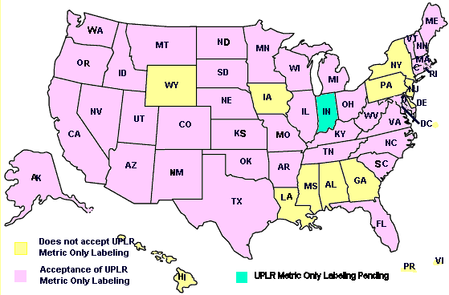

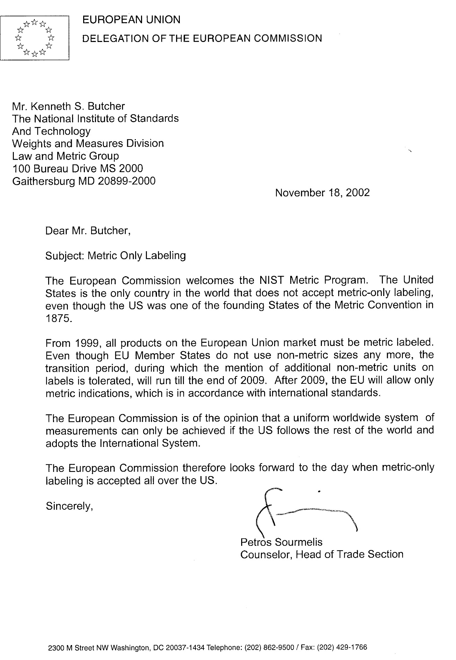

any remainder in terms of inches or common or decimal fractions of the foot or yard;

(iv) if on a package labeled in terms of measure of area, shall be expressed in terms of the largest whole square unit (square yards, square yards and square feet, or square feet, as appropriate) with any remainder in terms of square inches or common or decimal fractions of the square foot or square yard;

(B) shall appear in conspicuous and easily legible type in distinct contrast (by topography, layout, color, embossing, or molding) with other matter on the package;

(C) shall contain letters or numerals in a type size which shall be (i) established in relationship to the area of the principal display panel of the package, and (ii) uniform for all packages of substantially the same size; and

(D) shall be so placed that the lines of printed matter included in that statement are generally parallel to the base on which the package rests as it is designed to be displayed; and

(4) The label of any package of a consumer commodity which bears a representation as to the number of servings of such commodity contained in such package shall bear a statement of the net quantity (in terms of weight or mass, measure, or numerical count) of each such serving.

(5) For purposes of paragraph (3)(A)(ii) and paragraph (6) of this subsection the term ''random package'' means a package which is one of a lot, shipment, or delivery of packages of the same consumer commodity with varying weights or masses, that is, packages with no fixed weight or mass pattern.

(6) The net quantity of contents statement for foods that are packaged at the retail store level and for random packages shall be expressed using one of three possible regimes: using only the most appropriate units of the metric system, using only the most appropriate inch-pound units, or using both the metric units and inch-pound units.

~~(6) The requirement of paragraph (2) that the statement of net quantity of contents include a statement in terms of the SI metric system shall not apply to foods that are packaged at the retail store level.~~

(b) Supplemental statements

No person subject to the prohibition contained in section 1452 of this title shall distribute or cause to be distributed in commerce any packaged consumer commodity if any qualifying words or phrases appear in conjunction with the separate statement of the net quantity of contents required by subsection (a) of this section, but nothing in this subsection or in paragraph (2) of subsection (a) of this section shall prohibit supplemental statements, at other places on the package, describing in nondeceptive terms the net quantity of contents: Provided, That such supplemental statements of net quantity of contents shall not include any term qualifying a unit of weight or mass, measure, or count that tends to exaggerate the amount of the commodity contained in the package.

**§1454. Rules and Regulations.**

(a) Promulgating authority - The authority to promulgate regulations under this chapter is vested in (A) the Secretary of Health and Human Services (referred to hereinafter as the ''Secretary'') with respect to any consumer commodity which is a food, drug, device, or cosmetic, as each such term is defined by section 321 of title 21; and (B) the Federal Trade Commission (referred to hereinafter as the ''Commission'') with respect to any other consumer commodity.

(b) Exemption of commodities from regulations - If the promulgating authority specified in this section finds that, because of the nature, form, or quantity of a particular consumer commodity, or for other good and sufficient reasons, full compliance with all the requirements otherwise applicable under section 1453 of this title is impracticable or is not necessary for the adequate protection of consumers, the Secretary or the Commission (whichever the case may be) shall promulgate regulations exempting such commodity from those requirements to the extent and under such conditions as the promulgating authority determines to be consistent with section 1451 of this title.

(c) Scope of additional regulations - Whenever the promulgating authority determines that regulations containing prohibitions or requirements other than those prescribed by section 1453 of this title are necessary to prevent the deception of consumers or to facilitate value comparisons as to any consumer commodity, such authority shall promulgate with respect to that commodity regulations effective to -

(1) establish and define standards for characterization of the size of a package enclosing any consumer commodity, which may be used to supplement the label statement of net quantity of contents of packages containing such commodity, but this paragraph shall not be construed as authorizing any limitation on the size, shape, weight or mass, dimensions, or number of packages which may be used to enclose any commodity;

(2) regulate the placement upon any package containing any commodity, or upon any label affixed to such commodity, of any printed matter stating or representing by implication that such commodity is offered for retail sale at a price lower than the ordinary and customary retail sale price or that a retail sale price advantage is accorded to purchasers thereof by reason of the size of that package or the quantity of its contents;

(3) require that the label on each package of a consumer commodity (other than one which is a food within the meaning of section 321(f) of title 21) bear (A) the common or usual name of such consumer commodity, if any, and (B) in case such consumer commodity consists of two or more ingredients, the common or usual name of each such ingredient listed in order of decreasing predominance, but nothing in this paragraph shall be deemed to require that any trade secret be divulged; or

(4) prevent the nonfunctional-slack-fill of packages containing consumer commodities. For purposes of paragraph (4) of this subsection, a package shall be deemed to be nonfunctionally slack-filled if it is filled to substantially less than its capacity for reasons other than (A) protection of the contents of such package or (B) the requirements of machines used for enclosing the contents in such package.

(d) Development by manufacturers, packers, and distributors of voluntary product standards - Whenever the Secretary of Commerce determines that there is undue proliferation of the weights or masses, measures, or quantities in which any consumer commodity or reasonably comparable consumer commodities are being distributed in packages for sale at retail and such undue proliferation impairs the reasonable ability of consumers to make value comparisons with respect to such consumer commodity or commodities, he shall request manufacturers, packers, and distributors of the commodity or commodities to participate in the development of a voluntary product standard for such commodity or commodities under the procedures for the development of voluntary products standards established by the Secretary pursuant to section 272 of this title. Such procedures shall provide adequate manufacturer, packer, distributor, and consumer representation.

(e) Report and recommendations to Congress upon industry failure to develop or abide by voluntary product standards - If (1) after one year after the date on which the Secretary of Commerce first makes the request of manufacturers, packers, and distributors to participate in the development of a voluntary product standard as provided in subsection (d) of this section, he determines that such a standard will not be published pursuant to the provisions of such subsection (d), or (2) if such a standard is published and the Secretary of Commerce determines that it has not been observed, he shall promptly report such determination to the Congress with a statement of the efforts that have been made under the voluntary standards program and his recommendation as to whether Congress should enact legislation providing regulatory authority to deal with the situation in question.

**§1455. Procedures for Promulgation of Regulations.**

(a) Hearings by Secretary of Health and Human Services - Regulations promulgated by the Secretary under section 1453 or 1454 of this title shall be promulgated, and shall be subject to judicial review, pursuant to the provisions of subsections (e), (f), and (g) of section 371 of title 21. Hearings authorized or required for the promulgation of any such regulations by the Secretary shall be conducted by the Secretary or by such officer or employees of the Department of Health and Human Services as he may designate for that purpose.

(b) Judicial review; hearings by Federal Trade Commission - Regulations promulgated by the Commission under section 1453 or 1454 of this title shall be promulgated, and shall be subject to judicial review, by proceedings taken in conformity with the provisions of subsections (e), (f), and (g) of section 371 of title 21 in the same manner, and with the same effect, as if such proceedings were taken by the Secretary pursuant to subsection (a) of this section. Hearings authorized or required for the promulgation of any such regulations by the Commission shall be conducted by the Commission or by such officer or employee of the Commission as the Commission may designate for that purpose.

(c) Cooperation with other departments and agencies - In carrying into effect the provisions of this chapter, the Secretary and the Commission are authorized to cooperate with any department or agency of the United States, with any State, Commonwealth, or possession of the United States, and with any department, agency, or political subdivision of any such State, Commonwealth, or possession.

(d) Returnable or reusable glass containers for beverages - No regulation adopted under this chapter shall preclude the continued use of returnable or reusable glass containers for beverages in inventory or with the trade as of the effective date of this Act, nor shall any regulation under this chapter preclude the orderly disposal of packages in inventory or with the trade as of the effective date of such regulation.

**§1456.Enforcement.**

(a) Misbranded consumer commodities - Any consumer commodity which is a food, drug, device, or cosmetic, as each such term is defined by section 201 of the Federal Food, Drug, and Cosmetic Act

(21 US C. 321), and which is introduced or delivered for introduction into commerce in violation of any of the provisions of this chapter, or the regulations issued pursuant to this chapter, shall be deemed to be misbranded within the meaning of chapter III of the Federal Food, Drug, and Cosmetic Act (21 USC 331 et seq.), but the provisions of section 303 of that Act (21 USC. 333) shall have no application to any violation of section 1452 of this title.

(b) Unfair or deceptive acts or practices in commerce - Any violation of any of the provisions of this chapter, or the regulations issued pursuant to this chapter, with respect to any consumer commodity which is not a food, drug, device, or cosmetic, shall constitute an unfair or deceptive act or practice in commerce in violation of section 45(a)of this title and shall be subject to enforcement under section 45(b) of this title.

(c) Imports - In the case of any imports into the United Statesof any consumer commodity covered by this chapter, the provisions of sections 1453 and 1454 of this title shall be enforced by the Secretary of the Treasury pursuant to section 801(a) and (b) of the Federal Food, Drug, and Cosmetic Act (21 USC. 381).

**§1457. Annual Reports to Congress: Submission Dates.**

Each officer or agency required or authorized by this chapter to promulgate regulations for the packaging or labeling of any consumer commodity, shall transmit to the Congress each year a report containing a full and complete description of the activities of that officer or agency for the administration and enforcement of this chapter during the preceding fiscal year. All agencies except the Department of Health and Human Services and the Federal Trade Commission shall submit their reports in January of each year. The Department of Health and Human Services shall include this report in its annual report to Congress on activities under the Federal Food, Drug, and Cosmetic Act (21 USC. 301 et seq.), and the Federal Trade Commission shall include this report in the Commission's annual report to Congress.

**§1458. Cooperation with State Authorities; Transmittal of Regulations to States; Noninterference with Existing Programs.**

(a) A copy of each regulation promulgated under this chapter shall be transmitted promptly to the Secretary of Commerce, who shall (1) transmit copies thereof to all appropriate State officers and agencies, and (2) furnish to such State officers and agencies information and assistance to promote to the greatest practicable extent uniformity in State and Federal regulation of the labeling of consumer commodities.

(b) Nothing contained in this section shall be construed to impair or otherwise interfere with any program carried into effect by the Secretary of Health and Human Services under other provisions of law in cooperation with State governments or agencies, instrumentalities, or political subdivisions thereof.

**§1459. Definitions.**

For the purpose of this chapter -

(a) The term ''consumer commodity'', except as otherwise specifically provided by this subsection, means any food, drug, device, or cosmetic (as those terms are defined by the Federal Food, Drug, and Cosmetic Act (21 USC. 301 et seq.)), and any other article, product, or commodity of any kind or class which is customarily produced or distributed for sale through retail sales agencies or instrumentalities for consumption by individuals, or use by individuals for purposes of personal care or in the performance of services ordinarily rendered within the household, and which usually is consumed or expended in the course of such consumption or use.

Such term does not include -

(1) any meat or meat product, poultry or poultry product, or tobacco or tobacco product;

(2) any commodity subject to packaging or labeling requirements imposed by the Secretary of Agriculture pursuant to the Federal Insecticide, Fungicide, and Rodenticide Act (7 USC. 136 et seq.), or the provisions of the eighth paragraph under the heading ''Bureau of Animal Industry'' of the Act of March 4, 1913 (21 USC. 151 et seq.), commonly known as the Virus-Serum-Toxin Act;

(3) any drug subject to the provisions of section 503(b)(1) or 506 of the Federal Food, Drug, and Cosmetic Act (21 USC. 353(b)(1) and 356);

(4) any beverage subject to or complying with packaging or labeling requirements imposed under the Federal Alcohol Administration Act (27 USC. 201 et seq.); or

(5) any commodity subject to the provisions of the Federal Seed Act (7 USC. 1551 et seq.).

(b) The term ''package'' means any container or wrapping in which any consumer commodity is enclosed for use in the delivery or display of that consumer commodity to retail purchasers, but does not include -

(1) shipping containers or wrappings used solely for the transportation of any consumer commodity in bulk or in quantity to manufacturers, packers, or processors, or to wholesale or retail distributors thereof;

(2) shipping containers or outer wrappings used by retailers to ship or deliver any commodity to retail customers if such containers and wrappings bear no printed matter pertaining to any particular commodity; or

(3) containers subject to the provisions of the Act of August 3, 1912 (37 Stat. 250, as amended; 15 USC. 231-233), or the Act of March 4, 1915 (38 Stat. 1186, as amended; 15 USC. 234-236).

(c) The term ''label'' means any written, printed, or graphic matter affixed to any consumer commodity or affixed to or appearing upon a package containing any consumer commodity.

(d) The term ''person'' includes any firm, corporation, or association.

(e) The term ''commerce'' means (1) commerce between any State, the District of Columbia, the Commonwealth of Puerto Rico, or any territory or possession of the United States, and any place outside thereof, and (2) commerce within the District of Columbia or within any territory or possession of the United States not organized with a legislative body, but shall not include exports to foreign countries.

(f) The term ''principal display panel'' means that part of a label that is most likely to be displayed, presented, shown, or examined under normal and customary conditions of display for retail sale.

**§1460. Savings Provisions.**

Nothing contained in this chapter shall be construed to repeal, invalidate, or supersede - (a) the Federal Trade Commission Act (15 USC. 41 et seq.) or any statute defined therein as an antitrust Act; (b) the Federal Food, Drug, and Cosmetic Act (21 USC. 301 et seq.); or (c) the Federal Hazardous Substances Labeling Act (15 USC. 1261 et seq.).

**§1461. Effect Upon State Law.**

It is hereby declared that it is the express intent of Congress to supersede any and all laws of the States or political subdivisions thereof insofar as they may now or hereafter provide for the labeling of the net quantity of contents of the package of any consumer commodity covered by this chapter which are less stringent than or require information different from the requirements of section 1453 of this title or regulations promulgated pursuant thereto.