

Generated



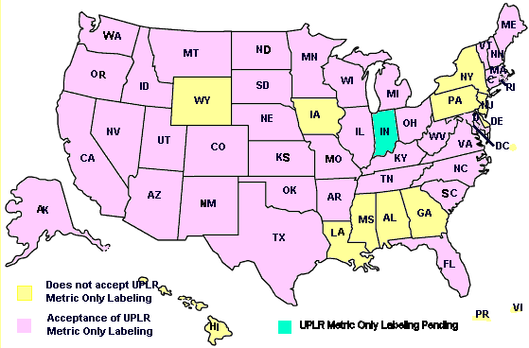

(a trade association representing food retailers) and a dairy industry representative. Their concerns relate primarily to the potential problems that would be encountered if changes in package sizes are imposed (i.e., hard conversion to metric sizes). Package size restrictions are no longer seen as a reasonable or practical means of enabling consumers to make value comparisons since unit pricing began eliminating the justification for imposing standardized package sizes in the United States more than three decades ago. A similar process is currently going on around the world with countries such as New Zealand and the member states of the EU considering the repeal of laws that mandate package sizes. The proposed amendment to the FPLA will not impose any restrictions on package sizes, so concerns in this area should be resolved.

Lorelle Young, President of the U.S. Metric Association (USMA) addressed the issue of package size restrictions in her presentation by saying that the USMA “does not support the notion of packaging in standard metric sizes” as it “believes companies are the best judges of the sizes to use in marketing their products.”

FMI’s most significant concern was that it believes that consumers may not be able to make value-comparisons between similar products of various sizes if some manufacturers use the metric-only option and others use inch-pound. Consequently, coordinated action is needed to address the concerns of industry and consumers.

# IV.Proposal to Amend the Fair Packaging and Labeling Act (FPLA)

## a.Objectives

A

mending the FPLA would give packagers greater flexibility to provide labeling information that meets the needs of their diverse consumers. Package label declarations stated in metric units would be exempt from the current requirement that declarations of net content also include inch-pound units, allowing packagers to label their products with either metric units only or with both metric and inch-pound units. The proposed amendment to the FPLA would help achieve the following objectives:

- Enable consumers to use metric information to make value comparisons.

- Update labeling options, allowing manufacturers to make labeling decisions based on knowledge of customer needs and the demands of their markets.

- Permit certain packagers, through increased labeling flexibility, to reduce production and packaging costs by producing fewer different labels for different markets.

- Permit packagers to continue to use existing packaging labeled with both inch-pound and SI units. This means that no producer, packager, or store would be required to take any action or incur any cost based on this amendment.

- Strengthen the ability of United States manufacturers to compete in the global marketplace.

## b. Background Information on the Fair Packaging and Labeling Act.

The Fair Packaging and Labeling Act relates only to the net quantity of contents information on packages, goods, or commodities that are sold on the basis of weight or measure (i.e., it does not apply to electronic or industrial equipment and appliances). Labeling requirements for packaged goods are applied to packages based on who will be the ultimate consumer. There are two classifications of products: one class is “consumer” packages that are intended for sale in retail stores, such as food or department stores. The other class is “non-consumer” packages that are intended for sale in wholesale trade, such as by a manufacturer who packages 25 kg bags of chemicals for sale to another manufacturer for use in producing another product. The Fair Packaging and Labeling Act requirements are not applicable to all packaged goods.

1.The FPLA requirements apply only to “consumer commodities,” including:

a.Foods, drugs (except prescription), and cosmetics, and these are subject to the labeling regulations of the Food and Drug Administration

b.Any other article, product, or commodity of any kind or class which is customarily produced or distributed for sale through retail sales agencies or instrumentalities for consumption by individuals, or use by individuals for purposes of personal care or in the performance of services ordinarily rendered within the household, and which usually is consumed or expended in the course of such consumption or use (e.g., soaps and detergents, paper products, and waxes and polishes.) and these are subject to the labeling regulations of the Federal Trade Commission

2.The FPLA requirements do not apply to:

a.Packages intended for export (unless they are also intended for sale in the U.S. marketplace.)

b.Meat or meat product, poultry or poultry product, and some packaged agricultural seed which are subject to the labeling regulations of the U.S. Department of Agriculture.

c.Pesticides that are subject to the labeling regulations of the Environmental Protection Agency.

d.Alcohol, beer, wine and tobacco or tobacco products which are subject to labelingregulations of the Department of Treasury

e. All other products that fall under the jurisdiction of State and local regulations that are based on the Uniform Packaging and Labeling Regulation (UPLR), NIST Handbook 130.

3.Some products that can already be labeled with only metric units of measurement.

The following packaged products currently may be labeled in metric-only units. Many of these products have been labeled with only metric units for more than 25 years.

a.Wine and spirits (except for beer).

b.Camera film, videotape, audiotape, and other imaging and audio media.

c.Packages of seed with net contents of less than 225 grams.

d.Consumer products not covered by the FPLA. The Uniform Packaging and Labeling Regulation (NIST Handbook 130), which the States adopt to regulate most consumer products not covered by the FPLA, states, “The requirements for statements of quantity in inch-pound units shall not apply to packages that bear appropriate SI units.”

e.Non-consumer packages of any product or commodity. This includes tens of thousands of different products and commodities bought and sold in wholesale trade. However, it does not include food, drugs, meat or poultry, pesticides, and some packaged agricultural seed.

# V.Proposal to Amend the FPLA for Permissible Metric-Only Labeling

T

he proposal that NIST has developed includes proposed amendments to Section 1453 of the Fair Packaging and Labeling Act (FPLA) for permissible metric-only labeling. The proposed amendments will modify the FPLA to require packages to have net quantity of contents declarations in metric units but would also allow inch-pound units to also be declared as an added option. Nothing in the proposed amendments should be construed to apply to unit pricing, advertising, recipes, nutrition labeling, other general pricing information or to require changes in package sizes.

The amendments should be adopted so that its effective date occurs well before the January 1, 2010, deadline for metric-only labeling in the European Union. This lead time is necessary so United States’ regulatory agencies can implement the metric-only labeling provisions in their regulations and so manufacturers who choose to switch to metric-only labeling for export purposes will have ample time to design and implement the use of the new packaging.

The complete text of the Fair Packaging and Labeling Act with the proposed amendments in their proper context is provided in Appendix B. The clauses of Section 1453 that would be amended include: (a)(2), (a)(3)(A), (a)(5), and (a)(6).

**Proposed amendments to: §1453 Requirements of Labeling; Placement, Form, and Contents of Statement of Quantity; Supplemental Statement of Quantity**

i.a. Amend (a)(2) by adding the text shown as underlined:

(a)(2) The net quantity of contents (in terms of weight or mass, measure, or numerical count) shall be separately and accurately stated in a uniform location upon the principal display panel of that label:

(A) using the most appropriate unit of the metric system of measurement and the inch-pound measurement equivalent, except as provided in paragraph (6) of this subsection; or

(B) using only the most appropriate units of the metric system of measurement.

**b.Amend (a)(2) by deleting the struck-through text:**

~~(a)(2) The net quantity of contents (in terms of weight or mass, measure, or numerical count) shall be separately and accurately stated in a uniform location upon the principal display panel of that label, using the most appropriate units of both the customary inch/pound system of measure, as provided in paragraph (3) of this subsection, and except as provided in paragraph (3)(A)(ii) or paragraph (6) of this subsection, the SI metric system.~~

**ii.Amend (a)(3) (A) by adding the underlined text and deleting the struck-through text:**

(a)(3) The separate label statement of net quantity of contents appearing upon or affixed to any package:

(A) for those portions of the net quantity of contents statement using inch-pound units,

(ii) if on a random package, may be expressed in terms of pounds and decimal fractions of the pound carried out to not more than three decimal places; ~~and is not required to, but may include a statement in terms of the SI metric system carried out to not more than three decimal places~~

**iii.Amend Section (a)(5) by inserting the underlined text as shown:**

(a)(5) For purposes of paragraph (3) (A) (ii) and paragraph (6) of this subsection, the term "random package" means a package which is one of a lot, shipment, or delivery of packages of the same consumer commodity with varying weight or mass, that is, packages with no fixed weight or mass pattern.

**iv.Revise (a)(6) by inserting the underlined text as shown:**

(a)(6) The net quantity of contents statement for foods that are packaged at the retail store level and for random packages shall be expressed using one of three possible regimes: using only the most appropriate units of the metric system, using only the most appropriate inch-pound units, or using both metric units and inch-pound units.

**Delete the struck-through text in (a)(6) as shown:**

~~(a)(6) The requirement of paragraph (2) that the statement of net quantity of contents include a statement in terms of the SI metric system shall not apply to foods that are packaged at the retail store level.~~

# VI.Conclusions

O

ver the last decade, the marketplace has gone through frequent cycles of evolution that at times are really revolutions. Today’s products and stores (e.g., the vast menu of ready-to-eat foods in food stores and superstores that sell only office or building supplies) were not even thought of 10 years ago. Consumers expect the marketplace to be a source of products from around the world as they have come to expect retailers to provide them with both quality and value in addition to new products.

Permissible metric-only labeling will enable manufacturers to package and ship their products to other markets where metric units are required without burdening them with the cost of maintaining two different packages or labels for the same package because of requirements for net content labeling. While multi-lingual labeling addresses the differences in languages around the world, there is the growing reality that the metric system will be the only measurement language in the global marketplace.

It is almost certain that the European Union will require metric-only labeling at the end of 2009 and that deadline, although still several years away, is coming up fast when we consider the time it would take for Congress to amend the FPLA, and then for the appropriate agencies to adopt changes in their regulations. Manufacturers will need to know long before 2009 whether they will be able to use their metric packaging and labeling in the U.S. marketplace as well others around the world, or whether we will be placing our manufacturers at a competitive disadvantage in the global marketplace.

Requiring manufacturers and importers to pay for special packaging for both inch-pound and metric units is simply untenable and would result in higher prices for consumers. Consumers also need this extended time period to become accustomed to packages labeled in only metric units. The gradual transition of the retail marketplace will allow the consumer to establish metric reference points for metric units through the experience of dealing with metric packages mixed in with common inch-pound units.

Amending the FPLA to permit metric-only labeling would be a step towards increased use of the metric system in this nation’s marketplace, helping consumers and others to use metric units on an everyday basis and to gain a greater understanding, while also allowing manufacturers and others to use packaging designed for a global marketplace. This will benefit U.S. consumers in the long term as they will gain a better understanding of the measurements connected with both prescription medicines and the nutritional contents of their foods that are mostly based on the metric system.

Long-term benefits will result if the everyday use of the metric system increases so that industry and businesses gain efficiencies through the use of an internationally accepted and used system of measurement. Increased use of the metric system in the marketplace will reinforce the efforts of the nation’s schoolteachers who teach the metric system to millions of children who currently don’t have that learning reinforced outside the classroom. This is an issue worthy of attention according to one recent study by mathematics teachers who found that American students have difficulty using what they learn because of the failure to have “the opportunity to experience the metric system in and out of school is a major factor.” It has been said more than once that math and measurement skills are a national resource that we must both enhance and use to keep America’s technology and science the best in the world. To that end we believe this effort will return benefits beyond those listed above for businesses.

Perhaps one of the clearest arguments for and latest recognition of the need for the United States to increase its everyday use of the metric system is found in an editorial by Thomas G. Dolan, Editorial Page Editor for *Barron’s* in its November 25, 2002, edition. In his editorial entitled “Measure for Measure” he says “there are few places in the economy where the government can actually legislate American efficiency. The system of weights and measures is one of them. Congress can and should convert the country to the metric system.”

**Proving that Voluntary Metric Conversion Can Work**

Amending the FPLA to permit metric-only labeling would show that Congress’s decision in 1975 to adopt a voluntary approach to metric conversion for the United States can and will work. Congress adopted that approach to allow the marketplace to decide when and where to implement the use of metric units because it can be done with the greatest efficiency and lowest cost when it is accomplished in coordination with routine revisions of packaging and labeling and with the introduction of new products or marketing initiatives. As long as there are legal or regulatory barriers to voluntary conversion to the metric system, we will need to continue to expend resources in working to have them changed so that the voluntary conversion works as it was intended and so that the benefits described above can be realized.

# Appendix A. European Union Letter regarding Metric-Only Labeling Directive

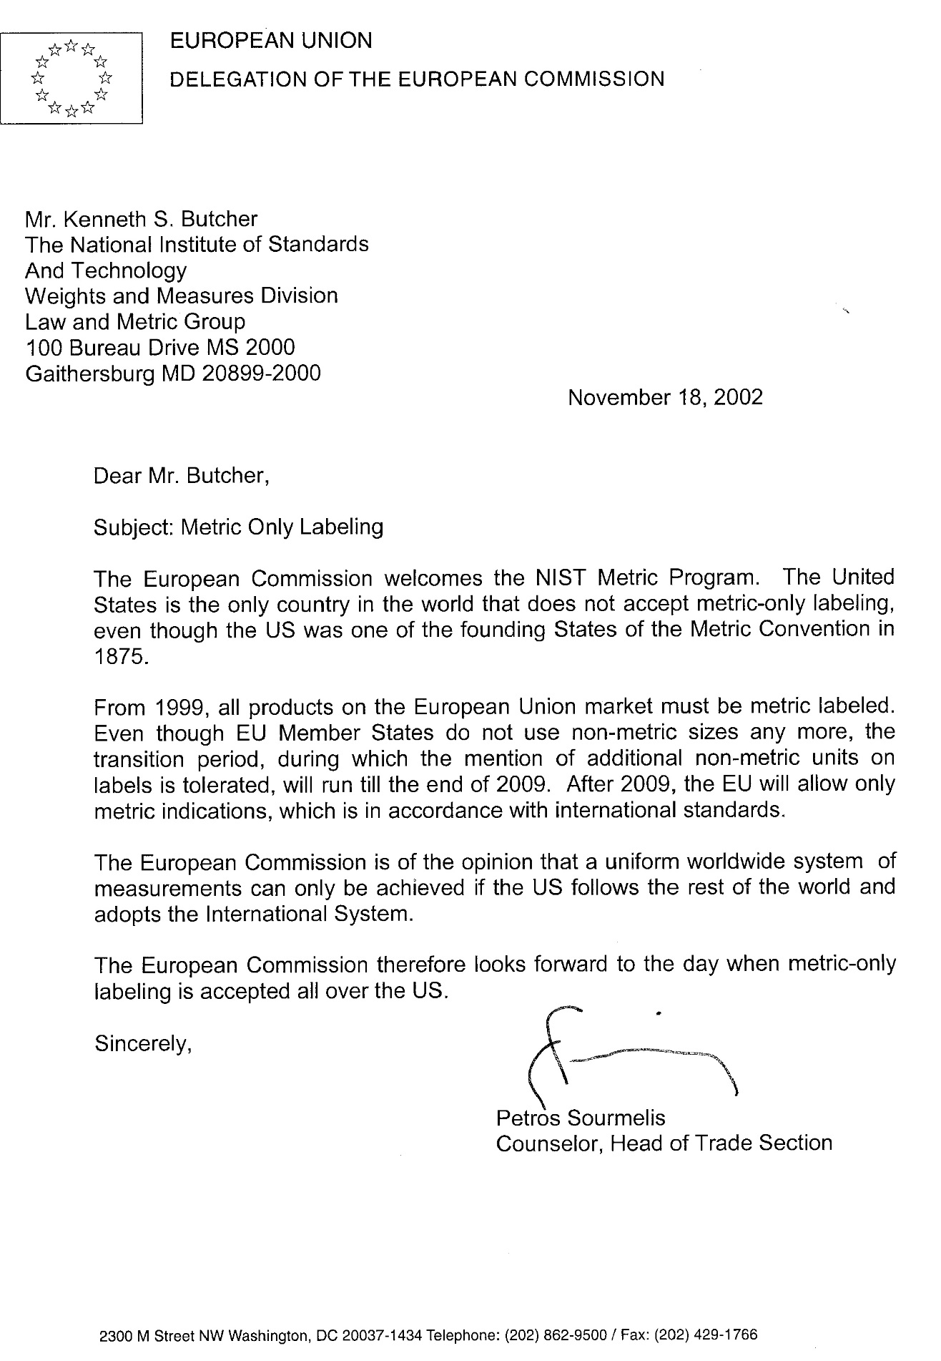

# Appendix B. The Fair Packaging and Labeling Act

# with

# Proposed Amendments Shown in Context.

**TITLE 15 - COMMERCE AND TRADE -- CHAPTER 39 - FAIR PACKAGING AND LABELING PROGRAM**

**§1451. Congressional Delegation of Policy.**