

Generated



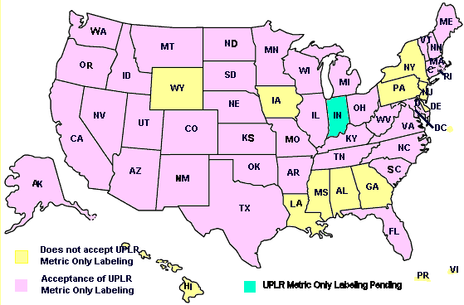

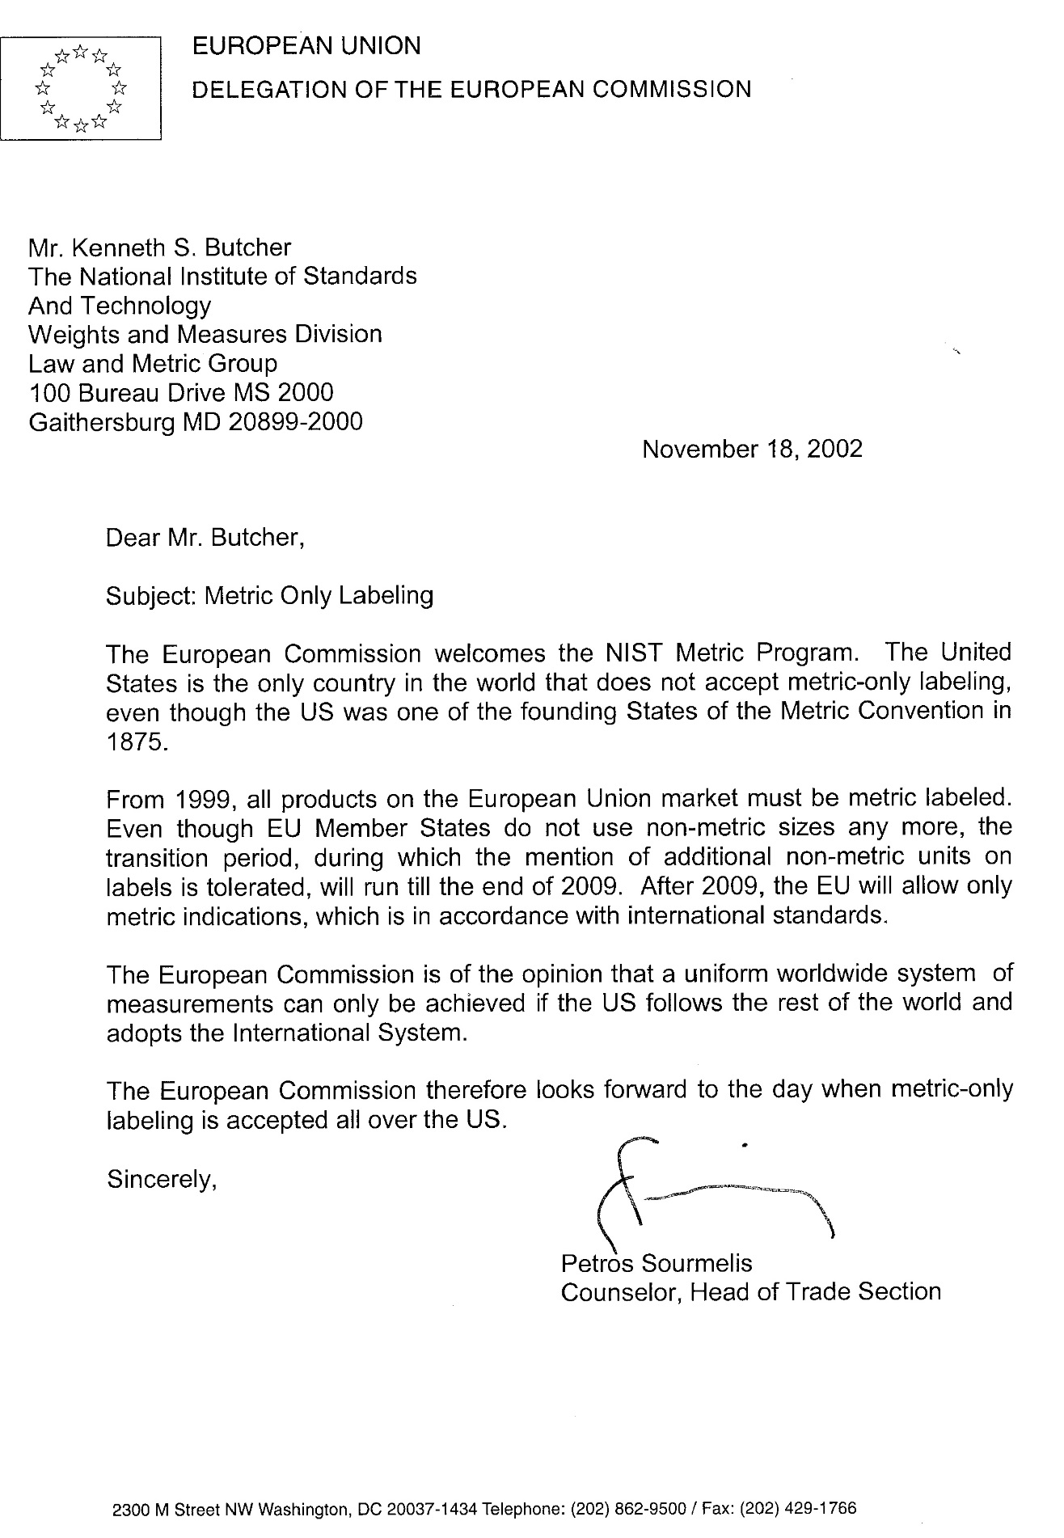

ll be expressed in terms of the largest whole square unit (square yards, square yards and square feet, or square feet, as appropriate) with any remainder in terms of square inches or common or decimal fractions of the square foot or square yard;

(B) shall appear in conspicuous and easily legible type in distinct contrast (by topography, layout, color, embossing, or molding) with other matter on the package;

(C) shall contain letters or numerals in a type size which shall be (i) established in relationship to the area of the principal display panel of the package, and (ii) uniform for all packages of substantially the same size; and

(D) shall be so placed that the lines of printed matter included in that statement are generally parallel to the base on which the package rests as it is designed to be displayed; and

(4) The label of any package of a consumer commodity which bears a representation as to the number of servings of such commodity contained in such package shall bear a statement of the net quantity (in terms of weight or mass, measure, or numerical count) of each such serving.

(5) For purposes of paragraph (3)(A)(ii) and paragraph (6) of this subsection the term ''random package'' means a package which is one of a lot, shipment, or delivery of packages of the same consumer commodity with varying weights or masses, that is, packages with no fixed weight or mass pattern.

(6) The net quantity of contents statement for foods that are packaged at the retail store level and for random packages shall be expressed using one of three possible regimes: using only the most appropriate units of the metric system, using only the most appropriate inch-pound units, or using both the metric units and inch-pound units.

~~(6) The requirement of paragraph (2) that the statement of net quantity of contents include a statement in terms of the SI metric system shall not apply to foods that are packaged at the retail store level.~~

(b) Supplemental statements

No person subject to the prohibition contained in section 1452 of this title shall distribute or cause to be distributed in commerce any packaged consumer commodity if any qualifying words or phrases appear in conjunction with the separate statement of the net quantity of contents required by subsection (a) of this section, but nothing in this subsection or in paragraph (2) of subsection (a) of this section shall prohibit supplemental statements, at other places on the package, describing in nondeceptive terms the net quantity of contents: Provided, That such supplemental statements of net quantity of contents shall not include any term qualifying a unit of weight or mass, measure, or count that tends to exaggerate the amount of the commodity contained in the package.

**§1454. Rules and Regulations.**

(a) Promulgating authority - The authority to promulgate regulations under this chapter is vested in (A) the Secretary of Health and Human Services (referred to hereinafter as the ''Secretary'') with respect to any consumer commodity which is a food, drug, device, or cosmetic, as each such term is defined by section 321 of title 21; and (B) the Federal Trade Commission (referred to hereinafter as the ''Commission'') with respect to any other consumer commodity.

(b) Exemption of commodities from regulations - If the promulgating authority specified in this section finds that, because of the nature, form, or quantity of a particular consumer commodity, or for other good and sufficient reasons, full compliance with all the requirements otherwise applicable under section 1453 of this title is impracticable or is not necessary for the adequate protection of consumers, the Secretary or the Commission (whichever the case may be) shall promulgate regulations exempting such commodity from those requirements to the extent and under such conditions as the promulgating authority determines to be consistent with section 1451 of this title.

(c) Scope of additional regulations - Whenever the promulgating authority determines that regulations containing prohibitions or requirements other than those prescribed by section 1453 of this title are necessary to prevent the deception of consumers or to facilitate value comparisons as to any consumer commodity, such authority shall promulgate with respect to that commodity regulations effective to -

(1) establish and define standards for characterization of the size of a package enclosing any consumer commodity, which may be used to supplement the label statement of net quantity of contents of packages containing such commodity, but this paragraph shall not be construed as authorizing any limitation on the size, shape, weight or mass, dimensions, or number of packages which may be used to enclose any commodity;

(2) regulate the placement upon any package containing any commodity, or upon any label affixed to such commodity, of any printed matter stating or representing by implication that such commodity is offered for retail sale at a price lower than the ordinary and customary retail sale price or that a retail sale price advantage is accorded to purchasers thereof by reason of the size of that package or the quantity of its contents;

(3) require that the label on each package of a consumer commodity (other than one which is a food within the meaning of section 321(f) of title 21) bear (A) the common or usual name of such consumer commodity, if any, and (B) in case such consumer commodity consists of two or more ingredients, the common or usual name of each such ingredient listed in order of decreasing predominance, but nothing in this paragraph shall be deemed to require that any trade secret be divulged; or

(4) prevent the nonfunctional-slack-fill of packages containing consumer commodities. For purposes of paragraph (4) of this subsection, a package shall be deemed to be nonfunctionally slack-filled if it is filled to substantially less than its capacity for reasons other than (A) protection of the contents of such package or (B) the requirements of machines used for enclosing the contents in such package.

(d) Development by manufacturers, packers, and distributors of voluntary product standards - Whenever the Secretary of Commerce determines that there is undue proliferation of the weights or masses, measures, or quantities in which any consumer commodity or reasonably comparable consumer commodities are being distributed in packages for sale at retail and such undue proliferation impairs the reasonable ability of consumers to make value comparisons with respect to such consumer commodity or commodities, he shall request manufacturers, packers, and distributors of the commodity or commodities to participate in the development of a voluntary product standard for such commodity or commodities under the procedures for the development of voluntary products standards established by the Secretary pursuant to section 272 of this title. Such procedures shall provide adequate manufacturer, packer, distributor, and consumer representation.

(e) Report and recommendations to Congress upon industry failure to develop or abide by voluntary product standards - If (1) after one year after the date on which the Secretary of Commerce first makes the request of manufacturers, packers, and distributors to participate in the development of a voluntary product standard as provided in subsection (d) of this section, he determines that such a standard will not be published pursuant to the provisions of such subsection (d), or (2) if such a standard is published and the Secretary of Commerce determines that it has not been observed, he shall promptly report such determination to the Congress with a statement of the efforts that have been made under the voluntary standards program and his recommendation as to whether Congress should enact legislation providing regulatory authority to deal with the situation in question.

**§1455. Procedures for Promulgation of Regulations.**

(a) Hearings by Secretary of Health and Human Services - Regulations promulgated by the Secretary under section 1453 or 1454 of this title shall be promulgated, and shall be subject to judicial review, pursuant to the provisions of subsections (e), (f), and (g) of section 371 of title 21. Hearings authorized or required for the promulgation of any such regulations by the Secretary shall be conducted by the Secretary or by such officer or employees of the Department of Health and Human Services as he may designate for that purpose.

(b) Judicial review; hearings by Federal Trade Commission - Regulations promulgated by the Commission under section 1453 or 1454 of this title shall be promulgated, and shall be subject to judicial review, by proceedings taken in conformity with the provisions of subsections (e), (f), and (g) of section 371 of title 21 in the same manner, and with the same effect, as if such proceedings were taken by the Secretary pursuant to subsection (a) of this section. Hearings authorized or required for the promulgation of any such regulations by the Commission shall be conducted by the Commission or by such officer or employee of the Commission as the Commission may designate for that purpose.

(c) Cooperation with other departments and agencies - In carrying into effect the provisions of this chapter, the Secretary and the Commission are authorized to cooperate with any department or agency of the United States, with any State, Commonwealth, or possession of the United States, and with any department, agency, or political subdivision of any such State, Commonwealth, or possession.

(d) Returnable or reusable glass containers for beverages - No regulation adopted under this chapter shall preclude the continued use of returnable or reusable glass containers for beverages in inventory or with the trade as of the effective date of this Act, nor shall any regulation under this chapter preclude the orderly disposal of packages in inventory or with the trade as of the effective date of such regulation.

**§1456.Enforcement.**

(a) Misbranded consumer commodities - Any consumer commodity which is a food, drug, device, or cosmetic, as each such term is defined by section 201 of the Federal Food, Drug, and Cosmetic Act

(21 US C. 321), and which is introduced or delivered for introduction into commerce in violation of any of the provisions of this chapter, or the regulations issued pursuant to this chapter, shall be deemed to be misbranded within the meaning of chapter III of the Federal Food, Drug, and Cosmetic Act (21 USC 331 et seq.), but the provisions of section 303 of that Act (21 USC. 333) shall have no application to any violation of section 1452 of this title.

(b) Unfair or deceptive acts or practices in commerce - Any violation of any of the provisions of this chapter, or the regulations issued pursuant to this chapter, with respect to any consumer commodity which is not a food, drug, device, or cosmetic, shall constitute an unfair or deceptive act or practice in commerce in violation of section 45(a)of this title and shall be subject to enforcement under section 45(b) of this title.

(c) Imports - In the case of any imports into the United Statesof any consumer commodity covered by this chapter, the provisions of sections 1453 and 1454 of this title shall be enforced by the Secretary of the Treasury pursuant to section 801(a) and (b) of the Federal Food, Drug, and Cosmetic Act (21 USC. 381).

**§1457. Annual Reports to Congress: Submission Dates.**