

Generated



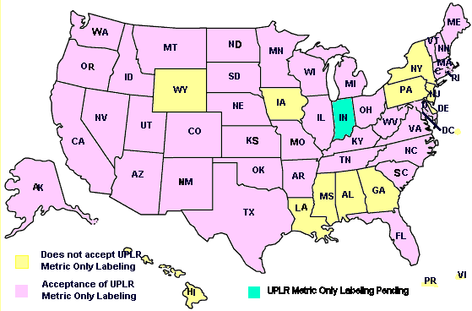

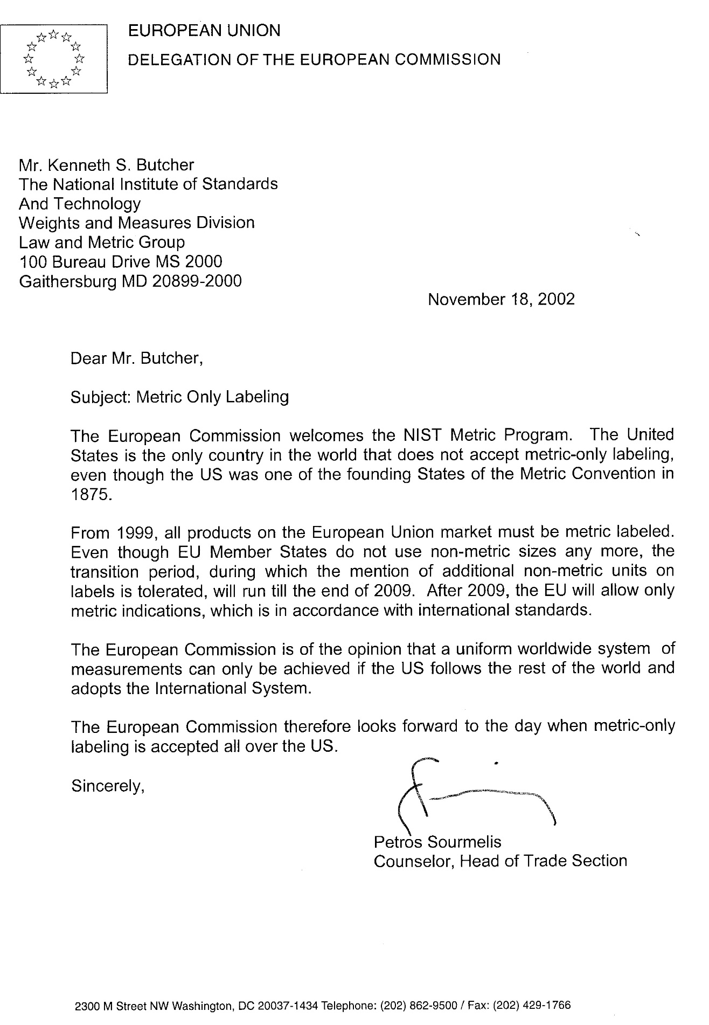

**- CHAPTER 39 - FAIR PACKAGING AND LABELING PROGRAM**

**§1451. Congressional Delegation of Policy.**

Informed consumers are essential to the fair and efficient functioning of a free market economy. Packages and their labels should enable consumers to obtain accurate information as to the quantity of the contents and should facilitate value comparisons. Therefore, it is hereby declared to be the policy of the Congress to assist consumers and manufacturers in reaching these goals in the marketing of consumer goods.

**§1452. Unfair and Deceptive Packaging and Labeling: Scope of Prohibition.**

(a) Nonconforming labels - It shall be unlawful for any person engaged in the packaging or labeling of any consumer commodity (as defined in this chapter) for distribution in commerce, or for any person (other than a common carrier for hire, a contract carrier for hire, or a freight forwarder for hire) engaged in the distribution in commerce of any packaged or labeled consumer commodity, to distribute or to cause to be distributed in commerce any such commodity if such commodity is contained in a package, or if there is affixed to that commodity a label, which does not conform to the provisions of this chapter and of regulations promulgated under the authority of this chapter.

(b) Exemptions - The prohibition contained in subsection (a) of this section shall not apply to persons engaged in business as wholesale or retail distributors of consumer commodities except to the extent that such persons (1) are engaged in the packaging or labeling of such commodities, or (2) prescribe or specify by any means the manner in which such commodities are packaged or labeled.

**§1453. Requirements of Labeling; Placement, Form, and Contents of Statement of Quantity; Supplemental Statement of Quantity.**

(a) Contents of label - No person subject to the prohibition contained in section 1452 of this title shall distribute or cause to be distributed in commerce any packaged consumer commodity unless in conformity with regulations which shall be established by the promulgating authority pursuant to section 1455 of this title which shall provide that -

(1) The commodity shall bear a label specifying the identity of the commodity and the name and place of business of the manufacturer, packer, or distributor;

(2) The net quantity of contents (in terms of weight or mass, measure, or numerical count) shall be separately and accurately stated in a uniform location upon the principal display panel of that label:

(A) using the most appropriate unit of the metric system of measurement and the inch-pound measurement equivalent, except as provided in paragraph (6) of this subsection; or

(B) using only the most appropriate units of the metric system of measurement.

~~(2) The net quantity of contents (in terms of weight or mass, measure, or numerical count) shall be separately and accurately stated in a uniform location upon the principal display panel of that label, using the most appropriate units of both the customary inch/pound system of measure, as provided in paragraph (3) of this subsection, and except as provided in paragraph (3)(A)(ii) or paragraph (6) of this subsection, the SI metric system.~~

(3) The separate label statement of net quantity of contents appearing upon or affixed to any package -

(A) for those portions of the net quantity of contents statement using inch-pound units,

(i) if on a package labeled in terms of weight, shall be expressed in pounds, with any remainder in terms of ounces or common or decimal fractions of the pound; or in the case of liquid measure, in the largest whole unit (quarts, quarts and pints, or pints, as appropriate) with any remainder in terms of fluid ounces or common or decimal fractions of the pint or quart;

(ii) if on a random package, may be expressed in terms of pounds and decimal fractions of the pound carried out to not more than three decimal places; ~~and is not required to, but may include a statement in terms of the SI metric system carried out to not more than three decimal places~~

(iii) if on a package labeled in terms of linear measure, shall be expressed in terms of the largest whole unit (yards, yards and feet, or feet, as appropriate) with any remainder in terms of inches or common or decimal fractions of the foot or yard;

(iv) if on a package labeled in terms of measure of area, shall be expressed in terms of the largest whole square unit (square yards, square yards and square feet, or square feet, as appropriate) with any remainder in terms of square inches or common or decimal fractions of the square foot or square yard;

(B) shall appear in conspicuous and easily legible type in distinct contrast (by topography, layout, color, embossing, or molding) with other matter on the package;

(C) shall contain letters or numerals in a type size which shall be (i) established in relationship to the area of the principal display panel of the package, and (ii) uniform for all packages of substantially the same size; and

(D) shall be so placed that the lines of printed matter included in that statement are generally parallel to the base on which the package rests as it is designed to be displayed; and

(4) The label of any package of a consumer commodity which bears a representation as to the number of servings of such commodity contained in such package shall bear a statement of the net quantity (in terms of weight or mass, measure, or numerical count) of each such serving.

(5) For purposes of paragraph (3)(A)(ii) and paragraph (6) of this subsection the term ''random package'' means a package which is one of a lot, shipment, or delivery of packages of the same consumer commodity with varying weights or masses, that is, packages with no fixed weight or mass pattern.

(6) The net quantity of contents statement for foods that are packaged at the retail store level and for random packages shall be expressed using one of three possible regimes: using only the most appropriate units of the metric system, using only the most appropriate inch-pound units, or using both the metric units and inch-pound units.

~~(6) The requirement of paragraph (2) that the statement of net quantity of contents include a statement in terms of the SI metric system shall not apply to foods that are packaged at the retail store level.~~

(b) Supplemental statements

No person subject to the prohibition contained in section 1452 of this title shall distribute or cause to be distributed in commerce any packaged consumer commodity if any qualifying words or phrases appear in conjunction with the separate statement of the net quantity of contents required by subsection (a) of this section, but nothing in this subsection or in paragraph (2) of subsection (a) of this section shall prohibit supplemental statements, at other places on the package, describing in nondeceptive terms the net quantity of contents: Provided, That such supplemental statements of net quantity of contents shall not include any term qualifying a unit of weight or mass, measure, or count that tends to exaggerate the amount of the commodity contained in the package.

**§1454. Rules and Regulations.**

(a) Promulgating authority - The authority to promulgate regulations under this chapter is vested in (A) the Secretary of Health and Human Services (referred to hereinafter as the ''Secretary'') with respect to any consumer commodity which is a food, drug, device, or cosmetic, as each such term is defined by section 321 of title 21; and (B) the Federal Trade Commission (referred to hereinafter as the ''Commission'') with respect to any other consumer commodity.