

Generated



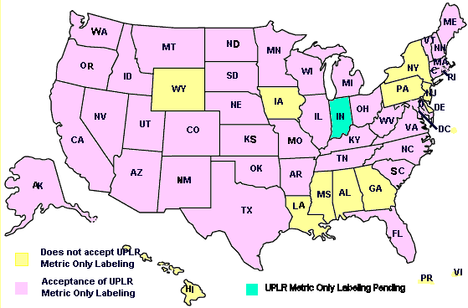

turers considering a change will be to conduct research to find out when using metric-only labeling would be appropriate. As companies introduce products with only metric units, they can use marketing and educational efforts to promote the new packaging. This type of effort is commonly used by businesses to help customers to accept new products or to introduce changes to existing brands and it is often supported with consumer information telephone lines.

The forum marked the beginning of a collaborative effort among government, industry and consumers to implement permissible metric-only labeling for products subject to only state regulation. Once FPLA is amended, it can be expanded to include all other products. Together, the working group will develop labeling and advertising guidelines for metric only packages and it can also create educational materials to assist retailers, consumers and others to better understand metric units and encourage consumers to use unit pricing and other available information to make value comparisons.

The option to use only metric units for package declaration information will also:

Permit manufacturers to label with only metric units, which will increase efficiencies for companies to market their products in international trade. Manufacturers will decide which method of labeling to use for both domestic and foreign markets based on the needs of their customers.

Simplify labels and reduce confusion on products that are required to be labeled by volume in one market and by mass in another, by eliminating the use of the same inch-pound unit “ounce” for volume and mass.

Reduce the space required for dual-unit labeling and free it up for other consumer information.

Allowing metric-only products on the shelves alongside products with dual-unit labeling will continue to help consumers establish mental "reference points" of the metric quantities they use routinely. One of the goals of this collaborative effort will be to ensure that consumers are able to make value comparisons between products with dual-unit labeling and those labeled with only in metric units. Another goal will be to explore ways to help consumers make value comparisons on a wider range of products where unit pricing information is not generally available. Another goal will be to promote uniform labeling and eliminate the use of incorrect symbols and improper quantity claims to ensure fair competition.

## Comments from Some Members of the Food Industry

Objections to metric-only labeling came primarily from the Food Marketing Institute

