

Generated



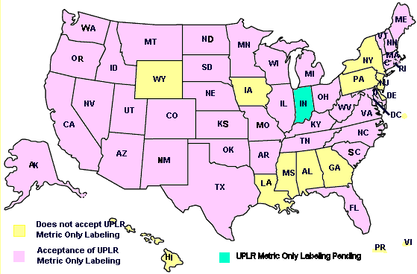

retail sales agencies or instrumentalities for consumption by individuals, or use by individuals for purposes of personal care or in the performance of services ordinarily rendered within the household, and which usually is consumed or expended in the course of such consumption or use (e.g., soaps and detergents, paper products, and waxes and polishes.) and these are subject to the labeling regulations of the Federal Trade Commission

2.The FPLA requirements do not apply to:

a.Packages intended for export (unless they are also intended for sale in the U.S. marketplace.)

b.Meat or meat product, poultry or poultry product, and some packaged agricultural seed which are subject to the labeling regulations of the U.S. Department of Agriculture.

c.Pesticides that are subject to the labeling regulations of the Environmental Protection Agency.

d.Alcohol, beer, wine and tobacco or tobacco products which are subject to labelingregulations of the Department of Treasury

e. All other products that fall under the jurisdiction of State and local regulations that are based on the Uniform Packaging and Labeling Regulation (UPLR), NIST Handbook 130.

3.Some products that can already be labeled with only metric units of measurement.

The following packaged products currently may be labeled in metric-only units. Many of these products have been labeled with only metric units for more than 25 years.

a.Wine and spirits (except for beer).

b.Camera film, videotape, audiotape, and other imaging and audio media.

c.Packages of seed with net contents of less than 225 grams.

d.

